Key to success in full arch reconstruction procedures with immediate loading.
Jean-Fabien GRANGEON, DDS, private practice, Periodontology & Implantology.
Clinique Dentaire des Mascareignes.
Reunion Island.
French overseas territories in the indian Ocean.

Abstract (300 word limit)
Full arch reconstruction procedures are nowadays well described and we’ll go through all the tips and skills required that drive us to reproductible success.
We will present the new paradigm in modern implantology :
- What is immediate implantation & loading :
  - Extraction
  - Immediate implant placement ( over drilling in the coronal aspect/ no compression/ controled torque )
  - Bone graft ( sticky bone graft with allograft materials)
  - Membranes ( Collagene, resorbable, PRF)
  - Release of Split thickness flap without periosteal incision ( Soft brushing technique)
  - Sutures ( apical matress techniques)
  - Immediate loading of the temporary rigid bridge

- We will present the new paradigm in modern implantology :
  - Less metal , More Bone.
  - Implant positioning
  - Choice of the implant :
    - Materials
    - Shape
    - Surface type
    - Thread ( apical vs cervical, single & double)
    - Connexion type ( platform switching)
  - Biologic investigations prior to surgery ( Vitamin D, LDL Chlesterol
  - Presentation and Use of PRF for angiogenesis purpose

A clinical presentation of several surgical cases will be added in the second part of the conference showing it’s predictible results through single tooth replacement procedures and full arch reconstructions in one step.

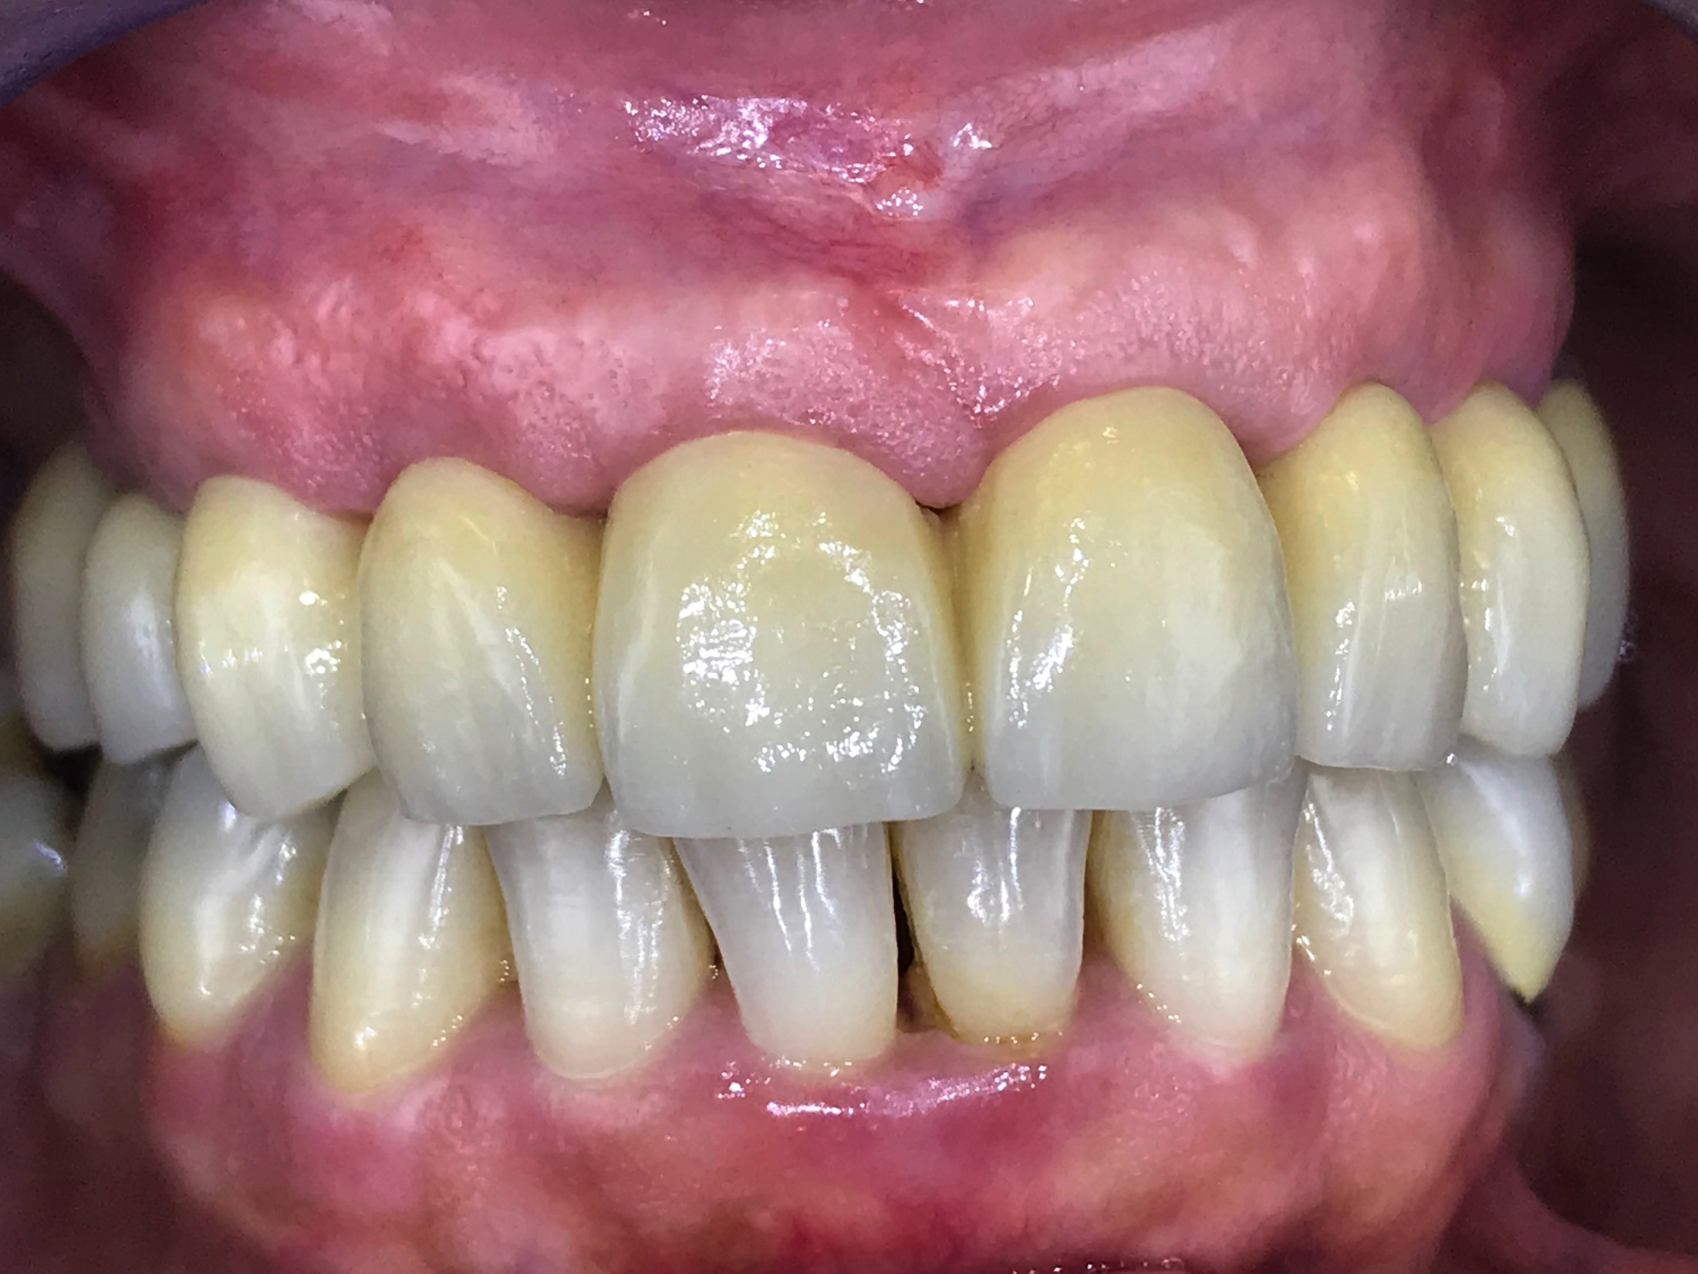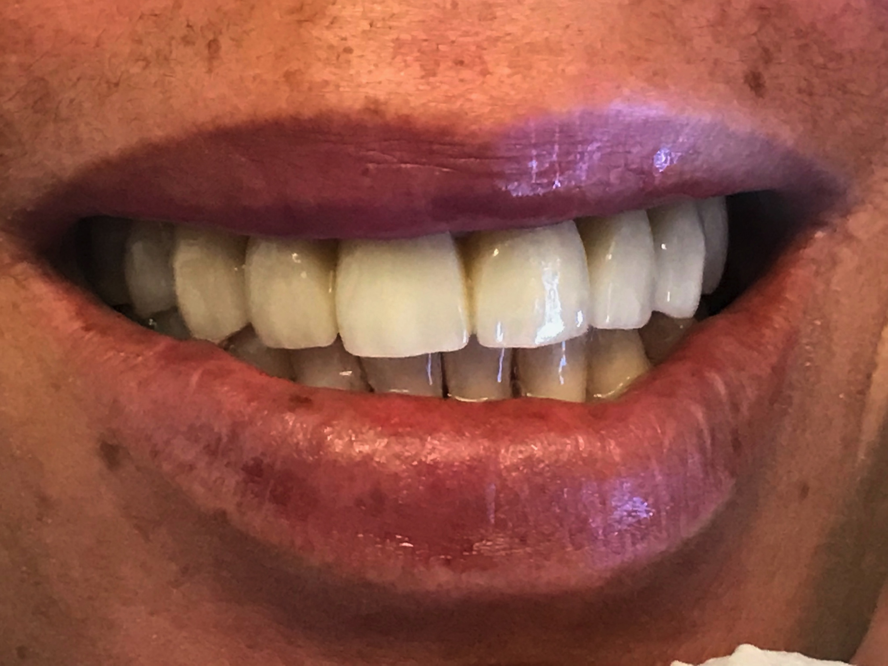
Recent publications (minimum 5)

- CHOUKROUN J, CHOUKROUN E, et Al. Two Neglected Biologic Risk Factors in Bone Grafting and Implantology: HighLow-DensityLipoproteinCholesterol andLowSerumVitaminD. Journal of Oral Implantology Feb 2014, Vol. 40, No. 1 (February 2014) pp. 110-114
- EREN G, KANTARCI A, SCULEAN A, Vascularization after treatment of gingival recession defects with platelet-rich fibrin or connective tissue graft. Clin Oral Investig. 2016 Nov;20(8):2045-2053.
- DELGADO-RUIZ R, ROMANOS G , et Al. Biological effect of compressive forces exerted on particule grafts during socket preservation : animal study. COI 2016 Aug 02.
- GEHRKE S, CALVO GUIRADO JL, et Al. Evaluation of insertion torque, implant stability quotient and drilled hole quality for different drill design : an in vitro investigation. COIR 2016 Mar
- BERTL K, KUKLA E.B, et Al. Timeframe of socket cortication after tooth extraction : A retrospective radiographic study. COIR 2017 Oct 15.
- GHANAATI S, CHOUKROUN J, et Al. Advanced platelet-rich fibrin: a new concept for cell-based tissue engineering by means of inflammatory cells. J Oral Implantol. 2014 Dec;40(6):679-89.
- MIRON RJ, ZUCCHELI G, et Al. Use of platelet-rich fibrin in regenerative dentistry : a systematic review. Clin Oral Investig. 2017 Jul ;21(6) : 1913-1927.

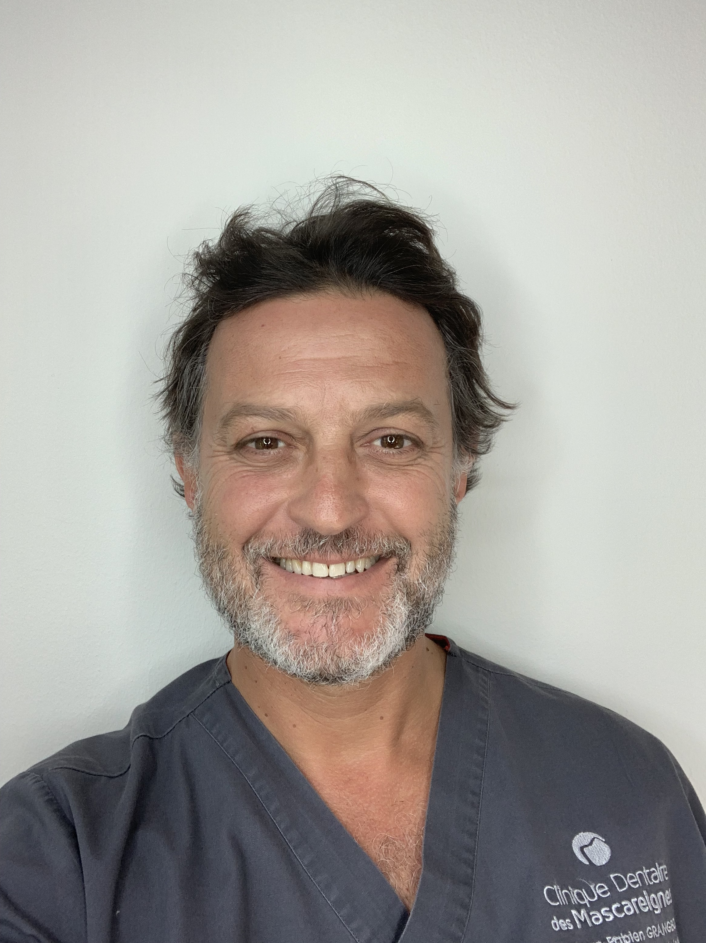

Biography (150 word limit)
Jean-Fabien Grangeon graduated in 1996 and since then kept on improving, always focused on bringing the best technics, confort and care to his patients. After 4 years as assistant in the dentistry service of an hospital he moved to private practice. Starting alone is own structure in 2004 , he’s now CEO of the « Clinique Dentaire des Mascareignes » and work as an exclusive practitioner in periodontology and implantology. In collaboration wit 5 other general practioners , a specialist in orthodontics and a specialist in endodontics and microsurgery. The structure is also a formation center with all the dedicated technologies, featuring 2 Operation rooms in relation with a conference room and 7 others dental units with CBCT, ZEISS microscope …He followed the teaching of many major dental surgeons and acquired the knowledge to perform advanced procedures. Passionate about his work, he now wants to transmit his knowledge and play his role in the chain of continuing education.

Email: drjfgrangeon@gmail.com

