DYNAMIC NAVIGATION FOR DENTAL IMPLANTATION

Mapping Virtual to Reality
Navident offers dental surgeons an easy to use accurate, highly portable and affordable way to plan the desired restoration and implant placement on a virtual patient, then execute the plan on the real patient’s jaw.The virtual patient’s jaw is created from the CT and digital impression data in seconds. The plan, including crowns and implants, is prepared in a few minutes and can be modified any time. During surgery, Navident shows the advance of the drill tip or implant in the patient’s jaw relative to surrounding structures and the implantation plan.
The position of the implant is planned in advnaced on screen by optimizing the impolant position considering both bone and crowns. This information allow the computer to calculate and display the virtual position relative to the image. This system dynamically tracks the drill and the patient provinding the guidance and the visual feedback to insure he implants are placed according to plan. Thus reducing faulty implant axes and placement. This proccess is guided throught sensors attached to the handpiece and the patient jaw. 3D positional information is transformed to the camera this information allows the computer to calculate the virtual position relative to the image data.
The benefit of navident is perform a flapless surgery leading to reduce patient disconmfort , faster the recovery period , reduce the iatrogenique damage to anatomical structures , finally increasing the succes rate of implant osteointegration by reducing the risk of infection. Therefore it reduces the partictioner stress level during surgery. It also reduce the treatment cost , moreover it demonstrates to the patients the abiliy to leverage the latest technology delevering better saffer and less INVASIVE care .

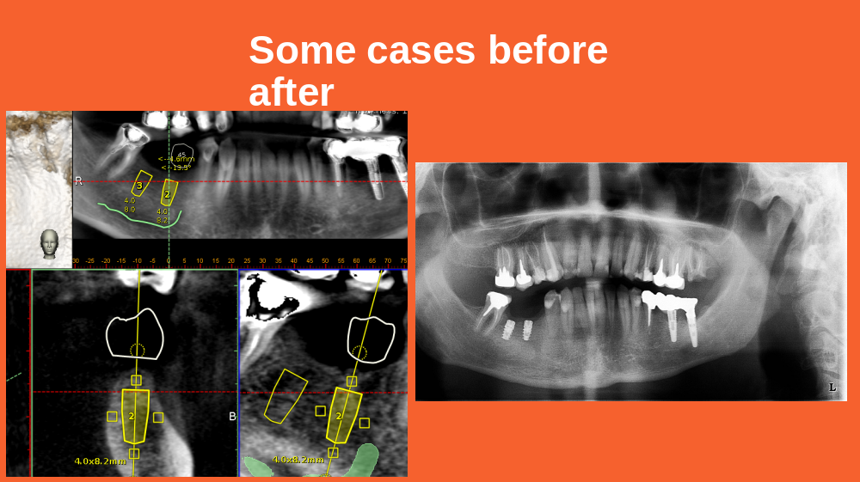

Recent publications :
- Consensus Statements and Recommended Clinical Procedures Regarding Contemporary Surgical and Radiographic Techniques in Implant Dentistry. Bornstein MM, Al Nawas B, Kuchler U, Tahmaseb A. Int J Oral Maxillofac Implants. 2013 Aug 15. doi: 10.11607/jomi.2013.g1
- Consensus statements and recommended clinical procedures regarding computer-assisted implant dentistry. Hämmerle CH1, Stone P, Jung RE, Kapos T, Brodala N. Int J Oral Maxillofac Implants. 2009;24 Suppl:126-31.
- Computer technology applications in surgical implant dentistry: a systematic review. Jung RE, Schneider D, Ganeles J, Wismeijer D, Zwahlen M, Hämmerle CH, Tahmaseb A. Int J Oral Maxillofac Implants. 2009;24 Suppl:92-109.
- Clinical advantages of computer-guided implant placement: a systematic review. Hultin M, Svensson KG, Trulsson M. Clin Oral Implants Res. 2012 Oct;23 Suppl 6:124-35
- Computer-aided manufacturing technologies for guided implant placement. Neugebauer J, Stachulla G, Ritter L, Dreiseidler T, Mischkowski RA, Keeve E, Zöller JE. Expert Rev Med Devices. 2010 Jan;7(1):113-29. doi: 10.1586/erd.09.61. Review.
- Glossary of Oral and Maxillofacial Implants. Laney WR, ed in chief. Chicago, IL: Quintessence Publishing Co, Ltd; 2007. (in 2013 Assessing Image-Guided Implant Surgery in Today’s Clinical Practice)
- Flapless surgery and its effect on dental implant outcomes. Brodala N. Int J Oral Maxillofac Implants. 2009;24(suppl):118-125. (in 2013 Assessing Image-Guided Implant Surgery in Today’s Clinical Practice)
- Accuracy of implantation using the RoboDent navigation system: a prospective, multicentric, clinical observation. Doctoral Thesis of Juliane Ernst, Department of Medicine – Charité – University Medicine Berlin, June 2008
- Somogyi-Ganss E, Holmes HI, Jokstad A. Accuracy of a novel prototype dynamic computer-assisted surgery system. Clin. Oral Impl. 2014 May 19. doi: 10.1111/clr.12414

Biography DR. Albert elKHOURY:
DU in oral biology and DU in dental public health.
I occupied, for several years, the position of Clinical chief at the UL dental school and B.A.U
I was responsible in the dental prevention on the lebanese territory for public and private schools for several years.
Moreover, for the same purpose, I hosted a dental program on lebanese television Tele Lumiere and Noursat for several years..
I took part as a participant or speaker in different local and international dental conferences:
- Dental Meetings at the Lebanese University
- Dental Summit of the Lebanese Dental Association
- Conferences organized by the European Association of osseo-integration
- Europerio - Zimmer Dental Implant Summit in Puerto Rico, Barcelona and Antalia
- Implant Direct Courses in California, USA
- SIC Dental Implant Seminares
- JD Evolution Dental Implant
- ATA Implant Seminares
- Maillfere Seminare
Email :albert.mk@homail.com
www.albertkhoury.com
phone 00961 3 213 246 --- 00961 71 001800

