TREATMENT OF FRACTURES OF THE ZYGOMATIC COMPLEX WITH DIFFERENT RETAINERS.
E. Astapenko, N. Lytovchenko
Bogomolets national medical university, Kiev, Ukraine
Fractures of the zygomatic complex (ZCF) is the second in frequency among all fractures of the maxillofacial area [8]. Unfortunately, the frequency of criminal injury has increased, except fractures, moreover a zygomatic bone has become more complex in nature of damage [3, 8]. Nowadays some algorithms that provide surgical care for victims of zygomatic complex (ZC) fractures are defined [1,7,9]. To fix the bone fragments different types of the bone plates and screws are used, such as titanium and resorptive. The titanium ones remain in the tissues after consolidation of the bone fragments. Recently, many researchers emphasize the need to remove the metal braces after consolidation of fractures due to the inflammatory processes in the surrounding tissues, cold response, the patient's desire to remove the metal retaining structure after the fusion of the bone fragments, etc. [2]. In our previous studies, we demonstrated the feasibility of bioactive plates’ resorptive action EPU-GAP-LEV for fixing bone fragments of the middle zone face (MZF) [4,5,6]. Therefore, in this and subsequent studies we concentrate attention on the particular choice of clamps for osteosynthesis depending on the location of the fracture and the clinical situation. Thus, in the area of ​​the zygomatic-alveolar crest (ZAC) which is MZF buttresses, the choice of lock depends on the nature and type of fracture.
The aim of our work is to decide how to choose the lock for osteosynthesis (titanium or resorptive) in the area of ZAC at various ZCF.
Materials and methods. Observation group were 120 patients with fractures of the ZC, after which clinical and radiographic examination surgical treatment of fractures was performed using various types of clamps. The surgery included reposition and fixation of ZC fragments revision of maxillary sinus using intraoral and one of the extraoral accesses. Osteosynthesis of ZC was carried by titanium and polymer plates based on poliuretan (EPU-GAP-LEV). Planning surgery and braces selection was based on the data of computer tomography (CT) and the intraoperative picture of the fractures. Analysis of the treatment was carried out on the basis of the CT study, 6 months after surgery with the definition of bone density in the area of ​​the fragments ZC fusion.
Research results.
The main role for the stable ZC fixation in the right position was given to the area of ​​osteosynthesis of zygomatic-frontal suture. However, it is undeniable thesis on the necessity to fix 2-3 zones. This important support for stabilization ZC space is given in the ZAC area​​osteosynthesis’.
Polymerosteosynthesis with the bone plates and screws in the survey was conducted to 79 patients. It was possible in case of absence of bone defects. In the vast majority of observations the fracture gap was accurately located, while the diagrams of X-ray density remained uniform due to a significant decrease in mineral saturation of the surrounding bone. In general radiographic bone density in the area of​​fusion detected 20-30% less than the intact side.
Resorptive retainers for osteosynthesis EPU-GAP-LEV, that we proposed [3], have certain advantages. Due to the hydroxyapatite and levamisole they have a good biocompatibility and positive influence on the course of reparative regeneration of bone tissue in the area of ​​the fracture. According to its physical and mechanical indicators they are close to the bone [6]. Therefore, during the fusion of bone fragments after osteosynthesis of their application, the load on the bone is shared equally, there is no effect of "mechanical shunt" and consolidation of fragments is on time. But this is possible only in the integrity recovery.
Based on the analysis of the results, it should be noted that if there are comminuted fractures in the area of ​​ZAC and bone defects, biodegradable polymer platesis impractical as the only way to fix bone fragments because in this area it is necessary to renew buttresses. This is possible only if the application of more stringent not resorptive bone plates for osteosynthesis. Polymer fixation plates and screws EPU-GAP-LEV should be used as an extra, they simultaneously function as "depot" to improve conditions for wound healing and prevent inflammatory complications in the postoperative period.
Thus, for 41 patients titanium plates and screws were used in the areas of fracture and polymer retainers EPU-GAP-LEV were used as additional latches. In these cases, the observed bone defects of different sizes were detected because of the removal of free fragments, which lost contact with the periosteum, and till the time of the survey (6 months after the surgery) were not filled with bone tissue. Radial density in these areas averaged 138 + 59 HU, and was 5-16 times lower than the healthy unaffected side.
In the postoperative period, all patients administered the standard course of anti-inflammatory therapy.
Clinical Example № 1.
Patient S., 30, arrived for treatment in the emergency procedure. He had a right traumatic fracture with displacement (Fig. 1).

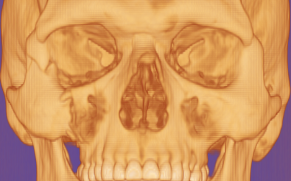

Fig.1. 3D CT facial reconstruction of the skull in the patient C. (condition after injury).

After clinical and radiographic examination operation was conducted- reposition, polimerosteosynthesis EPU-GAP-LEV of the right zygomatic complex. With an intraoral access and direct access to the right zygomatic-frontal suture ZC reposition was made, its fixation with plates EPU-GAP-LEV in the area of ​​right zygomatic-frontal suture and ZAC. The operation was completed with revision and catheterization of the right maxillary sinus (Fig. 2).

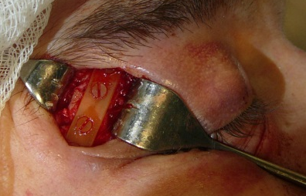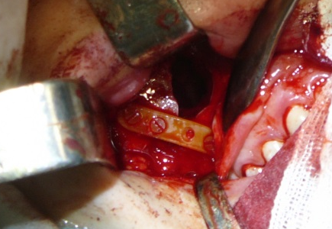

A B
Fig. 2. Step operative care:
A - polimerosteosynthesis in the area of zygomatic-frontal suture with the plate and screws EPU-GAP-LEV.
B - polimerosteosynthesis in the ZAC area with the plate and screws EPU-GAP-LEV.

The postoperative period was uneventful. The X-Ray of the position of bone fragments of the zygomatic complex testified the correct position of the plates and screws. The stitches were removed. The patient was discharged from the office in satisfactory condition.
A survey in 3 months after the operation testified to the full rehabilitation of the patient. The polymer plate in the osteosynthesis areas was not palpated.
After 6 months CT 3D control of the facial skull showed a complete anatomic restoration of the affected area (Fig. 3). Indicators of mineral density bone regenerated in the area of polimerosteosyntesis EPU-GAP-LEV approached to the mineral density of unaffected bones on the symmetrical side 879 + 124 HU versus 951 + 132 HU, indicating the timeliness of all phases of the regeneration of bone tissue, including the mineralization and restructuring (Fig. 4).

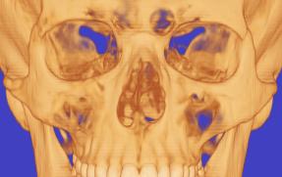

Fig. 3. 3D CT patient’s status, 6 months after surgery.
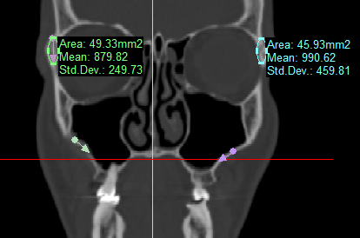

Fig. 4. The research density of bone fusion fragments, 6 months after surgery.

Comparison of the bone mineral density in polimerosteosyntheis and the symmetrical unaffected areas (in this slice MSCT indicators of the mineral bone density in the area with polimerosteosynthesis was 879,82 HU against 990,62 HU on the unaffected side).
Clinical example № 2. Patient S., 28, arrived for treatment in emergency procedure. He had a traumatic fracture of the right zygomatic complex with displacement. He addressed doctors 5 days after the injury.
At CT 3D determined violations of integrity skull bone clastic complex of the right zygomatic complex near the body of the ZC, the lower edge of the orbit and ZAC with the offset (Fig. 5).

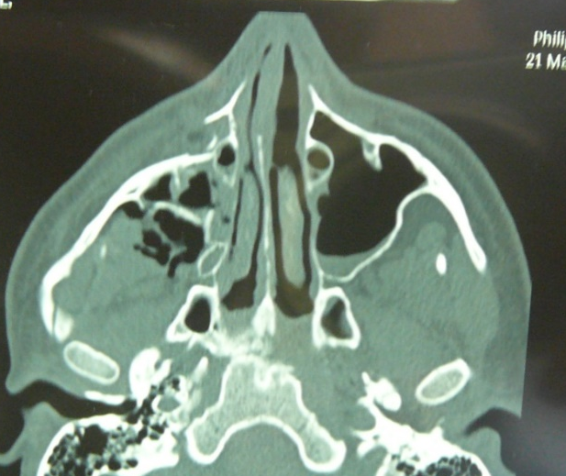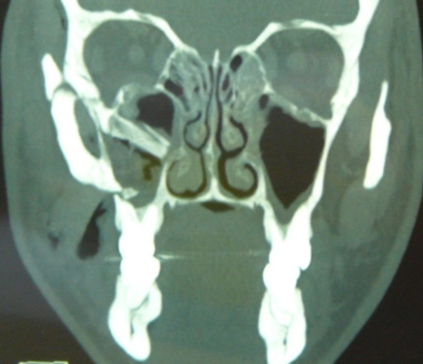
A B

Fig. 5. Patient S., Diagnosis: right traumatic ZC fracture with the offset:
A. Photo slice CT in axial projection.
B. Photo slice CT in frontal projection.

After clinical and radiographic examination an operation was conducted - reposition, osteosynthesis of the right ZC. With intraoral access and direct access reposition of ZC was made, it was fixed with the plate EPU-GAP-LEV near the body of ZC.
Taking into account that ​​the fracture was debris and after the removal of free pieces a small bone defect was created the length of which was 1.4 mm, there was a need not only to fix this locus bone fragments, but also to play buttresses.
Therefore, a fixation on the ZC body was carried with a plate EPU-GAP-LEV, and in the area of ​​scales with a bone titanium plate and screws (Fig. 6). The operation was completed with revision and catheterization of the right maxillary sinus.

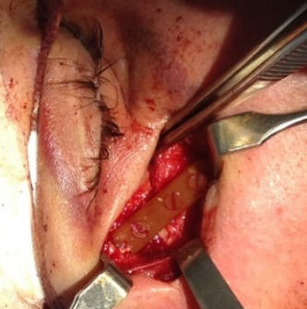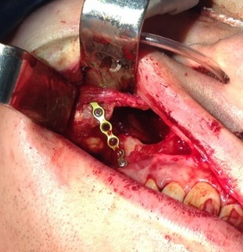
A B

Fig. 6. Stage of the surgery of patient S.: A – polimerosteosynthesis (EPU-GAP-LEV) in ZC on the body; B – metaloosteosynthesis in the ZAC area.

The postoperative period was complicated.The X-ray testified the correct position of the fragments (Fig. 7). Within a year after the surgery there were no complications.

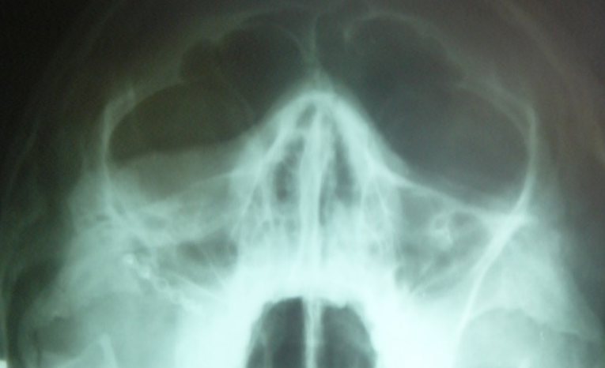

Fig. 7 Axial projection X-ray of the patient 7 days after the surgery.

After 6 months of the operation as a result of the MSCT control consolidation of the fracture was detected in all the loci where the bone fragments were in contact during osteosynthesis. In the ZAC area a bone defect remained that was restored with a bone titanium plate (Fig. 8).

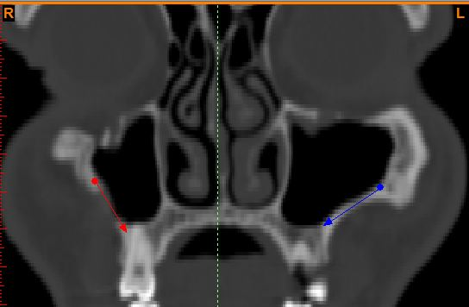

Fig. 8. MSCT facial bones of the skull of the patient S., 28 years, 6 months after osteosynthesis in the defected ZAC area.

Conclusions. Analysis of clinical cases showed that the choice of retainers for osteosynthesis in the ZAC area should be treated differently. If the surgery in the area formed a bone defect and buttress should be restored,use hard not resorptive catches, including titanium. In cases of the ZAC integrity restoring resorptive bone plates and screws EPU-GAP-LEV should be used.
Prospects for further research: To evaluate the efficiency of osteosynthesis of resorptive accessory EPU-GAP-LEV in other areas of maxillo-facial area.

References:
1. Ankht L.N. Practical traumotology: European standards of diagnosis of treatment and / L. N.Ankht, N.L. Ankyn // - M., 2002. - 480 p.
2. Varese Ya.E. Indications for removing metallic mini plates in traumatology and reconstructive surgery maxillofacial / Ya.E.Vares // Ukr.med.almanah. - 2009. - T.12, № 2. - P. 42-45
3. Galatenko N.A. Biodegrating action of bioactive material based on polyuretan-epoxy compositions as a carrier of drugs / N.A.Halatenko, M.A.Kuksin, R.A.Rozhnova [et al.] // The polymer journal. - 2008. - T.30, №2. - P.169-173.
4. Malanchuk V.A. Application of bioresorbable polymeric bioactive action miniplates for osteosynthesis in fractures of the zygomatic complex / V.A.Malanchuk, E.A.Astapenko // Herald of stomatology. - 3013. - № 4. – P. 68-72.
5. Malanchuk V.A. Comparative dynamics of the morphological violations and morphometric indexes in the defected lower jaw area during the implantation of the poliuretan and titanium plates and screws in the experiment / V.A. Malanchuk, E.A. Astapenko, V.V. Hryhorovskyy // Russian dental journal. - 2012. - №2. - P.7-12.
6. Results of the study of physical and mechanical biodegrading polymer properties, used in reconstructive bone surgery / V.A. Malanchuk, E.A. Astapenko, N.A. Galatenko [et al.] // Bulletin problems of biology and medicine. - 2013. - № 2 (100). - P. 304-308.
7. A.A. Soloveva Anatomic-topographic substantiation of ways to restore zygomatic-alveolar crest buttress for fractures of zygomatic complex: Author. Dis. on PhD degree. med. Sciences: spec. 14.00.14 "Stomatology" 14.03.01 "Human Anatomy" / A.A. Soloveva. - Moscow, 2014. - 19 p.
8. Surgical dentistry and maxillo-facial surgery: textbook; The 2 vols. - T. 2 / V. Malanchuk, I. Logvinenko, T. Malanchuk, O. Tsilenko. - K .: Logos, 2011. - P. 66-72.
9. Sharhorodskyy A.G. Soft tissue traums and facial bones / Sharhorodskyy A.G. // Moscow: HECTOR-MED, 2004. - 383 p.

