

Complex maxillary odontomas: what treatment?
Zidane Fatima Ezzahra, resident In pediatric dentistry, UIR
Fawzi Rachid , higher education teacher In pediatric dentistry, UIR

Abstract (300 word limit)
Odontomas are the most common benign tumors of the maxillae. According to the classification of the World Health Organization (WHO): There are two types: Odontomas composed of a set of small rudimentary teeth, assembled in clusters and complex odontomes, less frequent, composed of a mass anarchic enamel, dentin, cement and pulp tissue. They are most often located in the posterior segments of the lower jaw.
Often asymptomatic and incidentally discovered, they are only diagnosed in children after the age of 10, often following a delay in the eruption of a permanent tooth
In some cases, these tumors can cause clinical manifestations such as pain, infections, fistulas and exteriorization. The indication of their surgical excision is therefore essential.
The clinical case reported is that of a young patient aged 14, in good general health, who consulted for delayed eruption of 12 and 13. The intraoral clinical examination revealed the presence of a hard mass of ovoid shape, non-reducible and non-compressible in this area, extending from the upper lateral lactis incisor to the first permanent premolar. The radiographic examination revealed a large radio-opaque mass of anarchic appearance, measuring approximately 2.5 x 1.5 cm in length. On the basis of the radiographic appearance, a diagnosis of complex odontoma was established.
The presumptive diagnosis, apart from the often crude clinical signs, is essentially based on the radiography which provides information on the tone of the image, its outline, the mono or polygeodic character.
The etiology of odontomas remains unexplained, however, a link with dental trauma, inflammatory changes and / or genetic predisposition is discussed.
The objective of this work is to focus on the diagnostic and therapeutic approach adopted in the management of a case of giant complex odontoma in a young patient
(Up to 250 words)

Key words: odontoma, inclusion, child

Image
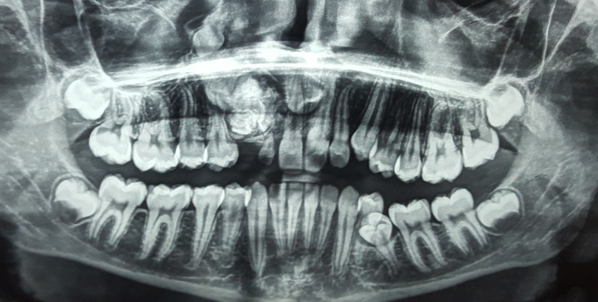

Recent Publications (minimum 5)
- Dagistan S et al. Internet J Dent Sci 2007 ;5 :1-6.
- Kramer et al. Second Edition ; Berlin Springer 1992 : 16-21.
- Korbendeau JM et al. Paris : CdP, 1998 :65-89.
- Hariri El Mehdi., et al.EC Dental Science 18.4 (2019) : 690-696

Biography
Zidane Fatima Ezzahra has her expertise in evaluation and passion in improving the health and wellbeing. Her open and contextual evaluation model based on responsive constructivists creates new pathways for improving healthcare. (Up to 100 words).

Presenting author details
Full name (As per the passport): Zidane Fatima Ezzahra
University/Industry/Organization name: université international de Rabat (UIR)
Designation (Director/Prof/Assistant or Associate prof/Researcher/Student): Dr
Country: Morroco
Mobile number (country code – number): +212661453217
Email: Fatima-ezzahra.zidane@uir.ac.ma
Track number: https://dentistrycongress.dentistryconferences.com/abstract-submission.php (For track number follow this link)
Category (Oral presentation/ Poster presentation/Young researcher forum/E-poster/ Workshop): E-poster Research interest:
Your profile page URL in your department:
Year of birth: 1993
Linked In/Facebook/twitter account: Fatima Ezzahra zidane

Note: Please fill up the Red mark fields so that it would be easier for us to cite your details in the conference particulars. (Please do not forget to fix your photo and Logo above the title)

.

