

Glycemic balance and oral state: a bidirectional association
Zidane Fatima Ezzahra, resident In pediatric dentistry, UIR
Fawzi Rachid , higher education teacher In pediatric dentistry, UIR

Abstract (300 word limit)
The relationship between diabetes and periodontal disease has been often discussed. Indeed, there is a two-way relationship where uncompensated diabetes promotes the development of periodontal diseases and, conversely, a bad oral condition negatively influences the oral state. The objective of our work is to show on the one hand the interrelation that exists between the glycemic balance and the oral state.
Materials and methods: This is a cross-sectional, case-control type analytical study carried out on 100 children and adolescents with type 1 diabetes, aged 3 to 17 years. The variables collected were socio-demographic, related to diabetes, and related to oral hygiene. The clinical examination made it possible to identify variables related to the oral state (DMFt, IP plaque index, GI gingival index,). The data was analyzed using Statistical Package for Social Science (SPSS 20.0.0) for Windows.
Results: Our study revealed an average Dmft index in diabetics and controls, namely 6.1 ± 3.26 vs 5.85 ± 3.58 (p = 0.6), the mean gingival index a was 0.96 ± 0.34 vs 0.58 ± 0.28 (p = 0.55), the mean plaque index was 0.97 ± 0.28 vs 0.45 ± 0.30 ( p = 0.05) and a 40% tartaric deposit vs 18% controls (p = 0.001). The univariate analysis of the results showed significant bidirectional associations between type 1 diabetics and the oral state
(Up to 250 words)

Key words: diabetes, periodontal, inflammation, type 1 diabetes, child

Image
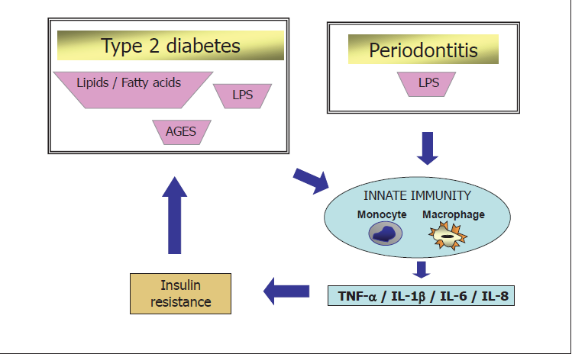

Recent Publications (minimum 5)
- Ana Sofia Coelho (2019) J Dental caries, diabetes mellitus, metabolic control and diabetes duration : A systematic review and meta-analysisEsthet Restor Dent. 2020 ;1–19
- Filippo Graziani1(2017) A systematic review and meta-analysis of epidemiologic observational evidence on the effect of periodontitis on diabetes. J Clin Periodontol. 2017 ;1–21.
- Mariano Sanz1 (2018) Scientific evidence on the links between periodontal diseases and diabetes: Consensus report and guidelines of the joint workshop on periodontal diseases and diabetes by the International Diabetes Federation and the European Federation of PeriodontologyJ Clin Periodontol. 2018;45 :138 –149.

Biography
Zidane Fatima Ezzahra has her expertise in evaluation and passion in improving the health and wellbeing. Her open and contextual evaluation model based on responsive constructivists creates new pathways for improving healthcare. (Up to 100 words).

Presenting author details
Full name (As per the passport): Zidane Fatima Ezzahra
University/Industry/Organization name: université international de Rabat (UIR)
Designation (Director/Prof/Assistant or Associate prof/Researcher/Student): Dr
Country: Morroco
Mobile number (country code – number): +212661453217
Email: Fatima-ezzahra.zidane@uir.ac.ma
Track number: https://dentistrycongress.dentistryconferences.com/abstract-submission.php (For track number follow this link)
Category (Oral presentation/ Poster presentation/Young researcher forum/E-poster/ Workshop): Oral presentation
Research interest:
Your profile page URL in your department:
Year of birth: 1993
Linked In/Facebook/twitter account: Fatima Ezzahra zidane

Note: Please fill up the Red mark fields so that it would be easier for us to cite your details in the conference particulars. (Please do not forget to fix your photo and Logo above the title)

