

“Association of cognitive impairment and dementia with periodontal disease: a systematic review and a meta-analysis”
Rizwan Nadim, MPH, University of Wolverhampton, UK
Jie J Tang, PhD, University of Wolverhampton, UK
Ruoling Chen, PhD, University of Wolverhampton, UK

Abstract (300 word limit)
Statement of the Problem: Dementia is recognized worldwide as a major health public problem [1], yet few studies have been done on dementia association with periodontal disease (PD). Periodontal disease (PD) is a chronic inflammatory disease, affecting the gums by infection of oral bacteria resulting in alveolar bone loss and eventually tooth loss [2]. PD has been reported to be the sixth most prevalent condition worldwide, affecting around 20-50% of the global population [3]. Although PD in adults increases the risk of dementia [4,5], it is unclear whether dementia also increases PD [6-9]. We carried out a systematic review and a meta-analysis to investigate the association of cognitive impairment and dementia with PD. Methodology: For this systematic review and meta-analysis, we searched 5 databases, including PubMed, PsycINFO, CINAHL, SocINDEX, and MEDLINE, from inception to 9th September 2019. Seven cohort studies and one case-control study were included for review. Relative risk (RR) with 95% confidence interval (CI) was pooled to determine the association of dementia and cognitive impairment with PD. Findings: In eight studies of dementia and cognitive impairment with PD, of which four showed a significant positive association, three non-significant associations and one reported non-significant inverse association. The pooled RR of PD from eligible five cohort studies was RR 1.10, 95% CI 0.96-1.27; in these dementia association with PD was RR of 2.72 (1.34-5.53) and cognitive impairment association with PD was RR 1.06 (0.95-1.17). Conclusion: The current evidence supports that dementia could cause PD but it is unclear whether cognitive impairment is also associated with PD. Further need for periodontal screening and treatment of elderly people with cognitive impairment and dementia should be emphasized.

Key words: cognitive impairment, dementia, periodontal disease, systematic review

Image

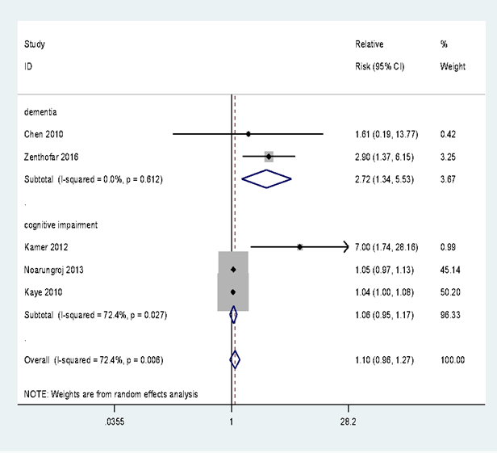
Recent Publications (minimum 5)
- Prince, M.J (2015). World Alzheimer Report 2015: the global impact of dementia: an analysis of prevalence, incidence, cost and trends. 2015: Alzheimer's Disease International
- Van Dyke T,E, Van Winkelhoff AJ (2013). Infection and inflammatory mechanisms. J Clin Periodontol. 2013;40:S7.
- Kassebaum, N. J., Bernabé, E., Dahiya, M., Bhandari, B., Murray, C. J. L., Marcenes, W (2014). Global burden of severe periodontitis in 1990-2010: a systematic review and meta-regression. Journal of dental research, 93(11), 1045-1053.
- Leira Y, Dominguez C, Seoane J, Seoane-Romero J, Pías-Peleteiro JM, Takkouche B, Blanco J, Aldrey JM (2017). Is periodontal disease associated with Alzheimer's disease? A systematic review with meta-analysis. Neuroepidemiology. 2017;48(1-2):21-31.
- Dominy SS, Lynch C, Ermini F, Benedyk M, Marczyk A, Konradi A, Nguyen M, Haditsch U, Raha D, Griffin C, Holsinger LJ (2019). Porphyromonas gingivalis in Alzheimer’s disease brains: Evidence for disease causation and treatment with small-molecule inhibitors. Science advances. 5(1): eaau3333.
- Naorungroj, S., Slade, G. D., Beck, J. D., Mosley, T. H., Gottesman, R. F., Alonso, A., Heiss, G. (2013). Cognitive decline and oral health in middle-aged adults in the ARIC study. J Den Res. 92(9): 795-801.
- Kamer AR, Morse DE, Holm-Pedersen P, Mortensen EL, Avlund K (2012). Periodontal inflammation in relation to cognitive function in an older adult Danish population. J Alzheimers Dis. 28(3):613-24.
- Ship, J.A. and S.A. Puckett, Longitudinal study on oral health in subjects with Alzheimer's disease. J Am Geriatr Soc (1994) p. 57-63
- Aragón F, Zea-Sevilla MA, Montero J, Sancho P, Corral R, Tejedor C, Frades-Payo B, Paredes-Gallardo V, Albaladejo A (2018). Oral health in Alzheimer’s disease: a multicenter case-control study. Clin Oral Investig. 22(9):3061-70.

Biography

Rizwan Nadim is a dentist and has over 12 years of clinical experience. He has gained extensive research experience during his time in Pakistan while teaching undergraduate dental students about community and preventive dentistry, for more than 7 years. Rizwan is currently doing a PhD from University of Wolverhampton, UK to further enhance his research skills. He is working on association between oral health and dementia and has recently received permission from NHS to conduct hospital-based case control study under supervision of Prof Ruoling Chen. During PhD , Rizwan has gained experience in conducting systematic review, meta-analysis and using mixed method research approach. (Up to 100 words).
Presenting author details
Full name (As per the passport): Rizwan Nadim
University/Industry/Organization name: University of Wolverhampton
Designation (Director/Prof/Assistant or Associate prof/Researcher/Student): PhD student
Country: UK
Mobile number (country code – number): 0044 07741083353
Email: R.Nadim@wlv.ac.uk
Track number: https://dentistrycongress.dentistryconferences.com/abstract-submission.php (For track number follow this link)
Category (Oral presentation/ Poster presentation/Young researcher forum/E-poster/ Workshop): Oral Presentation
Research interest: Oral health diseases and prevention, dementia and elderly care
Your profile page URL in your department:
Year of birth:
Linked In/Facebook/twitter account:

Note: Please fill up the Red mark fields so that it would be easier for us to cite your details in the conference particulars. (Please do not forget to fix your photo and Logo above the title)

