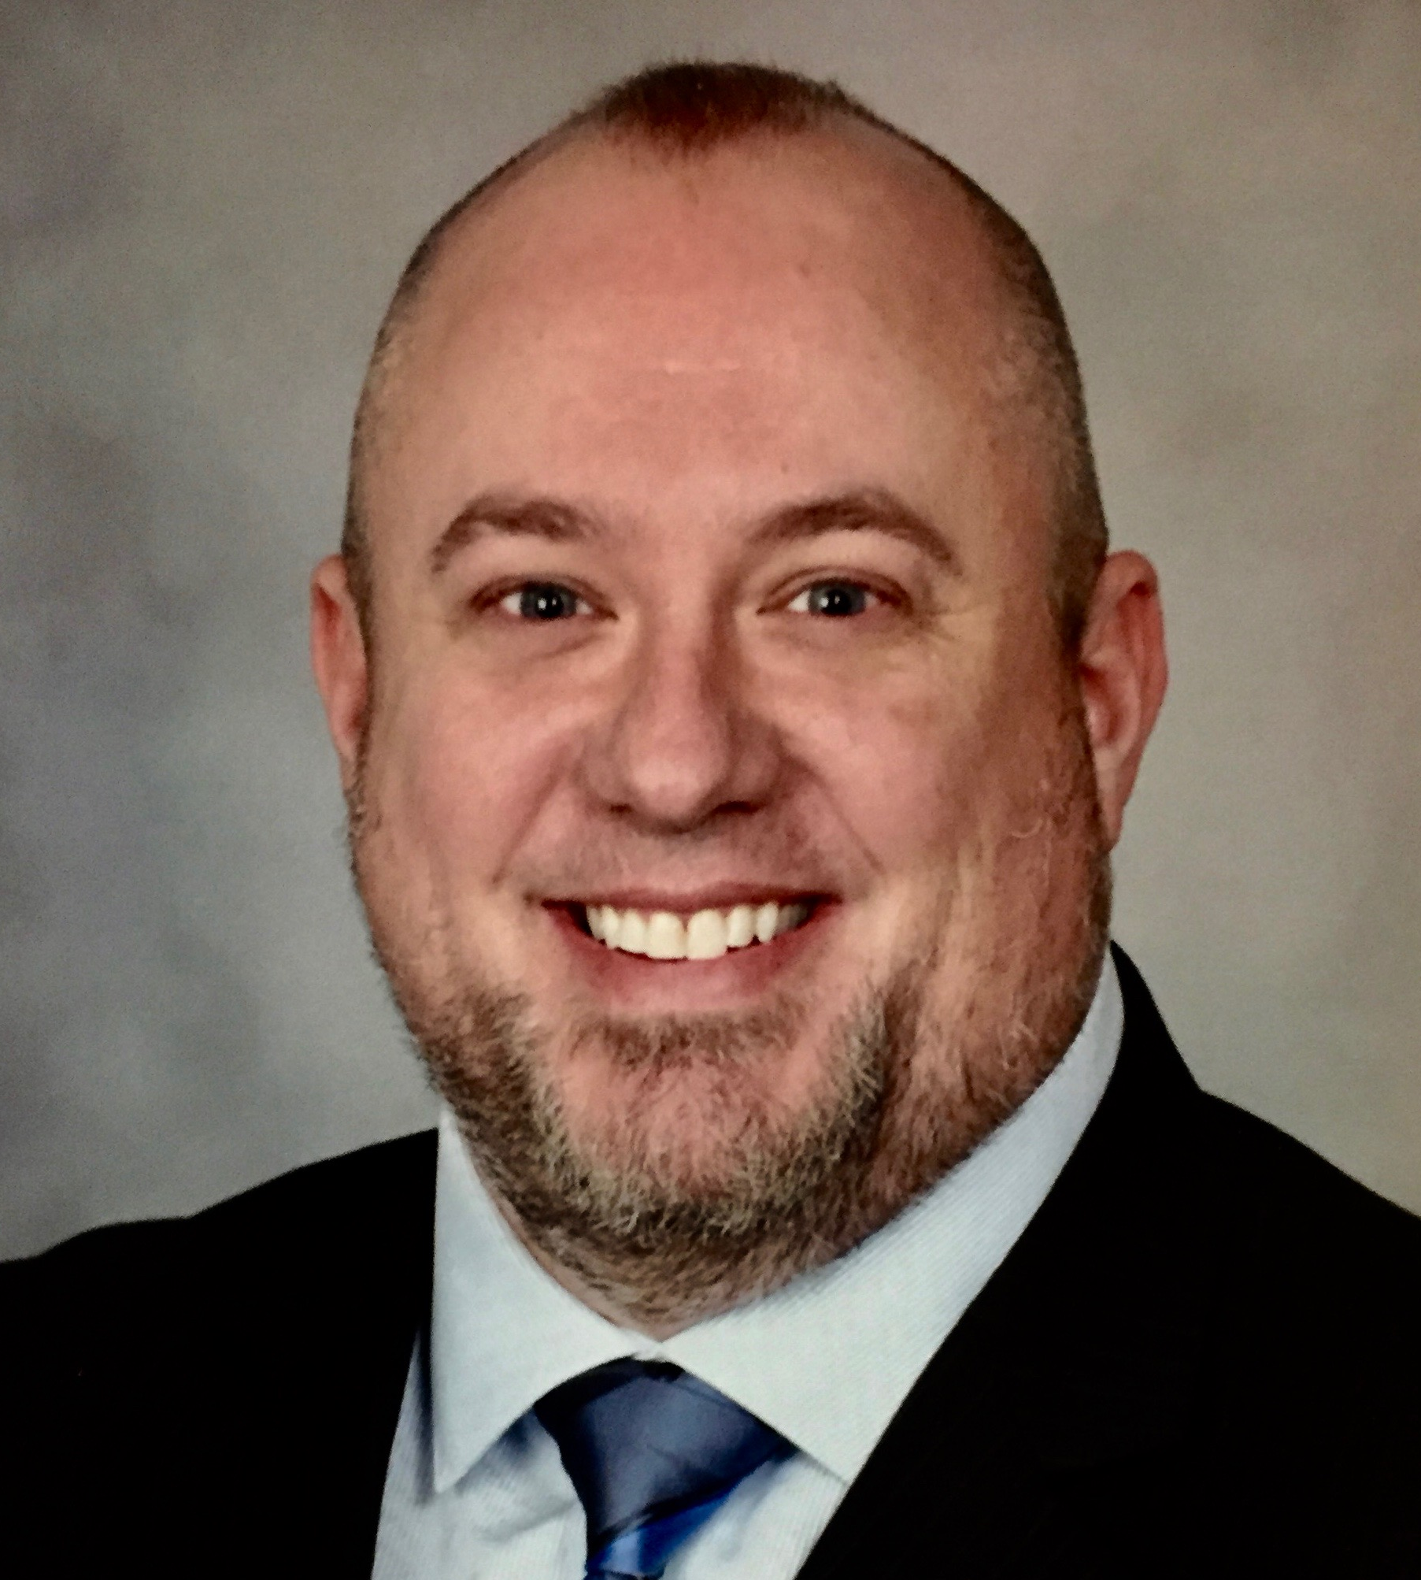

Title: A facial landmark approach to complex rehabilitations involving orthodontics and maxillofacial surgery

Chad M. Rasmussen, D.D.S.
Mayo Clinic, Rochester, Minnesota
Rasmussen.Chad@Mayo.edu
Phone Number: +1 (507) 538-1075

Abstract:
When treatment planning complex orofacial rehabilitations, use of facial landmarks can provide a framework for maximizing facial harmony. The premise of this method is to identify the optimal location of dental and skeletal structures unique to each individual, allowing clinicians to make informed treatment decisions that best suit the needs of the patient. This lecture will discuss complex patients treated with orthodontics, orthognathic surgery, total TM joint replacements, and mandibulectomy to support the use of facial landmarks in planning complex transdisciplinary cases. Objectives: 1) Identify facial landmarks used to evaluate facial harmony in all three planes of space, 2) Identify the optimal position of dental and skeletal structures, and 3) Apply these landmarks in the treatment planning of complex rehabilitations.

Biography:
Dr. Rasmussen obtained his D.D.S. from the University of Minnesota and certificate in orthodontics and dentofacial orthopedics from Washington Hospital Center in Washington, D.C. He is a Consultant in the department of Dental Specialties at Mayo Clinic, Instructor in Dentistry at Mayo Clinic School of Medicine and Science, Associate Program Director of the orthodontic residency at Mayo Clinic Graduate School of Biomedical Sciences, and a Diplomate of the American Board of Orthodontics.

Presenting author details
Full name: Chad Michael Rasmussen
Contact number: +1 (507) 538-1075
Session: 26th World Congress on Dentistry and Oral Health
Category: Oral presentation

