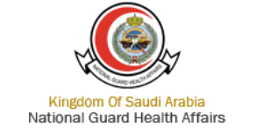
Aggressive case of postpubertal cherubism: A case report
Ghadah Aljumah1, Ahmed Nasser1*, Ahmed Alomar2, Faleh alshahrani3 and Talal Bokhamseen4

Abstract
Cherubism is a non-neoplastic fibro-osseous lesion that is diagnosed among children based on its characterization by bilateral painless enlargement of jaws that offers a cherubic appearance to the affected persons. Cherubism treatment is combative given that it is believed that the lesion regress at puberty but cases with severe facial disfiguration can be corrected surgically. This case reports a 23-year-old male reported to the Department of Oral and Maxillofacial surgery at National Guard Health Affairs, King Abdulaziz Medical City, Riyadh, Saudi Arabia by his mother with chief complaint of asymptomatic, progressive and bilateral enlargement of the mandible. Based on facts and the clinical, historical, family and radio-graphical findings this report prepared a cherubism diagnosis of the patient. The purpose of this case report is to present the unusual postpubertal cherubism.

Key words: cherubism, fibro-osseous, autosomal dominant, postpubertal

Image
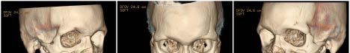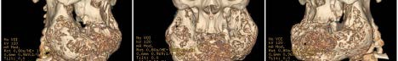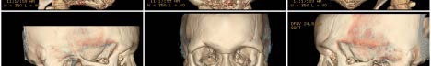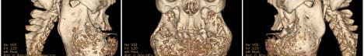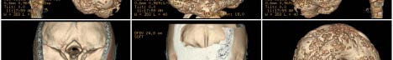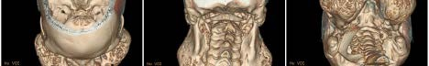

Presenting author details
Full name (As per the passport): Ghadah Aljumah
University/Industry/Organization name: King Abdulaziz Medical City , National Guard Health Affairs

Designation(Director/Prof/Assistant or Associate prof/Researcher/Student): general dentist
Country: Saudi Arabia
Mobile number (country code – number) :00966565121675
Email: ghadahaljumah@gmail.com
Track number: https://dentistrycongress.dentistryconferences.com/abstract-submission.php
(For track number follow this link)
Category (Oral presentation/ Poster presentation/Young researcher forum/E-poster): poster presentation
Research interest: oral and maxillofacial surgery
Your profile page URL in your department: not available
Year of birth: 1992
Linked In/Facebook/twitter account: not available

Note: Please fill up the Red mark fields so that it would be easier for us to cite your details in the conference particulars. (Please do not forget to fix your photo and Logo above the title)
*** regarding photo I’m covering my face so I will not upload it

