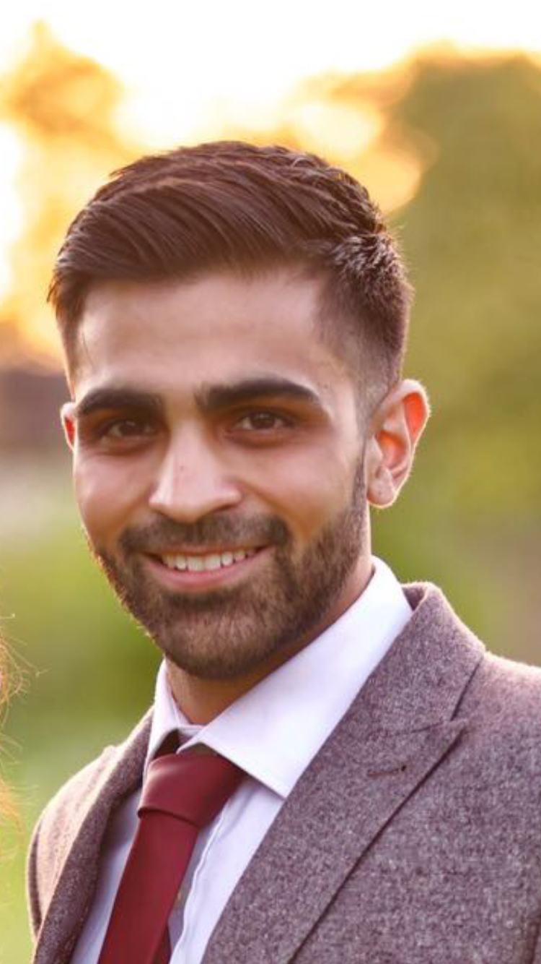

Study of wisdom teeth referrals into Birmingham Dental Hospital, UK
Dr Jinesh Thakrar, Hertfordshire Community NHS Trust

Abstract (300 word limit)

Third molar surgery is one of the most common procedures performed in oral surgery. There is no controversy when it comes to removing third molars which show signs of pathology or present with symptoms but prophylactic removal of 3rd molars has caused lots of debates for a number of years.

Before the National Institute for Clinical Excellence (NICE) created the guidelines for third molar extractions, wisdom teeth extraction was a very common procedure costing the NHS around £30 million per year and roughly £20 million was spent privately.

From 27th March 2000 NICE published guidelines on wisdom teeth removal resulting in a decrease in 30% of wisdom teeth extractions. It does not however include distal decay in the second molar as a reason for removal.

My research project looked at wisdom teeth referrals into Birmingham Dental Hospital, UK and assessed which NICE guidance category they fell under as well as if there was any radiographic evidence of distal decay in the second molar.

A total of 69 cases were assessed, 45 female and 22 male. The most common age group of referrals was between 24-30 with 61% of all cases presenting with a vertical impaction. Caries was the most common reason for referral (39%) with 22% of all cases having radiographic evidence of caries in the lower second molars.

Of those that presented with caries in the lower second molars only 33% had it mentioned in their referral letter and this was most commonly in mesially impacted lower wisdom teeth.

There is a relatively low proportion of those with evidence of caries in the second molar and so I would not consider it to be a necessary change for NICE guidelines. I would however put more emphasis providing oral hygiene advice to patients with mesially impacted wisdom teeth.

Key words: Wisdom teeth, Impaction, Referrals

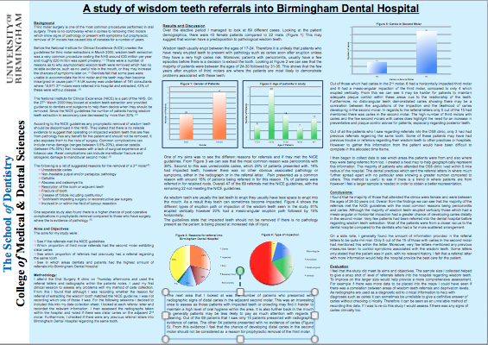
Image

Biography
Dr Thakrar graduated from Birmingham Dental School in 2015 and is currently working as a dental officer for Hertfordshire Community NHS Trust. He has also spent time working in Oral and Maxillofacial surgery as a Senior House Officer. During his time at University he noticed a number of patients were having their wisdom teeth and secondary molars removed due to caries and was interested to investigate further.

Presenting author details
Full name (As per the passport): Jinesh Shailesh Thakrar
University/Industry/Organization name: University of Birmingham (At time of study) – Currently working for Hertfordshire Community NHS Trust
Designation(Director/Prof/Assistant or Associate prof/Researcher/Student): Dental Officer
Country: England
Mobile number (country code – number) : +447708817646
Email: Jineshthakrar@hotmail.com
Track number: https://dentistrycongress.dentistryconferences.com/abstract-submission.php
(For track number follow this link) – Track 2 (Oral and Maxillofacial Surgery)
Category (Oral presentation/ Poster presentation/Young researcher forum/E-poster): Poster Presentation
Research interest: Oral Surgery
Your profile page URL in your department:
Year of birth:
Linked In/Facebook/twitter account:

Note: Please fill up the Red mark fields so that it would be easier for us to cite your details in the conference particulars. (Please do not forget to fix your photo and Logo above the title)

