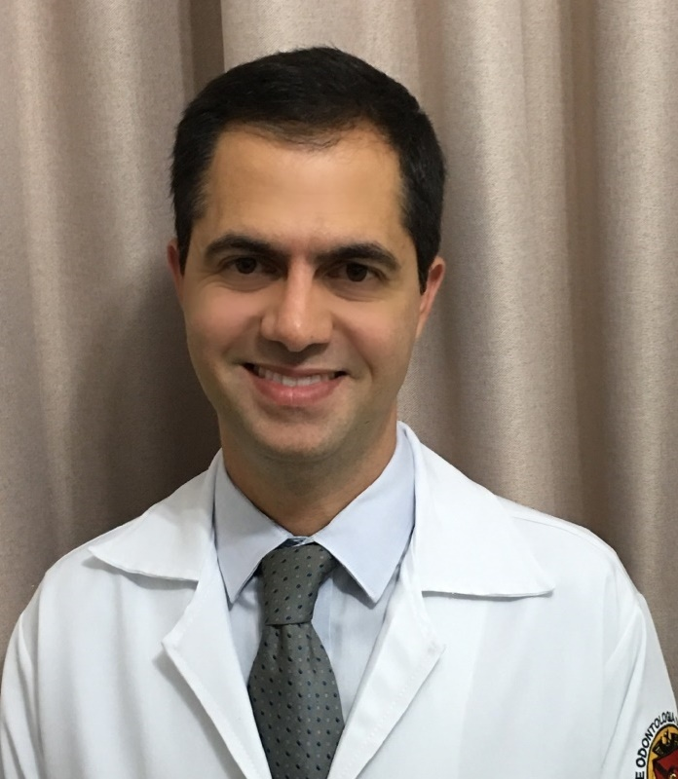
Papillon-lefèvre syndrome: seven years of multidisciplinary treatment in a child – Case report
Virgilio M Roriz, PhD in Oral Rehabilitation, Federal University of Goias, Brazil
Francine CL Moreira, PhD in Health Sciences, Dentist in private practice in Goias, Brazil
Paolla L Martins, Degree in Dentistry, Dentist in private practice in Goias, Brazil
Cerise C Campos . PhD in Health Sciences, Federal University of Goias, Brazil

Abstract
Papillon-Lefèvre syndrome (PLS) is a rare autosomal recessive genetic disorder with a prevalence of one to four cases per million. The disorder is characterized by diffuse or localized hyperkeratosis of the palm of the hands and feet. The etiology and pathogenesis of PLS are still obscure, however, it is caused by a genetic defect located on chromosome 11, which is responsible for coding the cathepsin-C, a lysosomal proteases, present mainly in epithelial regions such as the palms of the hands, soles of the feet, knees and keratinized oral mucosa, which are the most commonly affected areas in SPL. The syndrome has as oral manifestation an fast periodontal destruction that results in the early loss of deciduous and permanent teeth. This study aims to report a case of an 11-year-old male patient diagnosed with PLS at 4 years of age. After this medical diagnosis, the child lost all deciduous teeth due progression of periodontal disease, bone lost and advanced mobility. In the last 2 years, sought the dental service of the Federal University of Goiás-Brazil, where he was being treated in a multidisciplinary way, involving the areas of periodontics (scalling and root planning associated with laser and antimicrobial therapy), pathology, orthodontics, in an attempt to avoid further losses of permanent teeth. With this multidisciplinary treatment, the patient’s and his mother’s satisfaction with the therapies were observed, being offered the conditions to keep the remaining healthy teeth, still seeking to favor the function and aesthetics.

Key words: Papillon-Lefèvre syndrome, periodontal destruction, lost teeth, multidisciplinary treatment.

Image
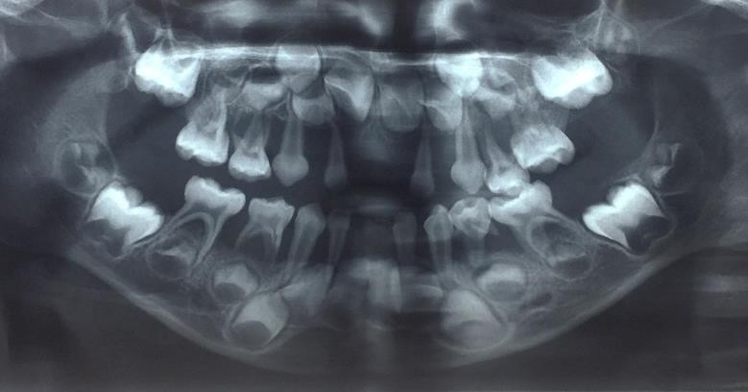
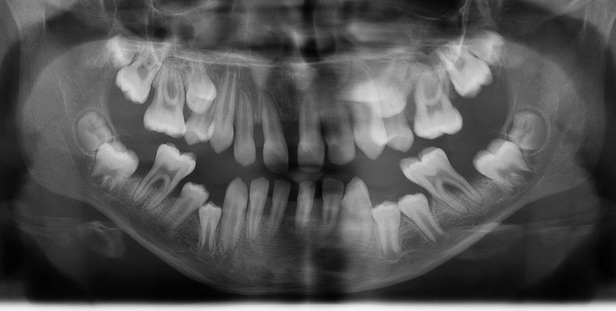
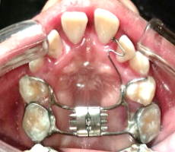
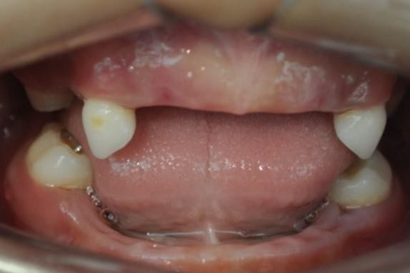
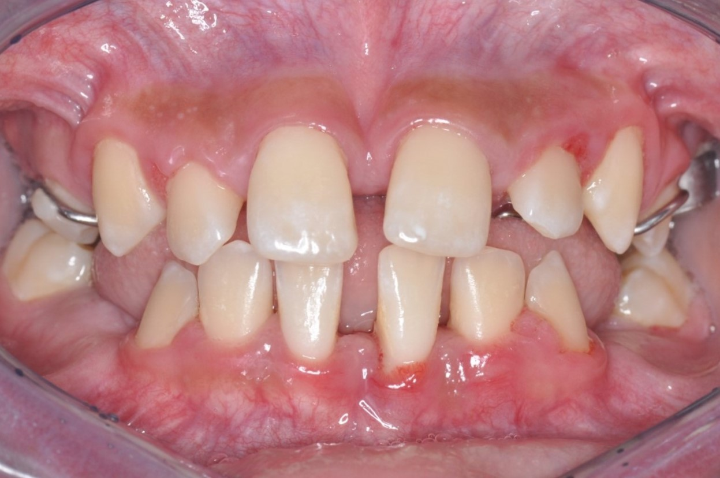
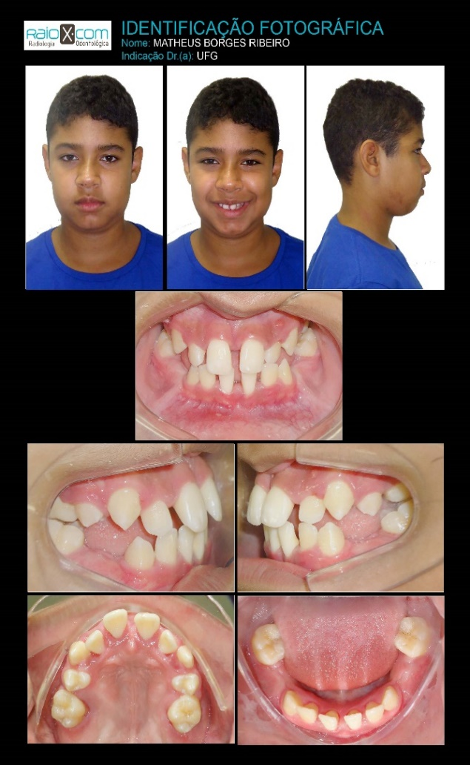

3
1
2

4
5
6

Figure 1 and 4: radiographs showing deciduous and permanent teeth respectively with extensive destruction of the alveolar bone. Figure 2: Teeth remaining after extraction of the elements indicated for exodontia. Figure 5: Occlusal view showing orthodontic appliance on permanent teeth. Figures 3 and 6: front and side views respectively showing the patient's current follow up.

Recent Publications
- Idon PI, Olasoji HO, Fusami MA (2015). Papillon–Lefevre Syndrome: Review of Literature and Report of Three Cases in the Same Family. Nigerian Postgraduate Medical Journal. 22(1):75-82.
- Sreeramulu B, Shyam N, Ajay P, Suman P (2015). Papillon–Lefèvre syndrome: clinical presentation and management options. Clinical, Cosmetic and Investigational Dentistry. 7:75–81.
- AIBarrak ZM, Adel AS, Elna PC, Sukumaran A (2016). Papillon–Lefèvre syndrome: a series of five cases among siblings. Journal of Medical Case Reports, 10:260.
- Toygar HU, Kircelli U, Guzeldemir E (2007). Combined Therapy in a Patient With Papillon-Lefevre Syndrome: A 13-Year Follow-Up. Journal of Periodontology.78:1819-24.
- Lux CJ, Kugel B, Komposch G, Pohl S, Eickholz P (2005). Orthodontic Treatment in a Patient With Papillon-Lefèvre Syndrome. Journal of Periodontology. 76:642-50.

Biography
Virgilio M Roriz is adjunct professor of Periodontology of Dentistry Faculty in Federal University of Goias-Brazil. He is PhD in oral rehabilitation.
Francine Moreira has master's degree in dentistry and a doctorate in health sciences from the Federal University of Goiás- Brazil
Paolla L Martins, has degree in Dentistry from Dentistry Faculty in Federal University of Goias and she is dentist in private practice in Brazil
Cerise C Campos is a Specialist in Pediatric Dentistry and is PhD in Health Sciences. She is currently an Associate Professor at the Faculty of Dentistry of the Federal University of Goiás - Brazil.

Presenting author details
Full name: Virgilio Moreira Roriz
University/Industry/Organization name: Dentistry Faculty in Federal University of Goias-Brazil.
Designation: Adjunct professor
Country: Brazil
Mobile number: 55 62981332347
Email: vmroriz@hotmail.com
Track number: https://dentalevent.conferenceseries.com/abstract-submission.php (For track number follow this link)
Category: Poster presentation
Research interest: implantology

