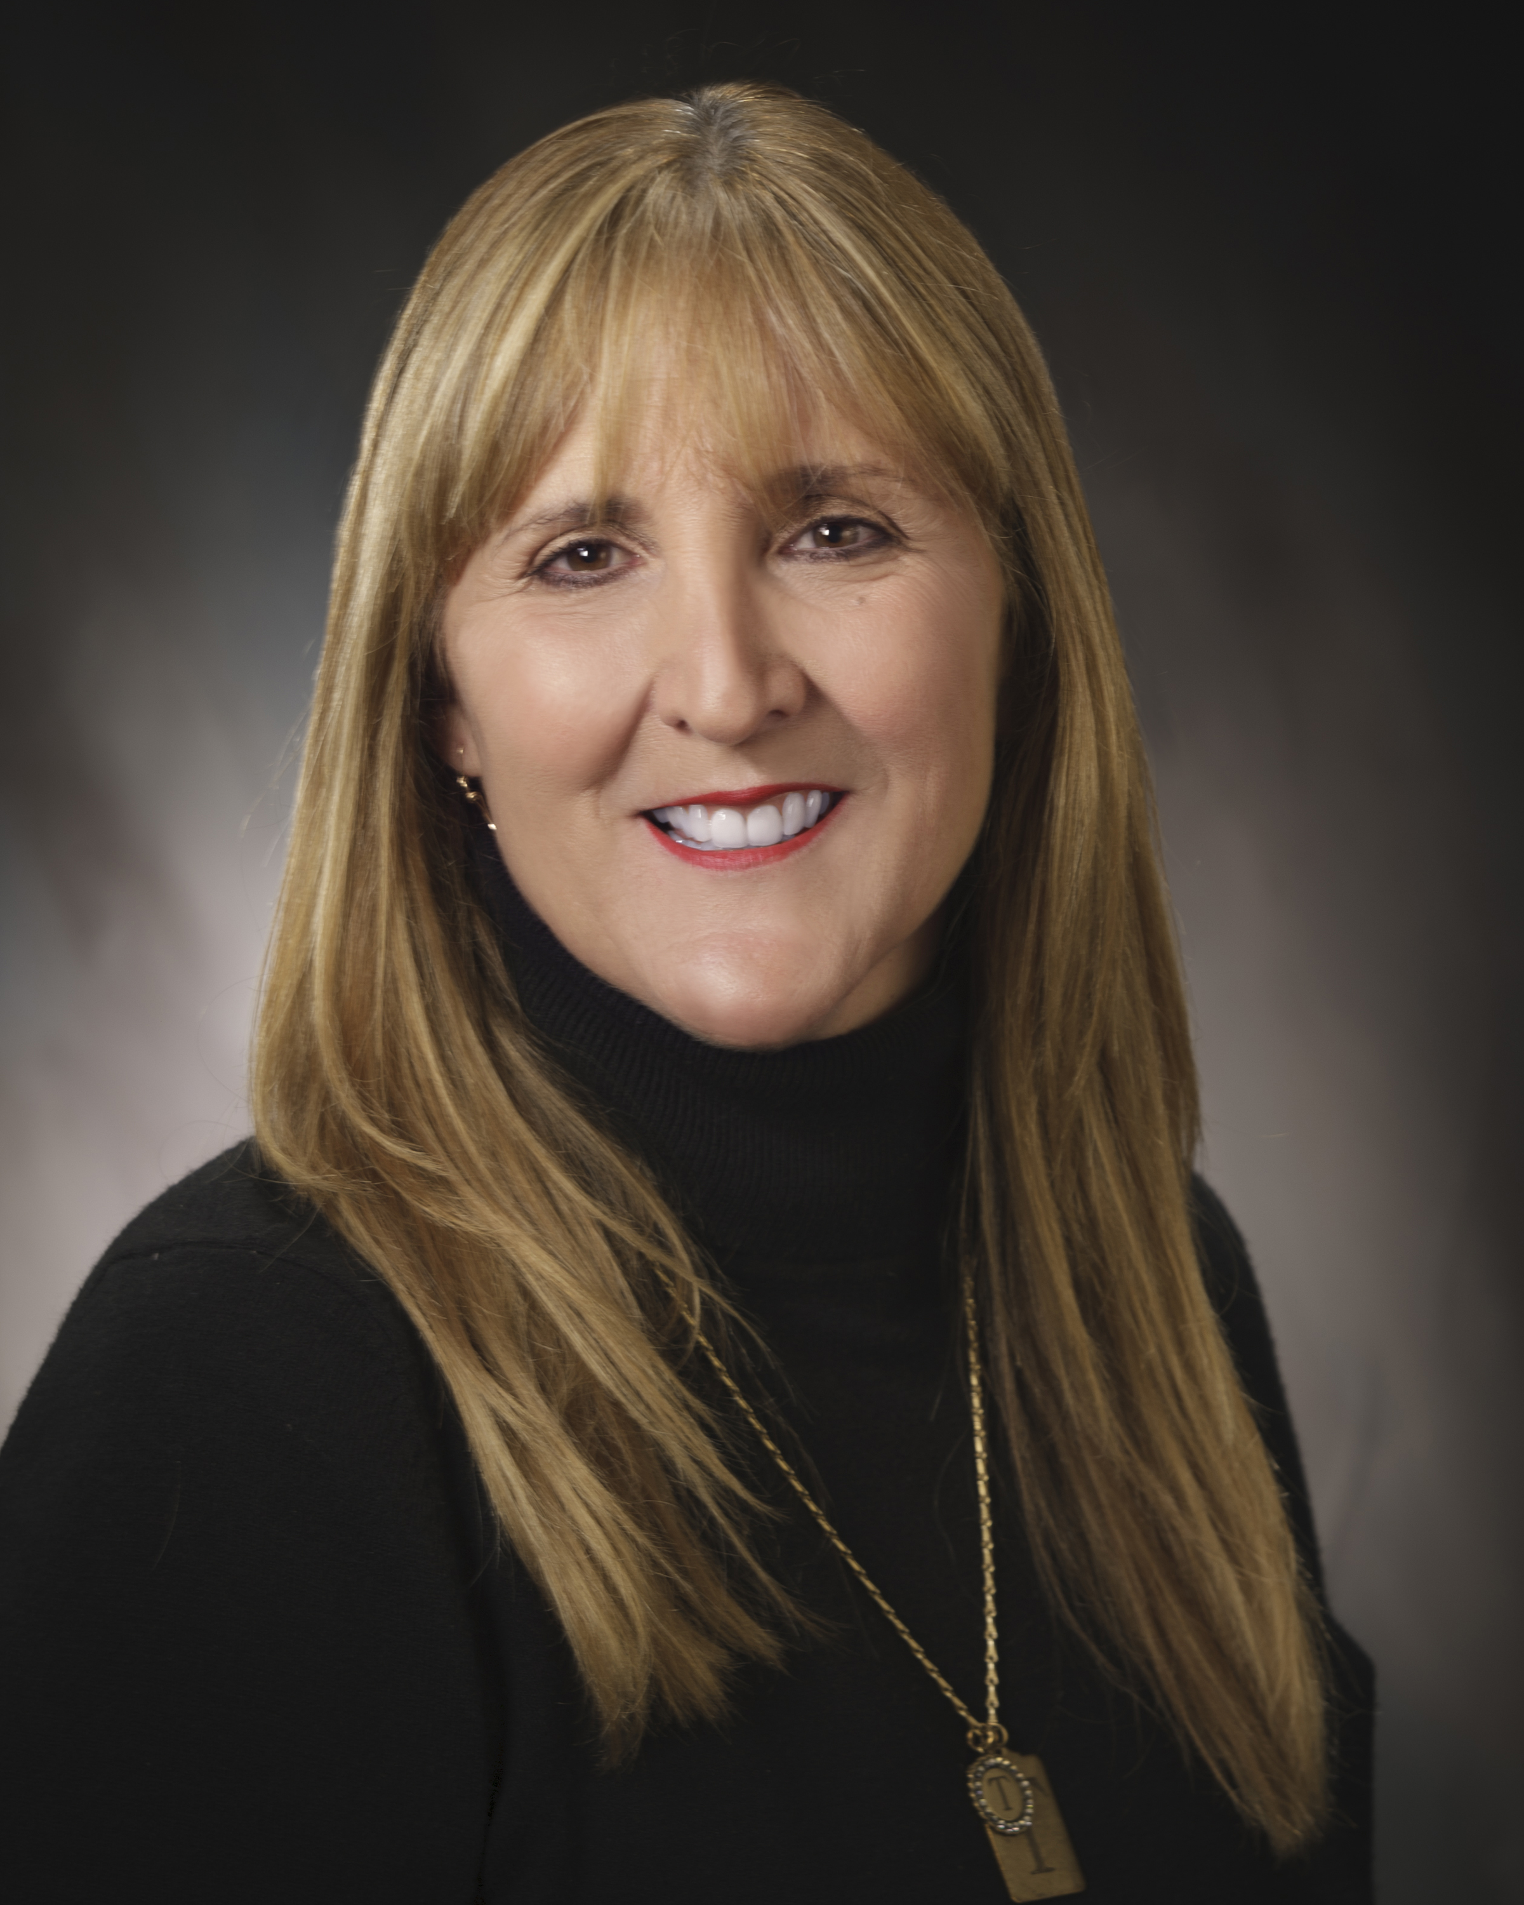

Abstract:

Title: Sitting is Killing Us: Move to Improve Your Health

Author: Theresa McCarter, RDH, BSDH

Presenter: Theresa McCarter, RDH, BSDH
Owner: HygieneWize, LLC

Introduction:

Dentists, Dental Hygienists and Dental Assistants are at risk for a variety of health conditions that can be dangerous and painful. Having the knowledge of these conditions and the techniques to improve overall health are vital to a healthy pain-free life.

Prolonged sitting and repetitive stress movements can be catalysts to many pain causing and life threatening conditions for the dental professional. It has been recognized that people spend half of their waking hours sitting which can lead to obesity, metabolic syndrome, cardiovascular disease, diabetes and musculoskeletal pain to name a few. We are designed as humans to stand, walk, run and move so when we choose a career that involves hours of sitting, we need to be cognizant of the changes that need to made to reduce the risk of developing these conditions.

In this educational presentation, the participant will learn to respect the blueprint of the human body and incorporate techniques that will support the dental professional where they will be able to reduce the risk of developing these life threatening and painful conditions.

This abstract is not connected to an organized session.

Biography:

Theresa’s desire to speak in front of people started at an early age. Theresa has had a life before entering the world of Dental Hygiene, and she feels that this has given her the wisdom, humor and practical approach to this career and her professional speaking career.

Theresa completed her initial education in dental hygiene at Cabrillo College and continued her education and attended Loma Linda University for her BS in Dental Hygiene. Theresa has her license in four states and continues to work as a clinical hygienist in California and Alaska. She is a part time clinical instructor at Carrington College in San Jose, California, which is a good blend of education and hygiene.

Theresa has given presentations across the state of California about many topics related to Dental Hygiene and Practice Management. She is a community health speaker for the Monterey Bay Dental Society, and she is an active member of the National Speakers Association. Theresa’s company, Hygienewize is a Licensed Training Provider for The American Red Cross and she provides CPR and BLS training all over California. Hygienewize is also a CE approved provider for the Dental Board of California and the Academy of General Dentistry.

Theresa has been married to her husband Mark for 35 years and has two grown children Jake and Elise who reside in California and Alaska. When she is not working as a clinical hygienist or doing presentations across the country, she enjoys fishing, camping and visiting her family.

Theresa A. McCarter, RDH, BSDH
P.O. Box 4340
Salinas, CA 93912
U.S.A.
1-831-840-3625
Oral Presentation
Hygienewize@gmail.com
www.hygienewize.com
Session: Practice Management

