Dentistry 2019
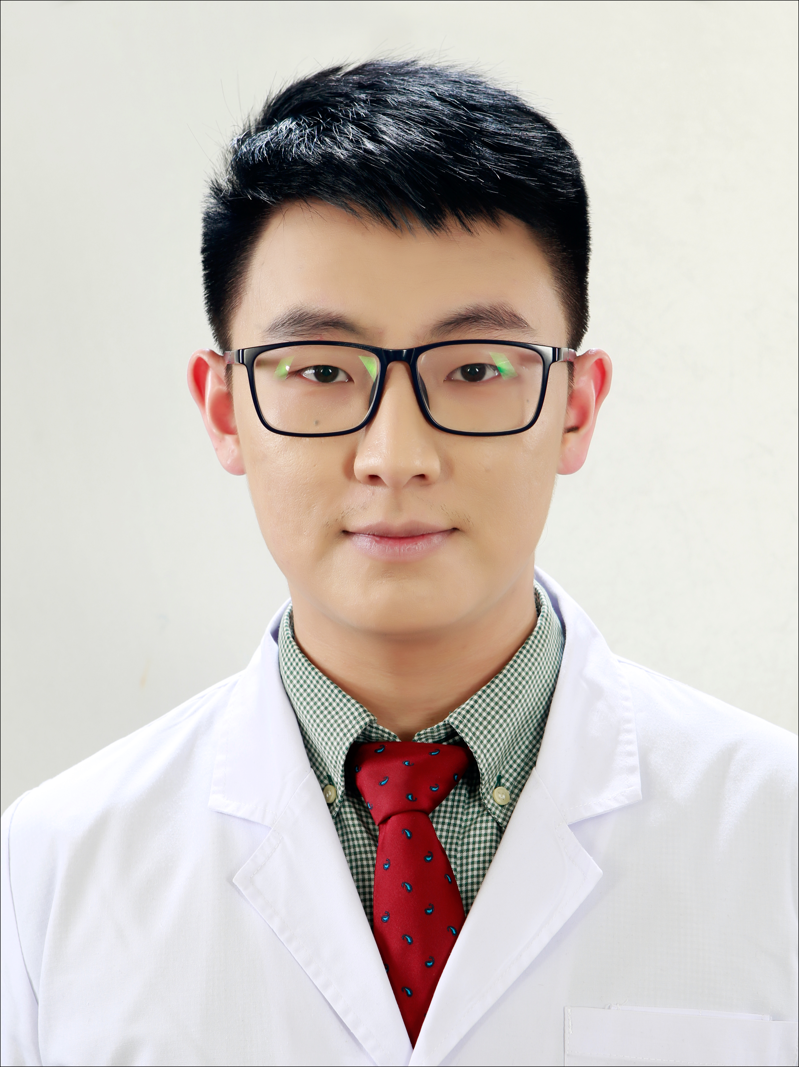

Title: Comparative Radiographic and Histomorphometric Evaluation of Alveolar Bone Healing Associated With Autologous Platelet-rich plasma After Bilateral Third Molar Surgery
Mongolian National University of Medical Science, School of Dentistry,
UB 15160, MN

Platelet-rich plasma (PRP) is a new approach to tissue regeneration and it is becoming a valuable adjunct to promote healing in many procedures. Although this has not been completely knowledged the use in surgical practice could have beneficial outcomes. The present study will be undertaken to evaluate the osteoregeneration in the extraction socket by using computer-assisted densitometric image analysis (CADIA) in 30 patients with bilateral symmetrical mandibular third molar impactions, after extraction. In one side the autologous platelet-rich plasma (PRP group) will be placed and the other will be filled with a blood clot (control group). Radiographic bone density will be quantified 3 times by the same examiner at different moments using HLImage 97 software, and data will statistically be analyzed by SPSS 24.0 software. The normal healing response to the tooth extraction procedure results in a significant loss of bone and collapse of the surrounding gingiva. Theoretically use of the autologous PRP method can skip the resorptive phase, and proceed bone regeneration. To confirm this theory six rats will have surgery and all mandibular molars will be removed by use of an atraumatic technique. One side will receive autologous PRP while the other side will be filled with a blood clot. First and second months post-extraction the rats will be sacrificed and mandible will be dissected, fixed 10% formalin & decalcified in EDTA (pH 7.2). Initial results from the analysis of bone healing will be presented and analytic issues will be discussed after the first month, including radiographic and histomorphometric methods that will help evaluate the statistically significant associations of autologous PRP in bone regeneration.

Biography

Misheel Munkhtsetseg DDS, MD is a young and motivated surgeon who has just begun his research career, graduated from Mongolian National University of Medical Science. Organizing member of Mongolian Society of Plastic and Reconstructive Surgeons, an active member of Mongolian Association of Oral and Maxillofacial Surgeons.

Presenting author details
Full name: Misheel Mukhtsetseg
Contact number: +97699655440
Twitter account: https://twitter.com/munkhtsettseg
Linked In account: https://www.linkedin.com/in/misheel-munkhtsetseg-76aa05bb/
Session name/ number: Transaction code : 362566
Category: Poster presentation

