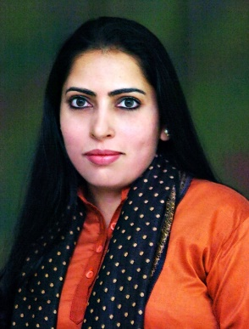
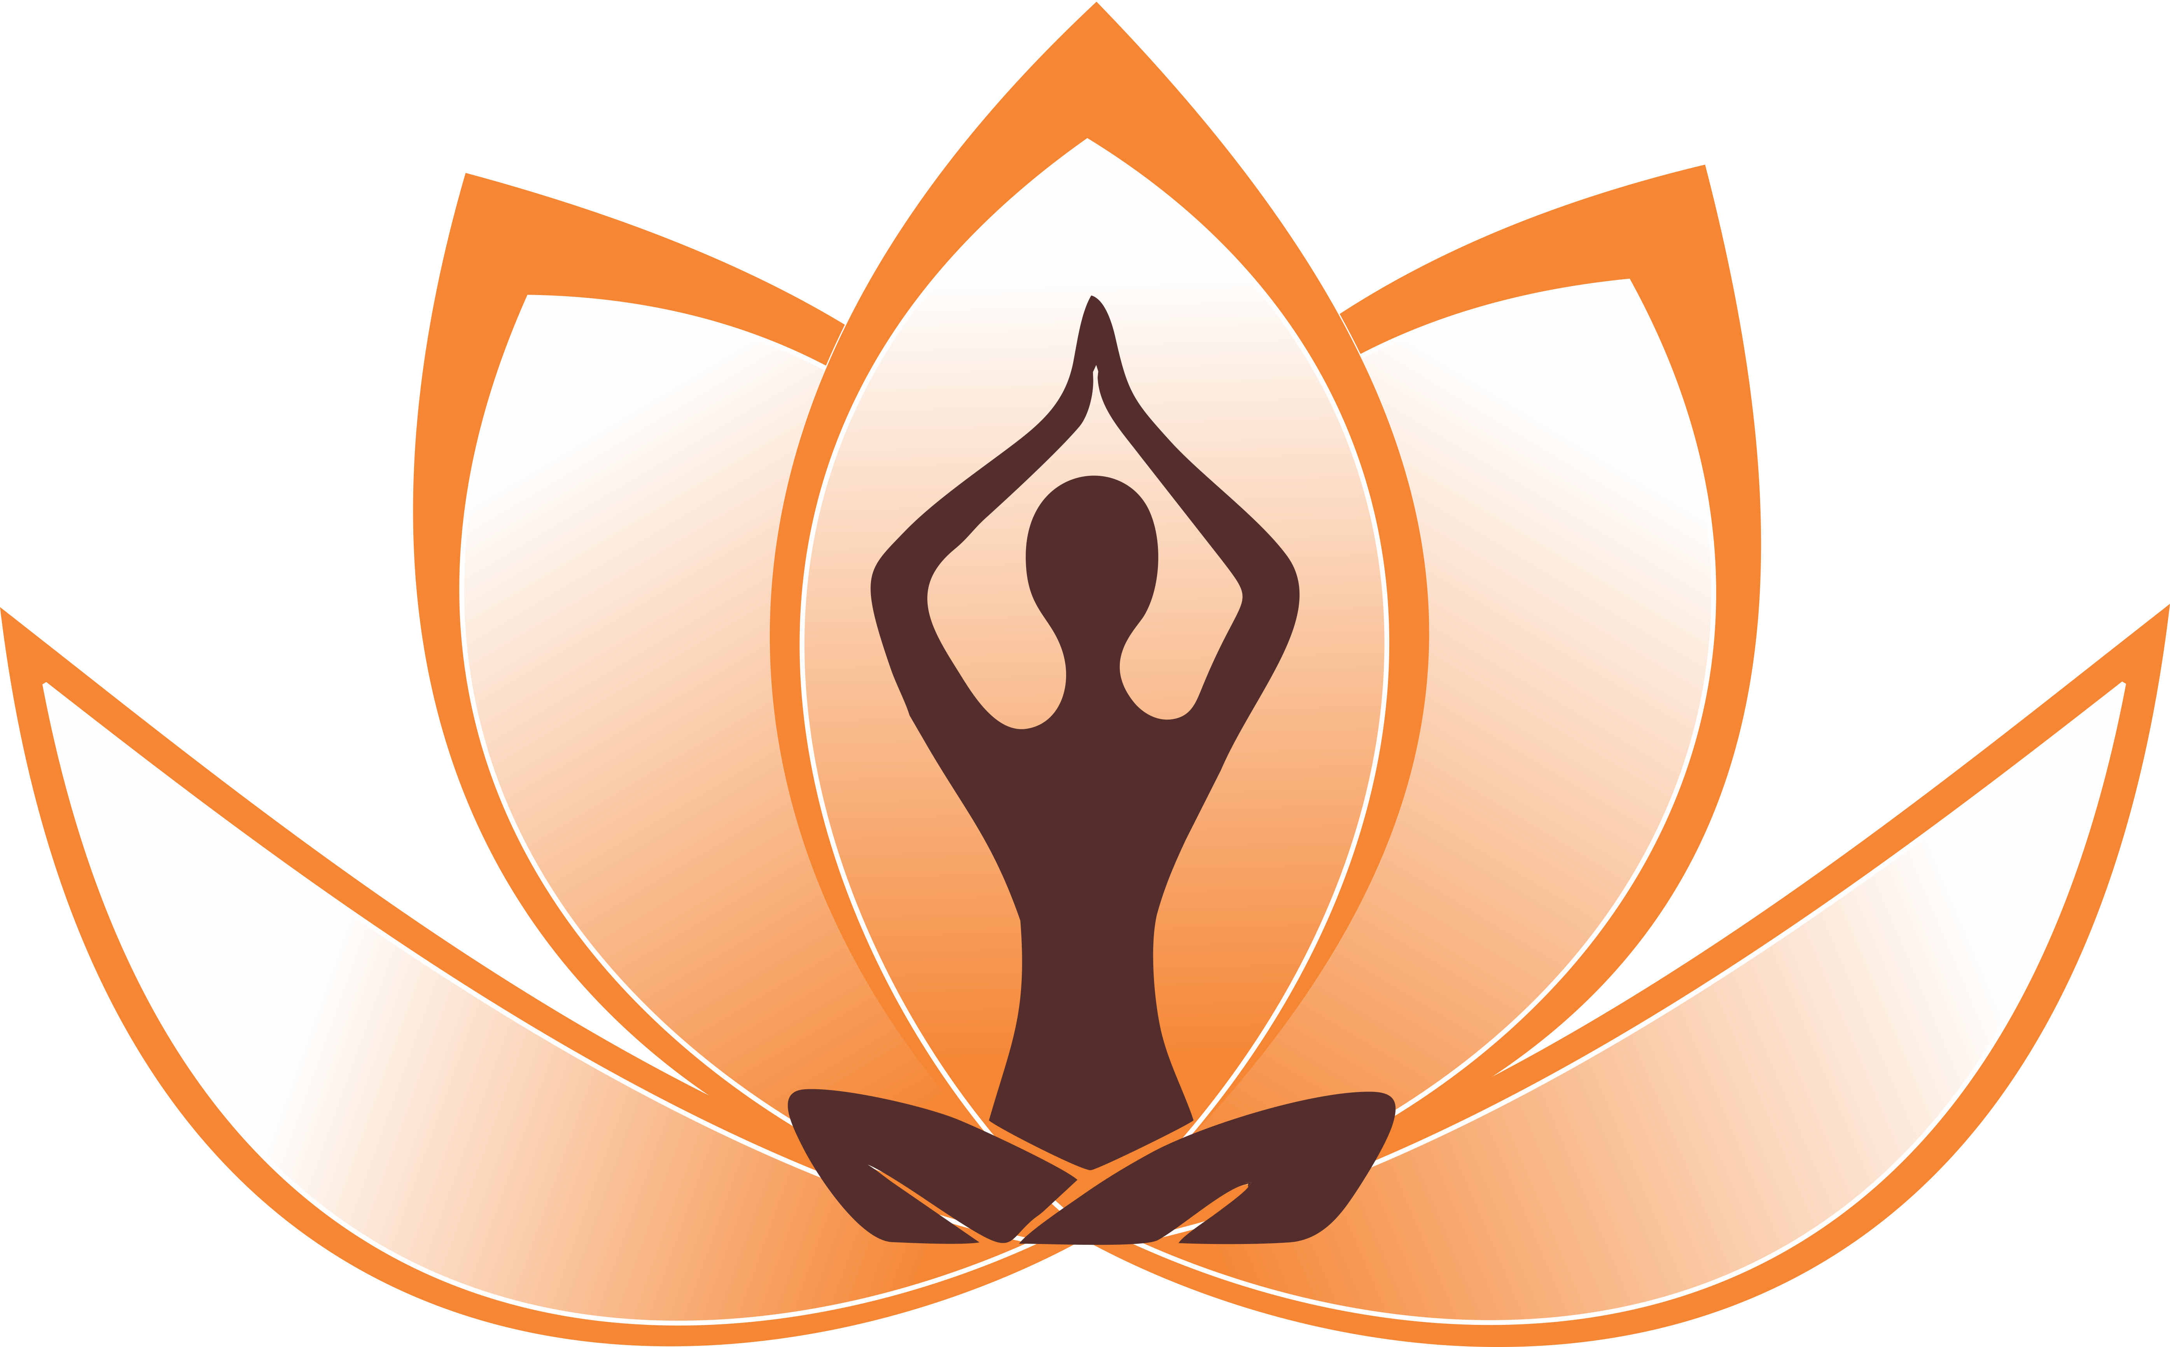

Paste your Logo here

Title: Dentistry: The Yogic Way
Name: Dr. Anjali Deshpande,
Director, Padma Yog Sadhana, a unit of Terna Public Charitable Trust, Navi Mumbai, India

Yoga, the spiritual and mind body practice of ancient Indian origin is gaining global recognition and is being established as an emerging trend in healthcare. Extensive research has proven efficacy of yoga in prevention, management of diseases and promoting health. This paper attempts to identify the concept of oral health in yoga, explore the application of yoga in oral health care and review the available scientific evidence on benefits of yoga for improving oral health. Benefits of yoga greatly contribute to preventive dentistry and oral medicine. Eliminating stress with yoga practices can prevent pain and oral health problems like dry mouth, bruxism, myofacial pain dysfunction syndrome, burning mouth syndrome, lichen planus and recurrent oral ulcerations. Yoga based myo-functional therapy corrects muscle imbalance and guides proper development of dento-facial complex. Yogic are useful in quitting tobacco addiction. Yoga practiced immediately before dental procedure can reduce anxiety in patients. Yoga enhances systemic immunity and also oral defense mechanisms. It creates awareness to lead a healthy life and adopt oral health practices. Yoga can be beneficial for comprehensive and sustained oral health as complimentary to routine dental procedures.
Dental professionals with knowledge of yoga can analyze, diagnose and prescribe yoga for therapeutic benefits to their patients and help them reduce dental treatment anxiety.
Yoga offers a promising, cost-effective, complementary, preventive and therapeutic modality. There is a need to develop multi-disciplinary team approach to facilitate effective health care services to the patients and society.

Biography
Dr. Anjali is a dentist and yoga therapist with 23 years of experience in dental education. She is Director of Padma Yog Sadhana, a unit of Terna Public Charitable Trust, Navi Mumbai, India. She is Honorary Advisor for World Yoga Foundation and won awards for her contribution in the field of yoga at national and international level. She is author of a book based on her yoga research in health science education. She has represented India to USA as cultural ambassador for Rotary International. She is practicing yoga since last 17 years and believes firmly in the science of yoga for holistic health.

