A tobacco cessation-training program in a Dentistry University in Brazil

Adriana ÁA, MD MsC, PhD Student*; Celso M Bandeira, MD MsC, PhD Student*; Daniela J Faria*, Igor B Silva *, Celina FL Carta, DDS, PhD**; Janete D Almeida, DDS, MsC, PhD, Associate Professor, Department of Bioscience and Oral Diagnosis*
* Universidade Estadual Paulista (Unesp), Instituto de Ciência e Tecnologia, São José dos Campos, São Paulo, Brazil **University of Braz Cubas – Brazil

Abstract
Introduction: The moment of dental treatment can be an opportunity for generalized or specific health interventions even if the individuals are seeking for aesthetic enhancement and/or pain relief, as well as being a motivator for cessation of smoking. Knowledge of the concepts by the dentist to the intensive approach of the smoker increases the chances of prolonged smoking abstinence and prevention of relapse. Objective: The objective of this project is to introduce as an extracurricular activity for the Dentistry undergraduate students of Universidade Estadual Paulista (Unesp), Instituto de Ciência e Tecnologia, São José dos Campos, São Paulo, Brazil l involving theoretical-practical training on approach, motivation and intensive treatment of smoking. Method: the following topics were addressed: Nicotine Dependence, Motivational Stages, Abstinence Syndrome, Smoking cessation medication, Cognitive and Behavioural Therapy Techniques, Cessation methods and Relapse prevention in a 06 meetings. Results: After training the students felt confortable and capable to start the intensive hands-on practice, applying the knowledge acquired. It was created a Facebook group (Image 1) with up-to date information, articles and educational material (Images 2 and 3). The project allowed undergraduate students for the management of smoking patients, expanding their activities in the area of ​​health promotion.

Image 1

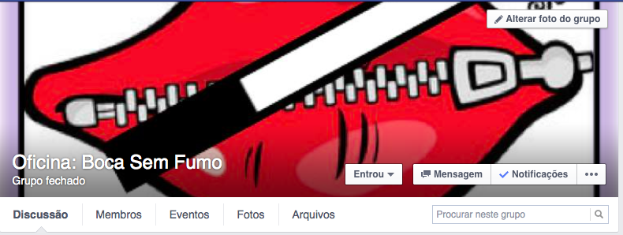

Image 2

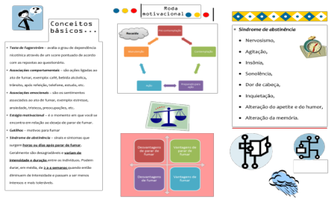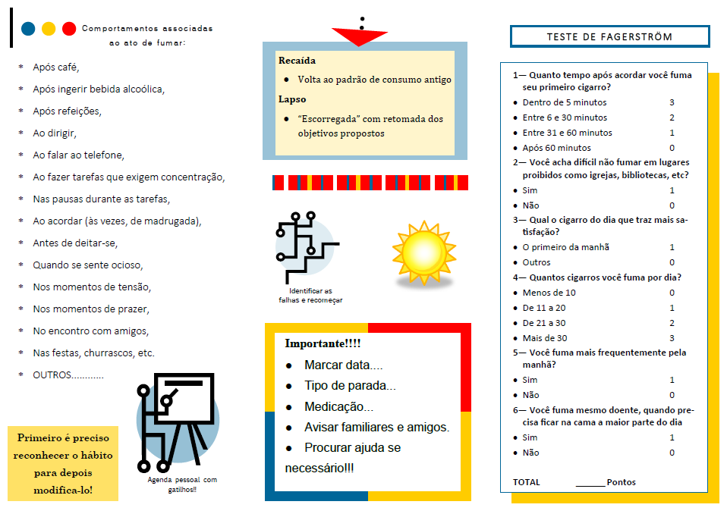

Image 3

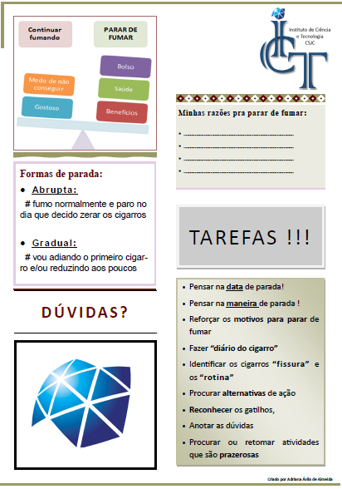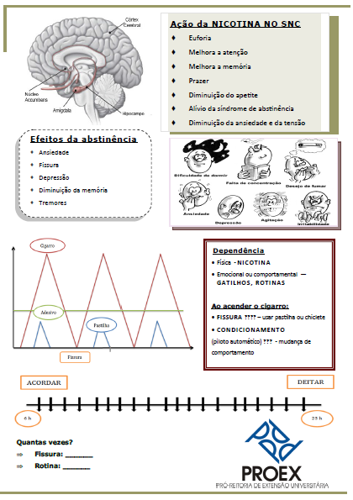
Recent publications (minimum 5)
- Nasser M. Evidence summary: is smoking cessation an effective and cost-effective service to be introduced in NHS dentistry? Br Dent J [Internet]. 2011 Feb 26 [cited 2017 Jan 9];210(4):169–77.
- Omaña-Cepeda C, Jane-Salas E, Estrugo-Devesa A, Chimenos-Kustner E, Lopez-Lopez J. Effectiveness of dentist’s intervention in smoking cessation: A review. J Clin Exp Dent [Internet]. 2015 [cited 2017 Jan 7];0–0.z
- Ramseier CA, Suvan JE. Behaviour change counselling for tobacco use cessation and promotion of healthy lifestyles: a systematic review. J Clin Periodontol [Internet]. 2015 Apr [cited 2017 Jan 7];42:S47–58.
- Davis JM, Ramseier CA, Mattheos N, Schoonheim-Klein M, Compton S, Al-Hazmi N, et al. Education of tobacco use prevention and cessation for dental professionals--a paradigm shift. Int Dent J [Internet]. 2010 Feb 60(1):60–72.
- Albert D, Ward A. Tobacco cessation in the dental office. Dent Clin North Am [Internet]. 2012/09/29. 2012;56(4):747–70.

Biography

Adriana Almeida is a physician and has her expertise in tobacco cessation intervention and treatment. At this moment she is PhD Student at the Universidade Estadual Paulista (Unesp), Instituto de Ciência e Tecnologia, São José dos Campos, São Paulo, Brazil where she has developed an work with graduation students teaching and training them to be confortable and able to intensive approach for smoking cessation. Her work has been recognized as an important initiative improving the knowledge about how tobacco use must be evaluated for multi health professionals since it is related with many burden diseases such oral cancer. She has accomplished this comprehension after years of experience in treating smokers including patients with cancer. She is also involved with research, teaching and education Institutions. She created a page at Facebook for training dentistry students. Her work is focused on improve and increase the wellbeing for patients and healthcare students.

.
Email: adriana.almeida@fosjc.unesp.br

