A new combined, regenerative and mucogingival, approach for the treatment of peri-implantitis : a report of 3 cases with one year of follow-up.

Longo E. DDS

Main goal of surgical treatment of peri-implantitis is to get access to implant surface in order to perform debridement and decontamination and the complete removal of granulation tissue.
While there is lack of scientific evidence on which are the most effective procedures to treat peri-implantitis² some authors suggest that surgical treatment including granulation tissue removal, implant surface debridement , decontamination and modification , and bone augmentation around implants may result in a better clinical outcome¹⁰.
Implant surface characteristics¹¹ and peri-implant defect configuration¹² could represents key factors in the outcome of surgical regenerative therapy
Despite several studies report encouraging results with “regenerative-like “ approaches¹³ , poor data are available about soft tissue behavior after surgical treatment of peri-implantitis.
A recent comparative prospective 10 year study demonstrated that implants with lack of keratinized tissue are more prone to plaque accumulation and REC, even in patients exercising sufficient oral hygiene and receiving adequate supporting periodontal therapy with higher number of sites that required additional surgical and/or antibiotic treatment¹⁴.
Probably due to the eterogenicity of techniques proposed in the literature for soft tissue augmentation at implant site , there’s no evidence on which are the most effective for peri-implant soft tissue augmentation¹⁵, and the role of mucogingival therapies around implants is still unclear in term of maintainance over time of long term, soft tissue stability and peri-implant bone level¹⁶ although scientific evidence in most part is lacking , soft tissue augmentation at implant site may be considerate to promote easier hygiene maintainnance and prosthetic restoration.
This article wants to introduce a new combined approach wich has the goal of correcting both bony and soft tissue deformities around implants affected by peri-implantitis. The combination of GBR and mucogingival procedures resulted in excellent recovery of both aspects on the three cases presented.

IMAGES AND TAB
Case 1

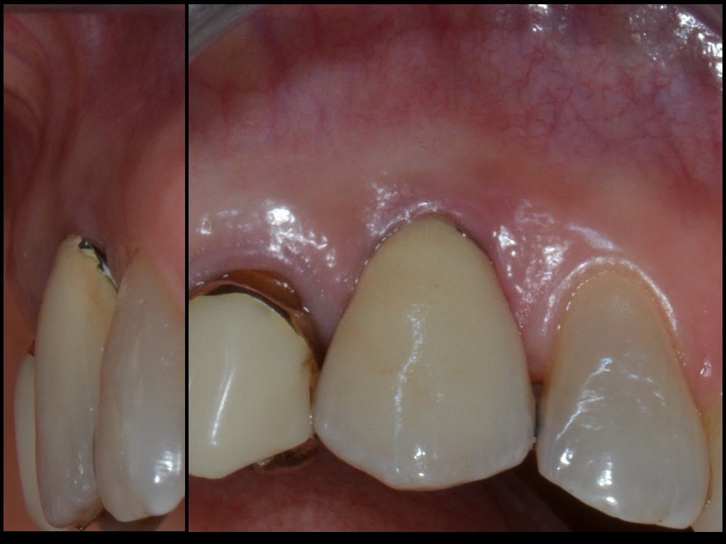
Initial view of implant

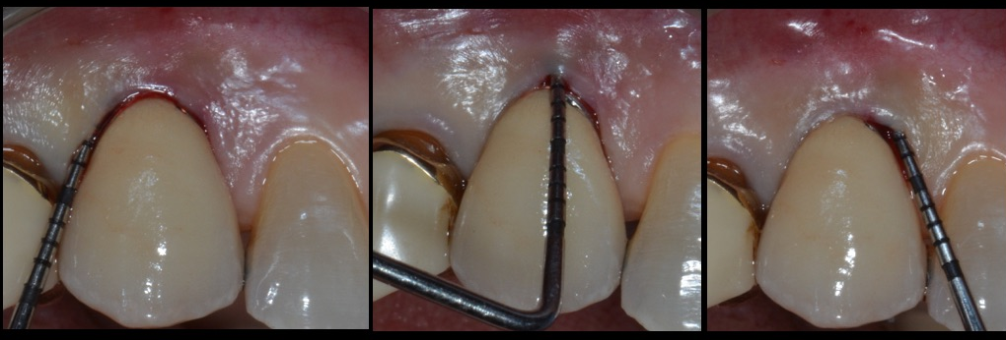
Peri-implant probing depth before surgery
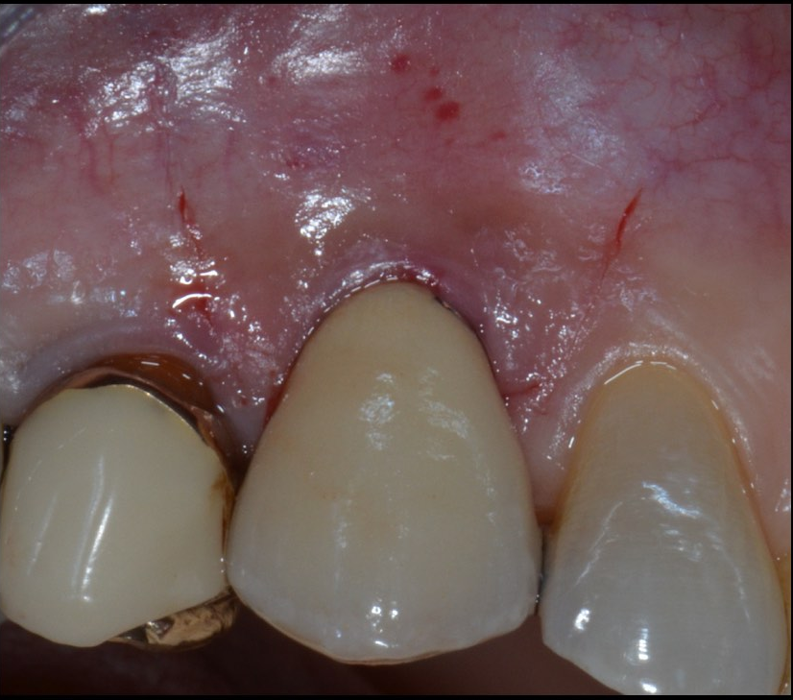
Flap design

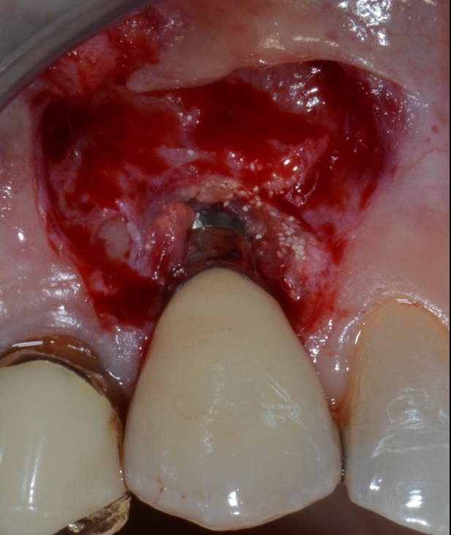

Flap elevation; note the split –full-split thickness raising ( split in correspondence of surgical papilla, full on implant surface and split again apical to the bone dehiscence)
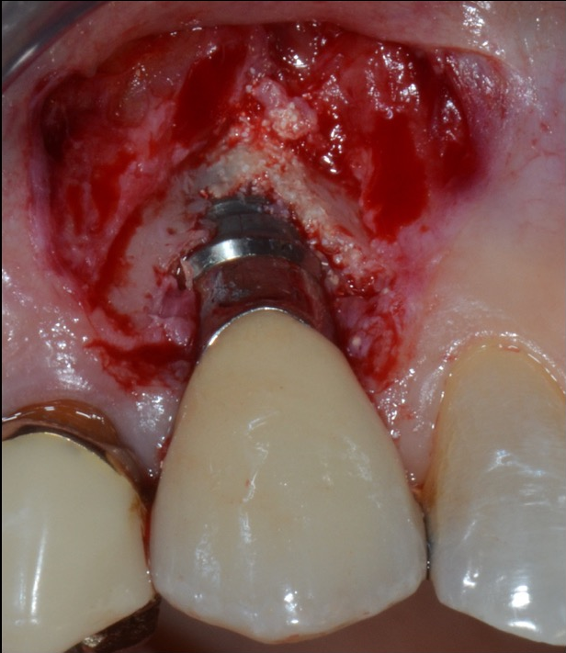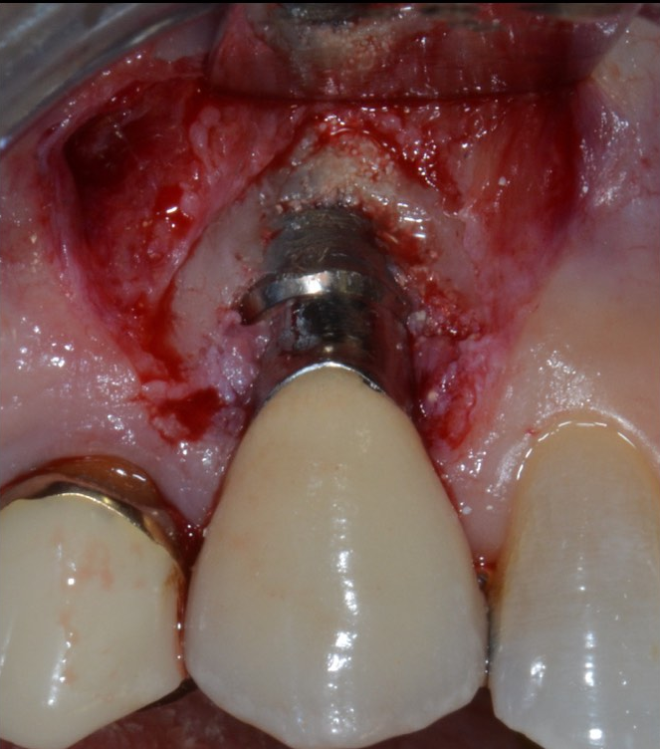

Defect degranulation; class 1a defect; Implantoplasty
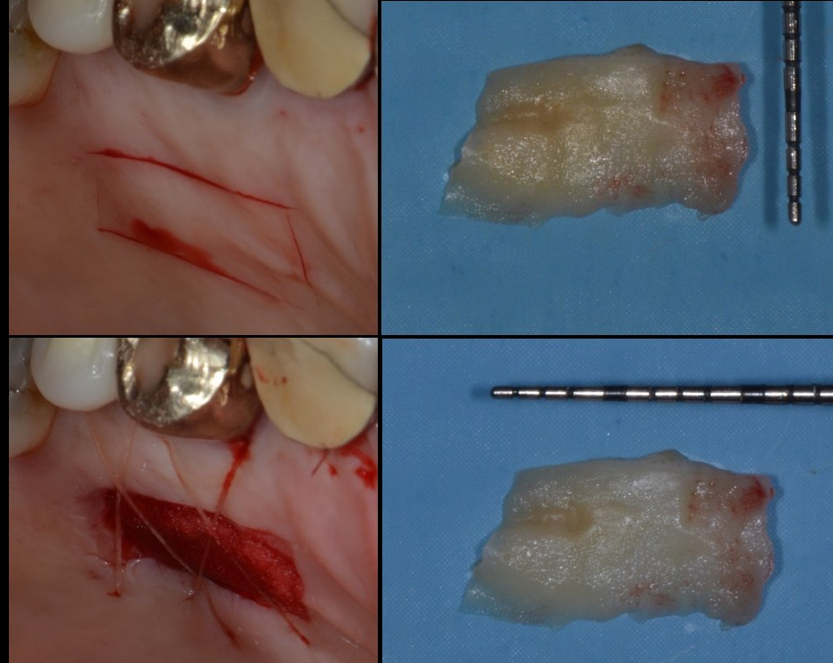
Free ginigival graft (FGG) harvested from palat and disepithelized ;

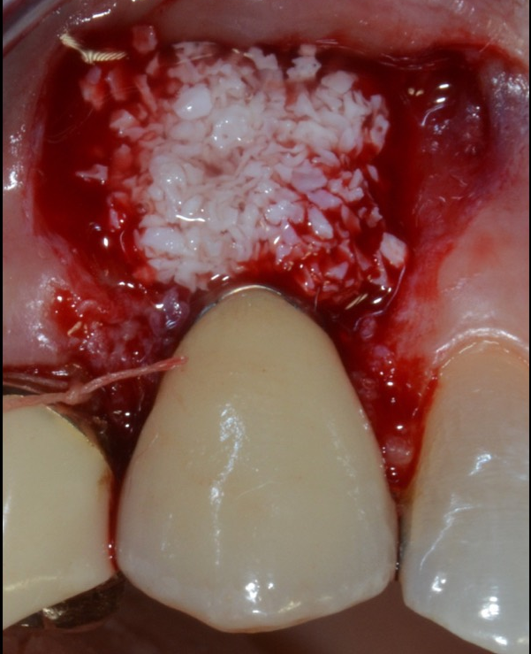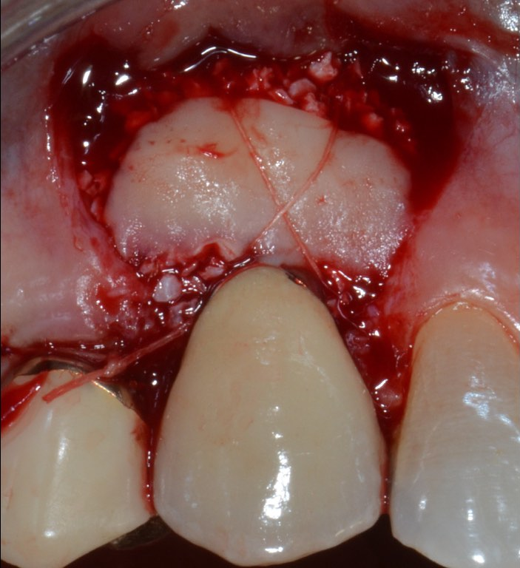After surgical papillas disepithelization , deproteinized bovine bone graft placed on the dehiscence and covered by CTG

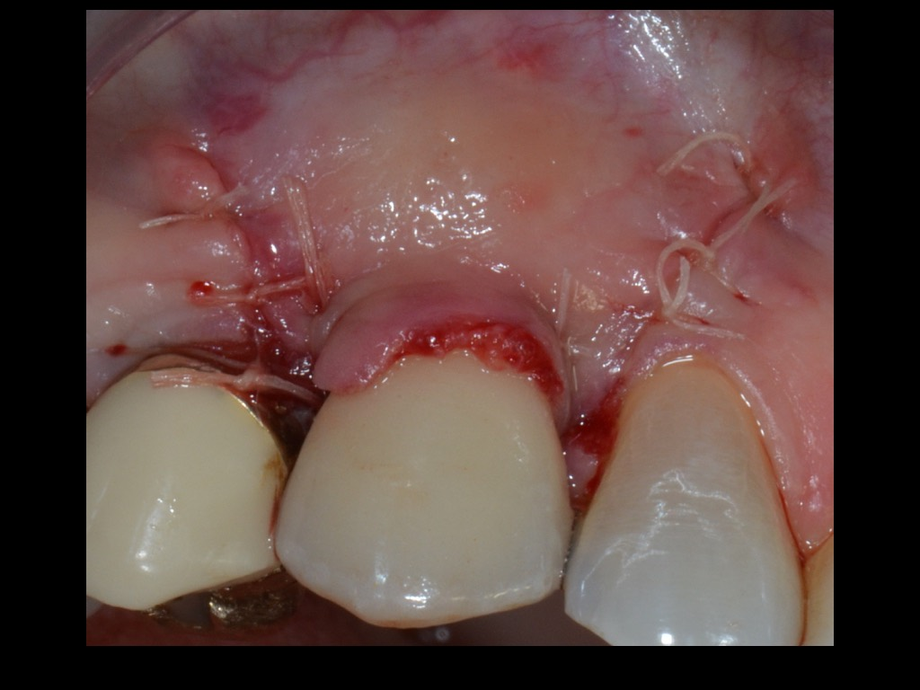
Coronally advanced and sutured flap with 6-0 resorbable sutures
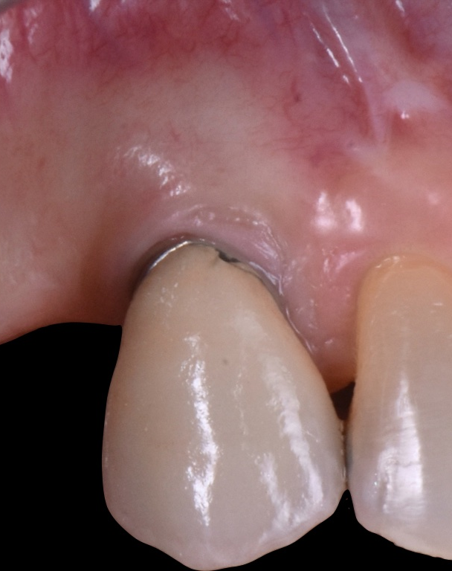Clinical view 1 year after surgery. During healing phase first upper right premolar was lost for fracture.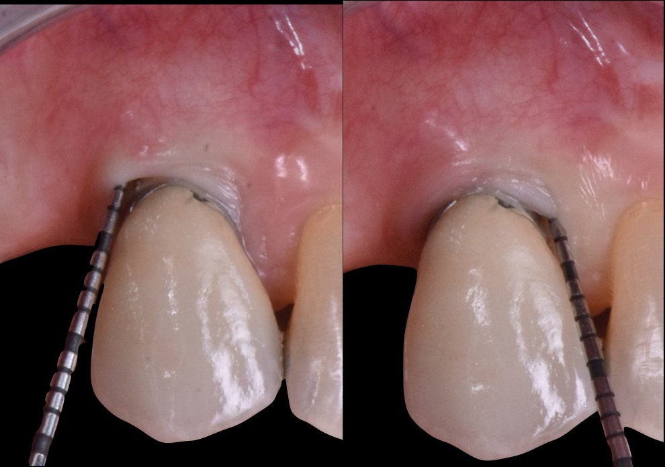Clinical PPD 1 year after surgery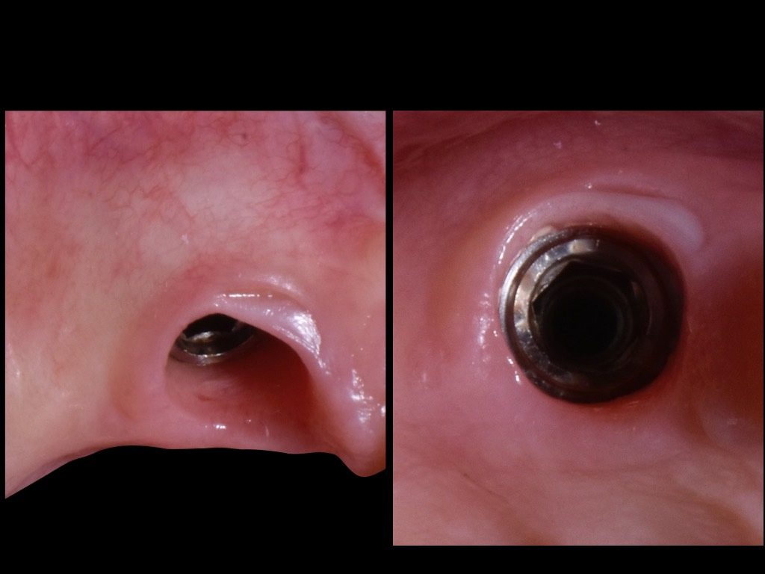
View of health peri-implant soft tissue collar 1 year after surgery.

Case 2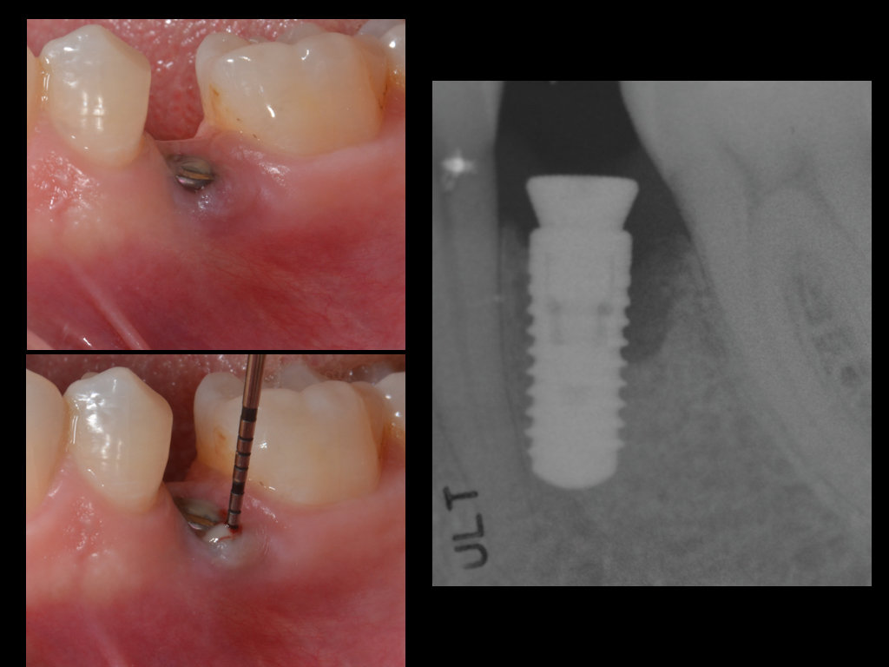
Clinical and radiographical view of the implant before surgery.
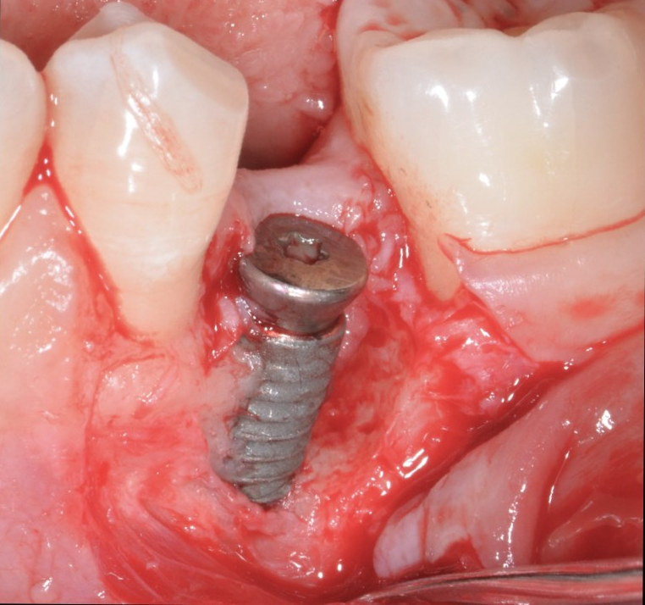

Implant view and defect configuration after flap elevation. Class 1b defect

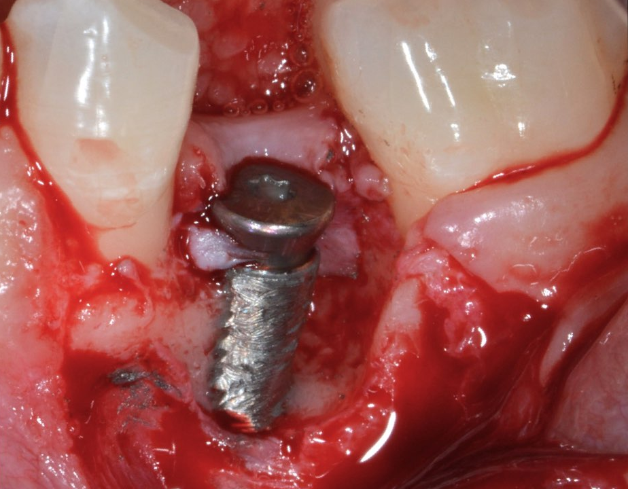
Implantoplasty

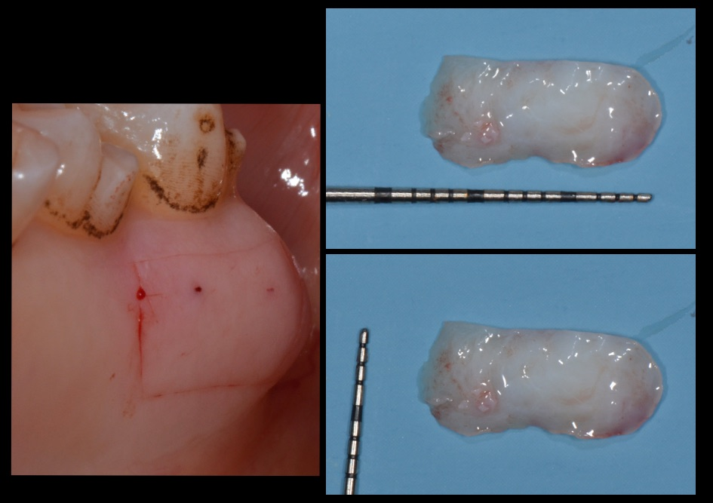

Graft harvesting from palate and disepithelizated.

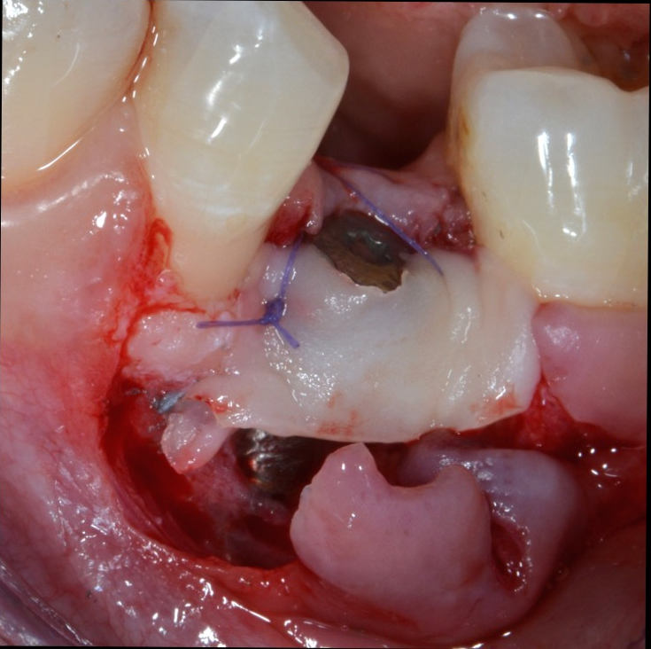
CTG placed as membrane and fixed with 6-0 resorbable sutures.
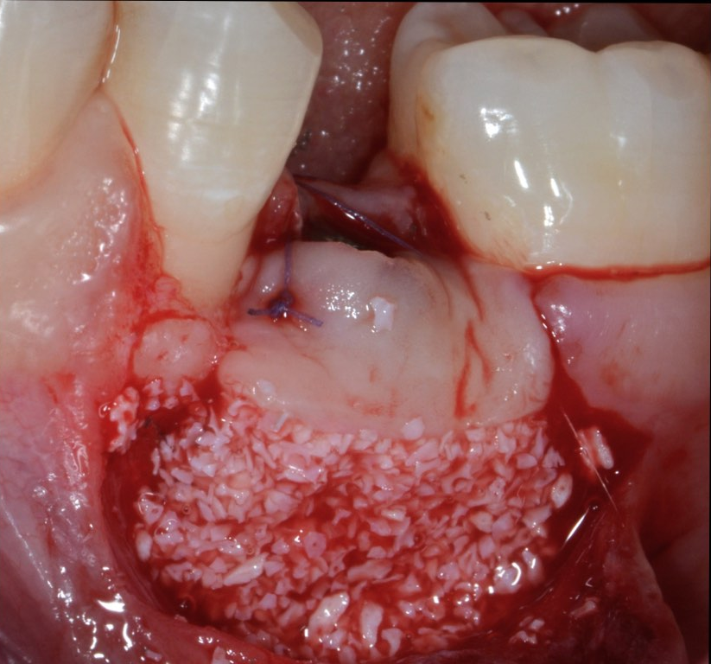
Deproteinezed bovine bone graft placed into the defect and between implant and CTG

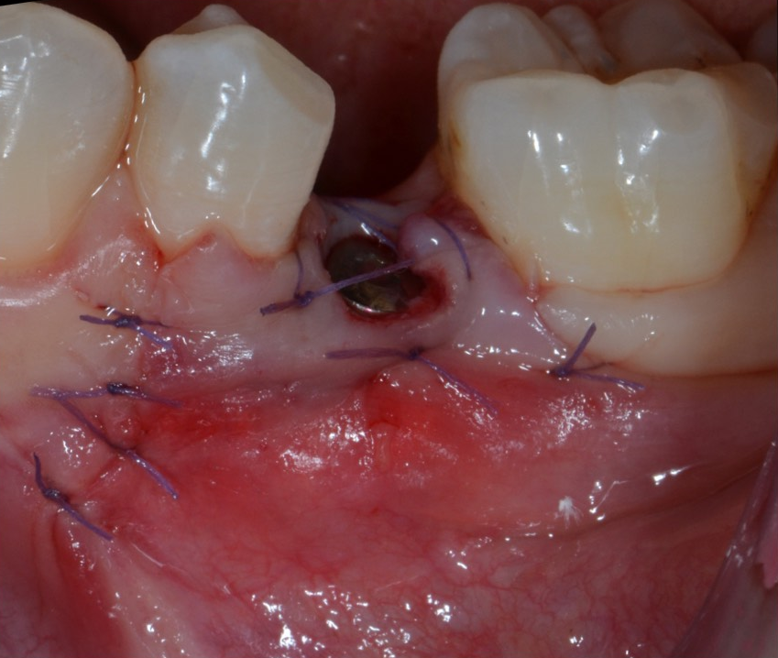
Flap coronally moved an sutured with 6-0 resobable sutures.
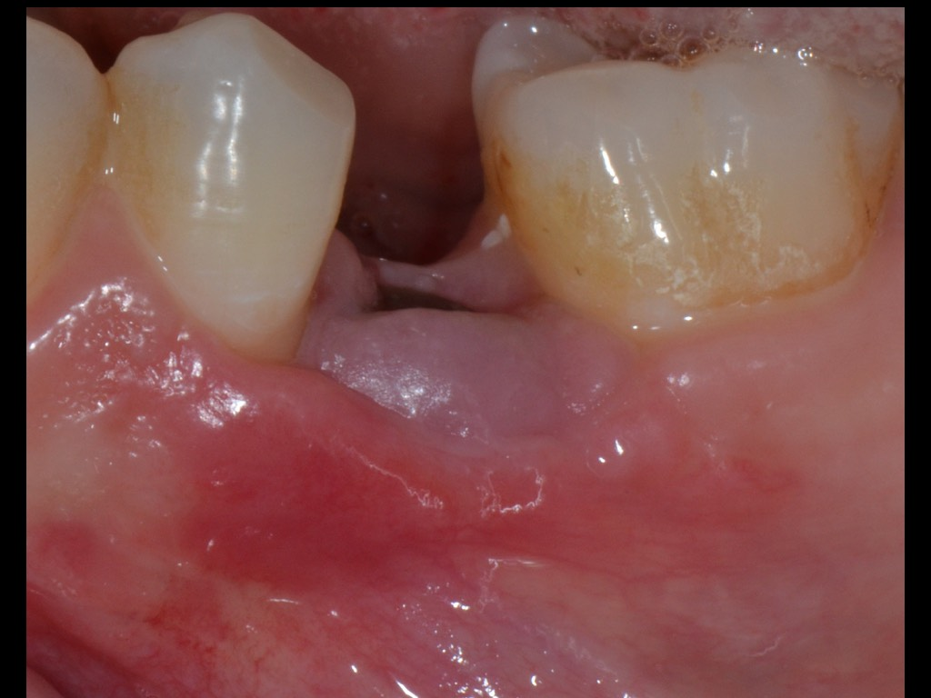
Suture removal after 14 days.

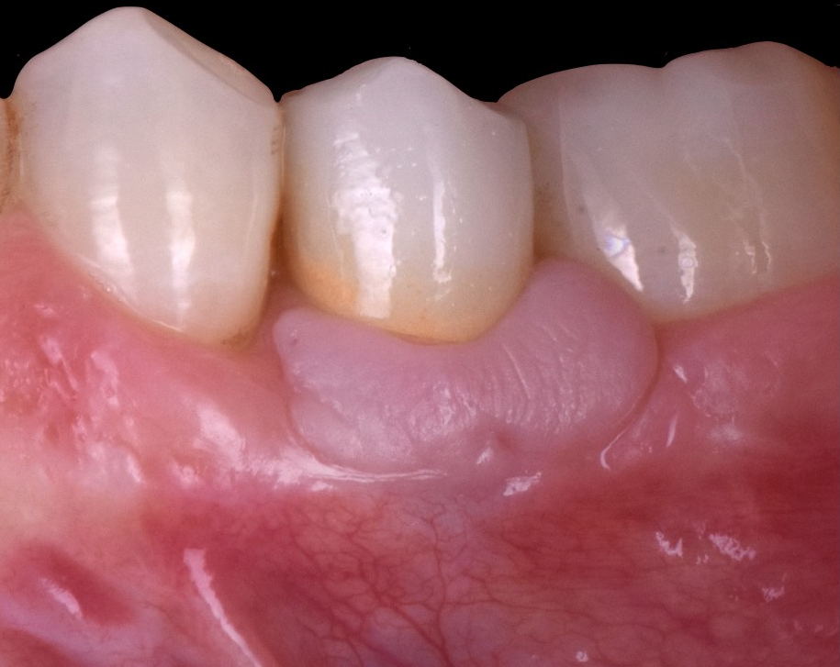
1 year after surgery; final restoration was performad 6 months after surgery

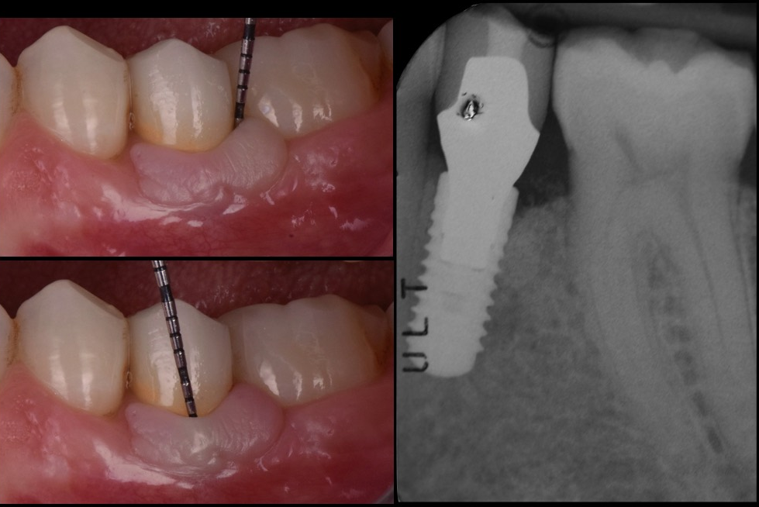
Clinical and radiographical view 1 year after surgery

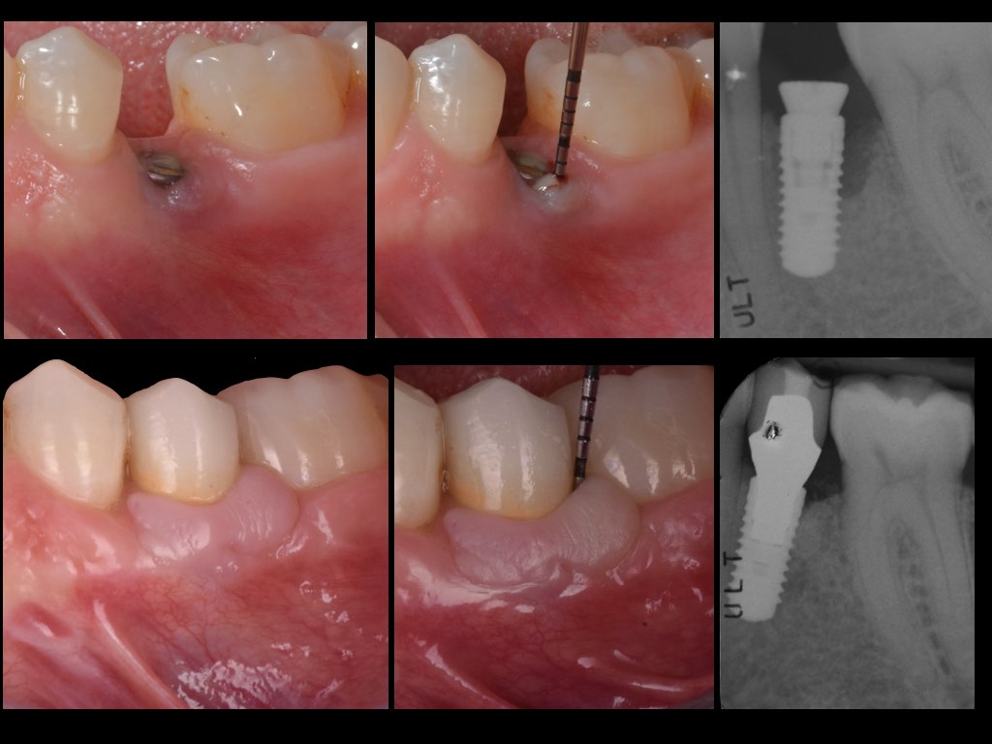
Clinical and radiographical view before and 1 year after surgery.

CASE 3
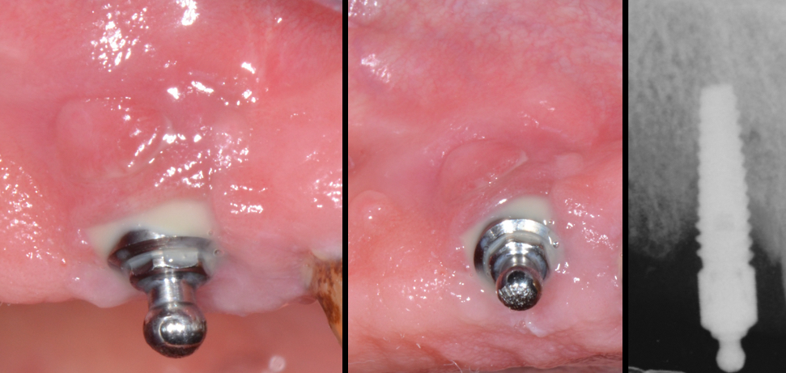
Clinical and radiographical view before surgery
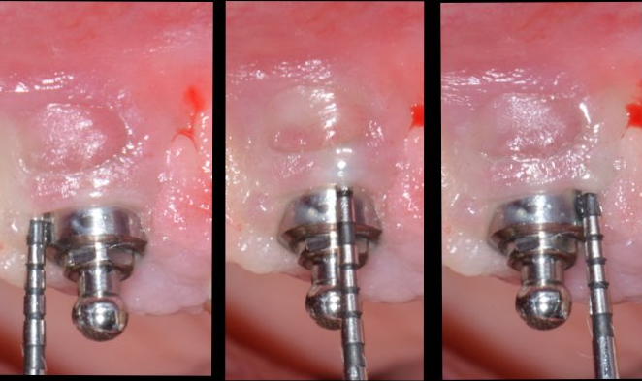Peri-implant probing before surgery.
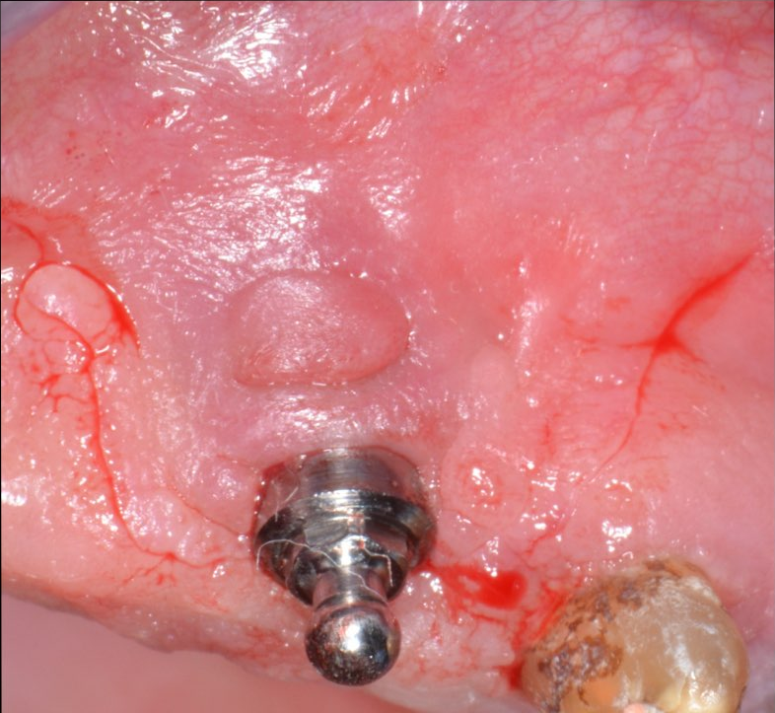
Flap design

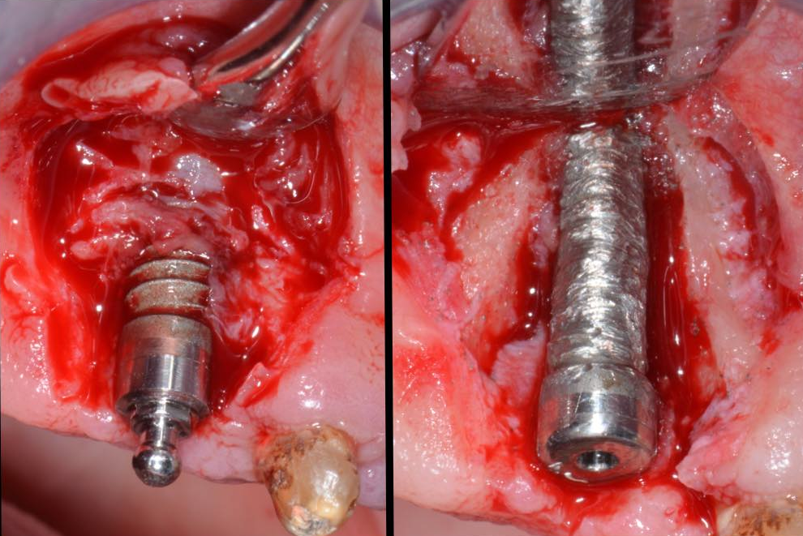
Flap elevation , defect degranulation and implantoplasty. Class I b defect.

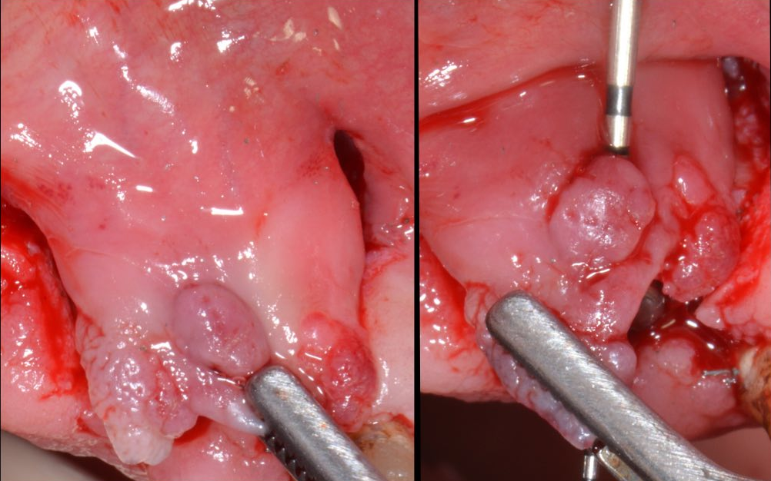
Coronally displacement of the flap; in this case note the presence of soft tissue fistula
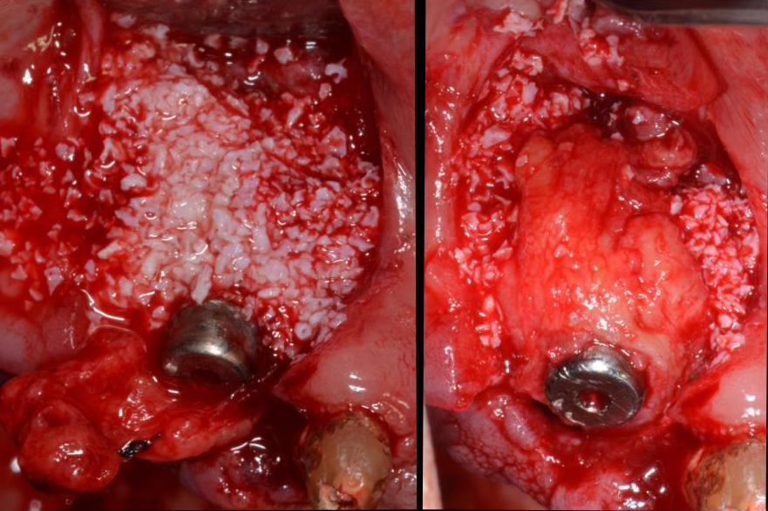
Deproteinized bovine bone graft placed in the defect and CTG placed around implant and upon bony graft, trimmed to hold implant neck.

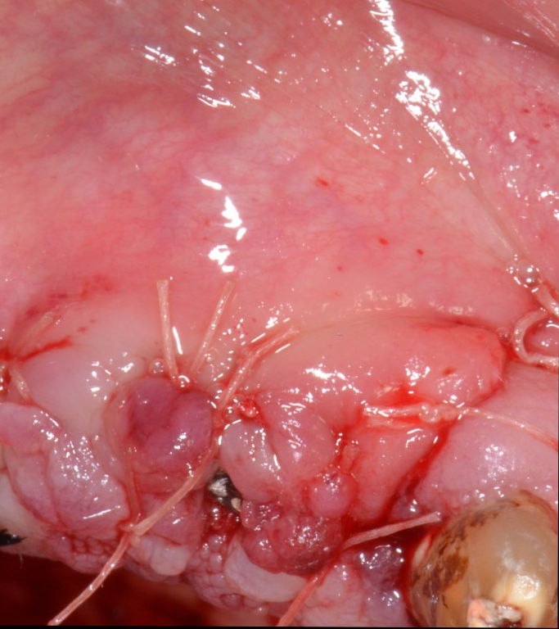
Coronally moved and sutured flap with 6-0 resorbable sutures.

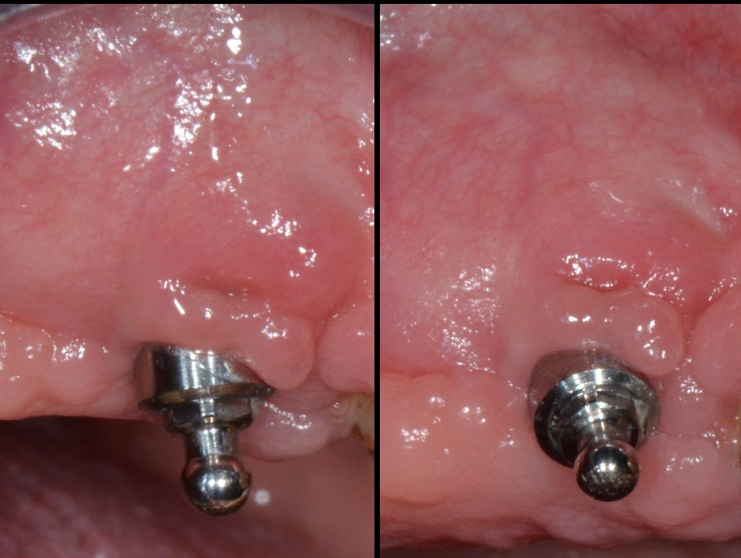
Clinical view after 1 year.

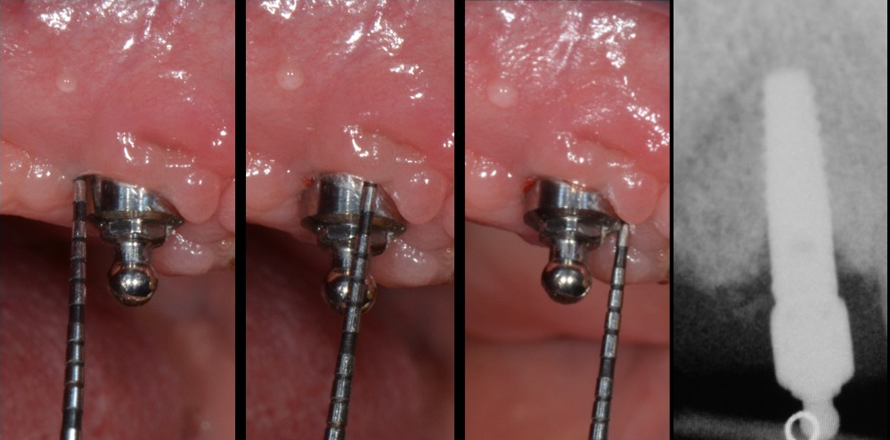
Clinical and radiographical parameters 1 year after surgery.
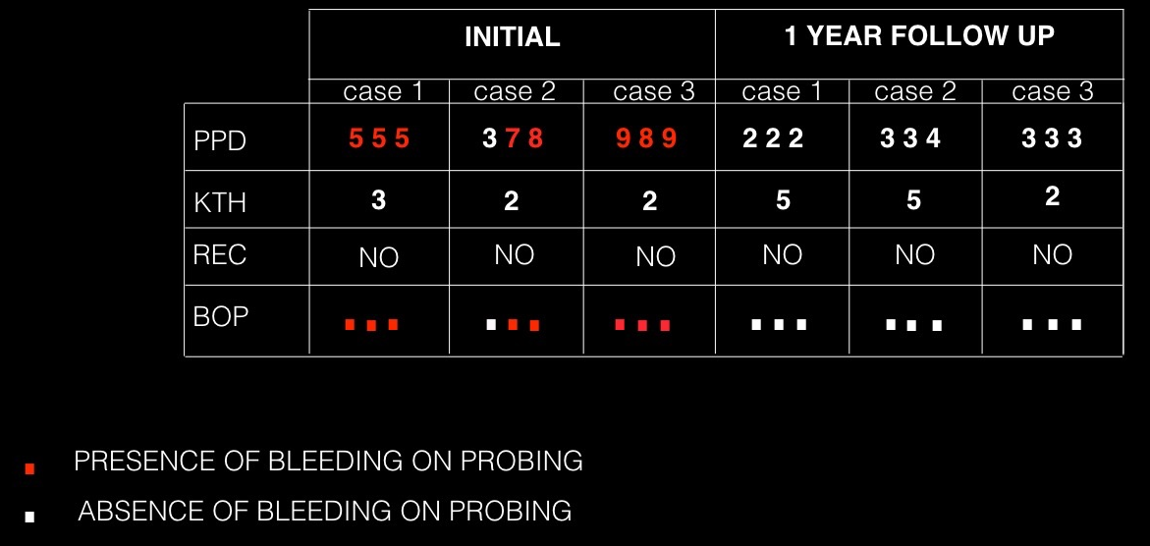
TAB. Clinical parameters before and after surgery at 1 year;
BIOGRAPHY

EUGENIO LONGO DDS,
PERIODONTST , IMPLANT AND ORAL SURGEON, WORK AND LIVE IN TUSCANY, WHEN COLLABORATE WITH PROFESSOR MASSIMO FROSECCHI ( UNIVERSITY OF GENOVA) IN DENATL CLINIC IN FLORENCE ( DENTAL MEDICINE FLORENCE).
GRADUATED AT UNIVERSITY OF SIENA IN NOVEMBER 2009, LIMITED PRIVATE PRACTICE ABOUT PERIODONTOLOGY, IMPLANTOLOGY AND ORAL SURGERY.
MEMBER OF ITALIAN SOCIETY OF PERIODONTOLOGY , ITALIAN ACADEMY OF OSTEOINTEGRATION AND ITALIAN ACADEMY OF ESTHETIC DENTISTRY.
FROM 2014 IS VISITING TUTOR AND SCIENTIFIC COORDINATOR OF AN IMPLANT AND MUCOGINGIVAL HANDS-ON COURSE IN BRAZIL , UNIVERSITY OF UNINOVE ( SAO PAULO).
RECENTLY BECAME A SPEAKER AND CHIEF IN MANY COURSES AND CONFERENCES ABOUT PERIODONTOLOGY , IMPLANTOLOGY AND ORAL SURGERY.

REFERENCES

Lindhe, J. & Meyle, J. (2008) Peri-implant diseases: consensus report of the Sixth European Workshop on Periodontology. Journal of Clinical Periodontology 35 (Suppl. 8), 282–285.
Renvert, S. & Polyzois, I. (2015) Clinical approaches to treat peri-implant mucositis and peri-implantitis. Periodontology 2000 68, 369– 404.
Schwarz F, John G, Mainusch S, Sahm N, Becker J. (2012) Combined surgical therapy of peri-implantitis evaluating two methods of surface debridement and decontamination. A two-year clinical follow up report. J Clin Periodontol 2012; 39: 789–797.
Roccuzzo, M., Bonino, F., Bonino, L. & Dalmasso, P. (2011) Surgical therapy of peri- implantitis lesions by means of a bovine- derived xenograft: comparative results of a prospective study on two different implant surfaces. Journal of Clinical Periodontology 38, 738–745.
Schwarz, F., Sahm, N., Schwarz, K. & Becker, J. (2010) Impact of defect configuration on the clinical outcome following surgical regenerative therapy of peri-implantitis. Journal of Clinical Periodontology 37, 449–455.
Sahrmann, P., Attin, T. & Schmidlin, P. R. (2011) Regenerative treatment of peri-implantitis using bone substitutes and membrane: a systematic review. Clinical Implant Dentistry and Related Research 13, 46–57.
Roccuzzo M. Grasso G., Dalmasso P. (2016) Keratinized mucosa around implants in partially edentulous posterior mandible: 10-year results of a prospective comparative study.Clin Oral Implants Res. Apr;27(4):491-6.
Cairo F, Pagliaro U, Nieri M. ( 2008)
Soft tissue management at implant sites.
J Clin Periodontol. Sep;35(8 Suppl
.Rotundo R, Pagliaro U, Bendinelli E, Esposito M, Buti J. (2015)
Long-term outcomes of soft tissue augmentation around dental implants on soft and hard tissue stability: a systematic review.

