A new combined, regenerative and mucogingival, approach for the treatment of peri-implantitis : a report of 3 cases with one year of follow-up.

Longo E, Frosecchi M.

Abstract:

The clinicians in the new millennium are facing a new very common disease, peri-implantitis. In the past the dentists thought that removing hopeless teeth and replacing them with dental implants would have been a viable long term solution. Nevertheless the age group of the patients receiving dental implants and their indications have radically changed. The evolution of implant surfaces from machined to rough to nano rough have yes improved and enhanced the adhesion of the blood clot to the implants but also exposed a weakness whenever the implant surfaces become exposed or for some reason attached by the biofilm. Peri-implantitis has become a silent enemy often compromising the long term success of implant supported restorations.
This article wants to introduce a new combined approach wich has the goal of correcting both bony and soft tissue deformities around implants affected by peri-implantitis. The combination of GBR and mucogingival procedures resulted in excellent recovery of both aspects on the three cases presented.

Introduction:

The 6th European Workshop on Periodontology confirmed that non-surgical therapy is not effective in treatment of peri-implantitis¹ Main goal of surgical treatment of peri-implantitis is to get access to implant surface in order to perform debridement and decontamination and the complete removal of granulation tissue.
During the last years, several systematic reviews on the treatment of peri-implant diseases have been published^{1,2,3,4,5,6,7,8,9}.
While there is lack of scientific evidence on which are the most effective procedures to treat peri-implantitis² some authors suggest that surgical treatment including granulation tissue removal, implant surface debridement , decontamination and modification , and bone augmentation around implants may result in a better clinical outcome¹⁰.
Implant surface characteristics¹¹ and peri-implant defect configuration¹² could represents key factors in the outcome of surgical regenerative therapy
Despite several studies report encouraging results with “regenerative-like “ approaches¹³ , poor data are available about soft tissue behavior after surgical treatment of peri-implantitis.
A recent comparative prospective 10 year study demonstrated that implants with lack of keratinized tissue are more prone to plaque accumulation and REC, even in patients exercising sufficient oral hygiene and receiving adequate supporting periodontal therapy with higher number of sites that required additional surgical and/or antibiotic treatment¹⁴.
Probably due to the eterogenicity of techniques proposed in the literature for soft tissue augmentation at implant site , there’s no evidence on which are the most effective for peri-implant soft tissue augmentation¹⁵, and the role of mucogingival therapies around implants is still unclear in term of maintainance over time of long term, soft tissue stability and peri-implant bone level¹⁶ although scientific evidence in most part is lacking , soft tissue augmentation at implant site may be considerate to promote easier hygiene maintainnance and prosthetic restoration.
This article wants to introduce a new combined approach wich has the goal of correcting both bony and soft tissue deformities around implants affected by peri-implantitis. The combination of GBR and mucogingival procedures resulted in excellent recovery of both aspects on the three cases presented.

Materials and Methods

This paper is presenting three cases with the following carechteristics:

At least one site showing signs of peri-implantitis, in the specific the defects were related to the buccal aspect of the fixtures without any kind of gingival recession
Patients were > 18 years old
Periodontally and sistemically healthy
FMBS and FMBS <15%
No previous surgical and non surgical tratment to the affected implant
Smoking less than 10 cigarettes a day;

According by the classification of Swharz at al.¹⁷ all defects belong to Class Ia (buccal dehiscence ) Ib ( buccal dehiscence + semicircumferential ) ;

The three patients treated showed at least one implant with BOP and suppuration in the buccal aspect, all three referred discomfort, swelling and bleeding at the bucca aspect of the implant supported restorations.
All implants showed radiographic evidence of bone loss without mucogingival complications (none of the implants presented gingival recession).
Clinical parameters concerning PPD (peri-implant probing depth), BOP ( bleeding on probing) , REC ( soft tissue recession) and KTH ( keratinized tissue high ) were recorded at baseline and one year post operatively.
Prior to surgery all patients received a session of prophylaxis including oral higyene instructions and professional scaling and implant cleaning.
Two months before surgery the implants were cleaned with teflon curettes and ultrasonic tip with clorexidine 0.2% .
Surgery was performed only after the patients showed good compliance and improvement of baseline conditions .

Surgical Protocol

After local anesthesia, a trapezoidal flap was raised following the design proposed by De Sanctis and Zuchelli¹⁸ for single type recession coverage, the flap was elevated in a split thickness mode in correspondence of the papilla and in a full thickness mode until the contaminated implant surface was completely exposed, and split thickness again apical to that. Coronally mobilization of the flap was obtained by means of two incisions, one deep to detach labial sub mucosal tissue from the periostium and one superficial to separate the labial submucosal tissue from the inner surface of the alveolar mucosa in order to obtain a free tension flap in conjunction with lateral beveled releasing incisions well extended in the alveolar mucosa.
The peri-implant defect was than debrided with curettes and the implant surface exposed, treated with diamond burs with different roughness, and than refined with an arkansas stone to completely polish the surface under copious irrigation with sterile saline solution (Schwartz et al 2011a)¹⁹ .
After titanium dust/deposits complete removal , a connective tissue graft ( CTG) was than harvested from the palate and used as a barrier membrane in the coronal portion of the implant and to protect the bone graft placed to restore the missing anatomy. Deproteinized bovine bone graft was used to correct the bony deformity and to restore the buccal bulk. The mean thickness of the connective tissue graft was 1 mm. The graft was placed buccally to the grafted area and the flap sutured on top of it to the de-epithelialized papilla with 6.0 resorbable sutures. The suture used to stabilize the system was a suspended horizontal mattress.
The sutures were removed after 14 days, while patients were instructed to take non-steroidal analgesics, as needed. Immediately after surgery, the patients applied ice at the treated area, and it was recommended that these be kept in place for at least 4 hours for next 3 days .
Patients were also advised to discontinue tooth brushing and to avoid trauma at the site of surgery for 3 weeks. They were also instructed to gently use 0.2% chlorhexidine digluconate rinse for 1 minute three times a day for the same period of time in the surgical area.
All subjects were recalled every 2 months for control and professional hygiene mantainnance session.

Case Presentation

CASE 1
CASE 2

CASE 3

Results and Discussion

In all patients, healing proceeded without complications and with minimal post-operative discomfort.
The clinical data of the 3 implants, at baseline and at 1-year follow-up, are listed in Table .
One year after treatment, all implants showed a significant improvement in terms of PPD and no site was bleeding on probing.
All sites showed and increase in keratinized gingiva , two of the three cases showed some creeping attachment as shown in pictures ( Case 2 and Case 3).
The use of the connective tissue graft in these three cases proved useful in providing stability to the flap and the underlying bone graft. The increase in volume of the soft tissue and amount of keratinized gingiva, provided better support to the prosthetic restorations, and made the overall situation easier for maintenance .

The principles of mucogingival therapy (beveled incision and careful suturing) seem to avoid any scar tissue formation, and the execution of a free tension flap in conjunction with the use of connective tissue graft seems to promote an increase of the keratinized tissue and to avoid soft tissue shrinkage at implant site.
The use of connective tissue graft in conjunction with coronally advanced flap was described in different studies deling with soft tissue recession treatment at implant sites: obtaining good results in terms of gain in keratinized tissue and soft tissue dehiscence coverage, but all the implants in those studies were not affected by any infection^{20,21,22}.
Some authors²³ suggest that the use of CT graft seems to promote the coronal stabilization of the soft tissue in periodontal regenerative therapy too.
A recent study showed a similar regenerative approach for treatment of peri-implantitis with main buccal bone dehiscences but without osteoplasty and using a smaller connective tissue graft. Authors reported an increase in all peri-implant clinical and radiographic parameters²⁴.
The plasty of the implant surface produced a better situation for re-attachment and to prevent bacterial adhesion, promote alkaline phosphatase and osteocalcin production ; that also modifies the titanium surface morphology, composition and wettability, resulting in high biocompatibility²⁵.
This approach put in conjunction the principles of regenerative and mucogingival therapy in order to modify both aspects in peri-implantitis treatment, and the implantoplasty produce a less favorable surface for biofilm formation .
The soft tissue behavior and the improvement of clinical parameters at 1 year suggest that this could be considerd a valid approache especially in the esthetic areas.
The small size sample and the short term follow up suggests further studies with larger number of defects to validate the real efficacy of this approach.

REFERENCES

1.Lindhe, J. & Meyle, J. (2008) Peri-implant diseases: consensus report of the Sixth European Workshop on Periodontology. Journal of Clinical Periodontology 35 (Suppl. 8), 282–285.
2.Esposito, M., Grusovin, M. G. & Worthington, H. V. (2012) Interventions for replacing missing teeth: treatment of perimplantitis. Cochrane Database of Systematic Reviews 6, Art. No.: CD004970.
3.Klinge, B. & Meyle, J. (2012) EAO consensus report: peri-implant tissue destruction. the third EAO consensus conference 2012. Clinical Oral Implants Research 23 (Suppl. 6), 108–110.
4.Renvert, S., Polyzois, I. & Claffey, N. (2012) Surgical therapy for the control of peri-implantitis. Clinical Oral Implant Research 23 (Suppl. 6), 84–94.
5.Khoshkam V. , Chan HL, Lin GH, MacEachern MP, Monje A, Suarez F, Giannobile WV, Wang HL.
J Dent Res. 2013 Dec; 92(12 Suppl):131S-8s
Reconstructive procedures for treating peri-implantitis: a systematic review.

6.Chan, H. L., Lin, G. H., Suarez, F., MacEachern, M. & Wang, H. L. (2014) Surgical management of peri-implantitis: a systematic review and meta-analysis of treatment outcomes. Journal of Periodontology 85, 1027–1041.
7.Figuero, E., Graziani, F., Sanz, I., Herrera, D. & Sanz, M. (2014) Management of peri-implant mucositis and peri-implantitis. Periodontology 2000 66, 255–273.
8.Heitz-Mayfield, L. J., Needleman, I., Salvi, G. E. & Pjetursson, B. E. (2014) Consensus statements and clinical recommendations for prevention and management of biologic and technical implant complications. International Journal of Oral & Maxillofacial Implants 29 (Suppl.), 346–350.
9.Renvert, S. & Polyzois, I. (2015) Clinical approaches to treat peri-implant mucositis and peri-implantitis. Periodontology 2000 68, 369– 404.
10.Schwarz F, John G, Mainusch S, Sahm N, Becker J. (2012) Combined surgical therapy of peri-implantitis evaluating two methods of surface debridement and decontamination. A two-year clinical follow up report. J Clin Periodontol 2012; 39: 789–797.
11.Roccuzzo, M., Bonino, F., Bonino, L. & Dalmasso, P. (2011) Surgical therapy of peri- implantitis lesions by means of a bovine- derived xenograft: comparative results of a prospective study on two different implant surfaces. Journal of Clinical Periodontology 38, 738–745.
12.Schwarz, F., Sahm, N., Schwarz, K. & Becker, J. (2010) Impact of defect configuration on the clinical outcome following surgical regenerative therapy of peri-implantitis. Journal of Clinical Periodontology 37, 449–455.
13.Sahrmann, P., Attin, T. & Schmidlin, P. R. (2011) Regenerative treatment of peri-implantitis using bone substitutes and membrane: a systematic review. Clinical Implant Dentistry and Related Research 13, 46–57.
14.Roccuzzo M. Grasso G., Dalmasso P. (2016) Keratinized mucosa around implants in partially edentulous posterior mandible: 10-year results of a prospective comparative study.Clin Oral Implants Res. Apr;27(4):491-6.
15.Cairo F, Pagliaro U, Nieri M. ( 2008)
Soft tissue management at implant sites.
J Clin Periodontol. Sep;35(8 Suppl
16.Rotundo R, Pagliaro U, Bendinelli E, Esposito M, Buti J. (2015)
Long-term outcomes of soft tissue augmentation around dental implants on soft and hard tissue stability: a systematic review.
Clin Oral Implants Res. Sep;26 Suppl 11:123-38.

17.Schwarz, F., Herten, M., Sager, M., Bieling, K., Sculean, A. & Becker, J. (2007) Comparison of naturally occurring and ligature-induced peri-implantitis bone defects in humans and dogs. Clinical Oral Implants Research 18, 161–170.
18.De Sanctis M, Zucchelli G. (2007)
Coronally advanced flap: a modified surgical approach for isolated recession-type defects: three-year results. J Clin Periodontol. Mar;34(3):262-8.

19.Schwarz F, Sahm N, Iglhaut G, Becker J. 2011 Impact of the method of surface debridement and decontamination on the clinical outcome following combined surgical therapy of peri-implantitis: a randomized controlled clinical study. J Clin Peridontol 2011; 38: 276–284.
20.Burkhardt, R., Joss, A. & Lang, N.P. (2008) Soft tissue dehiscence coverage around endosseous implants: a prospective cohort study. Clinical Oral Implants Research 19: 451–457.

21.Zucchelli G, Mazzotti C, Mounssif I, Marzadori M, Stefanini M. (2013) Esthetic treatment of peri-implant soft tissue defects: a case report of a modified surgical-prosthetic approach. Int J Periodontics Restorative Dent. May-Jun;33(3):327-35.

22.Roccuzzo M, Gaudioso L, Bunino M, Dalmasso P (2014)
Surgical treatment of buccal soft tissue recessions around single implants: 1-year results from a prospective pilot study.
Clin Oral Implants Res. Jun;25(6):641-6.

23..Zucchelli G, Mazzotti C, Tirone F, Mele M, Bellone P, Mounssif I. ( 2014)
The connective tissue graft wall technique and enamel matrix derivative to improve root coverage and clinical attachment levels in Miller Class IV gingival recession.
Int J Periodontics Restorative Dent. 2014 Sep-Oct;34(5):601-9

24.Roccuzzo M, Gaudioso L, Lungo M, Dalmasso P. (2016) Surgical therapy of single peri-implantitis intrabony defects, by means of deproteinized bovine bone mineral with 10% collagen.J Clin Periodontol. Mar;43(3):311-8.
25.Toma S, Lasserre J, Brecx MC, Nyssen-Behets C. (2015)
In vitro evaluation of peri-implantitis treatment modalities on Saos-2osteoblasts.
Clin Oral Implants Res. Sep 10. doi: 10.1111/clr.12686. [Epub ahead of print]

Glossary

IMAGES AND TAB
Case 1

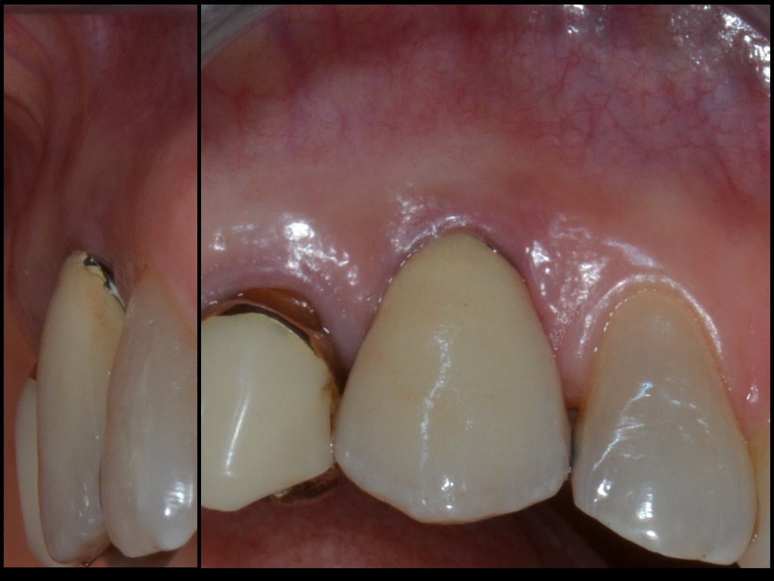
Initial view of implant

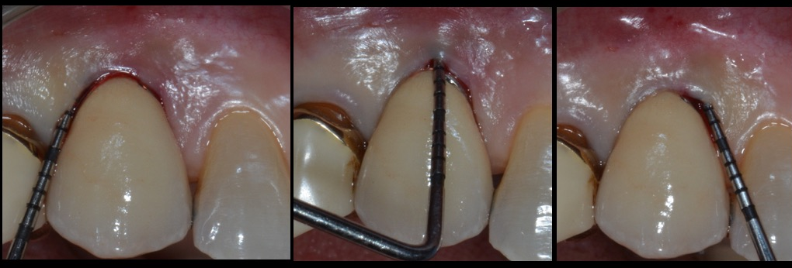
Peri-implant probing depth before surgery
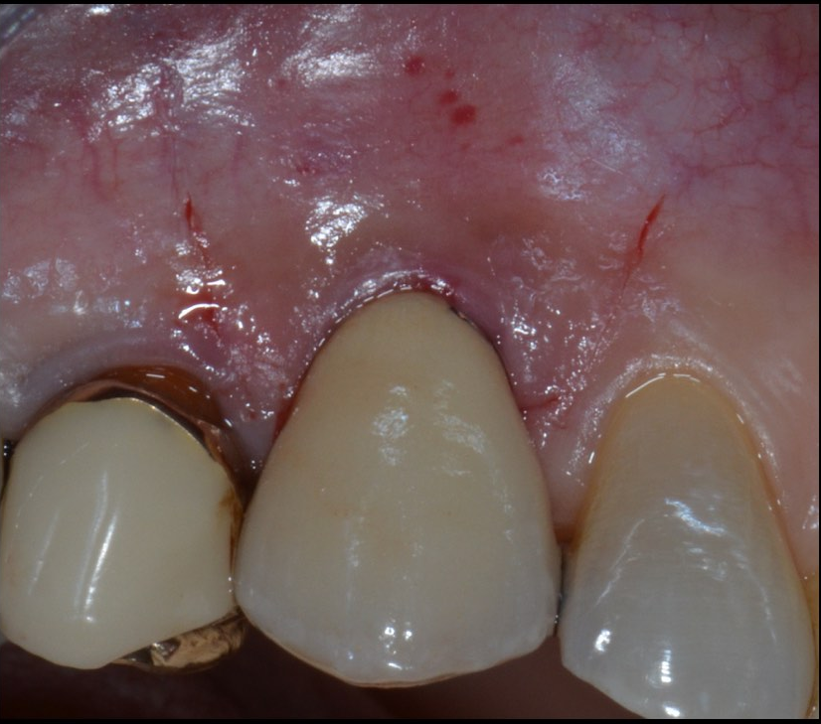
Flap design

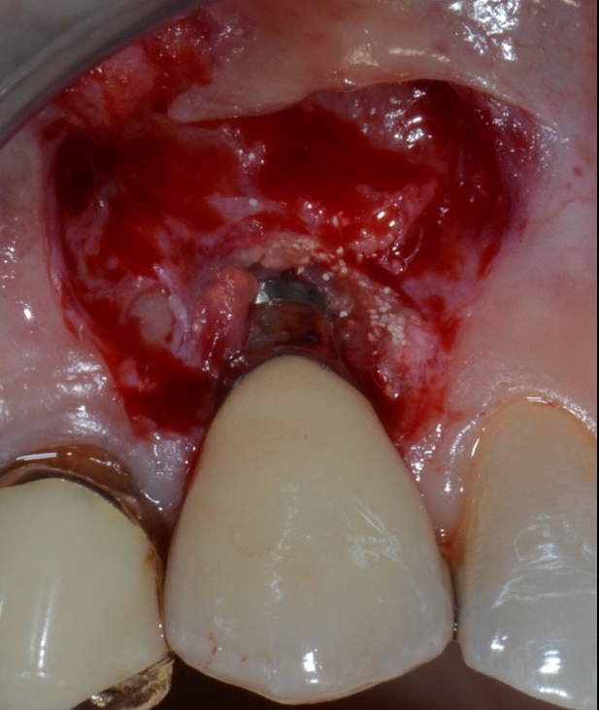

Flap elevation; note the split –full-split thickness raising ( split in correspondence of surgical papilla, full on implant surface and split again apical to the bone dehiscence)
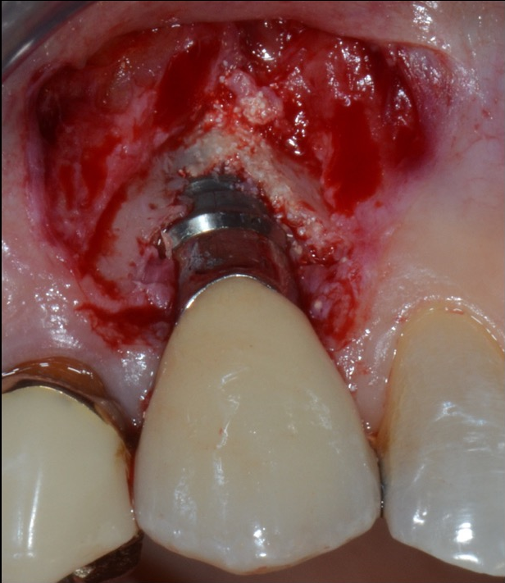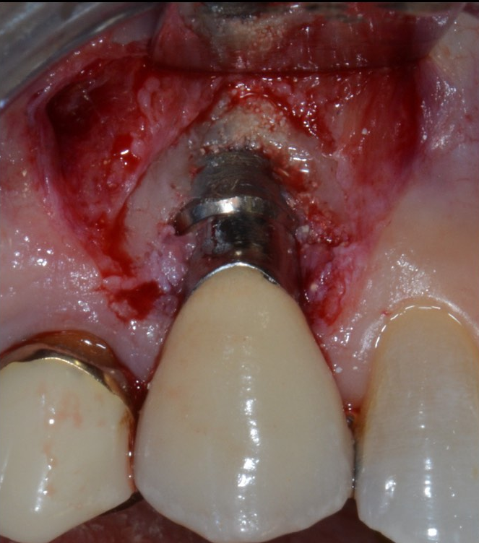

Defect degranulation; class 1a defect; Implantoplasty
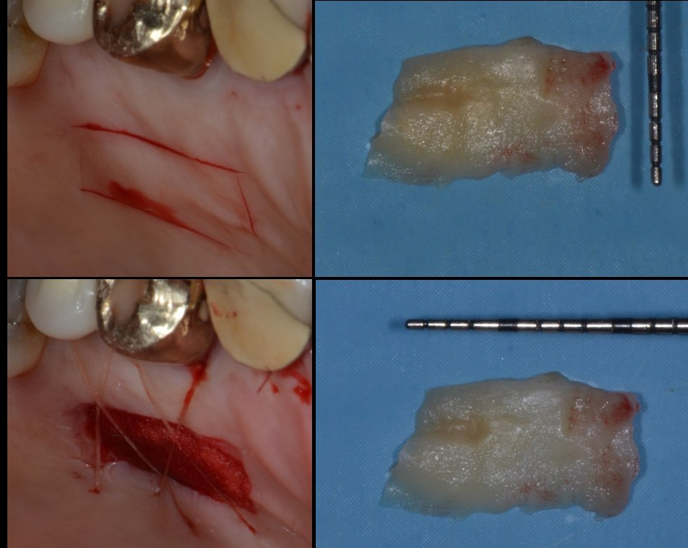
Free ginigival graft (FGG) harvested from palat and disepithelized ;

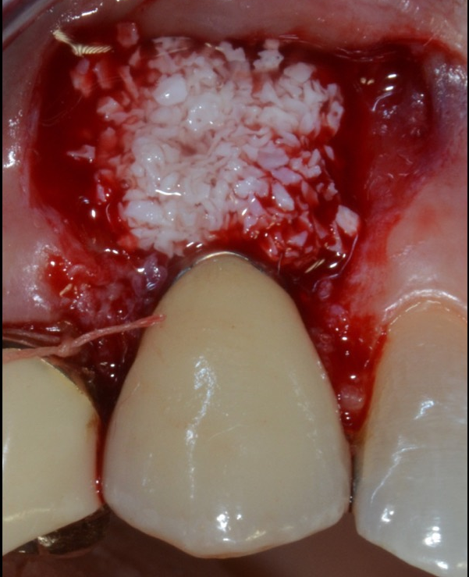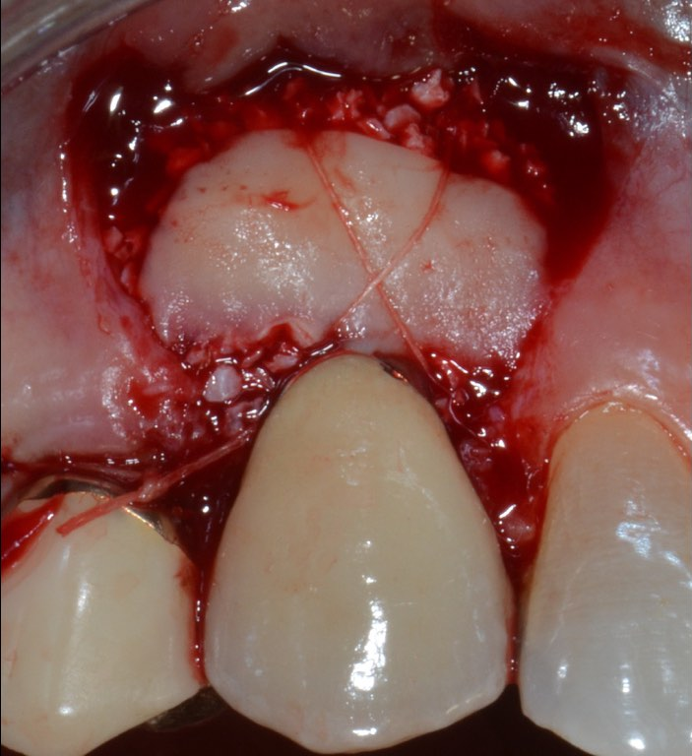After surgical papillas disepithelization , deproteinized bovine bone graft placed on the dehiscence and covered by CTG

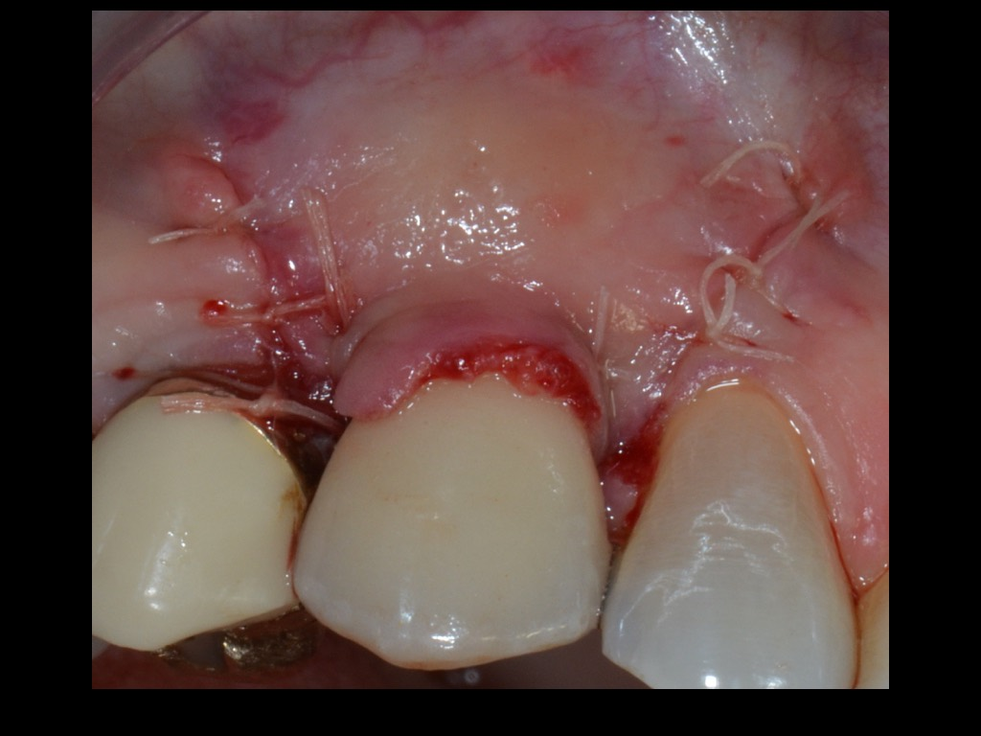
Coronally advanced and sutured flap with 6-0 resorbable sutures
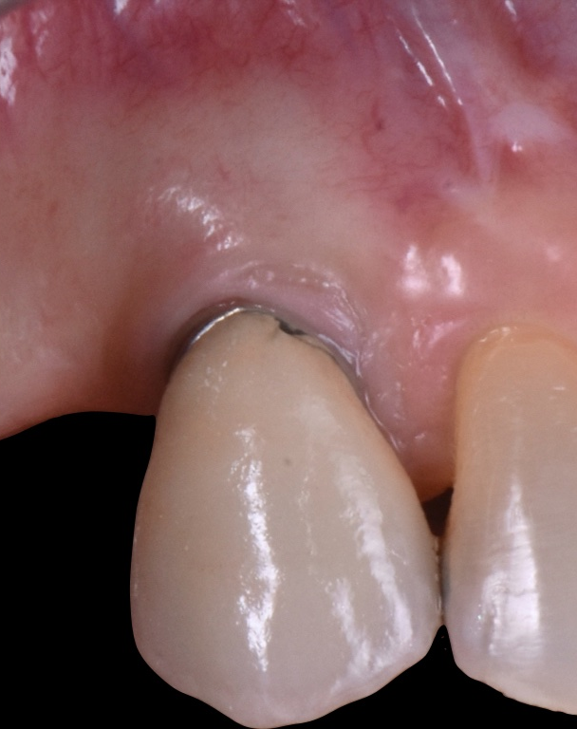Clinical view 1 year after surgery. During healing phase first upper right premolar was lost for fracture.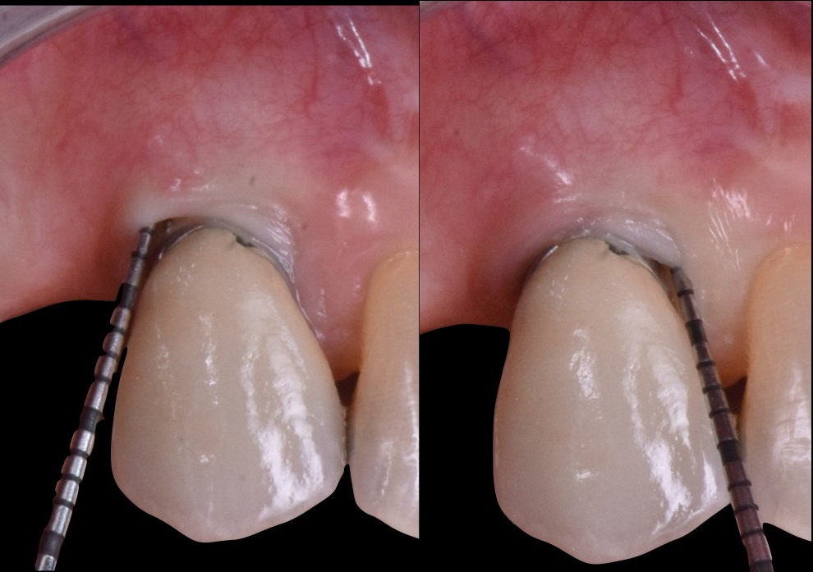Clinical PPD 1 year after surgery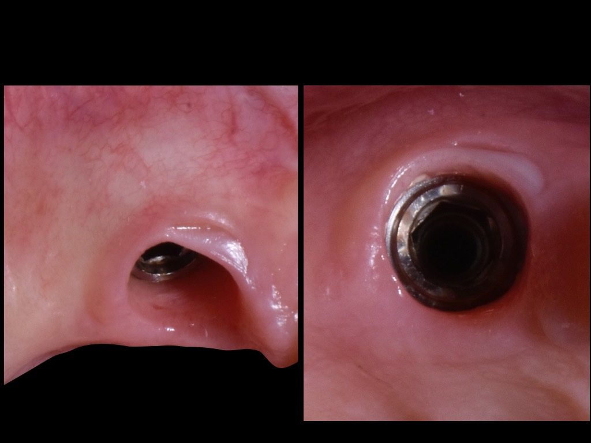
View of health peri-implant soft tissue collar 1 year after surgery.

Case 2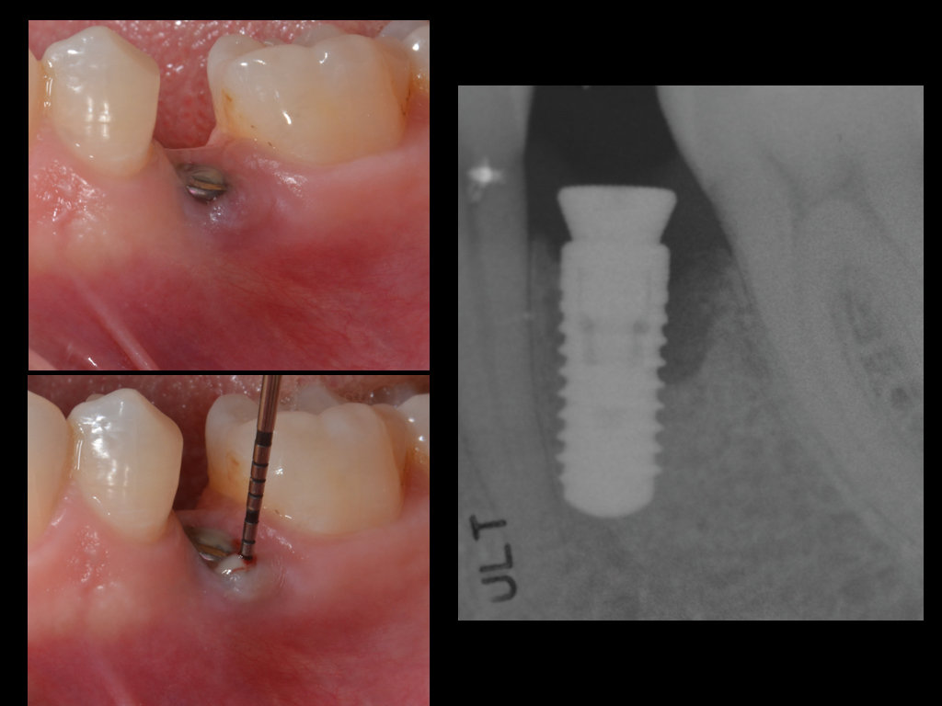
Clinical and radiographical view of the implant before surgery.
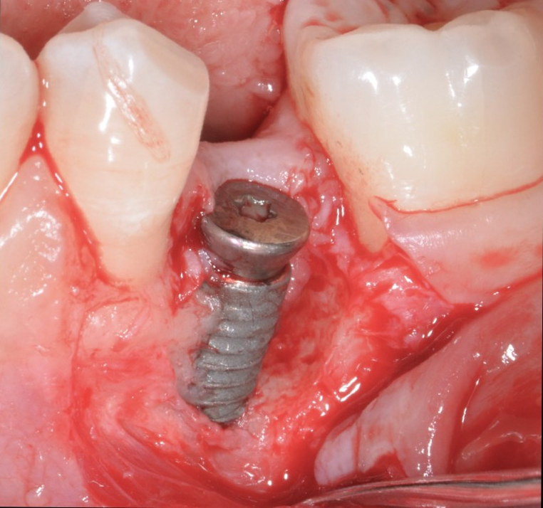

Implant view and defect configuration after flap elevation. Class 1b defect

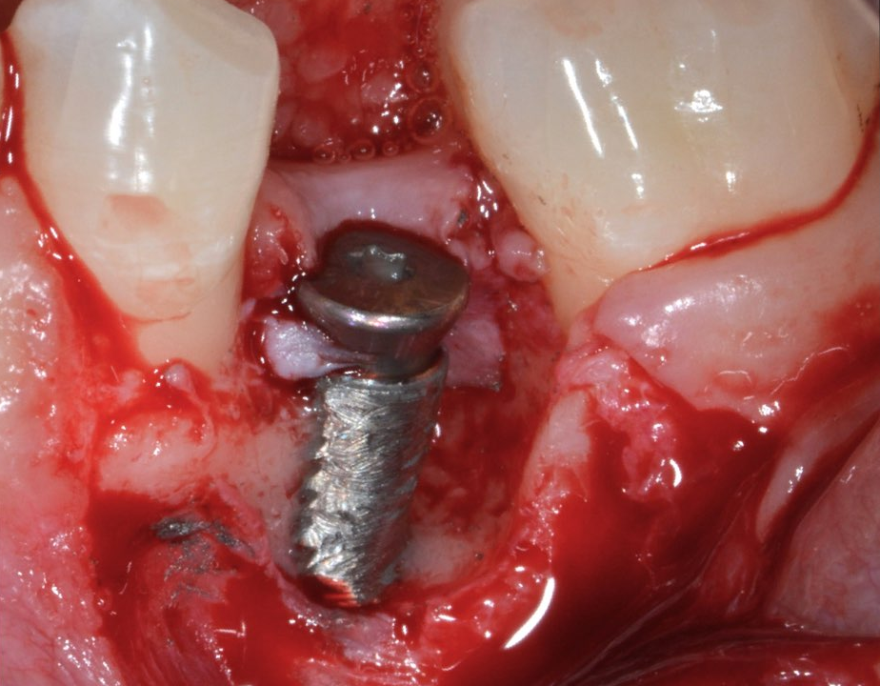
Implantoplasty

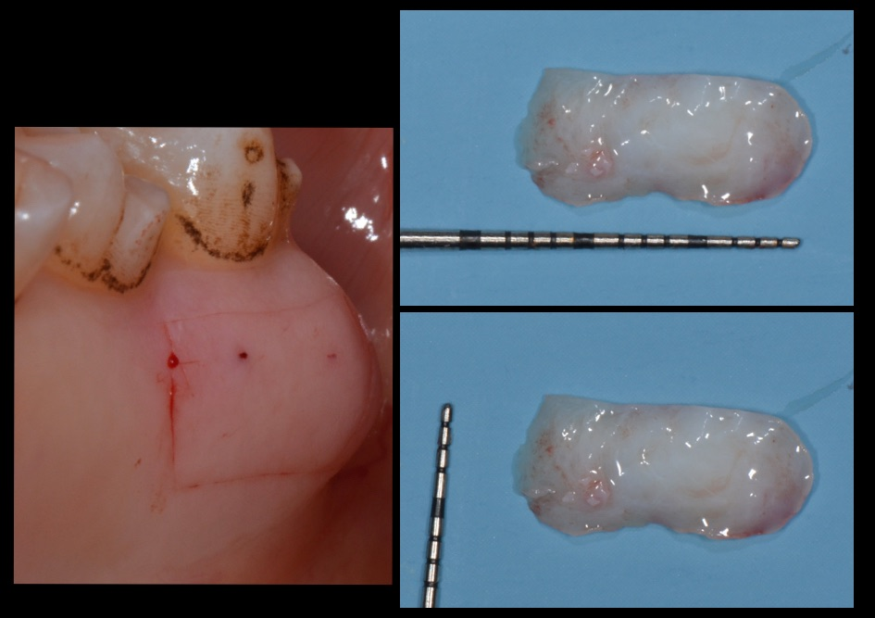

Graft harvesting from palate and disepithelizated.

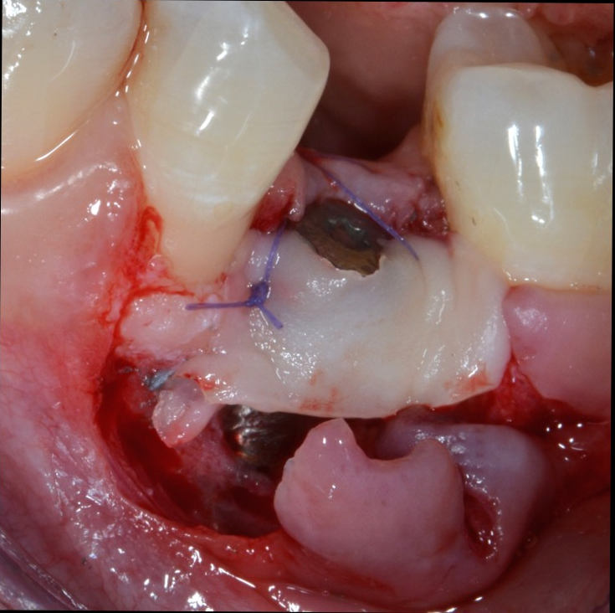
CTG placed as membrane and fixed with 6-0 resorbable sutures.
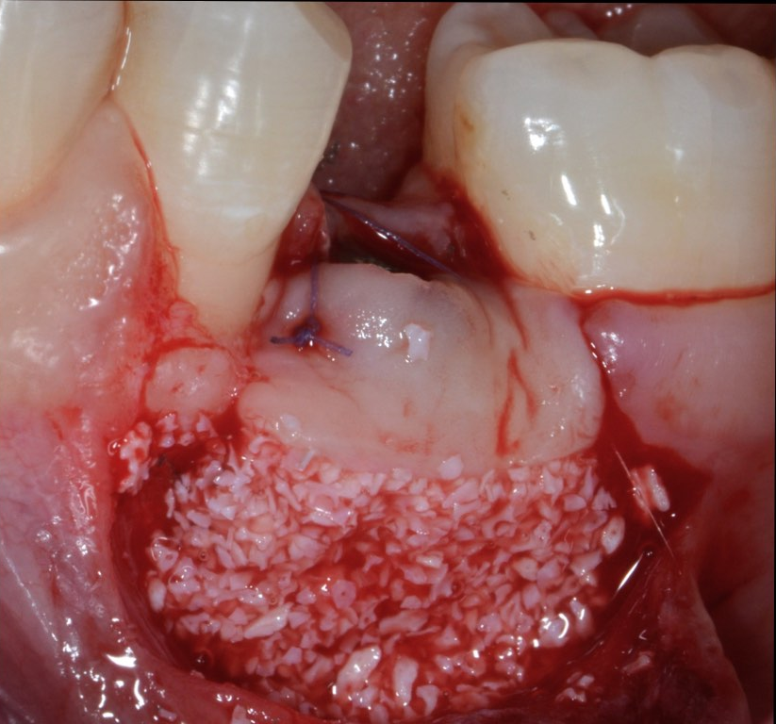
Deproteinezed bovine bone graft placed into the defect and between implant and CTG

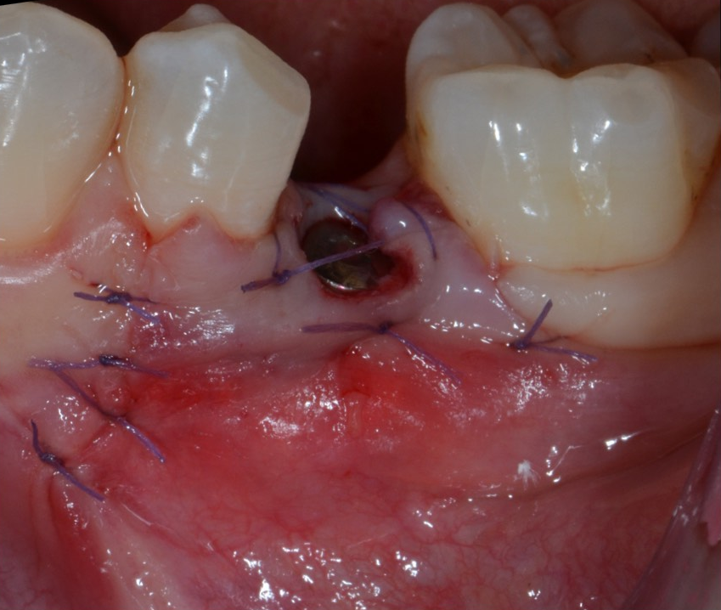
Flap coronally moved an sutured with 6-0 resobable sutures.
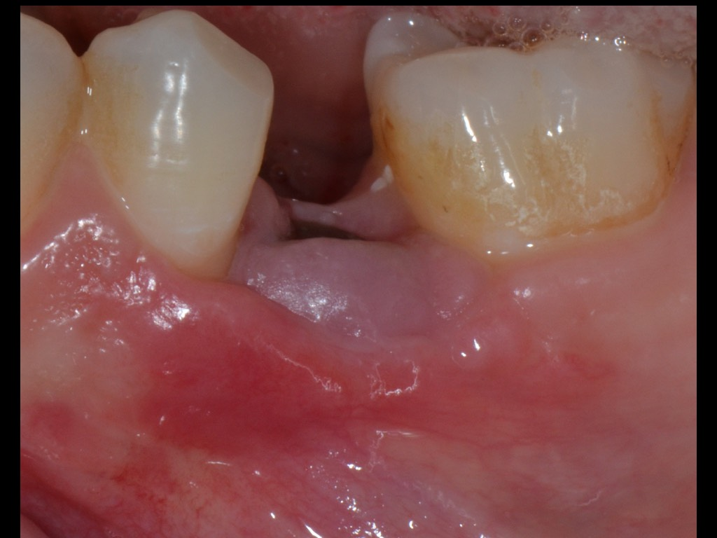
Suture removal after 14 days.

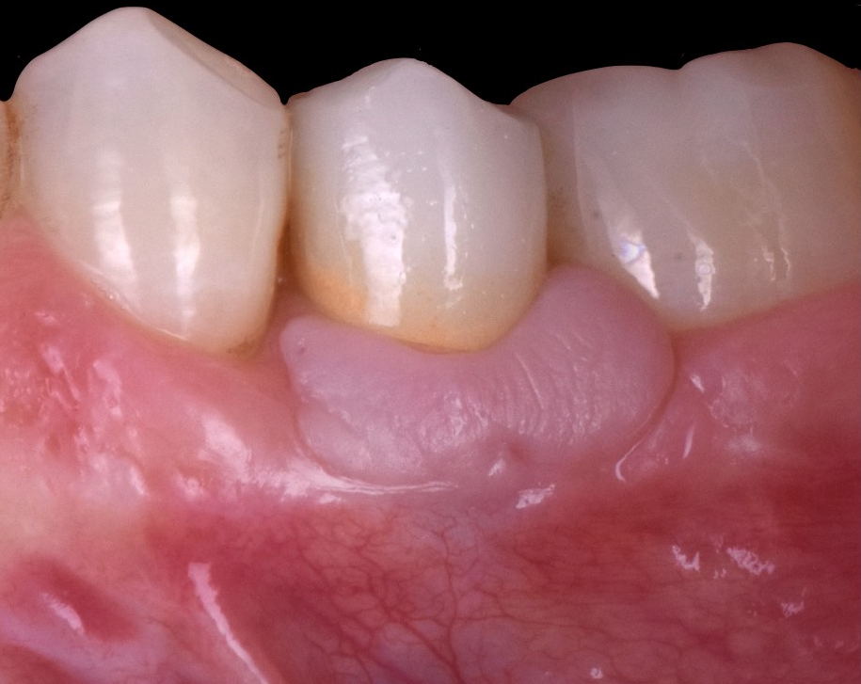
1 year after surgery; final restoration was performad 6 months after surgery

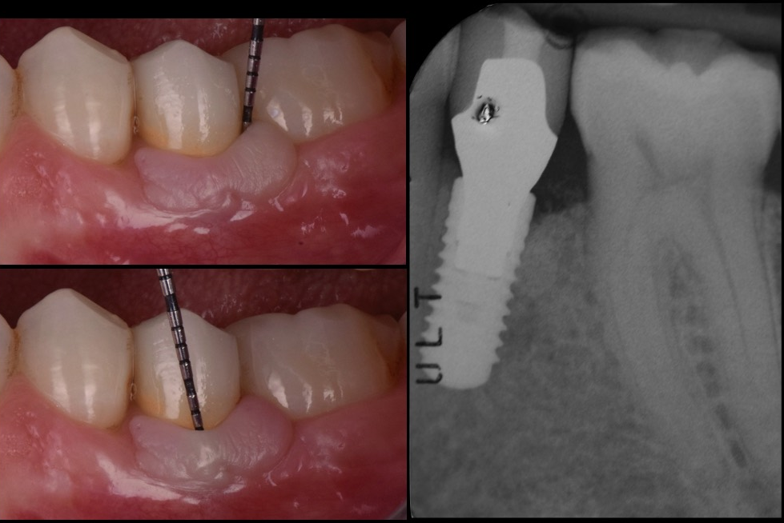
Clinical and radiographical view 1 year after surgery

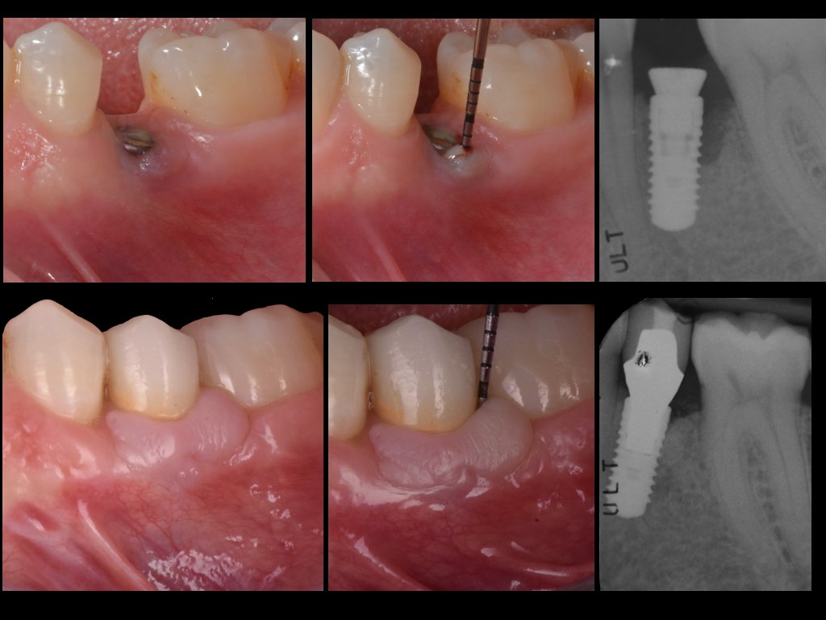
Clinical and radiographical view before and 1 year after surgery.

CASE 3
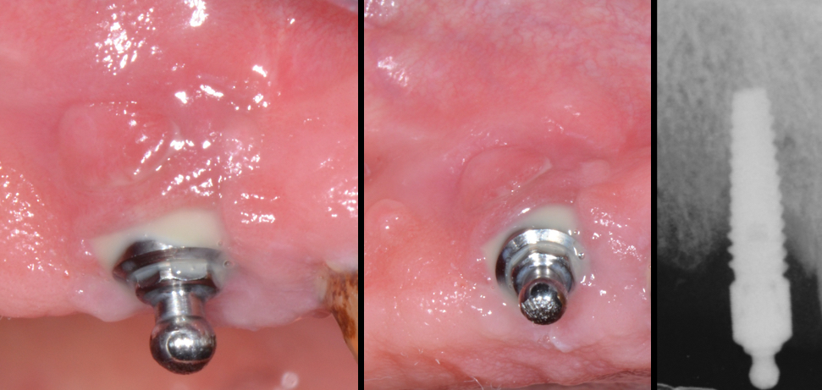
Clinical and radiographical view before surgery
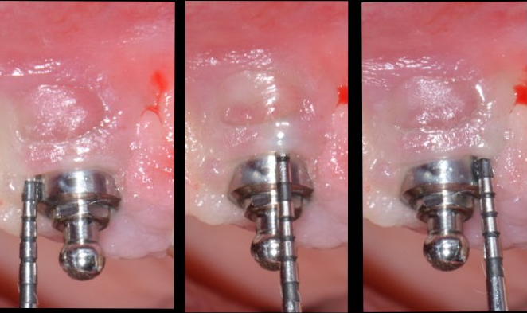Peri-implant probing before surgery.
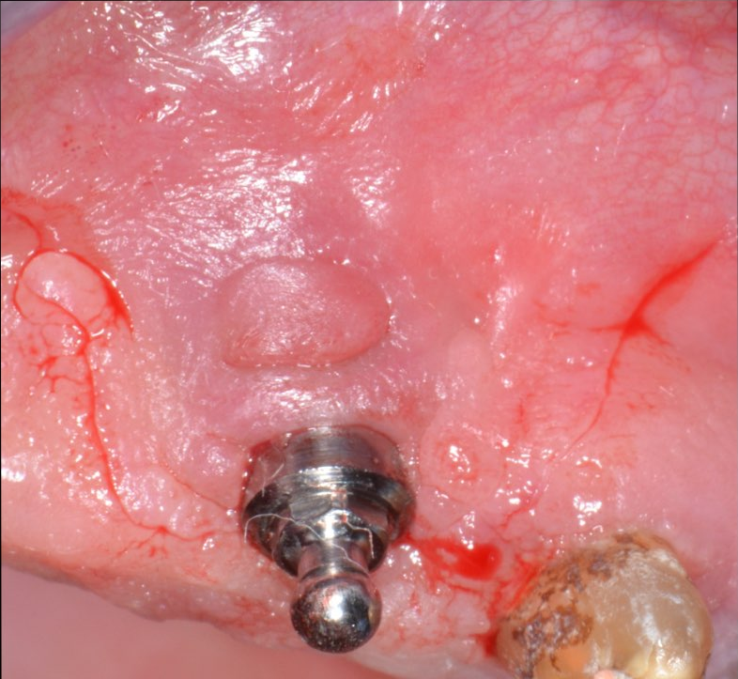
Flap design

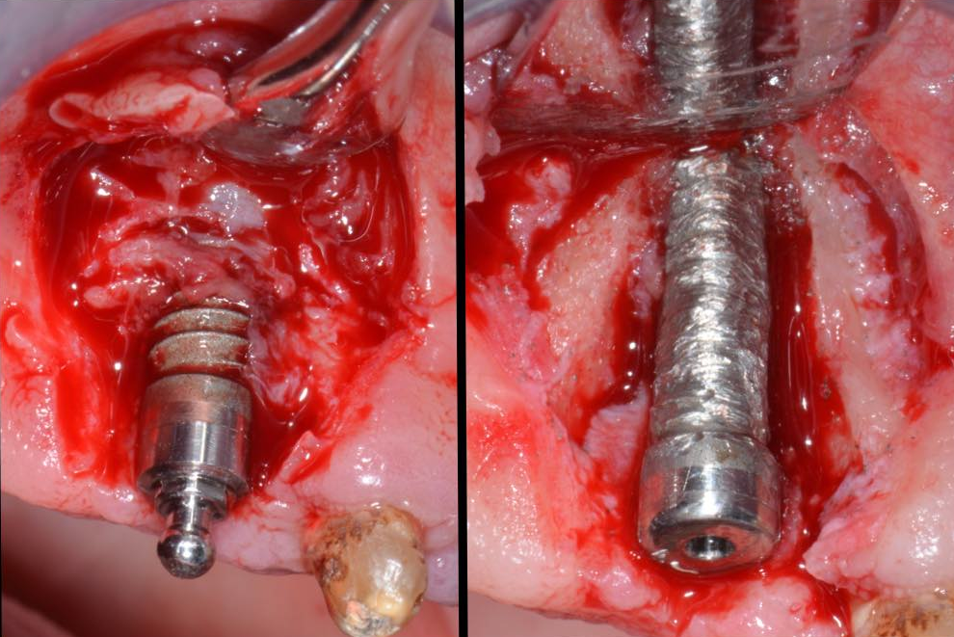
Flap elevation , defect degranulation and implantoplasty. Class I b defect.

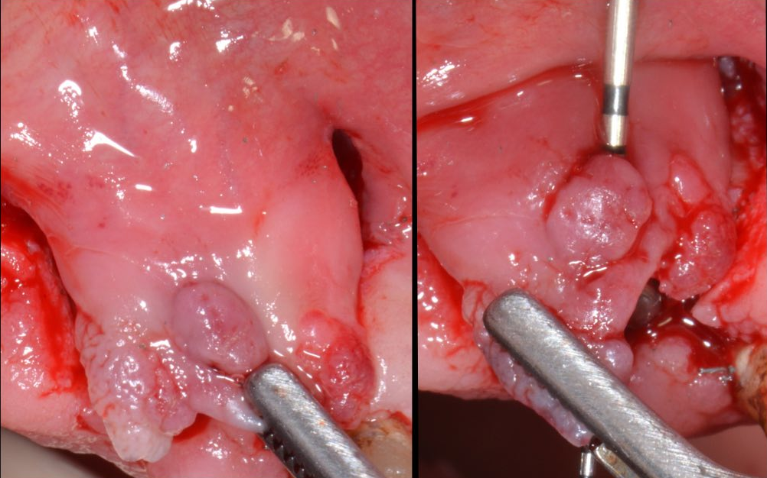
Coronally displacement of the flap; in this case note the presence of soft tissue fistula
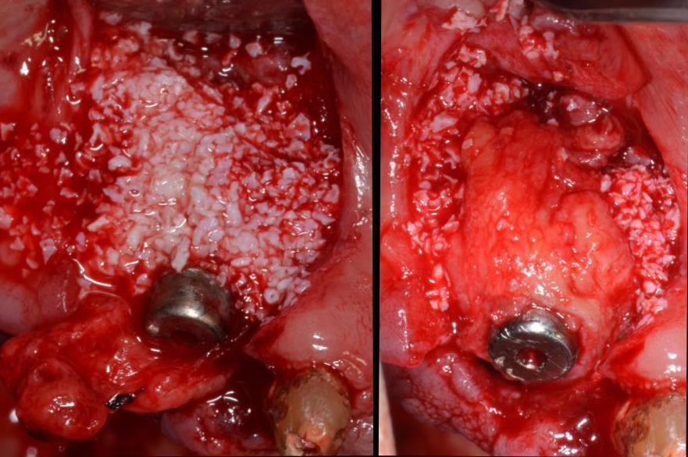
Deproteinized bovine bone graft placed in the defect and CTG placed around implant and upon bony graft, trimmed to hold implant neck.

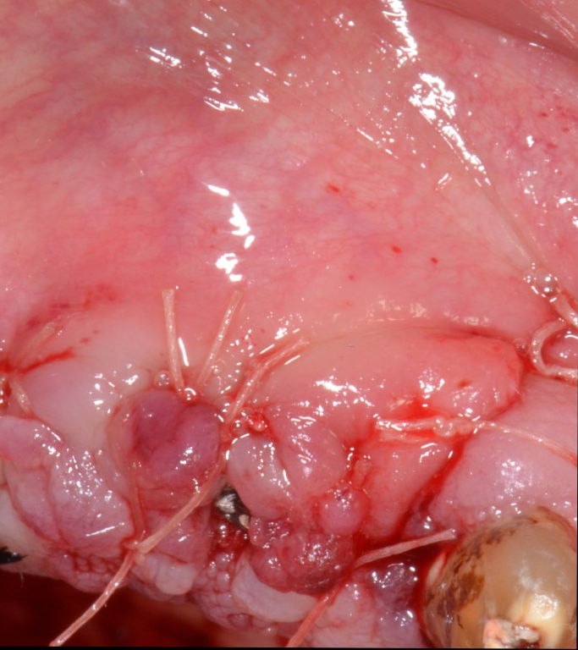
Coronally moved and sutured flap with 6-0 resorbable sutures.

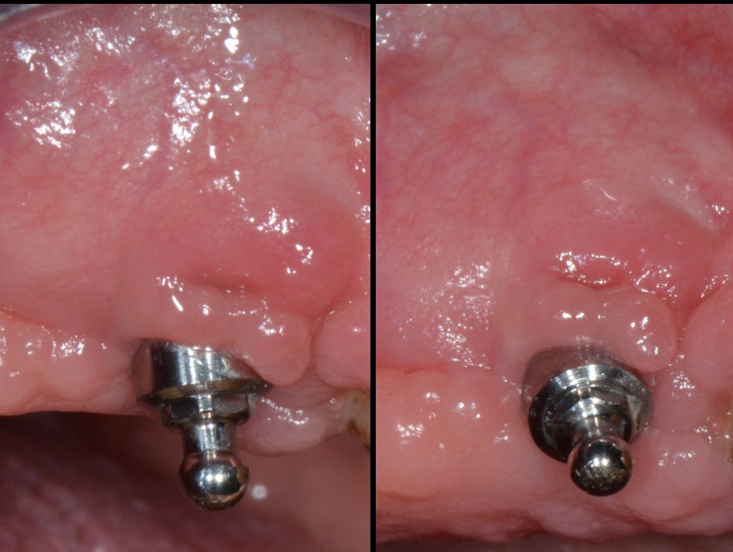
Clinical view after 1 year.

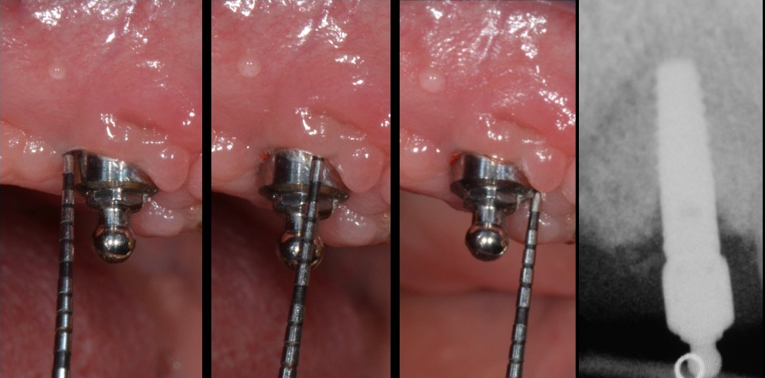
Clinical and radiographical parameters 1 year after surgery.
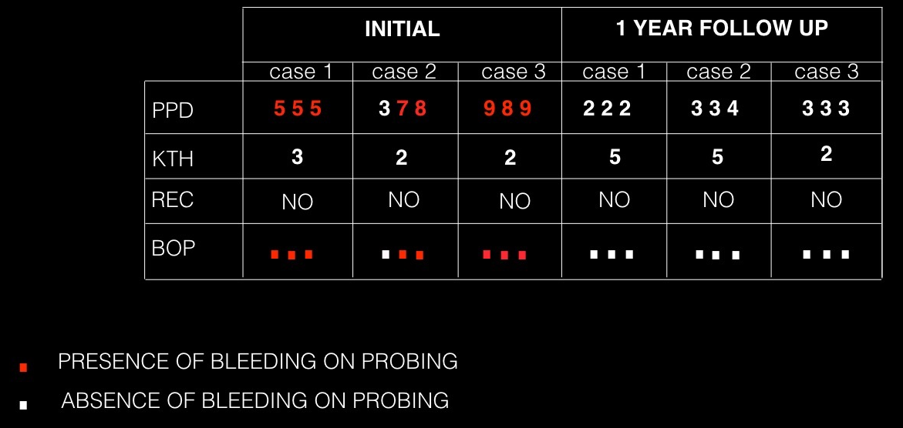
TAB. Clinical parameters before and after surgery at 1 year;
BIOGRAPHY

EUGENIO LONGO DDS,
PERIODONTST , IMPLANT AND ORAL SURGEON, WORK AND LIVE IN TUSCANY, WHEN COLLABORATE WITH PROFESSOR MASSIMO FROSECCHI ( UNIVERSITY OF GENOVA) IN DENATL CLINIC IN FLORENCE ( DENTAL MEDICINE FLORENCE).
GRADUATED AT UNIVERSITY OF SIENA IN NOVEMBER 2009, LIMITED PRIVATE PRACTICE ABOUT PERIODONTOLOGY, IMPLANTOLOGY AND ORAL SURGERY.
MEMBER OF ITALIAN SOCIETY OF PERIODONTOLOGY , ITALIAN ACADEMY OF OSTEOINTEGRATION AND ITALIAN ACADEMY OF ESTHETIC DENTISTRY.
FROM 2014 IS VISITING TUTOR AND SCIENTIFIC COORDINATOR OF AN IMPLANT AND MUCOGINGIVAL HANDS-ON COURSE IN BRAZIL , UNIVERSITY OF UNINOVE ( SAO PAULO).
RECENTLY BECAME A SPEAKER AND CHIEF IN MANY COURSES AND CONFERENCES ABOUT PERIODONTOLOGY , IMPLANTOLOGY AND ORAL SURGERY.

