Patients with cardiovascular pathology in the focus of the dentist
Dr. Aldo Vangjeli O.M.F Clinic, Regional Hospital Vlore
Dr.Renato Isufi O.M.F Clinic
Prof. Gafur Shtino QSU Tirane/ University Hospital Center Tirane
Abstract: It is the middle age and the third age patients that usually face Pathologies of different course such as Cardiac, Endocrine, neurological but not only, there are combined natured Pathologies which need more attention and more importance in treatment for the patients who need Dental Surgical Intervention. In this study, our attention is focused on the Pre-Treatment and Post-Treatment of the patients who suffer from a Cardiovascular Disease while prone to a Dental Surgical Intervention.
The purpose: To Specify, clarify and outline the codes and the regulations of interventions in this category of patients for the only purpose, that of getting the right treatment while in the Outpatient Ambulatory Clinics/Private Offices rather than in the Regional Hospital. Surely we have to assure the patients that the treatment offered is of the high level of Proficiency, meanwhile focusing on the reduction of the cost for the patient and for our Health Institutions.
In these days, the continuous changes in the life style we lead, the huge change we see in the quantity and the quality of the food we consume every day followed by the increase Longevity/Life Expectancy has made all of us aware of the high number of people that suffer from Cardiovascular Diseases.

It is not the assignment nor the purpose of our study to diagnose the pathologies of Cardiovascular nature in these patients, for this information is given in the patients’ charts by the family Doctor. A good doctor in the past history of clinical evaluation of the patient and of course after laboratory examinations can be found opposite undiagnosed cardiac pathologies. any patient ask for age, obesity should be assessed properly in the preparatory phase. It should be considered that at the time of presentation and visit patients over 45-50 years of age who have an indication as whether an intervention in the form of extraction should be treated with special care, and this for several reasons. Patients who are treated with blood thinner like aspirin or kardioaspirina are not inclined to show this in history, especially in cases when they are rejected by the first dentist where they are. They also try to keep secret any previous episode of hemorrhagic complexity.
Cardiovascular Pathologies more often encountered are:
- Valvular heart Diseases. Mitral valve stenosis and Stenosis of Aorta. Mitral valve stenosis refers to a condition in the heart in which one of the valve openings has become narrow and restricts the flow of blood from the upper left chamber (left atrium) to the lower left chamber (left ventricle). If the mitral valve is abnormally narrow, due to disease or birth defect, blood flow from the atrium to the ventricle is restricted. Both of the stenosis are almost always caused by rheumatic fever in early life and of idiopathic nature in rare cases. In 80 % of the patients followed up, there is a predisposition of the Mitral Valve Stenosis in female patients above 40 years old of age and a Predisposition of the Aorta Stenosis in male patients. The main treatment plan for these patients is the Anticoagulant medication.
- Atherosclerosis. This pathology is almost always responsible for the MI( Myocardial Infarct) and the CI (Cerebral Infarct), and it is considered the cause of the highest number of deaths in population. The term Atherosclerosis is used to describe the cause of coronary artery disease, in which the walls of the coronary arteries thicken due to the accumulation of plaque in the blood vessels. In our daily practice the risk factors are very important and need to be taken in consideration during the patients ‘case history and anamnesis. These risk factors are as listed:
- Hyperlipidemia.
- Diabetes Mellitus
- Obesity
- Smoking
- Arterial Hypertension
- Age
- Physical Inactivity.
- Cardiomyopathies are a group of chronic diseases of the heart muscle (myocardium of the ventricles), in which the muscle is abnormally enlarged, thickened, and/or stiffened.
Discussing the most often Heart Pathologies that we face in our daily office practices, we cannot avoid mentioning the patients suffering from “Insufficiencia Cardiaca”/Heart Failure. This is a physiopathology health state in which the heart for different reasons it is not able to fulfill its metabolic needs. This pathology should be easily diagnosed as such, by identifying its main physical sign, Cyanosis (bluish discoloration of the skin and mucous membranes).
Treatment of these patients begins with laboratory tests. Protombinës level is important and International Normalized Ratio (INR), which in patients with therapy is 25-30% and INR 1:50 to 4:50.
Thrombocytopenia which is manifested by reduction in platelet aggregation which leads to the appearance of spontaneous or hemorrhagic manifestations caused. Critical threshold is the level below 50 to 60.000. Because one of the clinical cases that will be presented below is with this pathology, we are trying to expand our gaze on this pathology. Platelets are cytoplasmic fragments in the form of round or oval discs with 2μm diameter. They are formed by fragmentation megakaryocytes cells of bone marrow. Platelets are of great importance in the process of stopping the bleeding when blood vessels are damaged. They participate in hemostasis processes, forming platelet thrombin at the site of damaged container. They also participate in blood clots by factors like FT3 or phospholipids membrane. The number of platelet is normally from 200,000 to 40,000 ML. Their average lifespan is 9-12 days. Their destruction is done in the reticuloendothelial system, mainly in the spleen. It is thought that their production is regulated by a negative feedback mechanism from some thrombopoietin produced in the spleen and promote platelet series of bone marrow. Increased platelet numbers called thrombocytosis and associated with increased blood clotting ability, and reducing their number is called thrombopenia and associated with reduced blood clotting ability. Hemostasis platelet action appears before Von Willebrand factor which is subunit of coagulation factor VIII.
The treatment plan for these patients begins with the interruption of Anticoagulant for around two days prior to the treatment, and the beginning of the Antibiotic therapy. The therapy is written by the dentist considering the patient’s health conditions. It is worth emphasizing that nowadays are introduced preparations such as Xarelto (rivaroxaban). The duration of treatment depends on the individual risk of venous thromboembolism. Major interventions treatment lasts 5 weeks while simpler interventions treatment lasts 2 weeks. When passed by vitamin K antagonists Xarelto INR values grow fictitious. During the transition from Xarelto to vitamin K antagonists the possibility of an inappropriate anticoagulant effect. Xarelto can contribute to increasing the INR. After termination of Xareltos reliability of INR values can be assessed only after 24 hours have elapsed from the last dose. After two days the laboratory re-examinations are required, and by our experience the threshold is above 35-45%, which allows us for the Surgical Intervention.
Symptoms displayed in such cases is this:
1- Gengival bleeding (bleeding in the mouth from the gingiva)
2- Scleral hemorrhage.
3- Epistasis. (Nosebleeds)
4- Rash (red spots)
5- Hematuria
6- Ecchymosis
7- Melena
8- Bruising
Materials and Method: For this study I have utilized and shared with you my personal experience extended in theory and practice in the surgical treatment plan of the patients with cardiovascular problems for a period of time approximately 15 years. I would like to mention my extended experience in the OMF Surgery Department and specifically the experience of Prof. Gafur Shtino and the experience of Prof. Ramazan Isufi. In this study we will present two clinical cases treated in the O.M.F Surgery Department.
Patient E.R 67 years of sex male presented to the emergency service with the diagnosis on admission: "Post-Extraction Hemorrhage of toth 28 '(Fig.nr. 1).
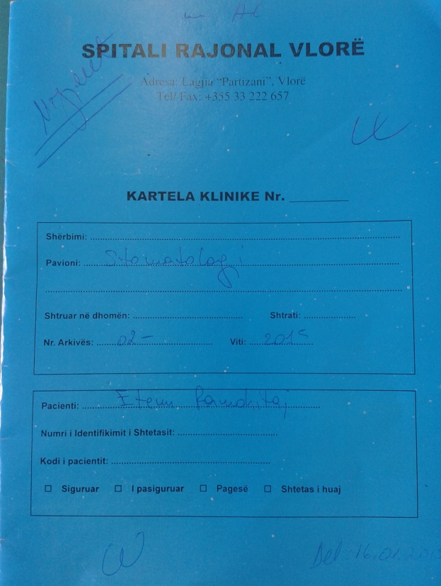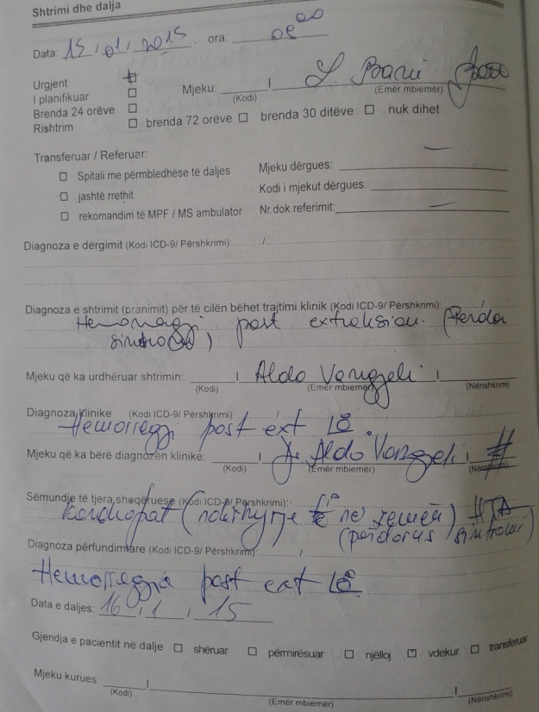
Fig. nr 1

According to the patient's past history he is a sintrom user and has undergone surgery on the heart. The claim of the patient was to perform extraction intervention itself. The patient presented in a few days from carrying out extraction with hemorrhage, weak, vertigo. In terms of emergency patient applied with two parallel systems perfusion in order to filling the vascular layer. It avails time for blood group and laboratory analysis of blood (fig.nr 2-3).
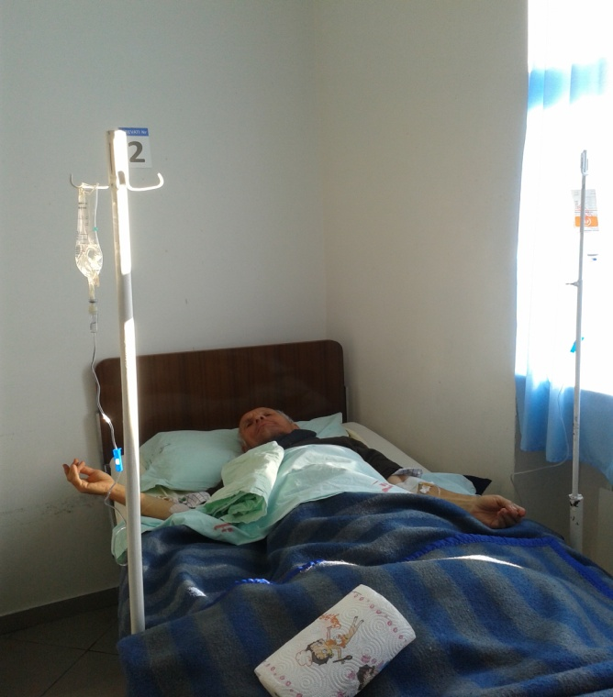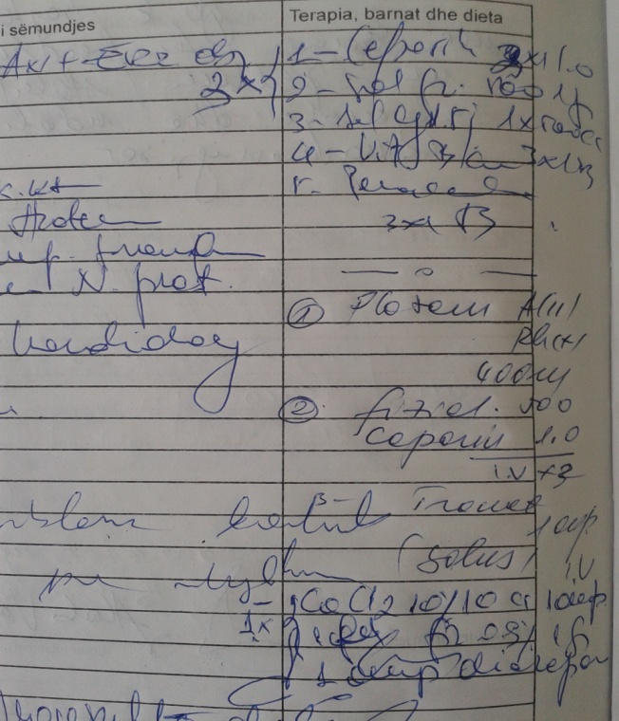
Fig. nr. 2
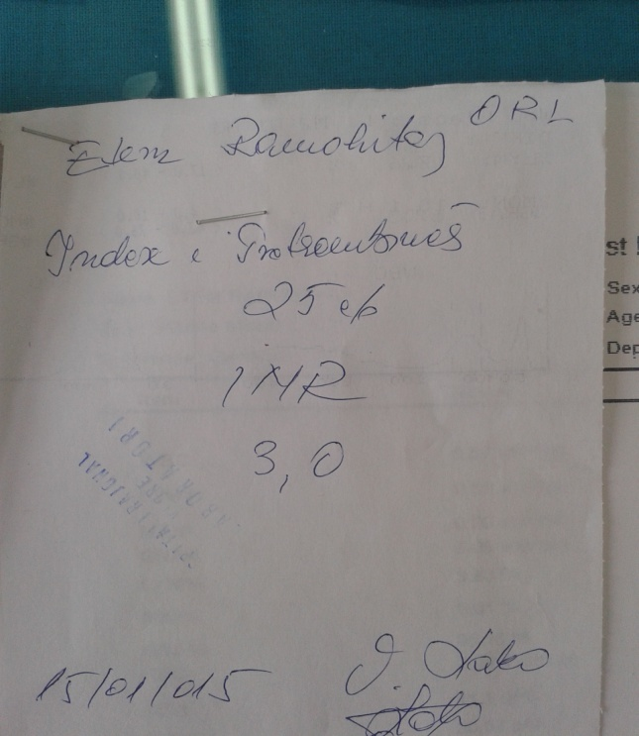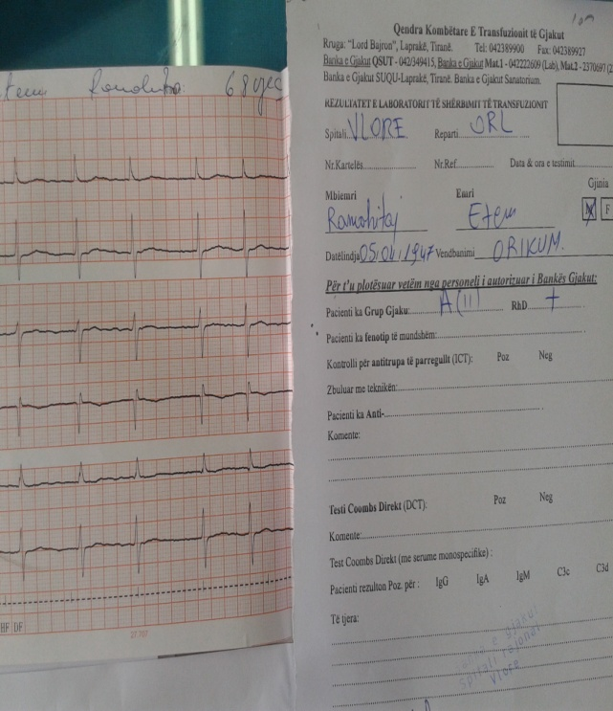
Fig. nr. 3 Analysis laboratory
After treatment with plasma A (II) Rh + patient started improving. After treatment with antibiotic therapy in the hospital the patient condition was stabilized by creating the opportunity to continue the cure in hospital.

Patient R.S female 62 years of treating cardiac surgery and treatment with anticoagulants presented in the clinic with the right mental concerns region panoramic x-rays gives this picture (fig.nr.4)
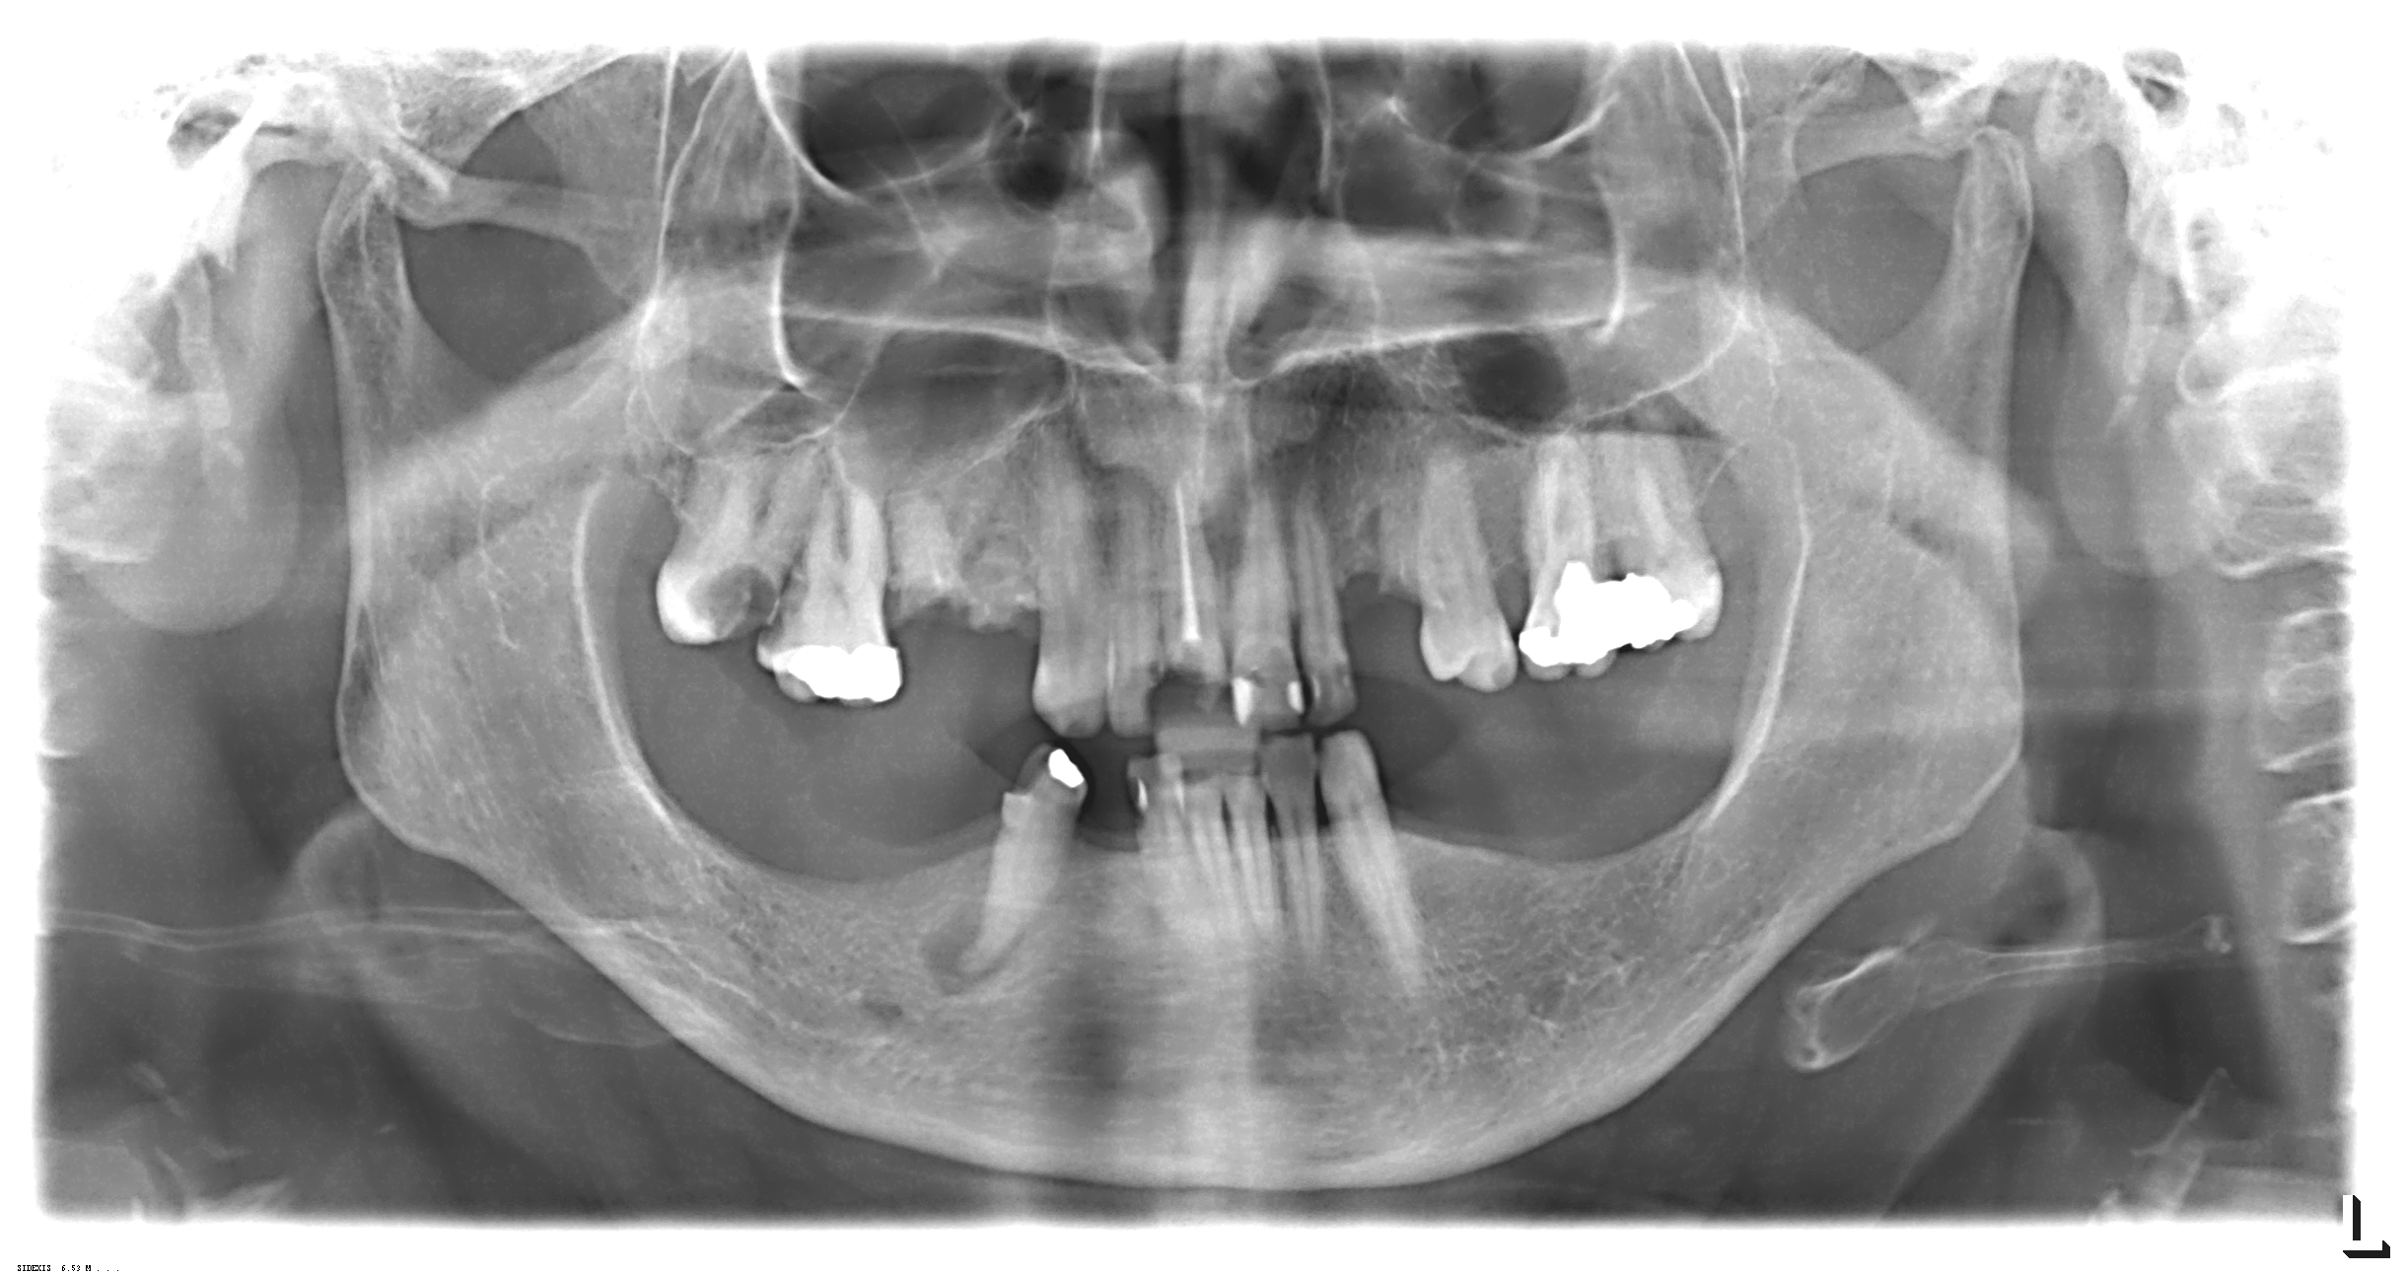
Fig. nr 4 Granulomatous pathology radiological appearance
In such circumstances the intervention recommended patient: 'Granuloma ectomia with extraction of 43.
A year after intervention control x-rays gives this picture (fig.nr.5).
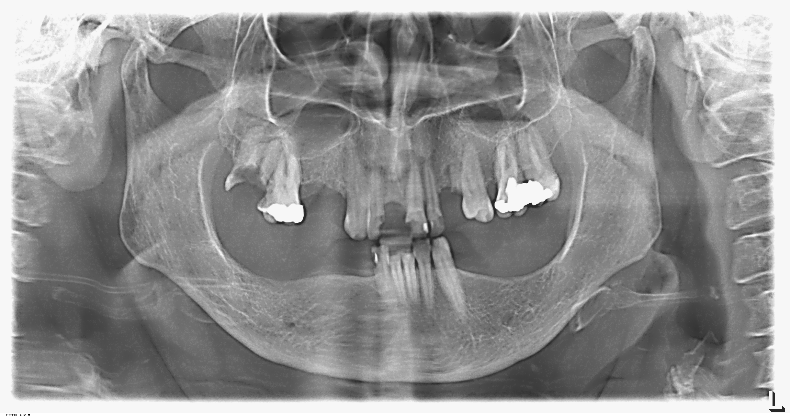
Figure No. 5 After 1 (one) year post intervention radiological view.
Since the patient would conduct ongoing extraction laboratory tests provide these data (fig.nr.6). In this case it was interrupted anticoagulant one day and the most recent laboratory tests showed these data (fig.nr.7). Viewing normalization of blood parameters was carried out extraction of 21.
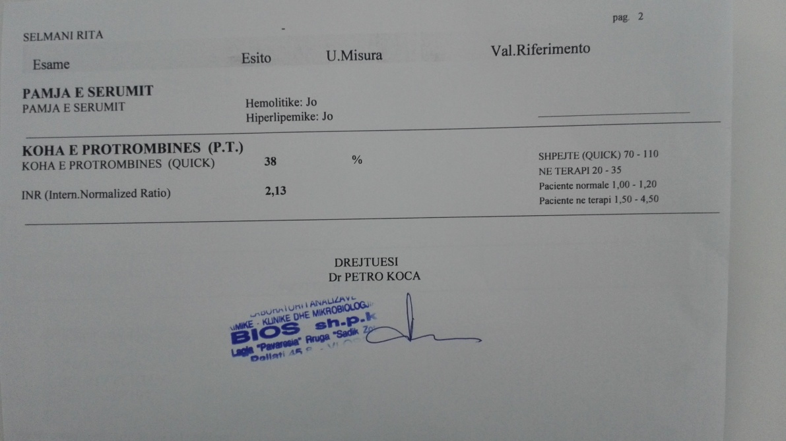
Fig. nr 6 Laboratory analysis
As seen patient without hemorrhage after kept in observation allowed to go further in order to follow-patient.
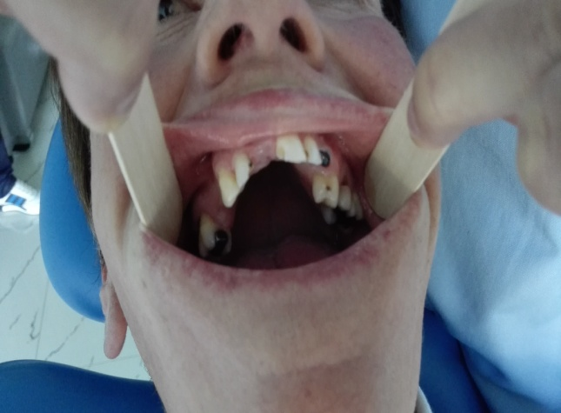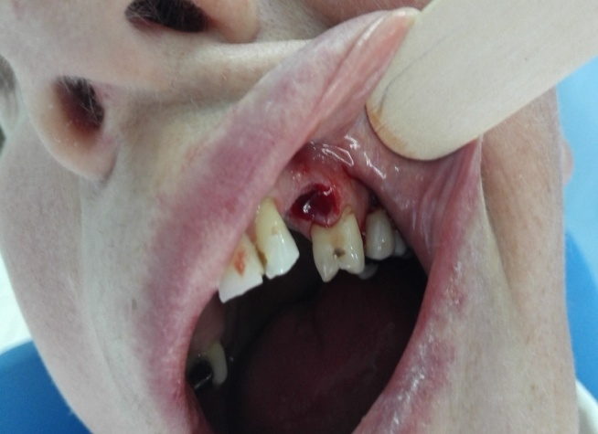
Fig.nr 7. Clinical view

Patient H.A 70 years with the diagnosis: 'acute coronary syndrome' (Fig.nr.8).
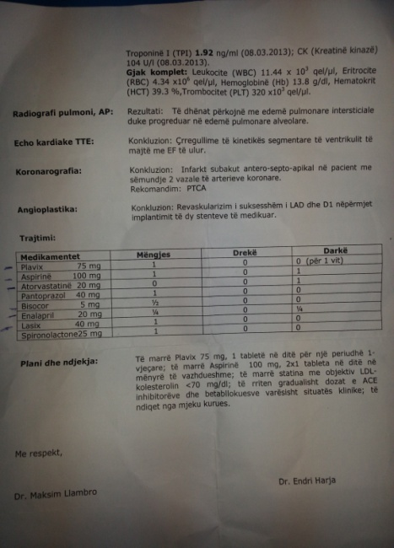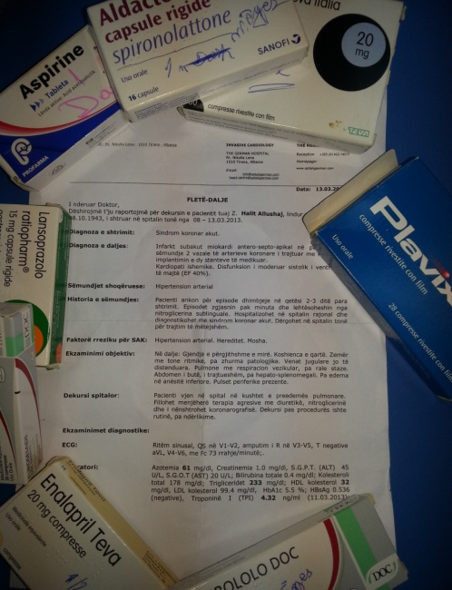
Fig nr. 8 View of epicrisis
The patient presented to the clinic with oral regioni problems. Panoramic x-rays gives such a picture (fig.nr.9)
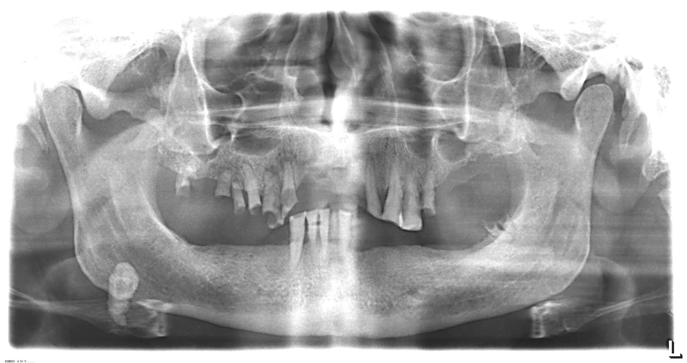
Fig. nr. 9 Orthopanoramic view

Prepared for extraction by stabilizing blood parameters (fig.nr.10)
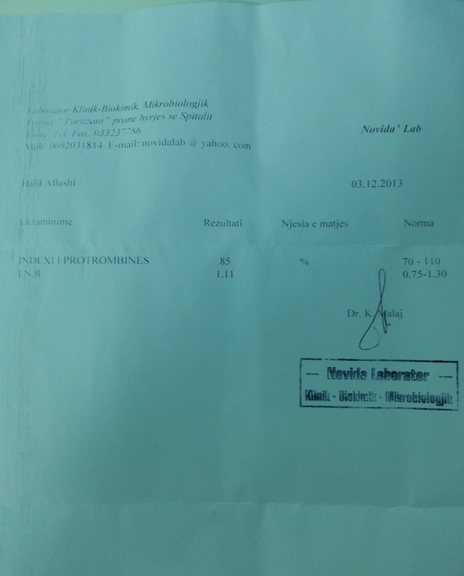
Fig. nr 10. Analysis laboratory
In hospital was performing some extractions. Quiet smoothly patient will be followed-patient hemorrhage (fig.nr.10)
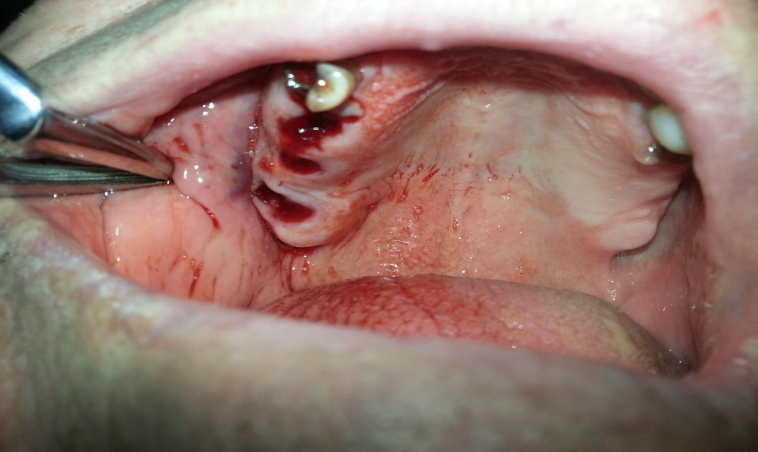
Fig. nr. 11 Clinical view after extraction

Conclusion: Patients with heart conditions should not be considered cases that cannot be treated in the ambulatory Services/Offices. Their treatment plan should follow a strict and documented paperwork to easily help the patient in his/her follow ups. Certainly, doctors should know their professional limits as to where their treatment plan will achieve success for these patients, avoiding any bad experience for the patients and the private office. The complicated dental pathologies, considered treatable in the private ambulatory offices, are a daily routine for every dentist. Even though these pathologies technically can be treated, the main obstacle remains the Time the diagnosis is found and the measures taken for the minimization and the “keeping it under the control” period of time. As for the patients with cardiovascular pathologies, our duty is to fully “Shape” the disease in its complete “Form”

Biography:
Prof.Isufi Ramazan “Kirurgjia OMF 2010”,
Prof.Vangjeli Sotir”Sëmundjet e aparatit kardiovaskular”2007
Prof. Shtino Gafur “Atlasi Kirurgjisë Maksilo-Faciale” 2011.
Carter LC et al”Surg ORAL MED ORAL PATHOL ORAL “1996
Curran AE MILLER EJ Oral surg oral med oral pathol 1997
Hirshberg A Oral path Med oral 1995
Ataoglu H., Uckan S., Oz G. and Altinors N. (2002) Maxillofacial hydatid cyst.Journal of Oral and MaxillofacialSurgery60, 454–456.
Peterson LJ et al : “Principles of oral and maxillofacial surgery “ Philadelphia 2002
Raymond J Fonseca “ Oral and maxillofacial surgery Vol I” Philadelphia 2000
Bruno de Michelis :”Trattato di clinica odonto stomatologica “ Edizione Minerva medica Torino 1992

