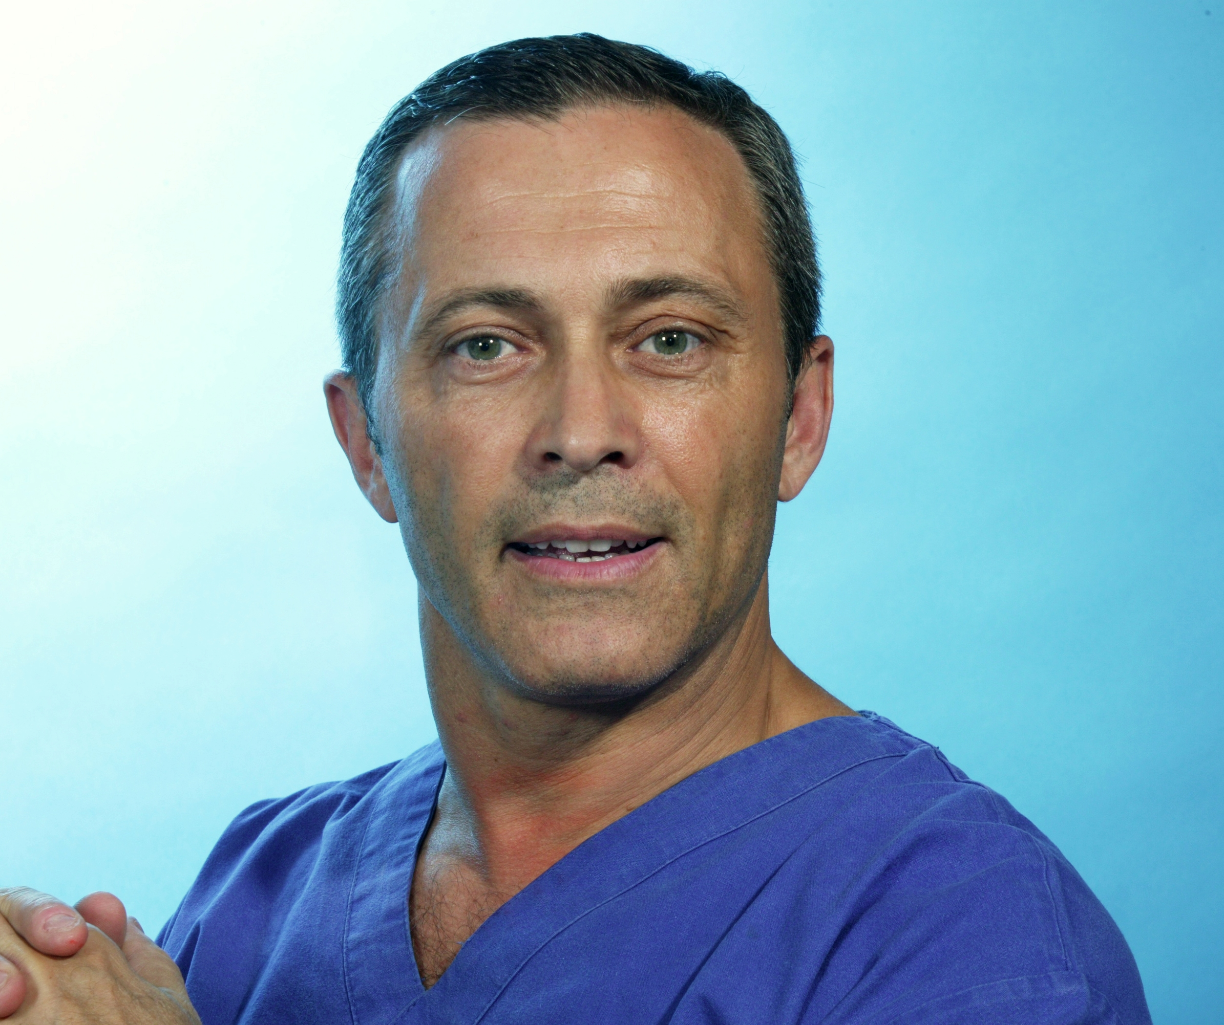

Title: Forensic Odontology for Human Rights Group

Name: Emilio Nuzzolese
Forensic Odontologist, Bari, Italy

After attending this presentation, attendees will be have a better understanding of the mission of this new international humanitarian group of volunteers called “Forensic Odontology for Human Rights”.
This presentation will impact the forensic science community by exploring the application of contemporary forensic odontology as an humanitarian tool to protect human rights.
The Forensic Odontology for Human Rights International Working Group was inaugurated on May the 5th 2015 at the Annual Interpol DVI Meeting in Lyon. The Group seeks forensic odontologists and oral health professionals with forensic background to promote forensic odontology and forensic science principles to caseworks with the purpose of preventing Human Rights violations through the application of best practice in human identification, age estimation and where dental evidence is involved.
This presentation will highlight the importance of dental evidence in criminal investigations and the importance of a multidisciplinary approach involving all the experts needed for the best outcome of the forensic analysis. Teeth and jaws can provide a tremendous amount of information in the field of disaster victim identification, missing and unidentified persons, child abuse and neglect, domestic violence and sexual abuse with bite mark evidence, age estimation of unaccompanied minors, border control and human trafficking. This underlines the importance of promoting international co-operation between experts, also on a volunteer basis.
Forensic Odontology for Human Rights Group members are volunteering for forensic casework, teaching and scientific research in odontology and dentistry applied to forensic sciences.
It should be clear to all those involved in the process of human identification that an incomplete post mortem assessment can lead to a delayed identification and represents a violation of human rights and international humanitarian law. Forensic Odontology can lead to a swift identification of nameless cadavers also providing evidence to the families which may be use in Court, as in cases of genocide and mass graves or after a terroristic attack.
In the year since constitution the number of members of Forensic Odontology for Human Rights has risen to 33 experts in Forensic Odontology from 14 different Countries: Australia, Brazil, Canada, Croatia, France, Hong Kong, Hungary, Israel, India, Italy, Saudi Arabia, Spain, Sweden, Thailand and the United States of America.
Given the low numbers of well-trained and experienced Odontologists around the world today and the risk of omitting odontological assessment where appropriate, Forensic Odontology for Human Rights can be utilized as a resource to prevent human rights violations by promoting routine involvement of odontologists and best practice in odontological assessments.

Biography
Contract Teacher in Forensic Dentistry at the Dental School of the University of Turin, since 2015. Graduated in dentistry at the University of Bari (Italy) in 1994. A post-graduate in Legal Medicine, Forensic Sciences and Forensic Odontology, holds a Research Doctorate degree on Analytic Morphometry. He presented over 80 papers in national and international forensic sciences meetings and has been invited speaker since 2006, in several congresses, among which the forensic dentistry session of the 2006 FDI World Dental Congress at Shenzen (Cina).
Lecturer for forensic odontology at the University of Catanzaro and Lecce (Italy), Expert witness in civil and penal Court for dental disputes and professional liability, Expert before the International Penal Court, participating odontologist in the Forensic Odontology Working Group within the Interpol DVI standing committee and President and Founder of the Civil Protection Association “Dental Team DVI Italia”.

Presenting author details
Full name: Emilio Nuzzolese
Contact number: +39 393 5225152
Twitter account: https://twitter.com/emilionuzzolese
Linked In account: https://it.linkedin.com/in/emilionuzzolese
Session name/number: Other
Category: Oral presentation

