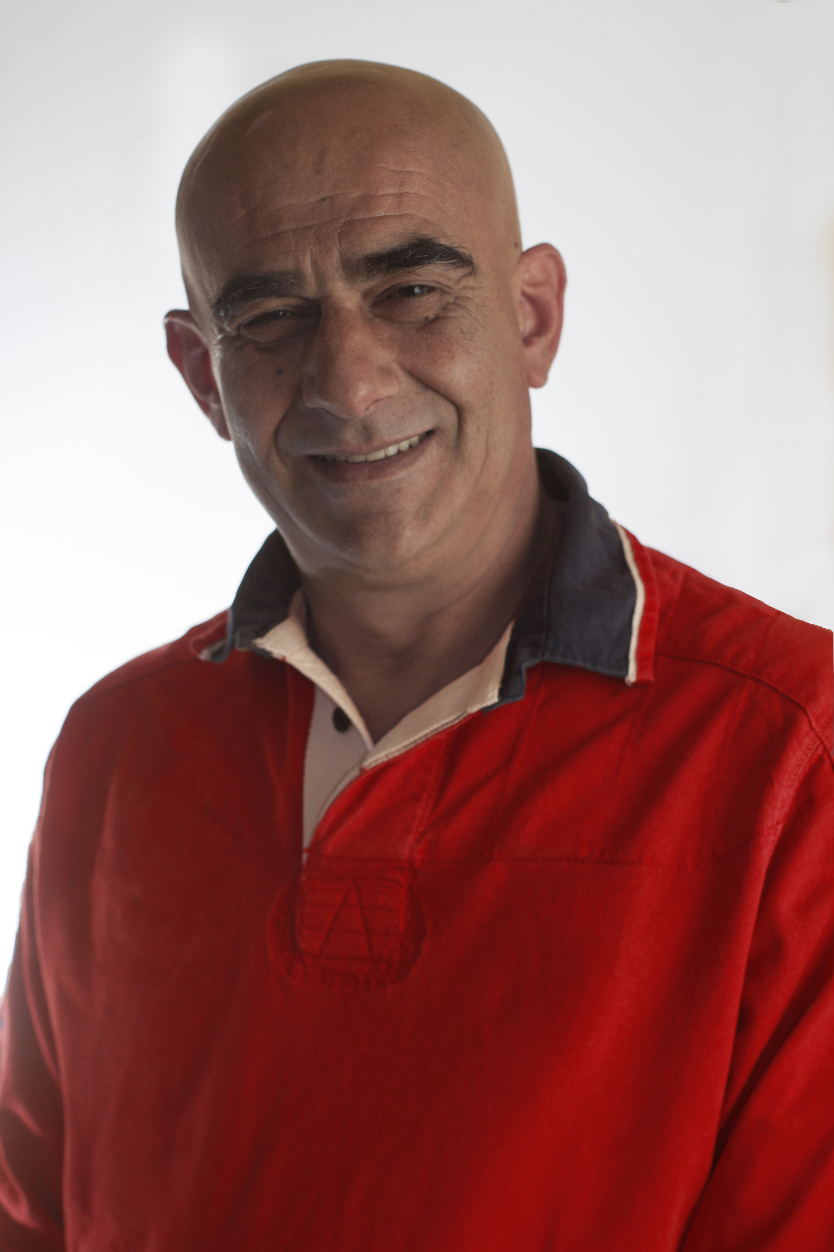
Name | George Pasias CDT
Title | Dental Technician
Contact | 81 Chiou str, 153 43, Ag. Paraskevi, Greece  +30 210 6001 329  pasias@pasiasdentallab.gr

Abstract
Lecture Title: Challenging Implant Supported Restorations - Cases
Description:
Implant restorations by now are an everyday choice for the restoration of missing teeth. But in many cases, the size, the implant positions, the soft and hard tissues deficit and a number of obstacles make those restorations difficult and challenging for both the clinician and the technician.
In this lecture I am presenting a variety of such cases and the methods I followed during their fabrication.

