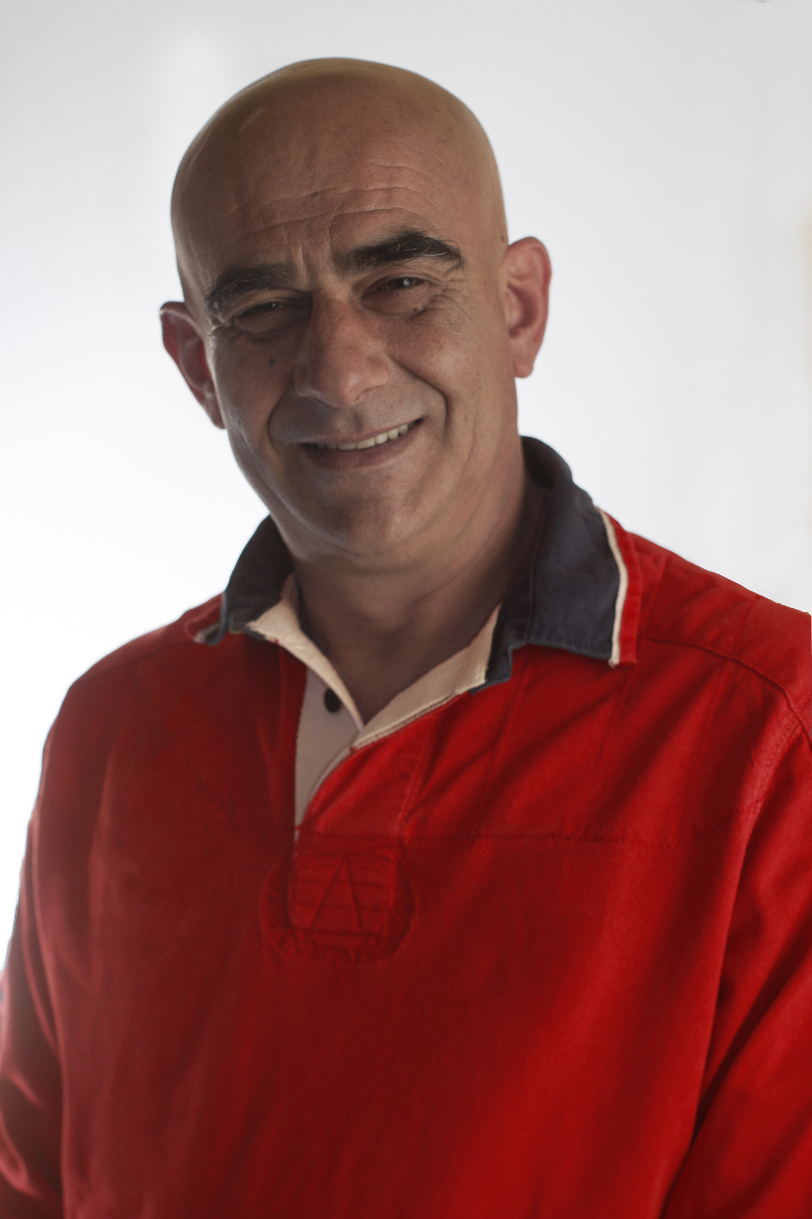
Name | George Pasias CDT
Title | Dental Technician
Contact | 81 Chiou str, 153 43, Ag. Paraskevi, Greece  +30 210 6001 329  pasias@pasiasdentallab.gr

Abstract
Lecture Title: Telescopic Restorations
Description:
The telescopic removable prosthesis are ideal when restoring periodontal teeth or teeth with unfavorable prognosis and optionally to link teeth with implants. There are also indications for implant-only supported restorations.
The clinical and technical aspects of the fabrication process of a telescopic restoration is unique and demands a different approach than more traditional restorations. The different preparation technique, the multiple fabrication steps and the technical sensitivity demands deep knowledge of the theory, experience and skill for a successful telescopic restoration.
In this lecture, we analyze the theory behind telescopic crowns and we present the fabrication process of three clinical cases.
The first case presents a restoration in the maxilla with a galvano removable prosthesis on an implant supported milled bar.
The second case presents a partial removable prosthesis in the mandible with combined support on soft tissue and on a friction-retained bar on 3 implants. (published on Journal of Prosthodontics Volume 22, Issue 6, pages 501–505, August 2013)
The last case is a restoration in the maxilla on seven teeth and two implants with seven primary crowns, two abutments, nine galvano crowns, a LASER sintered supra-structure with composite teeth and gingiva. Both the clinical and technical procedures are presented with video as a whole. A trailer is available on this link: https://www.youtube.com/watch?v=1uXQI7MxV2w

