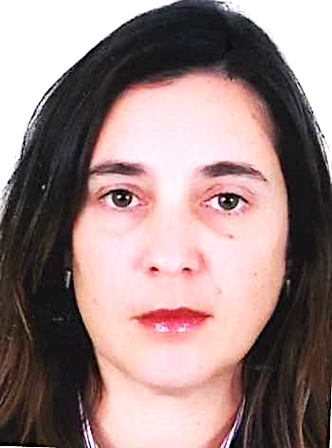
Title: Study of gingival health during orthodontic treatment

Name : Wiam RERHRHAYE*, Salwa REGRAGUI*
Faculty of Dental medecine, Mohammed V University of Rabat, Morocco.

AIM: The aim of this investigation is to evaluate the influence of orthodontic appliances, on the gingival health of the adult patients.
Material and methods: We keep 7 adult patients (average age = 22 years) wich are voluntary, and presenting a complete dentition, without periodontal diseases and careful to the hygiene instructions. 168 periodontal sites (24 sites by patient) constitute the study sample. Only one of the dental arches is supporting appliances (maxillar or mandibular, at random), the other arch is left as witness. The sites are distributed in 84 on applianced arch (A.A.) and 84 on control arch (C.A.). An initial preparation, are realized two weeks before starting the orthodontic treatment. The orthodontic treatment was starts in good gingival conditions when plaque and gingival indexes are near of 0. The orthodontic appliances that are constituted by stainless steel alloy are unchanged throughout 6 months. The same operator uses the method of Löe and Silness, the day of the orthodontic treatment starting (Jo) and after 1 month, 2 months, 4 months and 6 months. The statistics study of the results uses the test of Mac Nemar for matched series.
Results: After 6 months of orthodontic treatment, a plaque index = 3 is noted on an alone site. Of more a value = 2 is found on 11 sites (9 on A.A) for plaque index and 29 sites (20 on A.A) for gingival index. We can conclude that there is a weak modification of gingival health on applianced arch. The increasing of the average values of plaque or gingival indexes versus time seems related to the variation of oral hygiene efficiency, and this for both arches.
Conclusion: This study allowed the evaluation of the influence of orthodontic appliances on gingival health. The results of this study do not show any significant modification of gingival health on applianced arch opposing to the control arch.

Biography
Wiam RERHRHAYE is a Professor of Orthodontics in Faculty of Dental medecine, Mohammed V University of Rabat, Morocco. She is DDS and PhD. Shee is the director of Master of Biology and materials in environment. She has published several papers in reputed journals as author and Co-Author.
Presenting author details
Full name: Wiam RERHRHAYE
Contact number: 00212661400232
Twitter account:
Linked In account: wiam.rerhaye@yahoo.fr
Session name/ number:Orthodontics
Category: Oral presentation

