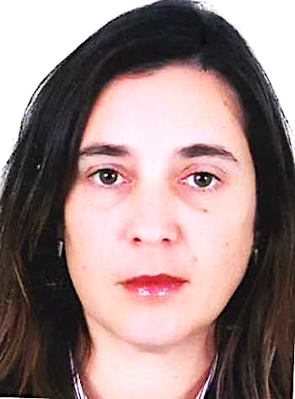
Title: Efficacy of clear aligners in controlling vertical tooth movement : A systematic review.

Name : Wiam RERHRHAYE*, Salwa REGRAGUI*
Faculty of Dental medecine, Mohammed V University of Rabat, Morocco.

Aim: To assess the scientific evidence related to the efficacy of clear aligner treatment (CAT) in controlling vertical tooth movement.
Materials and Methods: PubMed, Embase, Cochrane, Web of Knowledge and Scopus, were searched from January 2005 to June 2015 to identify all peer-reviewed articles potentially relevant to the review.
Results: Twelve relevant articles were selected (five prospective non-randomized, five retrospective non-randomized and two Randomized Clinical Trials). The amount of mean intrusion reported was 0.72 mm. Extrusion was the most difficult movement to control (30% of accuracy). All studies affirmed that attachments number and configuration improve efficiency of CAT.
Conclusions: CAT aligns and levels the arches; it is effective in controlling anterior intrusion but not anterior extrusion. However, the results of this review should be interpreted with caution because of the number, quality, and heterogeneity of the studies.

Biography
Wiam RERHRHAYE is a Professor of Orthodontics in Faculty of Dental medecine, Mohammed V University of Rabat, Morocco. She is DDS and PhD. Shee is the director of Master of Biology and materials in environment. She has published several papers in reputed journals as author and Co-Author.
Presenting author details
Full name: Wiam RERHRHAYE
Contact number: 00212661400232
Twitter account:
Linked In account: wiam.rerhaye@yahoo.fr
Session name/ number:Orthodontics
Category: Oral presentation

