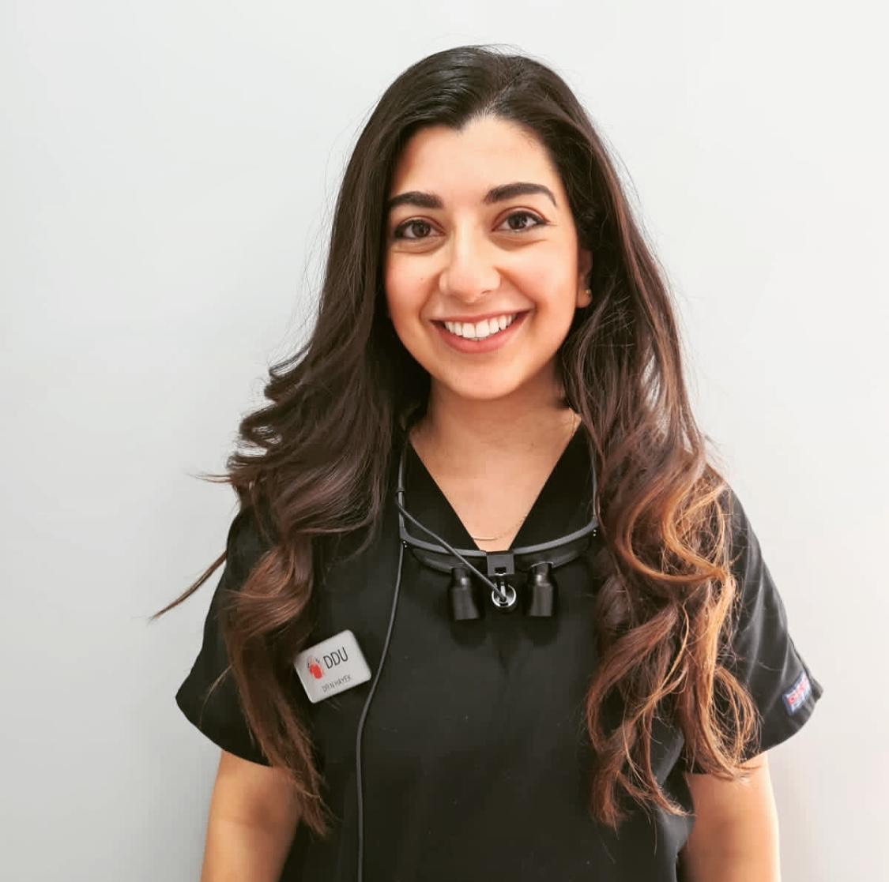
Title: A service evaluation to improve the confidence of patients in placing elastics following orthognathic surgery
Name: Nermin Hayek
King’s College London

Abstract:

- Objectives: The purpose of this quality improvement project is to review the confidence of patients in placing elastics following orthognathic surgery and to implement changes to improve their experience

- Materals and Methods: All orthognathic surgery completed from 1st September to December 2020 were identified and compiled in a datasheet. Each patient was contacted and a questionnaire was conducted to assess their confidence levels in placing elastics following their recent surgery.
- Results:
- The mean level of confidence was 6/10 (60%)
- The least confident score was 2 and the most confident score was 10
- Previous elastic use during orthodontic treatment increased their confidence

- Conclusion
There appeared to be a large variation of confidence levels amongst the cohort and the reason for this was multifactorial. Some claimed the pain and swelling following the surgery were limiting factors, whereas others found it hard to focus and retain information following the general anesthetic.
Interestingly, patients that had previously used elastics during their orthodontic treatment expressed higher confidence scores.
These factors identified could help the clinician be more aware of people at risk of showing less confidence in elastic placement.
The change of elastic routine varied across the patient cohort. More than half did not change their elastics between discharge and first review with an orthodontist.
Some recommendations were suggested, including the construction of a leaflet that describes how to place elastics and a demonstration to patients of how to place elastics before the surgery rather than after.
Biography

Nermin Hayek completed her Bachelor of Dental Surgery degree from King’s College London. She worked as a dental core trainee in the Oral and Maxillofacial Surgery deperatment in King’s College Hospital and is currently carrying out a dental core training year in Community Dental Services. She is focused on furthering her post graduate education by participating in post graduate training courses- particularly in the field of paediatric dentist and orthodontics.

Presenting author details
Full name: Nermin Hayek
Contact number: 00447568349053
Email address: hayeknermin@gmail.com
Category: Poster presentation

