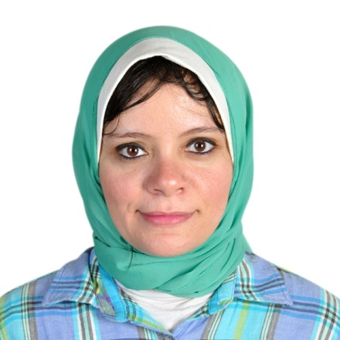
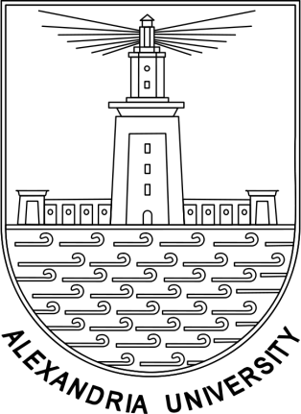
Management of skeletal class III in mixed dentition with rapid maxillary expansion and facemask therapy -Case report

Baraka M, B.D.S, M.Sc Pediatric Dentistry, Faculty of Dentistry, Alexandria University

Anterior cross bite, which is the negative horizontal overjet between the anterior teeth, occurs due to skeletal, functional, and/or dental irregularities. It is often found in mixed dentition stage and usually results in severe aesthetic, functional, and psychosocial impairment. In the current case reports facial and occlusal effects of maxillary protraction associated with rapid maxillary expansion in two young patients with mixed dentition. Other problems and minor irregularities of mixed dentition were also confronted in these two cases. The proposed treatment plan consisted of protraction and rapid maxillary expansion and correction of other minor irregularities found. The mechanical device chosen was the facial mask combined with a rapid palatal expander. The anterior cross bite was corrected, minor irregularities were corrected and significant facial and cephalometric benefits were obtained. The treatment of skeletal class III due to maxillary deficiency during the mixed dentition stage, in cases where there is good acceptance and compliance by patients and their parents, provides excellent clinical results and constitutes a valuable treatment option.
Keywords: Skeletal class III, maxillary protraction, face mask, rapid palatal expander, mixed dentition.

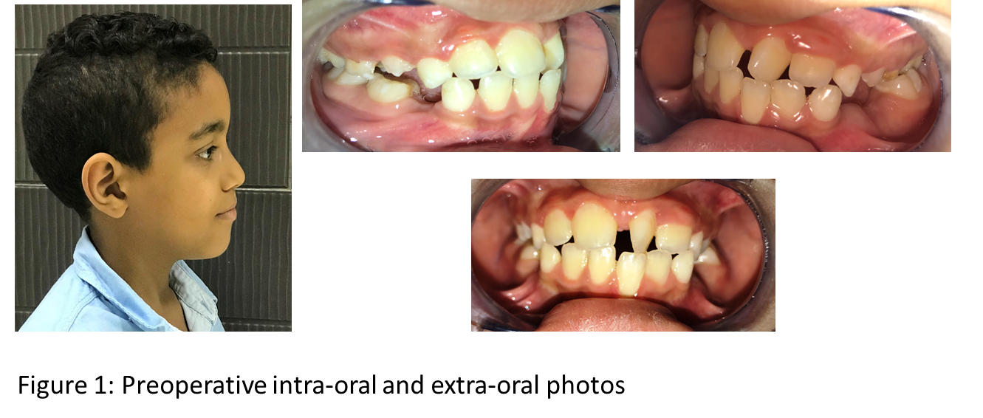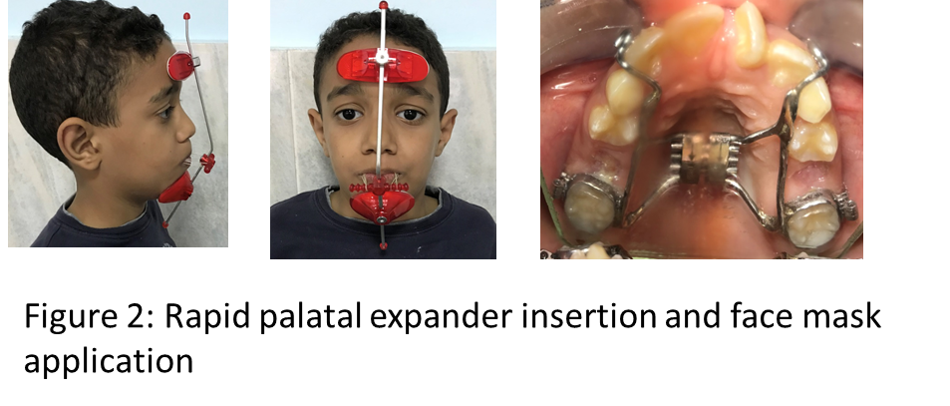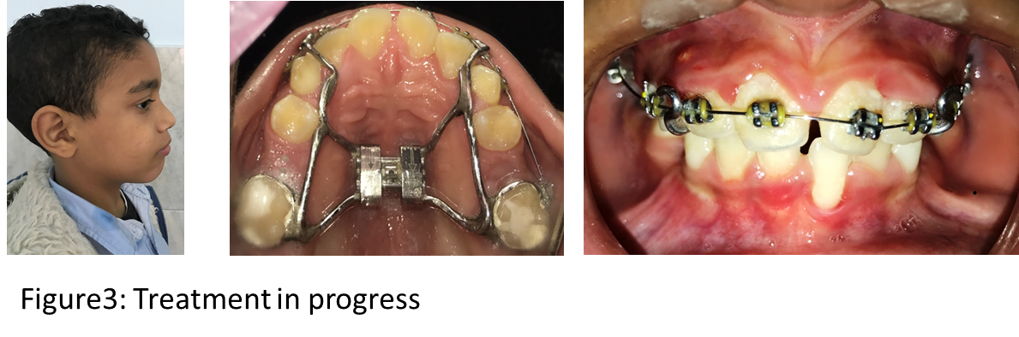

Recent Publications
- 2017: Baraka M, Hanno A, Bakry N S et al. Transverse Dental Arch Relationship and Occlusion in Surgically Repaired Unilateral Cleft Lip and Palate Egyptian Children. Med-Clin Res &amp; Rev.2017; 1 (2):1-7.
- 2017: E-poster entitled “ Assessment of Transverse Dental Arch Relationship and Occlusion in Surgically Repaired Unilateral Cleft Lip and Palate Egyptian Children” published in 25th Euro dentistry congress 2017 in Ireland
- 2016: An article entitled “Dental Arch Dimensions in Surgically repaired unilateral cleft lip and palate children” published in Alexandria Dental Journal.

Presenting author details:
Name: Marwa Mohamed Ahmed Lotfy Baraka.
B.D.S, Alex. Univ., 2010, M.Sc Pediatric Dentistry, 2015
Faculty of Dentistry
Alexandria University

Current occupation: Assistant lecturer at Faculty of Dentistry, Alexandria University, Egypt
Date and place of Birth: 24 th of February, 1987. Alexandria, Egypt
Current Address: 21, Saint Gini Kafr Abdo, Roshdy, Alexandria, Egypt
Work Address: Champolion Street, Faculty of Dentistry, Alexandria University, Egypt
Email: marwa.baraka87@gmail.com
Cell Phone No.: (+203) 01000804757

