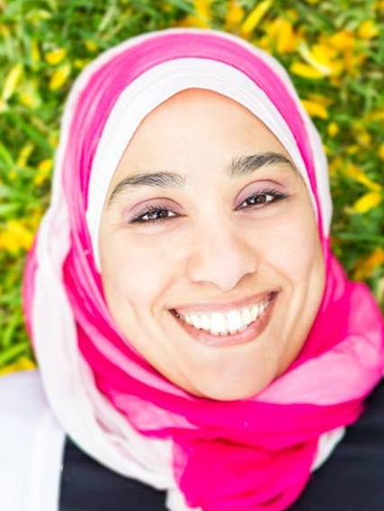
Title: Influence of glycerol on alkaline tolerance and biofilm viability of Enterococcus faecalis
Name: Amira Salem, Peter Cathro, and Geoffrey Tompkins
Sir John Walsh Research Institute, College of Dentistry, Otago University, New Zealand

Enterococcus faecalis is often isolated from root canals following treatment failure. This study examined the involvement of glycerol metabolism in its alkaline tolerance and biofilm viability by comparing a mutant (∆Ers “Enterococcal regulator of survival”), in which Glycerol facilitator membrane protein “GlpF” was down-regulated, to the wild type and an Ers-complimented strain.
Growth of E. faecalis JH2-2 in (TSB) without dextrose supplemented with either glucose or glycerol (0.055 M) adjusted to pH 8 and pH 11 was monitored spectrophotometrically (A600) at 37°C for 28 hours. E. faecalis biofilms were developed in microtiter plates in similar medium at pH 8 for two days. The medium was renewed with either pH 8 or pH 11 for another two days. The viability of the biofilm was determined by the alamar blue fluorescence assay.
In TSB-glucose at pH 8 there was no difference in growth between the ∆Ers mutant and the wild-type. However, at pH 11, the lag phase of ∆Ers was extended by 2 hours. In contrast, in TSB-glycerol media there was slower growth of the ∆Ers strain at high pH compared to the wild type, but no difference at pH 8.
TSB with glycerol, at either pH, greatly promoted biofilm viability of the wild-type compared to glucose, but viability of ∆Ers biofilm was reduced when grown in glycerol at either pH. Complementation of the mutant restored the wild-type biofilm viability.
In conclusion, Ers regulator functions in the alkaline tolerance and biofilm viability of E. faecalis possibly through the down-regulation of GlpF.

Biography
Amira Salem is a PhD student and the PhD students representative in Sir John Walsh Research Institute, College of Dentistry, Otago University. She finished her master degree in Endodontics, Conservative Dentistry and Fixed prosthodontics from Faculty of Dentistry, Alexandria University, Egypt in 2010. She was a former Lecturer of Endodontics in College of Dentistry, Qassim University, Saudi Arabia from 2011 till 2015.
Presenting author details
Full name: Amira Samir Ahmed Ibrahim Salem
Contact number: 0064226307060
Linked In account: https://nz.linkedin.com/in/amira-salem-28325540
E-mail: amira.salem@otago.ac.nz
Session name/ number: Endodontics/8
Category: (Poster presentation)

