ANTIMICROPEPTIDE LL-37 AND VITAMIN D PLAYS A VITAL ROLE IN ORAL HEALTH
DR.NIREEKSHA, M.D.S,INDIA

Abstract (300 word limit)
Oral diseases are among the most prevalent diseases globally and have serious health and economic burdens, greatly reducing quality of life for those affected. The most prevalent and consequential oral diseases globally are dental caries [The Lancet, 2020.] The untreated dental caries in permanent teeth is responsible for various outcomes like severe pain,malocclusion,abscess and tooth loss. But individuals with similar exposure of dietary food,cariogenic bacteria and other environmental risk factors may be less likely or more likely to be affected by caries. The underlying individual susceptibility to caries occurrence even when individuals were exposed to fluorides the necessity to look at underlying genetic players contributing to dental occurrence and prevalence. This defines the term host susceptibility ,the attempt to understand various genetic factors uplifts the ability of clinicians to explain the role of genetic and inherited risk factors. Vitamin D is identified as a risk factor due to its association with dental caries occurrence and prevalence. This metabolite plays a key role in different avenues in oral cavity a) Tooth mineralisation b) Anti-bacterial affect through the release of antimicrobial peptides c) effect of ameloblasts and odontoblasts i.e., formation of enamel and dentin through signalling pathways. The antibacterial role is mainly achieved through LL-37(CATHELICIDINS) via TLR2/1- VITAMIN D CATHELICIDINS(LL-37) PATHWAY .It is a human antimicrobial protein of 18kDa, only known member of cathelicidins in human. They possess antimicrobial, antibacterial, also disrupts pathogen membrane and facilitates wound healing through epidermal growth factors. Also enhances production of immunoglobulin's, decreases apoptosis of cells, chemotactic and cytokine release activity. The polymorphism in the Vitamin D receptor element (VDRE) effects the activation of LL-37.Therefore vitamin D and antimicrobial peptides play a vital role in providing protection against inflammation and bacteria's in the oral cavity.

Image
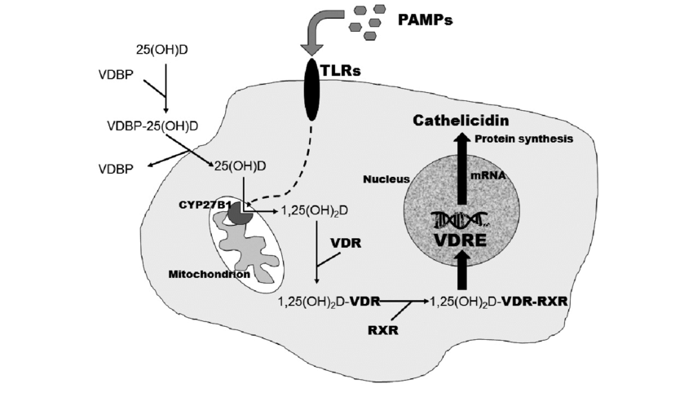TLR2/1- VITAMIN D CATHELICIDINS(LL-37) PATHWAY
Recent Publications (minimum 5)
- Immunomodulatory Expression of Cathelicidins Peptides in Pulp Inflammation and Regeneration: An Update. Curr. Issues Mol. Biol. 2021, 43, 116–126. https://doi.org/ 10.3390/cimb43010010
- Antimicrobial peptide cathelicidin and vitamin D receptor gee polymorphism in oral health. Indian journal of Forensic medicine and Toxicology.15(4)Oct 2021.
- Fatty Acids and Oral Health: A Review Research Journal of Pharmaceutical and Chemical Sciences Issn No: 0975-8585 May –June 2018, 9(3) Page No.1080-1083.
- Salivary selenium levels in Dental caries. Indian journal of public health research and development. Vol 11.No.2,feb 2020.
- Salivary proteins as biomarkers in dental caries: in vivo study. Dental, oral and craniofacial research, Dent Oral Craniofacial Res,Volume 3(2): 1-7
- Saliva as a biomarker of heat shock protein in chronic renal disease. J interdiscipl med dent sci 4:195. Doi: 10.4172/2376- 032x.1000195.

 Biography (150 word limit)
Dr. Nireeksha, currently assistant professor in Department of conservative dentistry and Endodontics,A.B.Shetty memorial institute of dental sciences ,Nitte(deemed to be) University, perceiving her PhD and owns a clinical practice. Received Budding research scholar award,2018 from Indian association of radiation biology and has grants from state government(VGST) .The area of interest in research primarily adheres to saliva research and its association with various oral health conditions.
Email: drnireeksha@nitte.edu.in

Notes/Comments:

