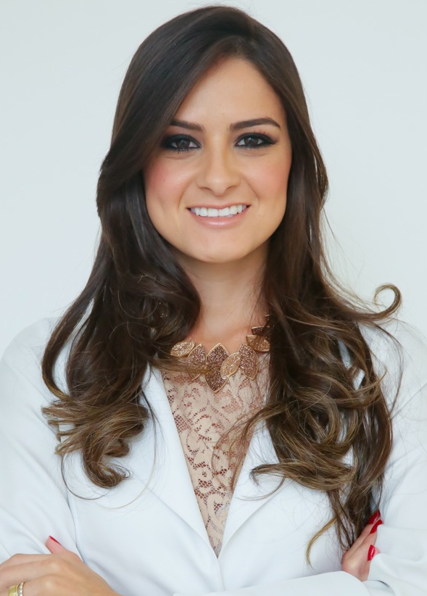

Title: Digital workflow for multidisciplinary diagnosis and dental treatment plan
Name: Isabelle Machado de Holanda
Universidade de São Paulo, São Paulo, Brazil

Conventional dental approach techniques based on just visual and clinical examinations are limited for evaluating patients in a conclusive manner. Dentistry has seen intensive improvements and advanced at full steam from the traditional techniques to the digital world that has widened the scope of dental treatments and procedures. The clinician must listen to the patient and establish realistic treatment objectives based on the patient’s needs and expectations. The interaction between patient and dental specialist, beyond conventional dentistry, must be improved by photos, videos and modern radiology, including two-dimensional and three-dimensional images.
During the treatment planning phase, the dental practitioner must apply a modern appointment protocol based upon the analysis of the patients facial and dental proportions, utilizing predetermined series of high quality digital photographs and videos, intra-oral images and also digital radiology to understand the relationship between teeth, gingiva, bones, lips, smile with the facial features in motion and with emotion. The objective is to result in a clear, accurately and optimized diagnosis, an attractive and understandable treatment presentation for patients. Furthermore, the protocol provides complete documentation of each case.
This article presents a systematic approach for dental multidisciplinary treatment plan for diagnosis, communication, execution, and case maintenance using tools for communication and coordination among the operators to achieve a satisfying multidisciplinary treatment result.
Biography

Isabelle de Holanda has completed her Master of Science studies from Universidade de São Paulo and her Orthodontics advanced specialty training from Brazilian Dentistry Association. She was invited by Dr Stanley Malamed to take the IV Sedation Course as an international guest at the University of Southern California, (USC). Also, has completed with awards the Oral and Maxillofacial Surgery Externship Program at Indiana University (IUPUI) in 2010.

Nowadays, she is a Dental Consultant in the Department of Dental Care at a Health Insurance Company in Brazil working principally with diagnosis and multidisciplinary treatment plan. She has been presenting in both national and international meetings.
Presenting author details
Full name: Isabelle Nathacha O. Machado de Holanda
Contact number: +55 11 98231 6369
Instagram account: @isabelledeholanda
Linked In account: Isabelle Machado de Holanda
Session name/ number: Dental Practice and Marketing
Category: Oral presentation

