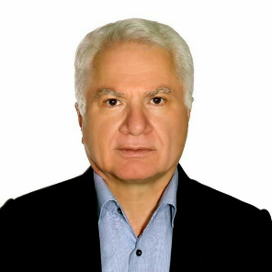

Title:Radiographic feature of Metastatic adenocarcinoma in mandible : a case report
Name: mir majid nabavi
Introduction:
metastatic lesions in the jaws usually arise from sites that are anatomically inferior to the clavicle. Jaw involvement accounts for fewer than 1% of metastatic malignancies found elsewhere, with most affecting the spine, pelvis, skull, ribs, and humerus. Nearly 90% of metastatic tumors occur in jawbones especially premolar-molar region of the mandible.
Case report
A 50-year-old man referred to us with a complaint of anesthesia and swelling in the mandibular right region over the past one month. Radiological investigations revealed a moderately well-demarcated lesion but there was not any corticated border at margins of the tumor. The history of the patient showed that the first molar should be extracted in 2014, however, the patient did not go for treatment, and after three years, in 2018, there was a huge lesion in that region. After extracting molar teeth, the lesion was sent to a laboratory. The Histopathological analysis revealed a Metastatic adenocarcinoma.
Discussion
In malignancy, when a lesion begins within the periodontal ligament space of a tooth, the appearance may be identical to that of a periapical inflammatory lesion. A point of differentiation is that the periodontal ligament space widening from inflammation is at its greatest width and centered about the apex of the root. In contrast, the malignant tumor usually causes irregular widening, which may extend up the side of the root. The prognosis of a metastatic tumor in the jaw is poor, and in most cases, the patient will die within one or two years.
Biography

Dr.Mir Majid Nabavi has completed his DDS at the age of 26 years from school of dentistry, Shahid Beheshti University of Medical Sciences, Tehran, Iran. Since that time he works as a dentist in Tehran.
Presenting author details
Full name: Mir Majid Nabavi
Contact number: +98 912 524 6473
Email: dr.majid.nabavi@gmail.com
Category: Oral presentation

Appendix
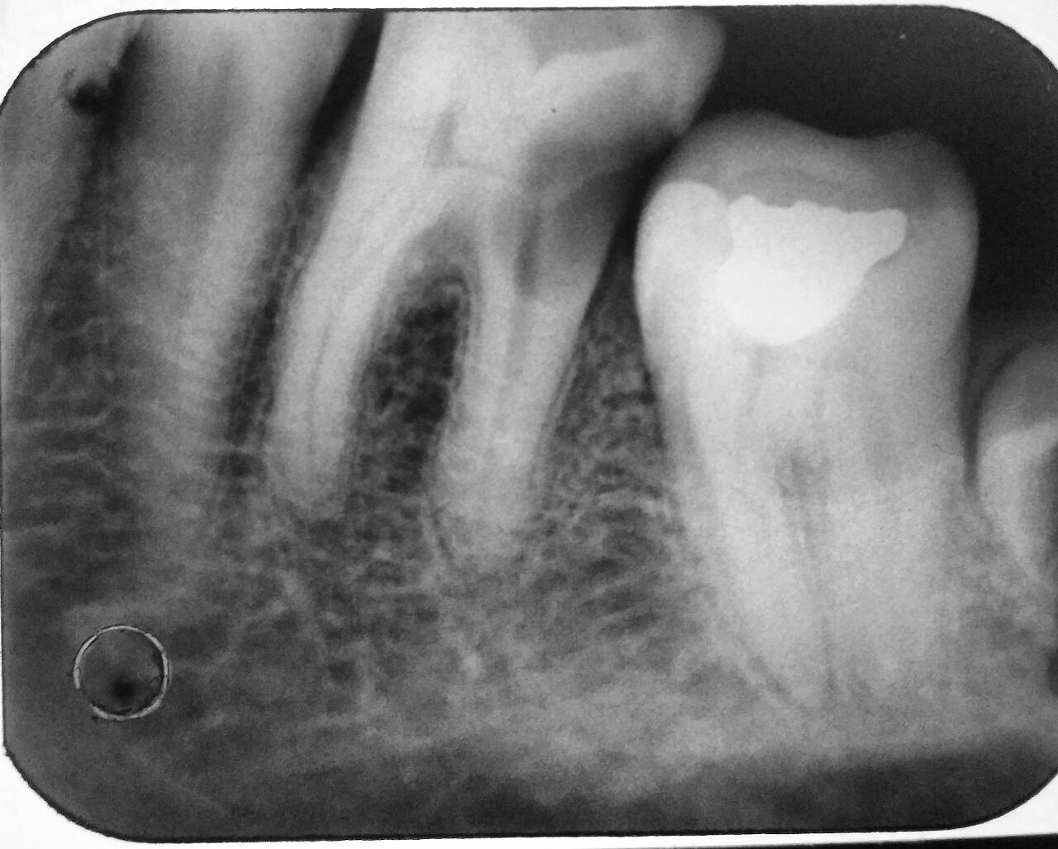
Periapical radiograph of the left first mandible tooth in 2014

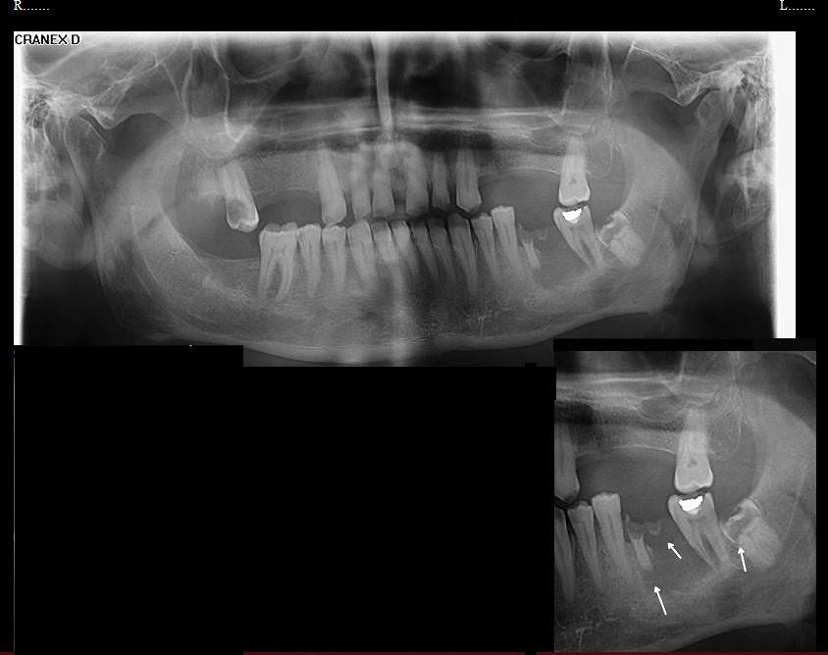
Panoramic radiograph in 2018

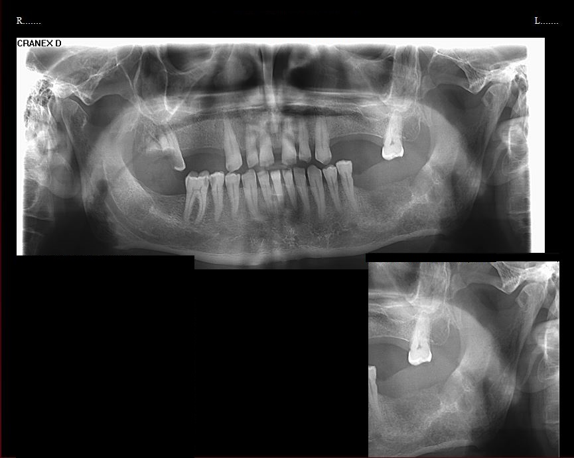
Panoramic radiograph after extracting molar teeth

