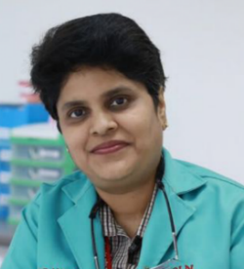

Title: Adjunctive Diagnostic Techniques as Screening Tools for Oral Premalignant and Malignant Conditions
Dr Anitha Krishnan Pandarathodiyil
BDS, MDS (Oral Pathology), MSc (Exptl Oral Pathology, UK)
Faculty of Dentistry, SEGi University & Colleges, Malaysia
Affiliate Member of the Royal College of Pathologists, UK

Abstract

It is one of the major objectives of the WHO to reduce the burden of oral cancer globally by identifying prevention and early detection of oral cancer. Visual examination of the mouth is still largely used for screening of oral premalignant and malignant lesions. However, simple visual examination has its limitations in rare occurrences when dysplasias or early oral squamous cell carcinomas occur in normal-looking oral mucosa. To assist in these situations adjunctive techniques have been developed and suggested to increase our ability to differentiate between benign and malignant oral lesions. Some of these techniques are the usage of tissue autofluorescence, toluidine blue, brush biopsy and chemiluminescence. This guest lecture will focus on these adjunctive techniques with a note on their advantages and disadvantages.

About the Speaker:
Dr Anitha Krishnan Pandarathodiyil has done her Masters in Oral Pathology and has worked as a senior lecturer in Oral Pathology in several dental colleges in India, Saudi Arabia, and Malaysia. She pursued her second Master’s degree in Experimental Oral Pathology from Queen Mary University of London. She is actively involved in scientific research and her field of interest is early detection of oral premalignant and malignant conditions. She has published many scientific articles in reputed journals and is the principal investigator of many ongoing research projects.
Presenting author details
Full name: Dr Anitha Krishnan Pandarathodiyil
Contact number: 0060129705012
Category: Oral presentation

