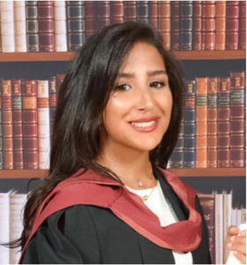

Title: Development of the Role of Dental Core Trainee Representative and Representative Network in the Midlands and East of England

Authors:
Dr Maha Aljefri BDS MFDS RCS (Edin) - Dental Core Trainee at Alder Hey Children’s Hospital, East Prescot Road, Liverpool, L14 5AB, UK (presenter)

Dr Neha Thakerar BDS MFDS RCSP (Glas) – Dental Core Trainee
Dr Bipandeep Dev BChD MJDF RCS (Eng) – General Dental Prectitioner
Dr Kasim Butt BDS (Dist) MJDF RCS (Eng) PgCert (Dent Ed) – StR in Restorative Dentistry

Abstract:
Introduction:
A project was initiated by the deanery for dental core trainee regional representatives to develop the representative role and network across the East and West Midlands and the East of England. Prior to this initiative, the methods for obtaining feedback from trainees varied across training posts in the three regions, with ambiguity regarding the pathway for escalating trainee matters.

Aims:
Development of the trainee representative network across three regions for voicing trainee concerns, improving the quality of feedback received and implementing changes to enhance trainee experiences.

Methods:
A framework was developed by the three regional representatives in 2019 focusing on early appointment of representatives and specifying a timeline for feedback submission. To gather high quality feedback, standardised forms were constructed to be completed twice yearly by trainees. The distribution and volume of received feedback was audited prior to, and after development of the framework to measure its success and implement necessary adjustments. This framework lead to an increase in feedback response rates from 38.9% to 89.9% from 2019 to 2020 across 18 hospitals in three regions.

Conclusion:
This pathway is designed for escalation of trainee concerns with representatives acting as sensible, informed and supportive peers to those who may be having issues during training. It promotes communication at an early stage of training and fosters positive relationships between trainees, supervisors, programme directors and the deanery. Most importantly, it reveals excellent response rates and displays how an effective trainee representative model can be used to improve training experiences.

Biography
Maha Aljefri is a young dentist and a Dental Core Trainee 2 in oral and maxillofacial surgery at Alder Hey Children’s Hospital in Liverpool. She previously acted as the regional trainee representative for the East Midlands Deanery during her time at Northampton General Hospital. She is aspiring to pursue a career in orthodontics and woking towards obtaining her post graduate certificate in clinical education.

Presenting author details
Full name: Dr Maha Aljefri
Contact number: 0044 (0) 7531 002022
Session name/ number: unknown
Category: Oral presentation

