
Title: Plaque removal efficiency of a multi-surface novel power toothbrush: a clinical study

Name: Mingjie Wang, Jing Zhao, Ruipeng Zhang, Yuelian Liu, Yuanna Zheng
Zhejiang Chinese Medical University, School of Stomatology, 310000, China

Aim: A multi-surface novel power toothbrush had already marketed in China, the aim of the study was to evaluate the toothbrush in clinic to test the plaque removal efficiency on different areas of the dentition(Figure 1). Methods: A split-mouth design, examiner-blind and single center study was executed. University students were instructed by staff and then brushed their teeth with novel multi-surface power toothbrushes and oscillating-rotating power toothbrushes (as the control group). Before cleaning, all the teeth of the students were colored, then started to be brushed. The total cleaning time in half mouth was 60s, and time points for taking photos for the study were 0s, 15s, 30s, 45s and 60s for the experiment group, and 0s, 30s and 60s for the control group. Rustogi Modification of the Navy Plaque Index and Image Pro-Plus software were adopted to score the plaque. Results: Multi-surface power toothbrush was more effective in removing plaque in lingual, gingival marginal, buccal and approximal areas. Reduction rates of using multi-surface toothbrush for 30s were 54.94%, 62.34% and 56.47% in lingual, buccal and whole mouth respectively (Figure 2) , which doubled the efficiency of oscillating-rotating mode. Using multi-surface toothbrush for 15 seconds shared a similar plaque removal efficiency with using oscillating-rotating mode for 60s.. Conclusions: Multi-surface power toothbrushes could improve the plaque removal efficiency in hard-to-clean areas and considerably shorten the time of brushing.
Figure 1. Structure of the novel power toothbrus
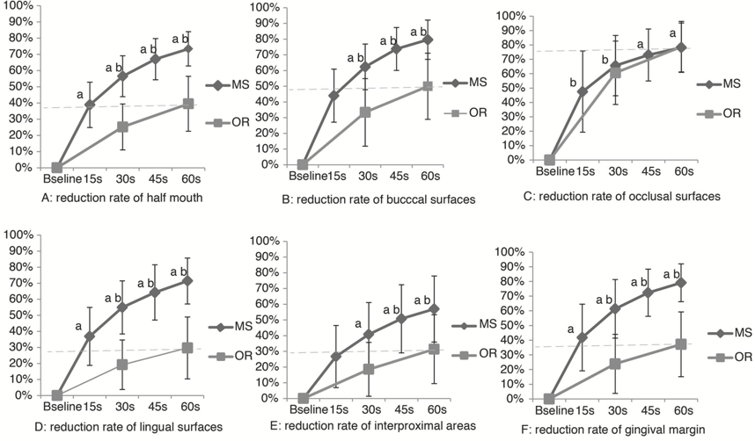
Figure 2. Plaque removal efficiency of the toothbrush

Biography

Mr. Mingjie Wang will get his bachelor degree of dentisry of Zhejiang Chinese Medical University this July. During his internship, he got an oppurtunity to be an exchange student to study in Academic Center for Dentisry Amsterdam(ACTA), and he is going to attand implantology master course in ACTA. He has published 2 papers and another one paper is under reviewing.
Presenting author details
Full name: Mingjie Wang
Contact number:08615397149195
Twitter account:
Linked In account: 543347419@qq.com
Session name/ number: Dental Hygiene
Category: (Oral presentation)

