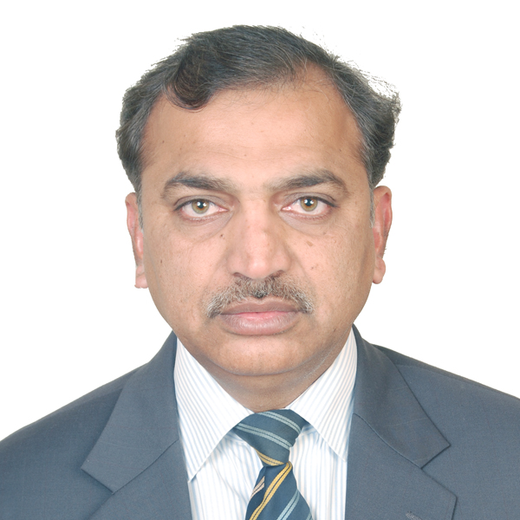
Title: Management of Frontal Sinus: When and How?
Name: Dr. Muhammad Mumtaz.
King Salman Hospital, Ministry of Health Riyadh, Saudi Arabia.

High Velocity trauma is increasing day by day in developing countries and badly effects the head & Neck region, resulting in functional and esthetic problems. Anterior and posterior tables of frontal bone are usually involved in Maxillofacail fracture and is really critical to decide when and how frontal sinus management is required. Posterior table fractures usually results in CSF leakage due to tear in the dura, entrapement of the mucosa within the intracarinal space and anterior table fracture results in facial asymmetry. Another concern of these fracture is to consider the status of nasofrontal duct. The general goal of surgical therapy includes protection of intracranial contents, prevention of early and late complications, restoration of aesthetic forehead contour and return of normal frontal sinus function. Although accomplishing all these goals may not be possible, the intracranial contents must be protected and safe sinus must be reconstructed. Current study focuses on the surgical management of frontal bone fractures resulting in CSF leakage and facial asymmetry, at king Salman Bin Abdul Aziz Hospital Riyadh Saudi Arabia by Oral and Maxillofacial Surgery department. These patients were treated either through existing lacerated wounds or bicoronal flap was raised. Patients were examined for early and late complications postoperatively for a period of three months. The collected information was analyzed by SPSS version 24 . We have concluded from our study that early intervention of these fractures results in significant improvement both esthetically and functionally.

Bibliography
Dr. Muhammad Mumtaz is a well-known Researcher and Oral and Maxillofacial surgeon at the Ministry of Health – King Salman Hospital in Riyadh, Saudi Arabia.. As an oral and maxillofacial surgeon, he has embraced the international medical community. He has unique skillset that enables them to diagnosis and treat many disparities of the head and neck region. In October 2017, he was awarded honorary fellowship by the International College of Dentists USA. As an oral and maxillofacial surgeon, he has risen to the top of his specialty field and has extraordinary ability in the field of medical sciences.
In 1998, he graduated from the de’Montmorancy College of Dentistry and has obtained MDS (Oral and Maxillofacial Surgery) degree from King Edward Medical University in 2008 Lahore, Pakistan. He is PhD in Oral Pathology reflecting that he is an extraordinary researcher. He has been Associate Professor of Oral & Maxillofacial Surgery for seven years at University College of Dentistry, The University of Lahore.
He is member of many National and International professional Organizations. He has represented his institutes as speaker on many occasions nationally and internationally and is a reviewer of many index journals.

Name: Dr Muhammad Mumtaz
Contact No: 00966549460477
LinkedIn: http://www.linkedin.com/in/muhammad-mumtaz-26b558a4
Official Email: muhammad@moh.gov.sa
Email: mumtazmaxfac@gmail.com
Session Name: Oral and Maxillofacial Surgeon
Category: Oral Presentation.

