A giant sialolith of the Wharton's duct appearing like an impacted lower right canine : a case report.
Dr Foudhil.W-A, Resident doctor in Oral Surgery.
University of Saad Dahleb.
CHU BLIDA, ALGERIA.
Email : algchirdent@gmail.com
Abstract :
Sialolithiasis is the most common disease of salivary glands. It is a condition characterized by the obstruction of a salivary gland or its excretory duct due to the formation of calcareous concretions, resulting in salivary ectasia and even determining the subsequent dilatation of the salivary gland.
Commonly, sialoliths measure 5–10 mm in size, and stones over 10 mm can be reported to be sialoliths of unusual size. They rarely measure more than 15 mm.
The aim of this work is to present a case of a giant sialolith (17 mm) occurring in a 41 male patient and mimicking an impacted mandibular canine tooth on routine radiographic examination and its surgical management through an intraoral approach.

Keywords: Sialoliths, Submandibular Glands, Wharton duct, Salivary duct

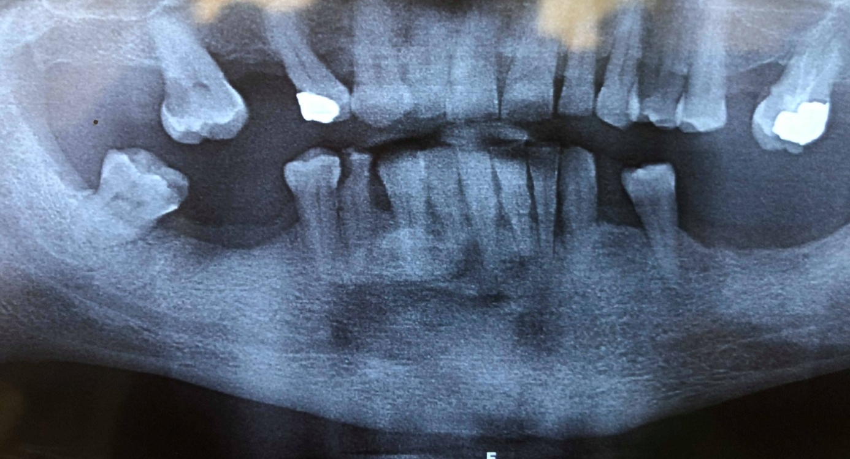
Orthopantomograph showing a large radiopaque mass appearing like an impacted canine.
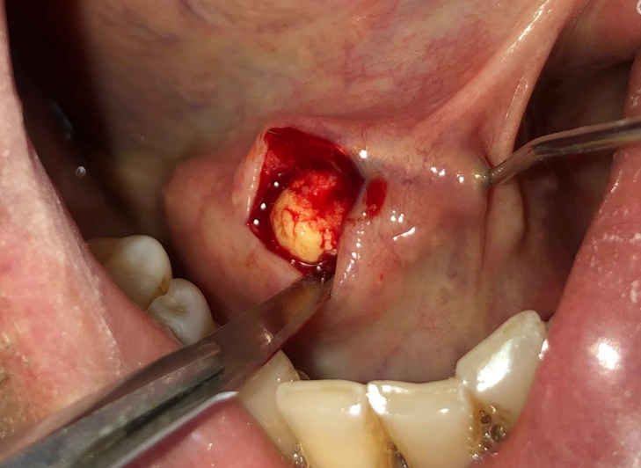
Incision of the salivary duct.

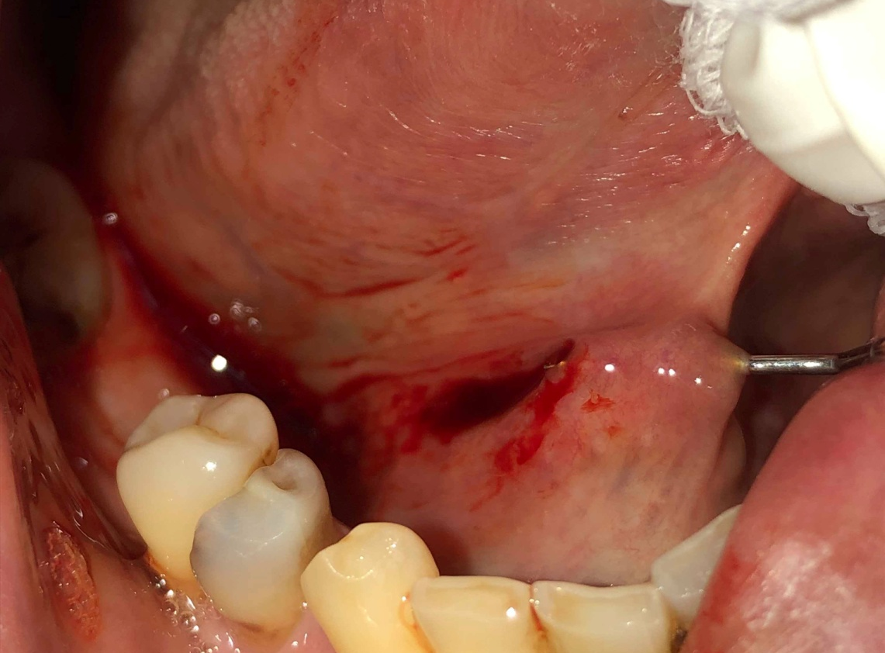
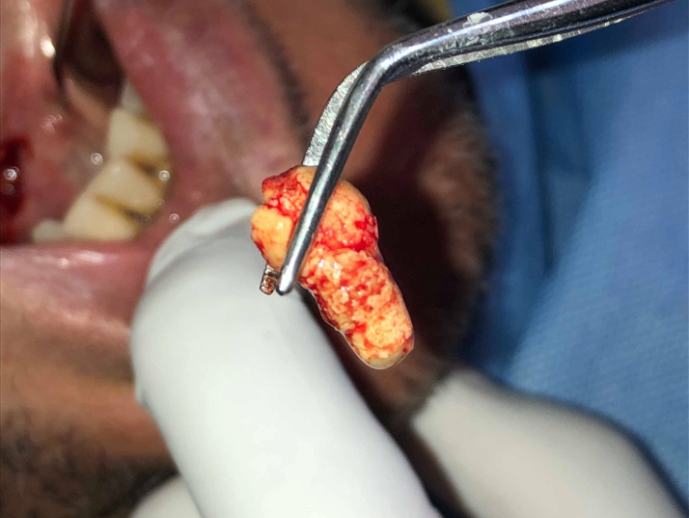
Sialolith removed.
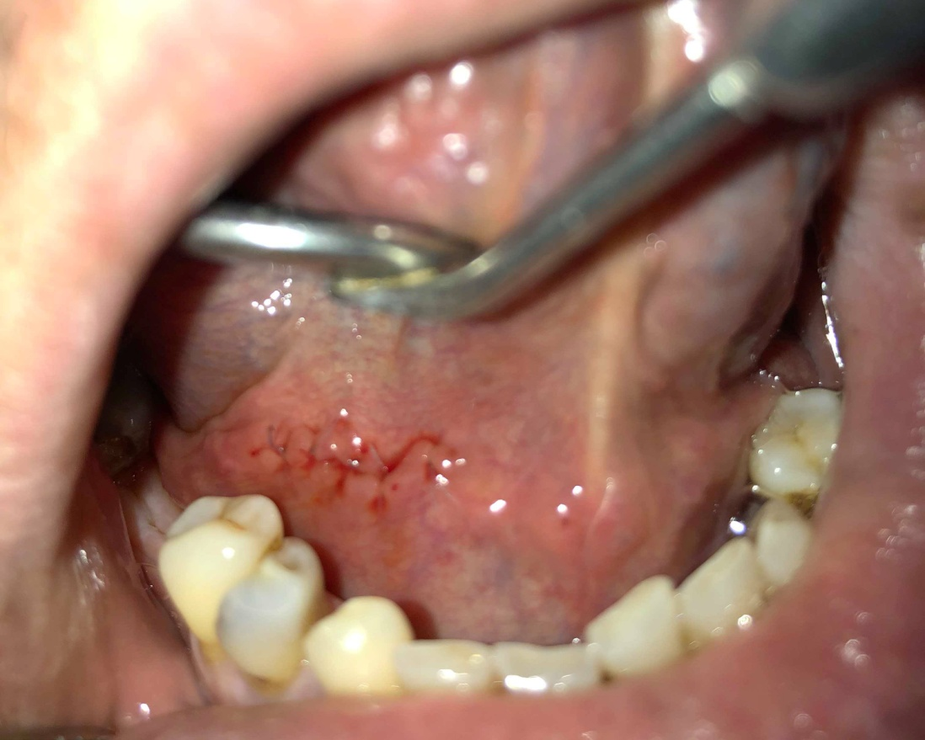
Postoperative photograph
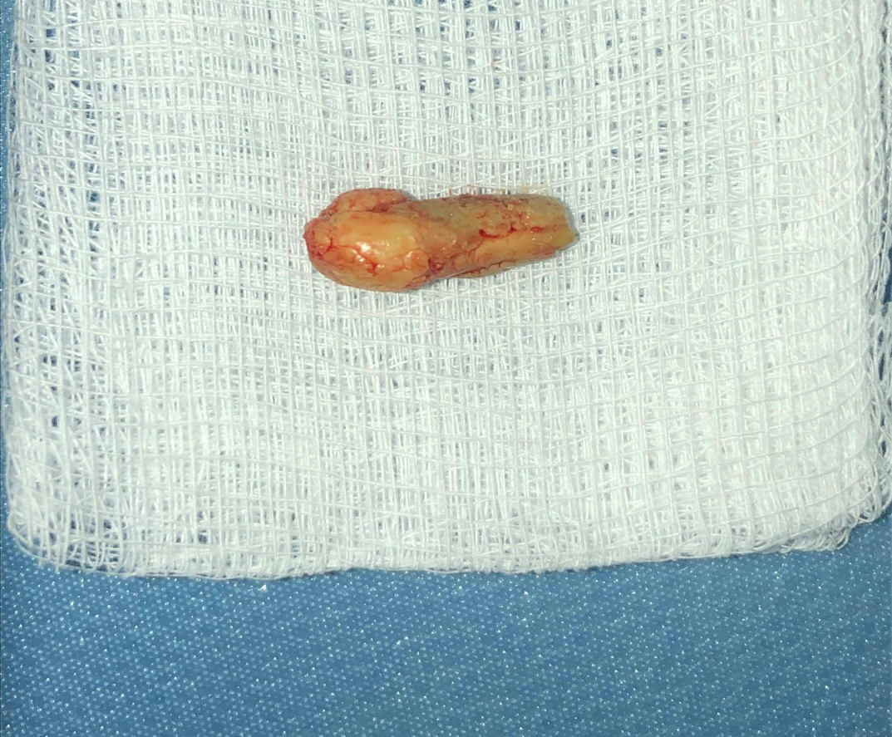
sialolith after removal measuring 1.7 mm

