Neuropsychiatric patterns in cerebral amyloid angiopathy and psychiatric presentations in old age

Key words: cerebral amyloid angiopathy, psychiatry, symptoms, neuropsychology

Abstract
Cerebral amyloid angiopathy (CAA) is diagnosed in various settings including stroke units, memory clinics and geriatric psychiatry. CAA is also observed in community dwelling populations. Clinical presentations including neuropsychiatric presentations were described in the last two decades. Various neuropsychological manifestations have been described which include impairment in perceptual speed, episodic memory, semantic memory, attention and executive function and global cognitive impairment. Neuropsychological manifestations included a new manifestation of high impulsivity, in addition to organic personality change, and depression. This study focuses on neuropsychological impairments and psychiatric manifestations observed in CAA patients and discusses the possibility of a neuropsychological profile for CAA.

Cerebral amyloid angiopathy (CAA) is a neurovascular disease characterised by b-amyloid fibrils deposited in the walls of cerebral blood vessels.¹ A contemporary systematic overview collectively studied the results of four population groups based on pathological studies concerning the link between the presence of CAA (of any severity) and dementia, and found that 55-59% of patients living with dementia also suffered from CAA, while a CAA prevalence of only 28–38% was determined in patients without dementia.² CAA micro bleeds are believed to occur in greater than 30% of adults over the age of 70, and are potentially even more prevalent given the amount of symptomatic individuals with micro bleeds.³ CAA is diagnosed in various settings including stroke units, memory clinics and geriatric psychiatry. CAA is observed in community dwelling populations as well.⁴ Risk factors in the development of CAA include age⁵ and a genetic facto, apolipoprotein E alleles.⁶ Clinical presentations including neuropsychiatric presentations have been described in the last two decades. These include symptomatic intracerebral haemorrhage, cognitive impairment and dementia, rapidly progressive cognitive and neurological decline and transient neurological symptoms.⁷ Various neuropsychological manifestations have been described which include impairment in perceptual speed, episodic memory⁸ semantic memory, attention and executive function and global cognitive impairment.⁹ Cognitive disorders in CAA patients were frequent, in numerous domains. Patients exhibited significant deficits in language, processing speed and executive and memory functions compared to the control group, but were not different on attention and praxis domains. Studies showed that naming was the most impaired process, as in the deep group, followed by executive and processing speed.¹⁰ This pattern of frontal cognitive dysfunction was already highlighted in the CAA population.¹¹

In clinical settings Modified Boston criteria¹² allow for probable or possible CAA diagnosis or exclusion of diagnosis of CAA. The Modified Boston criteria were proposed in 2010 in order to incorporate cortical superficial siderosis into the radiological diagnosis of probable CAA. They comprise of combined clinical, imaging and pathological parameters, and are based upon the original Boston criteria.¹³ The Modified Boston criteria for diagnosis of 'probable CAA' was pathologically validated in 2010, and compared to the Boston criteria had an increase in sensitivity (95%, 95% confidence interval (CI) 76% to 99%) with only a modest decrease in specificity (81%, 95% CI 62% to 93%)

Intracerebral haemorrhage from CAA is most common in the frontal lobes.¹⁴ CAA pathology might cause cortical atrophy, an effect that might at least partly be mediated by vascular dysfunction.¹⁵ CAA is mainly a neurological illness, but may present with psychiatric symptoms. Currently there are no studies that address the psychiatric manifestations of CAA in a systematic way. We report a case series describing four cases with neuropsychiatric manifestations presented to a geriatric psychiatric unit.

Case 1
A 77 year old male with a background of paroxysmal atrial fibrillation had presented with headache, drowsiness and left visual inattention. His computerised tomographic (CT) head scan showed a right temporal lobe acute intra parenchymal haemorrhage with 4mm of midline shift. A Magnetic Resonance Image (MRI) brain scan two months later showed a right temporal lobe residual haematoma with a background evidence of amyloid angiopathy on susceptibility weighted imaging (SWI) with confluent hyper intensity in the periventricular white matter of both occipital lobes on T2/FLAIR. On follow up he developed temporal lobe focal seizures. There was also evidence of cognitive decline [Addenbrooke’s Cognitive Examination (ACE III) - 71/100¹⁶]. He was referred to a psychiatrist for depression, anhedonia and poor sleep with little response to Citalopram. There were no frank delusions or hallucinations and past psychiatric history was unremarkable. As there was only partial control of seizures on Leviteracetam and the potential for this agent to contribute to low mood this was cross-titrated with carbamazepine and eventually stopped. Additionally, Citalopram was switched to Mirtazapine. Following this depression markedly improved and seizures abated.
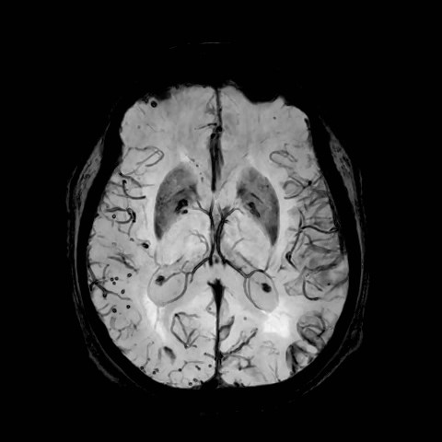
Figure 2 (a)

The figure shows an axial slice of the brain using a SWI sequence showing multiple microhaemorrhages.
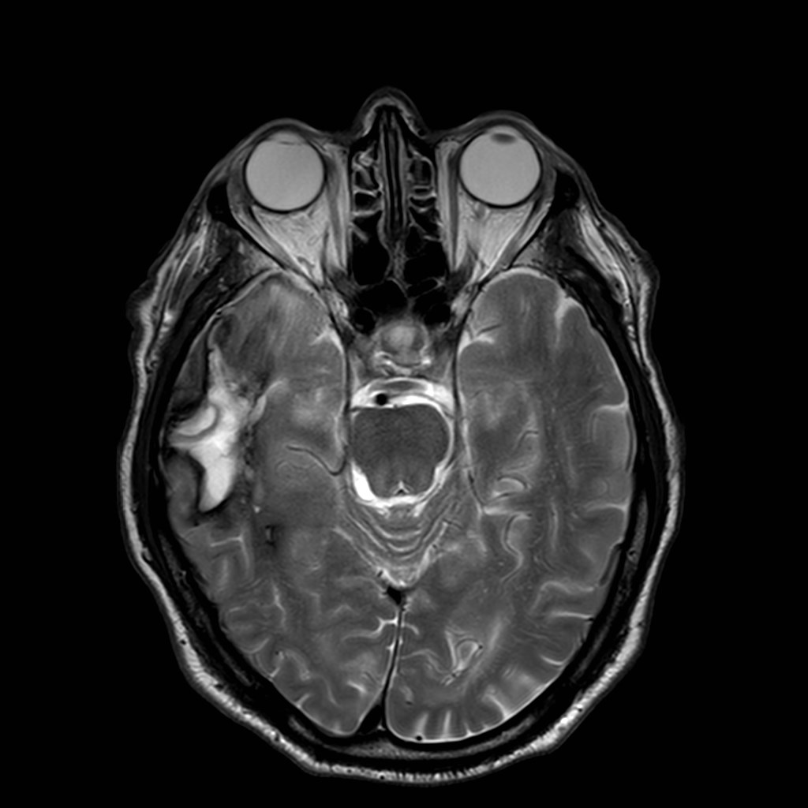
Figure 2 (b)

Axial sequence demonstrating late sub-acute haemorrhage in the right temporal lobe with a rim of low T2 signal haemosiderin staining

Case 2
A 74 year old female with a background history of hypertension, ischemic heart disease and possible subcortical degeneration presented with low mood, tiredness and inability to cope with recent stressful situations. She reported a longstanding history of depression and was on Citalopram at the time of presentation. Collateral information from her husband and two daughters suggested changes in her personality over the last three to four years. Her notable changes include: struggling to manage time, irritable and argumentative for trivial reasons, ruminating on past issues, difficult to ’stop’ thinking. She had issues with urinary incontinence for five years and gait was wide-based, unsteady and veering to left. Mental state examination showed low mood, no delusions or hallucinations and judgment was intact. She scored 90/100 in ACE III. On neuropsychological testing her attention, concentration and processing speed were below expectations. There was a significant decline in impulse control and cognitive flexibility. The pattern of results also indicates that she struggles to freely recall unstructured information and became overwhelmed with complex tasks. Qualitative information suggested that pre-morbidly, she showed behaviours indicative of impulse control difficulties, however, the degree of change suggested a clear decline in executive function that has exacerbated these longstanding traits. MRI imaging on two separate occasions one year apart showed multiple bilateral foci of susceptibility in the cerebral cortex suggestive of amyloid angiopathy. No significant generalised or focal parenchymal atrophy and the hippocampi are normal bilaterally. MRI also showed moderate small vessel ischaemic disease in the deep cerebral white matter. She was stabilised with Mirtazapine 45mg, Quetiapine 100mg and Clonazepam 500mcg. She showed improvement in impulsivity sleep and appetite and became euthymic with no somatic complaints.

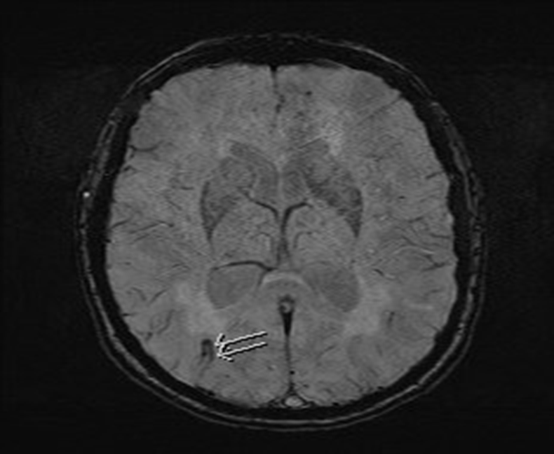
Figure 3 (a)
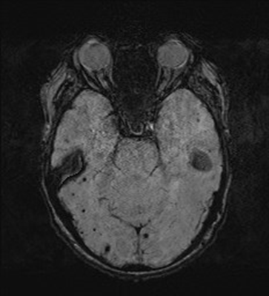
Figure 3 (b)
Figure 3 (a) and (b) shows SWI sequence MRI with evidence of cerebral amyloid angiopathy. 3 (a) demonstrates a small area of superficial siderosis (arrows). 3 (b) demonstrates multiple old peripheral micro haemorrhages.

Case 3
An 80 year old female with a background of mastectomy for breast cancer and Hashimoto thyroiditis (on Levothyroxine) but no previous psychiatric history, presented with intermittent confusion and fixed false beliefs, and auditory and visual hallucinations complicated by anxiety and agitation. This culminated in an attempt to jump out of a moving car. Following admission to a psychiatric unit she was diagnosed with delirium secondary to a urinary tract infection. A brain CT showed extensive presumed physiological calcification within the basal ganglia and cerebellum and mild small vessel white matter ischaemic change. ACE III score was 78/100 on admission but improved to 86/100 just before discharge. Three weeks later she was readmitted to hospital when her symptoms recurred. A repeat CT scan did not indicate new changes. A lumbar puncture revealed no growth with normal protein and glucose levels. An MRI brain revealed punctate foci of susceptibility within the cerebral hemispheres peripherally in keeping with cerebral amyloid angiopathy. There were also separate areas of susceptibility within the basal ganglia and cerebellum in keeping with calcification seen on the prior CT imaging. ACE III was 83/100 and 79/100 three months later. She was treated with a small dose of Risperidone and discharged home after her symptoms improved. On follow up she developed further episodes of intermittent confusion, apathy and decline in memory. She died suddenly about six months after discharge.
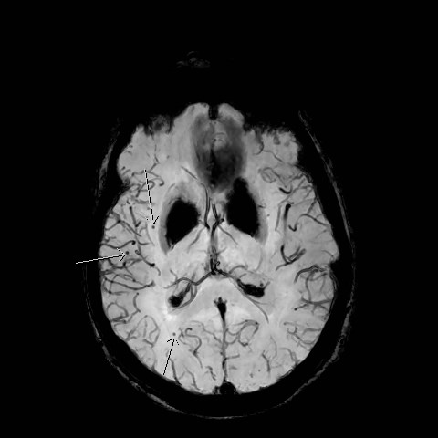
Figure 4 (a)
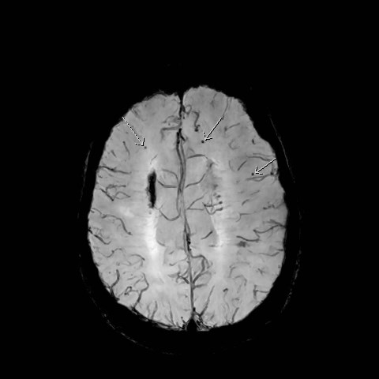
Figure 4 (b)

Figure 4 (a) and (b) shows multiple peripheral punctate micro haemorrhages on SWI sequence MRI. The confluent low signal in the basal ganglia reflects calcification.

Case 4
An 81 year old Eastern European migrant female who works as a French Language teacher presented to a geriatrician with mild subjective retrieval deficits for French words five years ago. Her medical history included paroxysmal atrial fibrillation, hypertension and breast carcinoma. Her CT scan was within normal limits for her age. She gained 96/100 on the ACE III, losing two marks each for recall and verbal fluency. She was informed that she probably suffered from an amnestic mild cognitive impairment. On follow up about a year later, she reported that her word-finding difficulties had worsened and her ACE III score dropped to 86/100. To minimise any possibility that Anastrozole may be contributing to her memory impairment, this agent was discontinued in liaison with the oncologist. A year later, her ACE III score improved to 91/100 with her deficits remaining largely stable. Six months later she presented with a sudden onset ataxia and was admitted to a medical ward where she also developed double vision. On MRI scan there were T2/FLAIR high signal foci within the periventricular and deep white matter, most likely representing small vessel ischaemic change. Additionally, there were numerous foci of susceptibility artefacts within the cerebral parenchyma with a cortical and subcortical distribution predominately at the cortical grey-white junction. Appearances were in keeping with previous micro haemorrhages related to amyloid angiopathy. No acute haemorrhage was identified. As a result her anticoagulation treatment was discontinued. On one and two years follow up she has continued to report memory deficits but her ACE III score has remained stable at 91/100. She currently presents to psychiatry with intermittent performance anxiety mainly centred on her deficits although she continues to work as a French language teacher. She has declined psychotropic treatment but receives intermittent counselling.

Discussion
In our case series we could not demonstrate histopathological confirmation of CAA. However, these cases all met the modified Boston radiological criteria for probable CAA (Figure 1). MRI findings in these cases (see figure 2 to 5) all include multiple old haemorrhages or varying size within lobar, cortical, or subcortical regions. Case one demonstrated an evolving sub-acute intra parenchymal macrohaemorrhage within the right temporal lobe. In case one, multiple factors could have contributed to his depression. It was difficult to ascribe the cause to CAA. But identification of CAA was important when considering treatment methods including medications. MRI imaging in case two demonstrates superficial siderosis. No alternative cause of haemorrhage identified. The personality changes in case two may be associated with the CAA. There was executive dysfunction and exacerbation of premorbid poor impulse control was a prominent feature in her. Case three demonstrated intermittent confusion, executive dysfunction and loss of memory. Multiple etiological factors are possible in this case and CAA may be an additional factor contributed to her presentation. Case four demonstrated mild cognitive impairment and performance anxiety. CAA could be a factor contributed to her presentation.

Psychiatric presentations are uncommon in CAA. These four cases show the importance of investigating for CAA in psychiatry settings. Psychiatrists need to be aware of CAA, particularly in the older population. In our cases, two cases had depression, but it is difficult to ascribe causality in these cases, due to multiple comorbidities in these cases. The spectrum of clinical symptomatology is mainly neurological as well as cognitive decline.¹⁷ Due to CAA being a chronic progressive illness of the central nervous system, the development of gradual psychiatric symptoms as the disease progresses is conceivable, especially in the first stages of CAA, which do not show typical, more overt clinical signs of intra cerebral bleeding or other neurological symptoms such as epileptic seizures. Cognitive impairment and dementia were reported. In case two, the patient developed organic personality change and/or exacerbation of pre-morbid personality traits in the last four years. There are no attributable reasons for her personality change other than CAA. The possibility of personality change due to CAA is mentioned in literature but not substantiated with studies.¹⁸ There was a case report of hereditary form CAA with personality change.¹ Our case is a sporadic one. Taking into account that dementia and neurodegeneration are frequently associated with behavioural problems and/or personality change¹⁹⁻²⁰ it seems plausible that CAA may also cause these clinical syndromes, although this connection has not yet been studied in a systematic way. Case four showed anxiety features and mild cognitive deficits.

Our study also highlights the importance of MRI scanning in psychogeriatric population to identify cases with CAA. A caveat regarding psychiatric presentation is that in patients with suspected CAA, MRI positivity might be incidental, given that the incidence of asymptomatic CAA at autopsy in healthy aged subjects is up to 50%²¹

Table 1 – Neuropsychiatric presentations and Neuropsychological findings
 | Neuropsychiatric presentation | Neuropsychological findings
Case 1 | - Cognitive impairment  - Focal temporal lobe seizures  - Depression | Poor concentration
Case 2 | - Depression  - Organic personality change | - Poor cognitive flexibility, decreased processing speed, impaired free recall and impaired executive function  - Accentuation of poor impulse control.
Case 3 | - Delirium  - Cognitive impairment | - Apathy  - Impaired memory  - Impaired executive function
Case 4 | - Cognitive impairment  - Anxiety | Performance anxiety

Neuropsychological manifestations (Table 1) in our series include cognitive impairment, organic personality change, depression, anxiety, focal temporal lobe seizure and delirium. Cognitive impairment is a well described manifestation in CAA^{2,10-11.} Three of the four cases presented here also showed cognitive impairment. A direct causality cannot be ascribed in these cases, but it is possible that CAA may have caused or contributed to current presentations. Other neuropsychological issues demonstrated in these cases include accentuation of poor impulse control, impaired concentration, poor cognitive flexibility, reduced processing speed, impaired free recall, reduced executive function and apathy. All these disturbances were described in previous studies,^{7,9,18} though there are no reports of organic personality change in sporadic cases or accentuation of poor impulse control.

Conclusion
The clinical spectrum of CAA continues to grow. Despite remarkable recent interest, CAA remains under-recognised by neurologists and stroke physicians.⁷ At present an awareness needs to be created among psychiatrists to recognise cerebral amyloid angiopathy as a possible contributor of psychiatric presentations. More insight is needed in demonstrating psychopathology and its relation to CAA. More studies are needed to delineate which psychiatric manifestations are parts of CAA. In addition long-term follow-up studies with repeated imaging will increase insight in the clinical meaning of these situations in CAA over time.

Acknowledgements
We would like to acknowledge Kristina Thomber for editorial assistance, Radiology Assistants and patients’ contributions.

References
- Biffi A, Greenberg SM. Cerebral amyloid angiopathy: a systematic review. J Clin Neurol 2011; 7: 1e9.
- Keage H, Carare R, Friedland R, Ince P, Love S, Nicoll J, Wharton S, Weller R, Brayne C, Populations based studies of sporadic cerebral amyloid angiopathy and dementia: a systematic review. BMC Neurol 2009; 9: 3.
- Viswanathan A, Greenberg SM. Cerebral amyloid angiopathy in the elderly. Ann Neurol 2011; 70: 871e80.
- Vernooij MW, van der Lugt A, Ikram MA, et al. Prevalence and risk factors of cerebral microbleeds: the Rotterdam Scan Study. Neurology 2008; 70: 1208–1214.
- Vinters H, Cerebral amyloid angiopathy 1987; Stroke18: 311–324.
- Verghese P, Castellano J, Holtzmann D. ApolipoproteinE in Alzheimer's disease and other neurological disorders. Lancet Neurol 2011; 10: 241–252.
- Charidimou A, Gang Q, Werring D, Sporadic cerebral amyloid angiopathy revisited: recent insights into pathophysiology and clinical spectrum. J.Neurol.Neurosurg. Psychiatry 2012; 83: 124–137.
- Arvanitakis Z, Leurgans S, Wang Z, Wilson R, Bennett D, Schneider J. Cerebral amyloid angiopathy pathology and cognitive domains in older persons. Ann.Neurol 2011; 69: 320–327.
- Boyle PA, Yu L, Leurgans S, Wilson R, Bennett D, Schneider J. Cerebral amyloid angiopathy and cognitive outcomes in community based older persons. Neurology 2015; 85: 1930–6.
- Planton M, Saint-Aubert L, Raposo N, Branchu L, Lyoubi A, Bonneville F, et al. High prevalence of cognitive impairment after intracerebral hemorrhage. PLoS ONE 2017; 12(6): e0178886. https://doi.org/10.1371/journal.
- Xiong L, Davidsdottir S, Reijmer YD, Shoamanesh A, Roongpiboonsopit D, Thanprasertsuk S, et al. Cognitive Profile and its Association with Neuroimaging Markers of Non-Demented Cerebral Amyloid Angiopathy Patients in a Stroke Unit. Journal of Alzheimer's disease 2016: 1±8.
- Linn J, Halpin A, Demearel P et al Prevalence of superficial siderosis in patients with cerebral amyloid angiopathy. Neurology 2010; 74: 1346–1350
- Knudson K, Rosand J, Karluk D, Greenberg S, Clinical diagnosis of cerebral amyloid angiopathy: validation of the Boston citeria.Neurology 2001; 56: 537–539.
- Schrag and Kirshner H. Curr Neurol Neurosci Rep. Neuropsychological effects of cerebral amyloid angiopathy 2016; 16: 76.
- Fotiadis P*, van Rooden S *, van der Grond J, Schultz A, Martinez-Ramirez S, Auriel E, Reijmer Y, et al. Cortical atrophy in patients with cerebral amyloid angiopathy: a case-control study. Lancet Neurology 2016; 15: 811-19
- Hsieh S, Schubert S, Hoon C, Mioshi E, Hodges JR: Validation of the Addenbrooke’s Cognitive Examination III in frontotemporal dementia and Alzheimer’s disease. Dement Geriatr Cogn Disord 2013; 36: 242–250.
- Attems Jellinger K, Thal J, van Nostrand W. Review: Sporadic Cerebral amyloid angiopathy. Neuropathol.Appl. Neurobiol 2011: 37: 75–93.
- Gahr M, Connemann B, Schönfeldt-Lecuona C. Behavioural problems and personality change related to cerebral amyloidangiopathy. Psychiatr.Prax 2012; 39: 410–413.
- Hope T, Keene T. Behavioural problems in dementia and biochemistry: clinical aspects. Neurodegeneration 1996; 5:399–402.
- Klugmann A, Marshall J, Tabet N. Impact of cerebrovascular pathology on behavioural and neuropsychiatric symptoms in patients with Alzheimer's dementia: findings from a retrospective, naturalistic study. Int. J.Clin.Pract 2009; 6: 1024–1030.
- Kovari E, Herrmann FR, Hof PR, Bouras C. The relationship between cerebral amyloid angiopathy and cortical microinfarcts in brain ageing and Alzheimer's disease. Neuropathol. Appl. Neurobiol 2013; 39: 498–509.
- Sveinbjornsdottir S, Sigurdsson S, Aspelund T, et al. Cerebral microbleeds in the population based AGES-Reykjavik study: prevalence and location. J Neurol Neurosurg Psychiatry 2008; 79: 1002–1006.

