Evidence of Neurovascular Un-Coupling in Mild Alzheimer’s Disease through Multimodal EEG-fNIRS and Multivariate Analysis of Resting-State Data
Pierpaolo Croce ¹, Antonio M. Chiarelli ¹, David Perpetuini ¹, Chiara Filippini ¹, Daniela Cardone ¹, Ludovica Rotunno ¹, Nelson Anzoletti ¹, Michele Zito ¹, Filippo Zappasodi ¹ and Arcangelo Merla ¹

¹ Department of Neuroscience, Imaging and Clinical Sciences, Institute for Advanced Biomedical Technologies, Faculty of Medicine, University G. D’Annunzio of Chieti-Pescara, Via Luigi Polacchi 13, 66100 Chieti, Italy

Abstract
Alzheimer’s disease (AD) is associated with modifications in cerebral blood perfusion and autoregulation. Hence, neurovascular coupling (NC) alteration could become a biomarker of the disease. NC might be assessed in clinical settings through multimodal electroencephalography (EEG) and functional near-infrared spectroscopy (fNIRS). Multimodal EEG-fNIRS was recorded at rest in an ambulatory setting to assess NC and to evaluate the sensitivity and specificity of the methodology to AD. Global NC was evaluated with a general linear model (GLM) framework by regressing whole-head EEG power envelopes in three frequency bands (theta, alpha and beta) with average fNIRS oxy-and deoxy-hemoglobin concentration changes in the frontal and prefrontal cortices. NC was lower in AD compared to healthy controls (HC) with significant differences in the linkage of theta and alpha bands with oxy-and deoxy-hemoglobin, respectively (p= 0.028 and p= 0.020). Importantly, standalone EEG and fNIRS metrics did not highlight differences between AD and HC. Furthermore, a multivariate data-driven analysis of NC between the three frequency bands and the two hemoglobin species delivered a cross-validated classification performance of AD and HC with an Area Under the Curve, AUC= 0.905 (p= 2.17× 10− 5). The findings demonstrate that EEG-fNIRS may indeed represent a powerful ecological tool for clinical evaluation of NC and early identification of AD.

Image
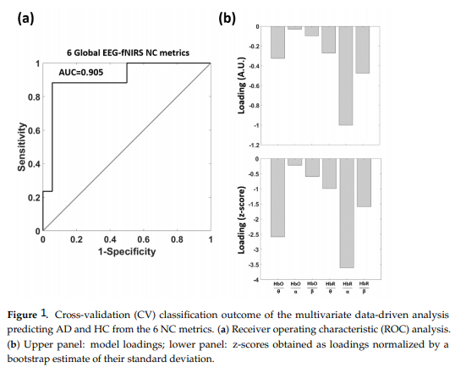
Recent Publications
- Kotliar, K.; Hauser, C.; Ortner, M.; Muggenthaler, C.; Diehl-Schmid, J.; Angermann, S.; Hapfelmeier, A.; Schmaderer, C.; Grimmer, T. Altered neurovascular coupling as measured by optical imaging: A biomarker for alzheimer’s disease. Sci. Rep. 2017, 7, 12906..
- Haydon, P.G.; Carmignoto, G. Astrocyte control of synaptic transmission and neurovascular coupling. Physiol. Rev. 2006, 86, 1009–1031LiX, SchwachaMG, ChaudryIH, ChoudhryMA (2008)Acutealcohol intoxication potentiates neutrophil-mediated intestinal tissue damage after burn injury. Shock 29:377.
- Stickland, R.; Allen, M.; Magazzini, L.; Singh, K.D.; Wise, R.G.; Tomassini, V. Neurovascular coupling during visual stimulation in multiple sclerosis: A MEG-FMRI STUDY. Neuroscience 2019, 403, 54–69.5.
- Dutta, A.; Jacob, A.; Chowdhury, S.R.; Das, A.; Nitsche, M.A. EEG-NIRS based assessment of neurovascular coupling during anodal transcranial direct current stimulation—A stroke case series. J. Med. Syst. 2015, 39, 36.
- Csipo, T.; Mukli, P.; Lipecz, A.; Tarantini, S.; Bahadli, D.; Abdulhussein, O.; Owens, C.; Kiss, T.; Balasubramanian, P.; Nyúl-Tóth, Á.; et al. Assessment of Age-related decline of neurovascular coupling responses by functional near-infrared spectroscopy (FNIRS) in humans. GeroScience 2019, 41, 495–509.

 Biography
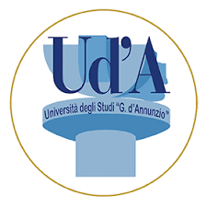
Pierpaolo Croce has a back-ground in Engineering and Electrophysiological Data Analysis with specific emphasis on Electroencephalography (EEG), Functional Magnetic Resonance (fMRI) and Functional Near-Infrared Spectroscopy (fNIRS) data analysis. In particular, his work is focused on evaluation of global connectivity metrics extracted from multimodal Electrophysiological measurements (EEG, fMRI, fNIRS) to be used as prognostic indices in neurological diseases such as Alzheimer disease or Stroke. Moreover, his activity is also focused on the evaluation of modifications of such indices obtained by trans-cranial magnetic stimulation (TMS). This aspect is strictly related to the use of connectivity indices as tools for the evaluation of the disease recovery.

Email: pierpaolo.croce@unich.it

Notes/Comments
Presenting author details
Full name: Pierpaolo Arturo Croce
Contact number: 3496735489
Mail id: pierpaolo.croce@unich.it
Category: Oral presentation

