Brain Metabolic and Functional Aspects of Frailty in Elderly with Mild Cognitive Impairments

Seong A Shin^{1,2}, Dong-Hyun Yoon³, Wook Song³, Jun-Young Lee⁴, Yu Kyeong Kim²

¹ Department of Biomedical Sciences, Seoul National University, Seoul, Republic of Korea
² Department of Nuclear Medicine, SMG-SNU Boramae Medical Center, Seoul, Republic of Korea
³ Department of Kinesiology, Seoul National University, Seoul, Republic of Korea
⁴ Department of Psychiatry, SMG-SNU Boramae Medical Center, Seoul, Republic of Korea

The presence of frailty in elderly population has been clearly linked to higher risks of cognitive impairments and even dementia. Literature documented that physical frailty was associated with accelerated cognitive decline, involving memory, perceptual speed and visuospatial cognitive systems (Boyle et al. 2010 J Am Geriatr Soc). Our study aimed to investigate alterations in metabolic and functional activity in patients with mild cognitive impairments (MCI) with frailty phenotypes defined according to Fried criteria, and to explore cognitive domains affected by frailty in association with the alterations in the brain. Participants were assessed for frailty status based on the presence of five phenotypic components according to Fried criteria, and twenty-one MCI without frailty (robust; absence of any frailty components) and twenty-seven age- and gender-matched MCI with frailty (at-risk; presence of one or more components) underwent [¹⁸F] FDG PET and resting state fMRI (rs-fMRI) scans. Using Statistical Parametric Mapping 12 software in Matlab 2014a, [¹⁸F] FDG PET images were spatially normalized to a standard space for voxel-wise statistical analyses. rs-fMRI data was also preprocessed to examine local intrinsic functional activity using fractional amplitude of low frequency fluctuations (fALFF) and regional homogeneity (ReHo) measures. Subtle metabolic and functional activity changes between groups as well as the associations between the activity of clusters showing significant group differences and the performance in cognitive function were assessed after controlling for age, gender and year of education. In at-risk group, reduced metabolic activity was found in left precuneus and right dorsolateral prefrontal cortex (Figure 1). Increased fALFF was found in left supplementary motor area (Figure 2), while disruptions in ReHo were found in bilateral caudate, right lateral and medial frontal cortex and superior temporal cortex in at-risk group (Figure 3). The alterations were significantly correlated with the performance in several cognitive functions including executive function, language and visuospatial function. Our results support that the physical frailty in MCI may accelerate the cognitive deteriorations by affecting frontal and temporal areas.
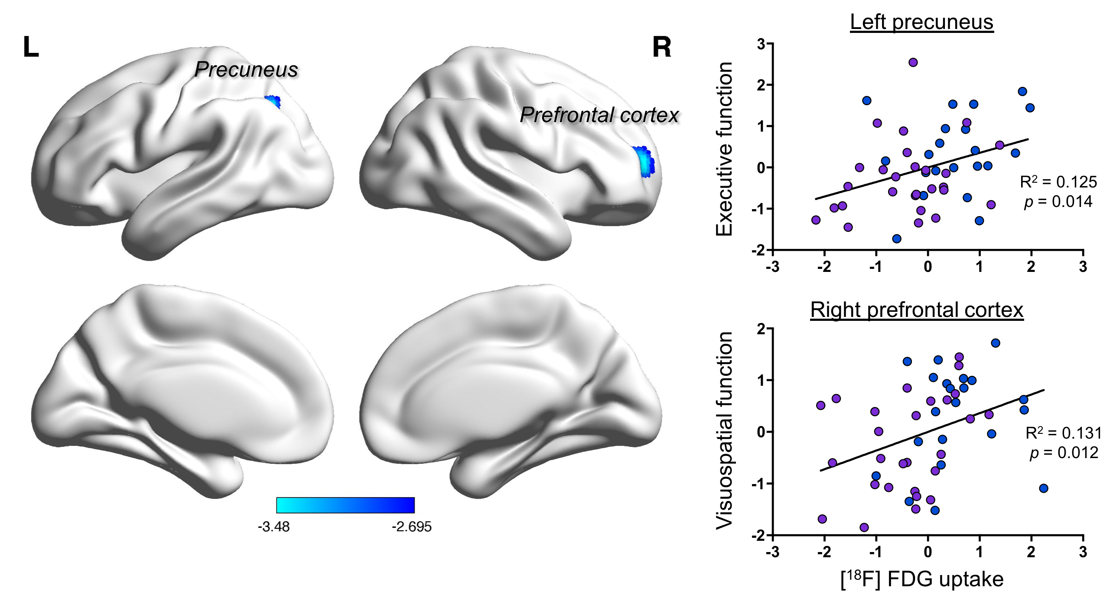
Figure 1. Reduced glucose metabolism in at-risk group

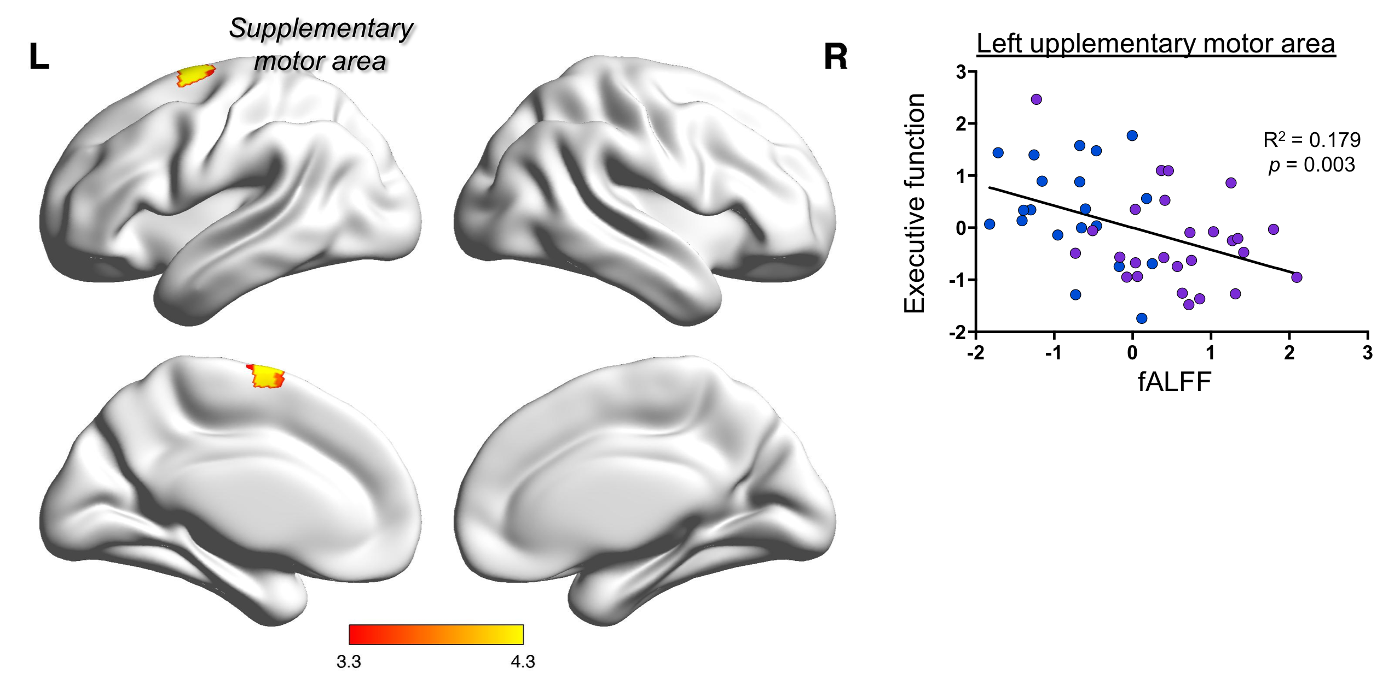
Figure 2. Increased fractional amplitude of low frequency fluctuations in at-risk group

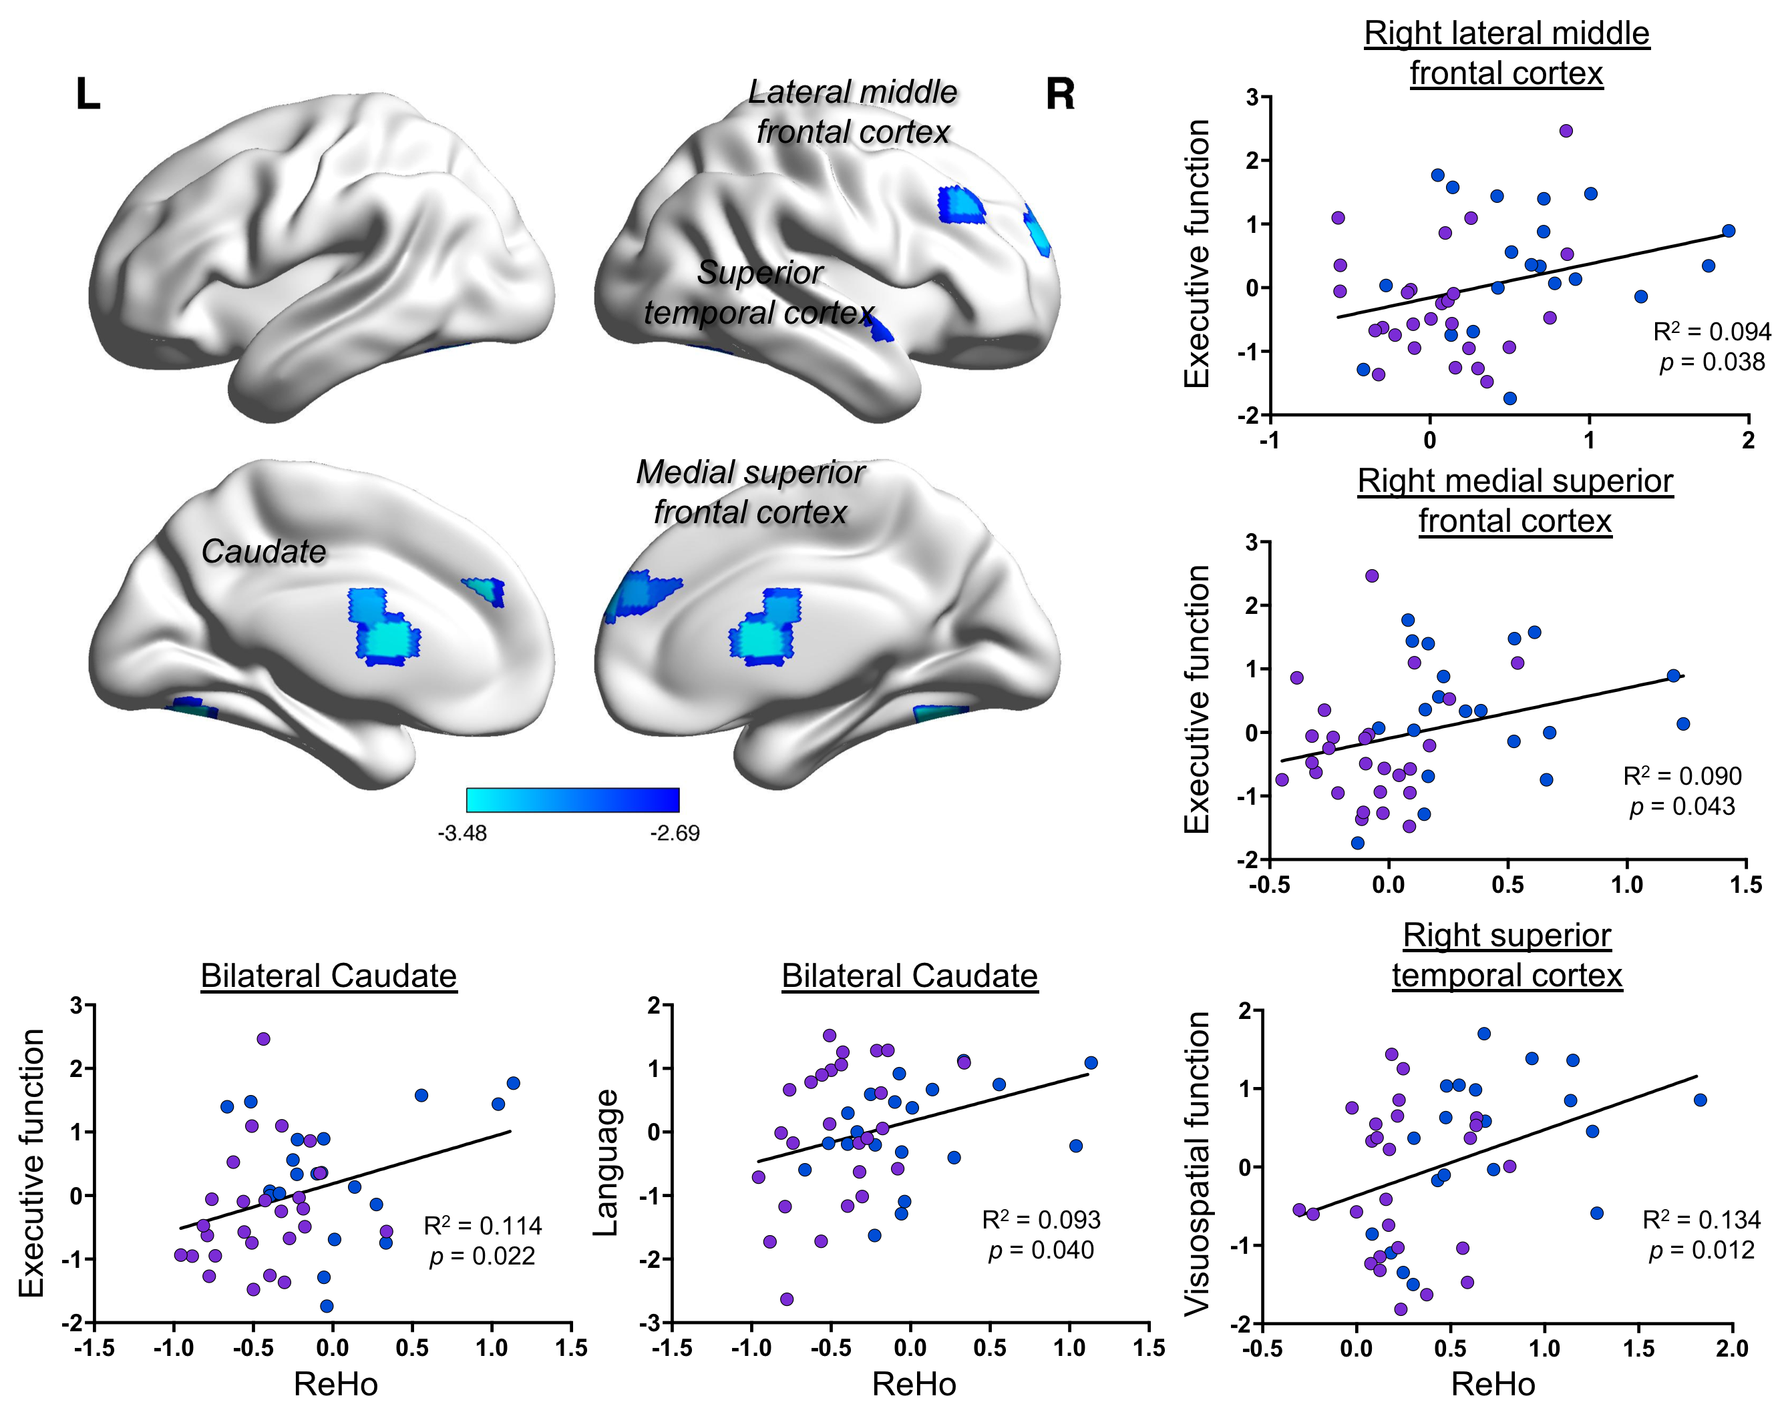
Figure 3. Reduced regional homogeneity in at-risk group

Biography
Seong A Shin has completed her undergraduate study, majoring in Neurobiology at Department of Biomedical Science from University of Auckland, New Zealand, and is continuing her postgraduate study (as a PhD candidate) on neuroimaging topics in neurodegenerative diseases including dementia and Parkinson’s disease.

Presenting author details
Full name: Seong A Shin
Contact number: +82-10-6225-8828
Category: Poster presentation

