Title: Surge-Adjusted Forecasting in Temporal Data Containing Extreme Observations
Name: Smaranya Dey, Subhadip Paul, Uddipto Dutta, Anirban Chatterjee
Company: Walmart Labs, Bangalore, India

Abstract
Forecasting in time-series data is at the core of various business decision making activities. One key characteristic of many practical time series data of different business metrics such as orders, revenue, is the presence of irregular yet moderately frequent spikes of very high intensity, called extreme observation. Forecasting such spikes accurately is crucial for various business activities such as workforce planning, financial planning, inventory planning. Traditional time series forecasting methods such as ARIMA, BSTS, are not very accurate in forecasting extreme spikes. Deep Learning techniques such as variants of LSTM tend to perform only marginally better than these traditional techniques. The underlying assumption of thin tail of data distribution is one of the primary reasons for such models to falter on forecasting extreme spikes as moderately frequent extreme spikes result in heavy tail of the distribution. On the other hand, literatures, proposing methods to forecast extreme events in time series, focused mostly on extreme events but ignored overall forecasting accuracy. We attempted to address both these problems by proposing a technique where we considered a time series signal with extreme spikes as the superposition of two independent signals - (1) a stationary time series signal without extreme spike (2) a shock signal consisting of near-zero values most of the time along with few spikes of high intensity. We modelled the above two signals independently to forecast values for the original time series signal. Experimental results show that the proposed technique outperforms existing techniques in forecasting both normal and extreme events.

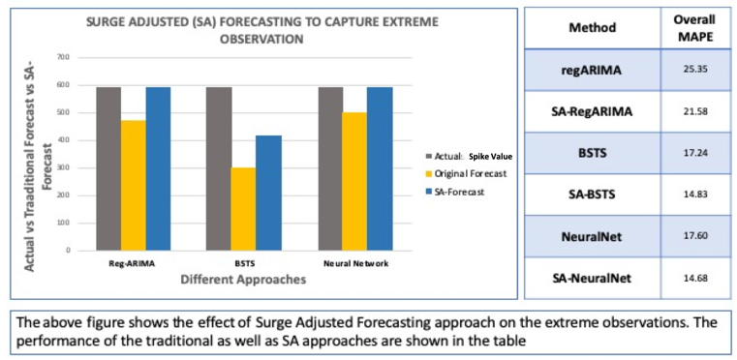

Biography

 Smaranya Dey is a Data Scientist in Walmart Labs, India. She is interested in researching areas of forecasting analysis and natural language processing. Email: Smaranya.Dey@walmart.com (LinkedIn Profile) (Contact No: +91-7506144159)
 Subhadip Paul is Statistical Analyst at Walmart Labs, India. His research interest lies in Time Series Analysis, Clustering and Analysis of Graphical Data. Email: Subhadip.paul0@walmartlabs.com (LinkedIn Profile) (Contact No: +91-9434848338)

 Uddipto Dutta is a Statistical Analyst at WalmartLabs, India. Time Series Analysis and Optimization are some of the areas he is interested to do research in. Email: uddipto.dutta@walmartlabs.com (LinkedIn Profile) (Contact No: +91-9830590076)

 Anirban Chatterjee is Staff Data Scientist in WalmartLabs, India. His research interest lies in Time Series Analysis and Modeling with High Dimensional Data. Email: Anirban.Chatterjee@walmartlabs.com (LinkedIn Profile) (Contact No: +91-7259854308)

Category: Oral Presentation
Note: All authors contributed equally to this work.

