Title: Solving Heterogeneities in Defibrillation for a Vascular Remodel of the Heart
Arianna Pahlavan, Jericho High School Senior, USA

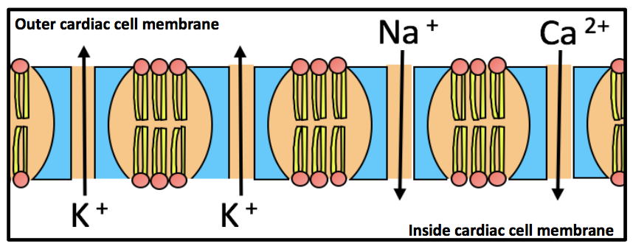
Abstract

Acute cardiac arrhythmias are the main cause of death in industrialized countries; despite clinical importance, the mechanisms behind the onset and dynamics of cardiac arrhythmias are still poorly understood. The purpose of this work is twofold: (1) determine how
smaller blood vessel radii affect the moving wave-front velocity, virtual electrode (VE) formation, and transmembrane potential induced by a shock (2) to elucidate a minimum radius correlative to shock strengths of interest. The model described here resolved tissue dynamics with a second-order solution to Poisson’s equation uniformly to boundaries. Through examining the role of small blood vessels, a minimum radius was identified at which a current will propagate, a range of 100-400µm. The velocity of the moving wave-front remained constant and no VEs form in the blood vessel region for all blood vessels below the size of the minimum radius. An alteration of fiber orientation, perpendicular to parallel, caused a twofold reduction in minimum radius. Blood vessels of radii 400µm do not affect the propagation of a 6V, 3V, 1.5V, .75V, and .33V induced shock strengths. Thus, 400µm blood vessels can be excluded in the first ever vascular mathematical model of the human heart at a feasible cost. An accurate anatomical model is needed to computationally verify the results of low energy antifibrillation pacing (LEAP) for the implication of painless defibrillation therapy in hospitals. The implementation of low energy automated defibrillators will save the US $1.1 trillion annually and universalize the CPR protocol for the minimization of anoxic encephalopathy. Future investigations may involve nanoparticles monitoring the cardiac ion channel currents and activating a painless electric shock where re-entry begins to occur, a potential solution to sudden cardiac arrhythmia death.

Image

Figure 1. The electrochemical gradient created by Na+, K+, and Ca2+
ions across the cellular membrane. Image created by student author.
Recent Publications (minimum 5)

[1] R.J. Adams et al. Heart disease and stroke statistics-2010 update: A report from the american heart association. Circulation, 121:46-215, Dec. 2009.
[2] B. J. Caldwell et al., “Cardiac response to low energy field pacing challenges the standard theory of defibrillation,” Circulation: Arrhythmia and Electrophysiology, pp. 1-21, Mar. 2015.
[3] J. N. Weiss et al., “The dynamics of cardiac fibrillation,” American Heart Association, pp. 1232-1240, Aug. 2015.
[4] D. Durrer et al., “Total excitation of the isolated human heart,” Department of Cardiology and Clinical Physiology, pp. 899-912, June 1969.
[5] K. L. Moore et al., “Clinically Oriented Anatomy,” Lippincott Williams and Wilkins, pp. 643-652, Feb. 2013.

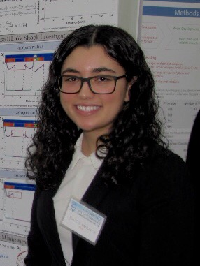

Working with Professor Glimm at Stony Brook University, Arianna Pahlavan was able to elucidate anatomical cardiac geometries for the first-ever efficacious vascular remodel of the human heart—a step necessary for the implication of painless defibrillation therapy in hospitals. She spent much of her time debugging tens of thousands of lines of code, in which Arianna’s solutions were often met with more debugging challenges. She savored the challenging and almost addictive cycle. These accomplishments helped Arianna to further define her career ambitions, and both came directly as rewards for her hard work and academic enthusiasm.
Email:ariannapahlavan@yahoo.com
- Full Name: Arianna Pahlavan
- Personal Email: arianna.pahlavan@jerichoapps.org
- Mobile Number: (516)-509-1282
- Facebook: https://www.facebook.com/arianna.pahlavan
- Session Name/ number:
- Category: I can do either. I have both prepared, but I registered under oral.
- Date of Birth: 10/10/01
- Postal Address: 3 Beech Tree Lane, Glen Head NY 11545

Notes or Comments:

