Precipitant-less Crystallization of Protein Molecules Induced by Substrate with Heterogeneous Topography and Surface Potential Gradient
Anindita Sengupta Ghatak, PhD, IIT Kanpur Animangsu Ghatak, PhD, Department of Chemical Engineering, IIT Kanpur, UP 208016, INDIA

Abstract (300 word limit)
Surfaces with heterogeneous structures facilitate protein crystallization by diminishing the energy barrier for nucleation. Nevertheless, a precipitant remains necessary for shielding the charges on protein molecules, which then overcomes electrostatic repulsion and self-assemble into crystalline structure. For yet-to-be crystallized proteins, identifying the right precipitant is non-trivial and therefore, despite existence of several heterogeneous surfaces, number of such yet-to-be crystallized proteins continues to be large. In this talk, we will present a novel surface which is decorated with both nanoscopic patterns and also surface charges, the combined effect of which show the remarkable ability to induce crystallization without use of any precipitant. This effect is demonstrated by crystallizing several protein molecules with molecular weight ranging from 14-450 kDa. These surfaces are shown to induce also directed crystallization of a specific protein from a mixture of two or more protein species and even simultaneous crystallization from a mixture of proteins. In essence, these surfaces consist of nanoscopic wrinkles with spatially varying curvature and surface charges. Kelvin probe force microscopy (KPFM) measurements show that surface potential gradient as high as 140 V/μm are generated on these surfaces which can drive largescale molecular ordering in the liquid at the vicinity of the surface. As a result, the surface itself acts both as a precipitant also as a nucleant. Heterogeneity allows it to crystallize protein molecules having large range of radius of gyration, that too at low to moderate concentration of the protein in respective solutions. The prospect of precipitant-less crystallization of protein is expected to open up several possibilities in the areas of disease diagnosis, drug discovery, drug delivery and protein engineering.

Image
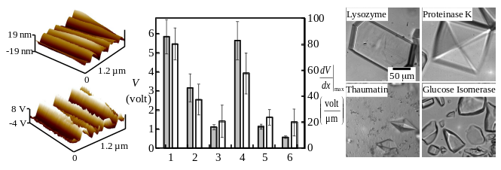
Figure 1. Nano-wrinkled surfaces with large surface potential gradient induces crystallization of several proteins without use of any precipitant.
Recent Publications (minimum 5)
- Ghatak A S, Ghatak A (2016) Precipitant-less Crystallization of Protein Molecules Induced by High Surface Potential. Journal of Crystal Growth and Design 16(9): 5323-5329.
- Mondal S, Phukan M, Ghatak A (2015), Estimation of solid-liquid interfacial tension using curved surface of a soft solid. Proceedings of the National Academy of Science, 112(41): 12563-12568.
- Chaudhury M K, Chakrabarti A, Ghatak A (2015) Adhesion-induced instabilities and pattern formation in thin films of elastomers and gels. European Physical Journal E, 38(7): 1-26.
- Ghatak A S, Ghatak A (2013) Disordered nano-wrinkle substrates for inducing crystallization over a wide range of concentration of protein and precipitant. Langmuir 29(13): 4373–4380.
- Ghatak A S, Koch M, Guth C, Weiss I M (2013) Peptide induced crystallization of calcium carbonate on wrinkle patterned substrate: implications for chitin formation in molluscs. International Journal of Molecular Science 14: 11842.
- Ghatak A S, Ghatak A (2011) Controlled crystallization of macro-molecules using patterned substrates in a sandwiched plate geometry. Industrial and Engineering Chemistry Research 50(23): 12984-12989.

Biography (150 word limit)
Animangsu Ghatak is currently a Professor at Indian Institute of Technology Kanpur, India. He works in the general area of soft matter with diverse topics of interest: bio-inspired adhesion, surface instability, friction, fracture of soft gels, microfluidic channels, mixing in microchannels. His current work stems from his interest in surface modification via generation of nano to microscopic hierarchical structures. He is using these surfaces for variety of applications, e.g. reusable adhesion, making of superhydrophobic and oleophobic effect. Recently he has shown that these surfaces can be used also for crystallization of macromolecules.
Email: aghatak@iitk.ac.in

Notes/Comments:

