Visualization of Evaporative Crystallization Dynamics Probed by Fluorescence Color Changes
Fuyuki Ito, Shinshu University, Japan

Abstract
Crystal formation from a solution is necessary for the fabrication of organic solid material. In solution crystallization, the formation of crystal nuclei plays an important role in determining crystal structure, size and polymorphism, and their crystal quality. Recently, a two-step nucleation model was developed to explain protein crystallization; involving a liquid-like cluster intermediate before nucleation, which has been shown to be of more general validity. The two-step nucleation model replaces the classical model of crystallization that is molecules are added on one by one to extend the crystal lattice and form embryo clusters in a one step process. Liquid-clusters are believed to originate from disordered liquids or amorphous metastable clusters in homogeneous solutions. We have focused the fluorescence detection for crystal formation process. The fluorescence spectra of the materials are sensitive to molecular environment and aggregation. In principle, the evolution of the molecular assembly can be assessed by fluorescence spectroscopy on the scale of only a few molecules or a bulk process scale. We have investigated fluorescence spectral changes of perylene and cyanostilbene derivatives showing aggregation-induced emission during solvent evaporation by fluorescence microscopy. We have claimed that the information on molecular assembly and crystal nucleation and growth processes is obtained by studying the concentration-dependent fluorescence spectral change of organic fluorescent dyes in the polymer film and solvent evaporation. In this paper, we investigate the fluorescence properties of 4,4’-di-tert-butyldibenzoylmethane boron difluoride (BF₂DBMb) solutions during evaporative crystallization. BF₂DBMb exhibits mechanofluorochromism, which originates from the different emission properties of its amorphous and crystalline states.

Image

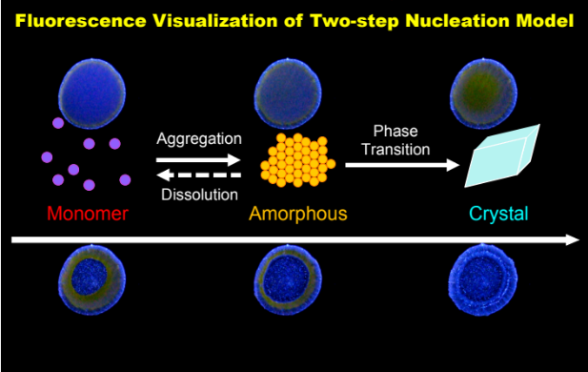
Recent Publications
- Fuyuki Ito, Yukino Suzuki, Jun-ichi Fujimori, Takehiro Sagawa, Mitsuo Hara, Takahiro Seki, Ryohei Yasukuni, and Marc Lamy de la Chapelle, “Direct Visualization of the Two-step Nucleation Model by Fluorescence Color Changes during Evaporative Crystallization from Solution”, Sci. Rep., 6, 22918 (2016).
- Fuyuki Ito, Jun-ichi Fujimori, “Fluorescence Visualization of Molecular Assembly Processes during Solvent Evaporation via Aggregation-induced Emission in a Cyanostilbene Derivative”, CrystEngComm., 16 (2014) 9779-9782.
- Fuyuki Ito, Yoshiko Kogasaka, Kazuki Yamamoto, “Fluorescence Spectral Changes of Perylene in Polymer Matrices during the Solvent Evaporation Process”, J. Phys. Chem. B, 117 (13) (2013) 3675-3681.
- Fuyuki Ito, Jun-ichi Fujimori, Narumi Oka, Michel Sliwa, Cyril Ruckebusch, Syoji Ito and Hiroshi Miyasaka, “AIE Phenomena of a Cyanostilbene Derivative as a Probe of Molecular Assembly Process”, Faraday Discussions, 196, 231-243 (2017).
5. Jun-ichi Fujimori, Akio Katsuki, Fuyuki Ito, “Fluorescence Enhancement of a Dicyanostilbene Derivative Film Casted from an Alcoholic Solution Triggered by UV light Irradiation”, Chem. Lett., 45 (2016) 421-423.

 Biography
Fuyuki Ito received his Ph.D. in 2004 from Tohoku University under the direction of Prof. Shozo Tero-Kubota. He worked as a postdoctoral fellow at Osaka University. He moved to Kyushu University in 2005 as a research associate. In 2009 he moved to Shinshu University and became an associate professor in 2010. His research interests photochemistry of molecular-assembly system and crystal formation process of organic molecules.
Email: fito@shinshu-u.ac.jp
Phone: +81-26-238-4114

Notes/Comments:

