Mandibular central giant cell granuloma, a radiographic diagnostic dilemma: Case report
Ava Nikbin¹ , Somayeh Nemati²
1-Postgraduated Student ,Department of Oral and Maxillofacial Radiology, Faculty of Dentistry, Guilan University of Medical Sciences, Rasht, Iran.
2-Assistant Professor of Dentomaxillofacial Radiology Department, Dental Faculty of Guilan University of Medical sciences, Rasht, Iran.

Abstract
Central giant cell granuloma (CGCG) is a rare benign intraosseous lesion with variable aggressiveness (non-aggressive to aggressive). This lesion might be just an incidental finding during routine radiography without any symptom, which is more common as a small lesion. Sometimes, especially in large aggressive lesions, a painless swelling and symptomatic lesion might be found. In this paper, the case of a 17-year-old boy with a chief complaint of a painful swelling on the right side of the mandible is presented. The patient referred to a radiology center of Guilan University of Medical Sciences. Radiologic examinations (CBCT, occlusal and panoramic views) revealed a large lesion with variable aggressive nature in different areas of it (most parts of the detected exhibited a non-aggressive behavior). The patient was referred to an oral and maxillofacial surgeon for biopsy and treatment. Histopathological findings confirmed a diagnosis of CGCG.

Images:

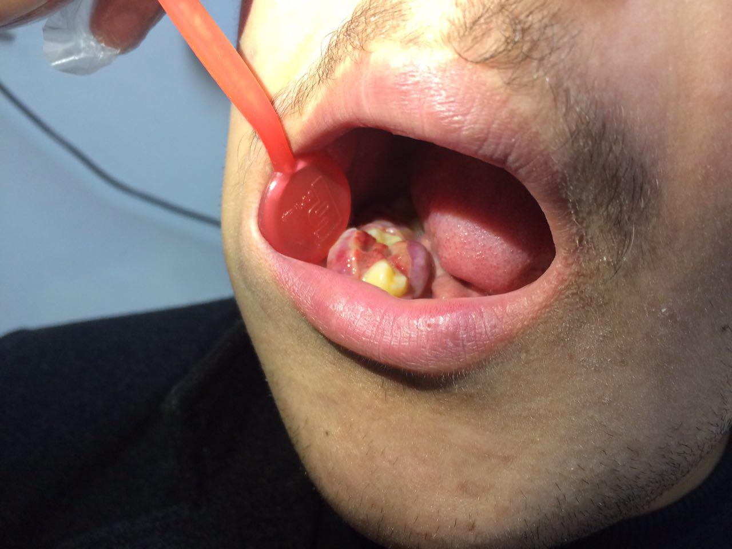
Fig. 1. Intraoral examination of the granulomatous tissue in the right mandibular premolar‒canine region with tooth displacement and expansion of the buccal and lingual cortices.

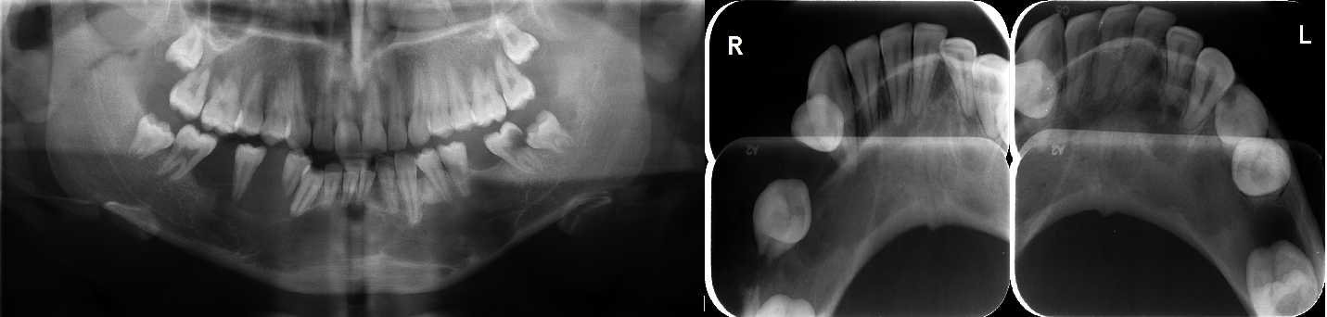
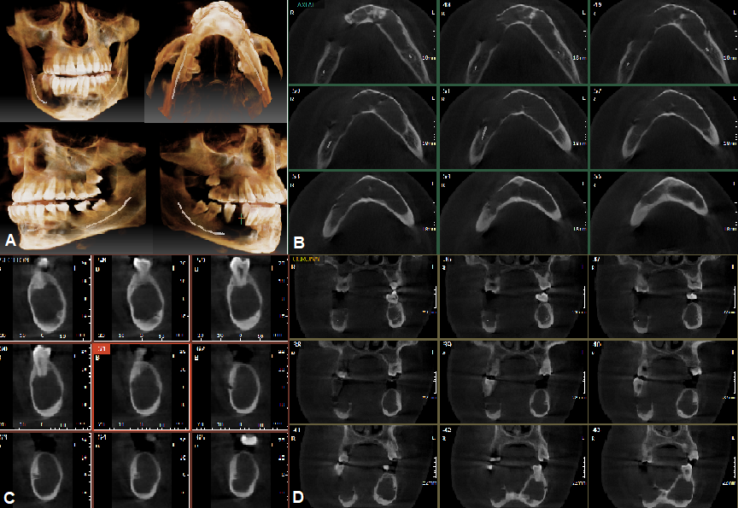
Fig. 2. Occlusal, panoramic and CBCT (A: 3D, B: axial, C: cross-sectional, D: coronal) views showed a well-defined lesion which crossed the midline of the mandible, extending from the mesial aspect of tooth #7 to the collateral side.

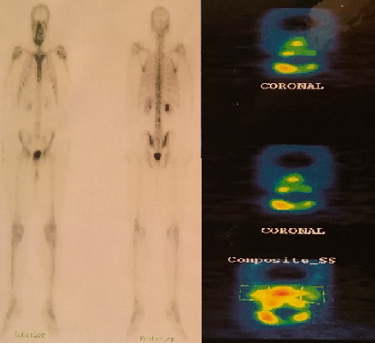
Fig. 3. Whole-body bone scan and SPECT findings showed no abnormal tracer uptake throughout the skeletal system, including the mandibular condyle.

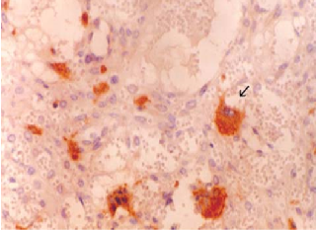
Fig. 4. Numerous osteoclast-like giant cells, cellular highly vascularized stroma, hemorrhage, hemosiderin-laden macrophages, covered by hyperplastic squamous epithelium.

References
1. Devi P, T Swaroopkanth, G Sudhakar, D Kiranmai, R Sasank, D Sridharreddy et al. Central GiantCell Granuloma of Maxilla: A Case Report. Indian J Otolaryngol Head Neck Surg.2013;65(Suppl1):S192-4.
2. Miloro M, Quinn PD. Synchronous Central Giant Cell Lesions of the Jaws: Report of a Case and Review of the Literature. J Oral Maxillofacial Surg 995;53:1350-55.
3. Vered M, Buchner A, Dayan D. Central giant cellgranuloma of the Jaw bones – new insights into molecular biology with clinical implications on treatment approaches. Histol. Histopathol 2008;23:1151-60.
4. Bilodeau E, Chowdhury K, Collins B. A Caseof Recurrent: Multifocal Central Giant Cell Granulomas.
Head and Neck Pathol 2009;3:174-78.
5. Regezi JA. Odontogenic cysts, odontogenic tumors, fibroosseous, and giant cell lesions of the jaws. Mod Pathol 2002;15:331–341.
6. Neville BW, Damm DD, Allen CM, Bouquot JE. Oral and maxillofacial pathology. 2nd ed. Philadelphia, PA: WB Saunders, 2002;522–525,695– 697.
7. Goaz PW, White SC. Oral radiology: principles and interpretation. 3rd ed. St. Louis, MO: CV Mosby, 1994;514–518,536–537.
8. Horner K. Central giant cell granuloma of the jaws: a clinico-radiological study. Clin Radiol 1989;40:622–626.
9. Sidhu MS, Parkash H, Sidhu SS. Central giant cell granuloma of jaws: review of 19 cases. Br J Oral Maxillofac Surg 1995;33:43–46.
10. Cohen MA, Hertzanu Y. Radiologic features, including those seen with computed tomography, of central giant cell granuloma of the jaws. Oral Surg Oral Med Oral Pathol 1988;65:255–261.
11. Whitaker SB, Waldron CA. Central giant cell lesions of the jaws. A clinical, radiologic, and histopathologic study. Oral Surg Oral Med Oral Pathol 1993;75:199–208.
12. Goshen O, Aviel-Ronen S, Dori S, Talmi YP. Brown tumour of hyperparathyroidism in the mandible associated with atypical parathyroid adenoma. J Laryngol Otol 2000;114:302–304.
13. Kaffe I, Ardekian L, Taicher S, Littner MM, Buchner A. Radiologic features of central giant cell granuloma of the jaws. Oral Surg Oral Med Oral Pathol Oral Radiol Endod 1996;81:720–726.
14. Miniƒ A, Staj…iƒ Z. Prognostic significance of cortical perforation in the recurrence of central giant cell granulomas of the jaws. J Craniomaxillofac Surg 1996;24:104–108.
15. Austin LT Jr, Dahlin DC, Royer RQ. Giant-cell reparative granuloma and related conditions affecting the jawbones. Oral Surg Oral Med Oral Pathol 1959;12:1285–1295.60.
16. Auclair PL, Cuenin P, Kratochvil FJ, Slater LJ, Ellis GL. A clinical and histomorphologic comparison of the central giant cell granuloma and the giant cell tumor. Oral Surg Oral Med Oral Pathol1988;66:197–208.
17. Bataineh AB, Al-Khateeb T, Rawashdeh MA. The surgical treatment of central giant cell granuloma of the mandible. J Oral Maxillofac Surg 2002;60: 756–761.
18. Chuong R, Kaban LB, Kozakewich H, PerezAtayde A. Central giant cell lesions of the jaws: a clinicopathologic study. J Oral Maxillofac Surg 1986;44:708–713.


Biography: Ava Nikbin has her expertise in oral and maxillofacial radiology as a postgraduate student. Here presented a case that is fallowed for several month. This is an unusual case of central giant cell granuloma with extensive manner. This case is try to treated with denosumab that will be presented later after 1 year fallow up. This is a case of unusual CGCG.

