Prevalence of Autoimmune Diseases among Psoriatic Patients in a Tertiary Hospital, Riyadh, Saudi Arabia
Alanoud Hakami, King saud Bin Abdulaziz for Health and Sciences, KSA

Abstract (300 word limit)
Background:
Psoriasis is a chronic inflammatory skin condition of unknown aetiology. It has been presumed that psoriasis is associated with several autoimmune diseases. Data regarding the prevalence of autoimmune diseases in psoriasis is scant. In addition, no study has yet determined the prevalence of autoimmune diseases amongst psoriatic patients in Saudi Arabia.

Objectives:
The aim of this study is to determine the prevalence of autoimmune diseases among psoriatic patients in a tertiary hospital, Riyadh, Saudi Arabia. By recognizing that some psoriatic patients may have strong links to other autoimmune diseases, the diseases can be monitored more efficiently, diagnosed earlier, and treated more effectively.

Methodology:
A cross-sectional study was conducted at King Abdulaziz Medical City (KAMC), Riyadh, Saudi Arabia, where conventional sampling technique was done to include all patients with psoriasis from 2016-2018, and the total sample was 841.

Results:
56.4% of our patients were female, and were mostly between the ages of 31-50 years, measuring 37.1%. Only 7.4% of those with psoriasis had a known family history. The majority of our patients did not have a comorbid autoimmune disease. The prevalence of autoimmune diseases in descending order was hypothyroidism 6.8%, alopecia areata 3.6%, atopic dermatitis 2.9%, hyperthyroidism 2.6%, vitiligo 1.9%, rheumatoid arthritis 1.5%, SLE, 0.8%, celiac disease 0.6% and Crohn’s disease 0.5%. Hypothyroidism was the only disease with a statistically significant association p<0.05. Additionally, a female predominance has been identified among all the autoimmune diseases except crohn’s disease.
Conclusions:
In our study, although multiple autoimmune diseases were present among psoriatic patients, only one autoimmune disease was statistically significant. Our findings suggest possible association between hypothyroidism and psoriasis. Nonetheless, more research is required to develop a deeper understanding of the relationship between psoriasis and autoimmune diseases.

Image

Recent Publications
- Meglio P, Villanova F, Nestle F. Psoriasis. Cold Spring Harbor Perspectives Med. 2014 Aug; 4(8): a015354 doi: 10.1101/cshperspect.a015354
- Parisi R, Symmons DP, Griffiths CE, Ashcroft DM. identification and Management of Psoriasis and Associated ComorbidiTy (IMPACT) project team. Global epidemiology of psoriasis: a systematic review of incidence and prevelance. J Invest Dermatol. 2013 Feb;133(2):377-85.doi: 10.1038/jid.2012.339. Epub 2012 sep 27.
- Sticherling M. Psoriasis and autoimmunity. Autoimmune Rev. 2016 Dec;15(12): 1167-117-. Doi: 10.1016/jautrev.2016.09.004. Epub 2016 Sep 15.
- Cai Y, Fleming C, Yan J. New insights of T Cells in the pathogenesis of psoriasis. Cell Mol Imunnol. 2012 Jul; 9(4): 302-309.
- Eberle C F, Brück J, Holstein J, Hirahara K, Ghoreschi K. Recent advances in understanding psoriasis. Version 1. F1000Res. 2016; 5: F1000 Faculty Rev-770. Published online 2016 Apr 28. Doi: [10. 12688/f1000research.7927.1]

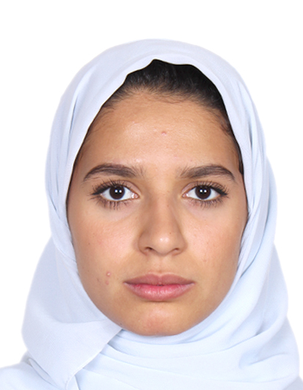 Biography (150 word limit)

Alanoud Hakami is an intern at King Abdulziz Medical City. She graduated in 2019 from King Saud Bin Abdulaziz for Health and sciences with first class honors and a GPA of 9.2.
Email: alanoudrhakami@gmail.com

Suggestion if any interested from your colleagues (Name and Mail Id): _____________________

