Neuronal Precursor Cell Expressed Developmentally down Regulated 4 (NEDD 4) gene polymorphism in keloid patients: A Clinical and Genetic study.

Azza GA Farag*, Wafaa Ahmed Shehata*, Mostafa A Hammam *, Mustafa Elsayed Elshaib, ** Nermin Reda Tayel***, Sahar Elsoudy Ibrahim Hommos**** and Eman Masoud AbdElGayed *****,
*Department of Dermatology, Andrology and STDs, Faculty of Medicine – Menoufia University, Egypt.
**Medical Student , Faculty of Medicine- Menoufia University, Shebin ElKom, Egypt.
***Department of Molecular Diagnostics and Therapeutics, Genetic Engineering Biotechnology Research Institute, Sadat City, Egypt.
**** Resident doctor, Ministry of Heath, Elsherouk General Hospital, Cairo.
***** Department of Biochemistry, Faculty of Medicine – Menoufia University, Egypt.

Key words: NEDD4; keloid; gene polymorphism.
Abstract Body
- Background: Keloids represent chronic fibroproliferative disorders of the skin which is characterized by excessive deposition of extracellular components especially collagen type 1, fibronectin and elastin. The exact aetiology of keloid formation is undefined but its development rests on genetic and environmental factors. Aim: to investigate NEDD4 (rs8032158) gene polymorphism in a sample of Egyptian patients having keloid. Patients and methods: The current case-control study was done on 80 subjects; 50 keloid patients and 30 ages and sex matched apparently healthy controls. All subjects underwent full history, weight and length measuring to calculate BMI, dermatological examination and analysis of NEDD4 rs8032158 (T/C) gene polymorphism using Real Time-PCR. Results: rs8032158 CC genotype was significantly observed in keloid patients and increased the risk for keloid development by about 4 times (p=0.038, OR=4.20) and was significantly associated with severe form of keloid (p<0.001). Moreover, C allele significantly increased the risk for keloid development by about 2 folds (P=0.028, OR =2.08). Conclusion: NEDD4 (rs8032158) gene polymorphism could participate in keloid formation in Egyptian population. NEDD4 (rs8032158) CC genotype may have a role in keloid severity.
.

- Image:

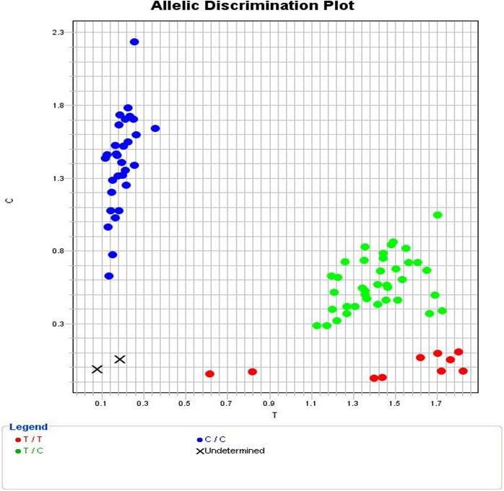
Allelic discrimination plot of (rs8032158) gene polymorphism in both cases and controls (TT genotypes ( red dots), TC genotypes (green dots) and CC genotypes (blue dots)).

- Reference:
- Chung, S., Nakashima, M., Zembutsu, H et al.: Possible involvement of NEDD4 in keloid formation; its critical role in fibroblast proliferation and collagen production. Proceedings of the Japan Academy, Series B 2010; 8: 563-573.‏
- Marneros, A. G.: A Role for the E3 Ubiquitin Ligase NEDD4 in Keloid Pathogenesis. Journal of Investigative Dermatology 2019; 2: 279-280.‏
- Ogawa, R., Watanabe, A., Than Naing et al.: Associations between keloid severity and single-nucleotide polymorphisms: importance of rs8032158 as a biomarker of keloid severity. J Invest Dermatol 2014 ;7: 2041-2043.‏
- Fujita M, Yamamoto Y, Jiang JJ et al.: NEDD4 is involved in inflammation development during keloid formation. Journal of Investigative Dermatology. 2019; 2 :333-341.
- Biography:
Azza Gaber Antar Farag has completed her PhD at the age of 24 years from Menoufia University and Postdoctoral Studies from Menoufia University, Egypt. She is assistant professor, Dermatology, Andrology & STDs department, Faculty of Medicine, Menoufia University. She has published more than 30 papers in reputed journals and has been serving as an editorial board member of repute. She is a reviewer in many international journals.

- Presenting author details:

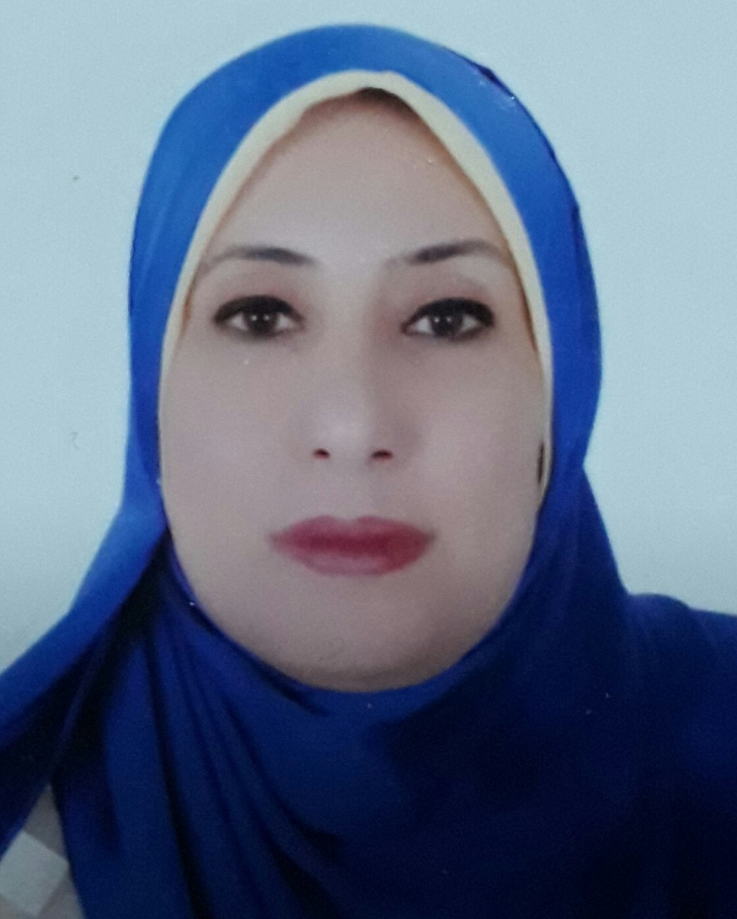

Full Name: Azza Gaber Antar Farag
Contact number: 002/ 01097787204
Linked In account: azzagaber92@yahoo.com
Session name/ number:
Category: Poster presentation
Passport Number: A20043658

