Comparative evaluation of therapeutic efficacy and safety of dermabrasion with PGE2 analogue (Dinoprostone), 5-Flourouracil cream (5%) and Tacrolimus(0.1%) cream in localised stable vitiligo
Dr Jaskirat kaur, resident GGSMCH, Faridkot, Punjab, India
Introduction: Vitiligo is associated with huge social stigma in Asain skin. The desire of novel molecules has been since long in the management of vitiligo. Our aim in the study was to evaluate therapeutic efficacy and safety of dermabrasion with PGE2 analogue (Dinoprostone gel), 5-Flourouracil (5%) cream and Tacrolimus 0.1% cream in localised stable vitiligo
Methodology & Theoretical Orientation: 60 patients of localised stable vitiligo were taken which were randomly divided into 3 groups. Dermabrasion with Dinoprostone gel, 5-Flourouracil and Tacrolimus 0.1% ointment was done in group 1, 2, and 3 respectively. The respective topical agents were instructed to be applied twice daily till 12 weeks. Follow up was done by VASI, DLQI and photographically four weekly till 36 weeks.
Findings: Repigmentation started within 4 weeks in all 3 groups. Excellent response (>75% repigmentation ) was seen in 43%,40% and 54% of group1,2 and 3 patients respectively. Good response(>50% respigmenatation) was observed in 34%,26%, 33%, of patients of group1,2 and 3 respectively. 25-50% repigmentation was seen in 4%,8%,10% in group1,2 and 3 aptients respectively. No significant side effects or reoccurence were found in the study period.
Conclusions and significance: Dermabrasion when combined with Dinoprostone gel, 5-Flourouracil (5%), or tacrolimus 0.1% ointment showed similar efficacy and side effect profile in all 3 groups with slight better response with tacrolimus ointment. This study adds novel molecule dinoprostone to the already existing basket for vitiligo mangement.
Recent Publications:
1)Sethi S, Mahajan BB, Gupta RR. A comparative evaluation of the therapeutic efficacy of dermabrasion, deramabrasion combined with 5% 5-flurouracil cream, and dermabrasion combined with topical placentrax gel in localized vitiligo. Int J Dermatol. 2007;46:875-9.
2)Kanwar AJ, DograS , Parsad D. Topical tacrolimus for treatment of vitiligo in Asians. Clin Exp Dermatol. 2004;29:589-92.
3) Xu AE, Zhang DM, Wei XD. Efficacy and safety of tacrolimus cream 0.1% in treatment of vitiligo. Int J Drmatol. 2009;48:86-90.
4)Parsad D, Pandhi R, Dogra S,Kumar B. Topical prostaglandin analogue (PGE2) in vitiligo –a preliminary study. Int J Dermatol. 2002;41:942-45.
5) Kapoor R, Phiske MM, Jerajani HR.Evaluation of safety and efficacy of topical prostaglandin E2 in treatment of viiligo. Br J Dermatol. 2008;160:861-63.
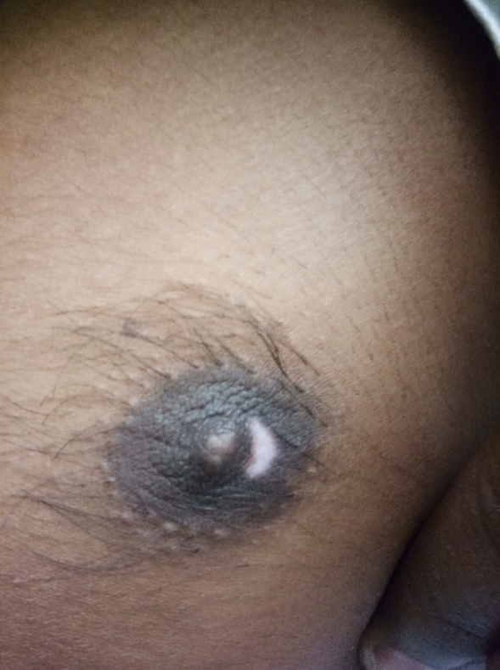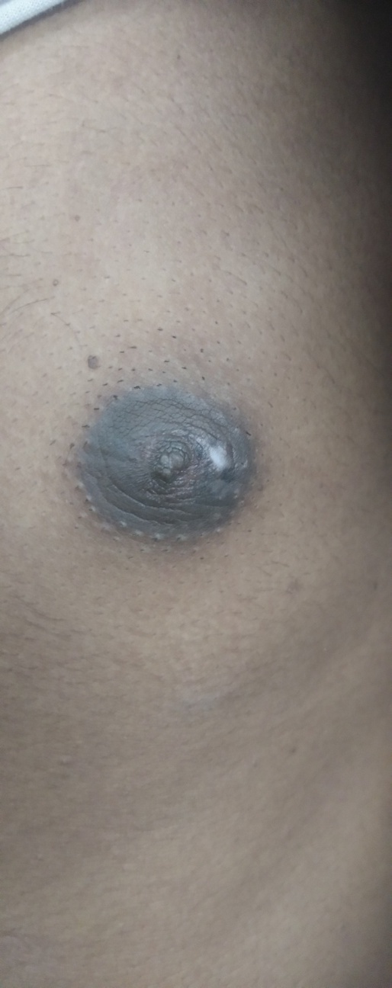
Fig 1 A vitiligo lesion on Fig 2: Repigmentation after 12 weeks
nipple

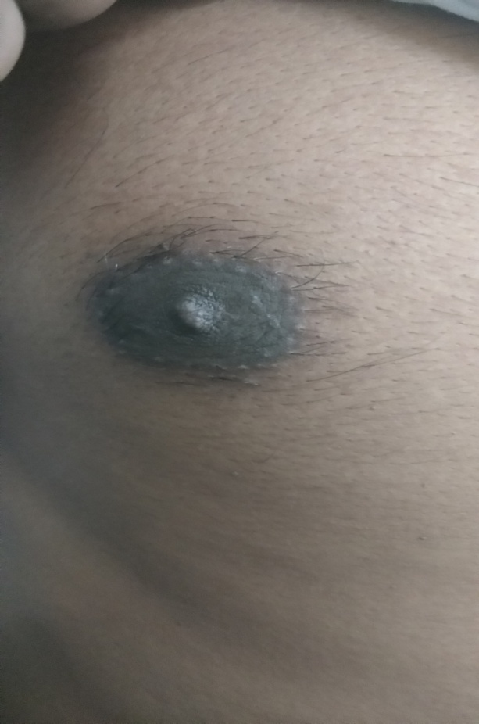 Fig :Completely repigmented lesion at 30 weeks

Bibiolography:
I , Dr Jaskirat kaur is submitting abstract in your prestigious conference. I have huge interst in field of vitiligo. I have my thesis topic on vitiligo. Apart from thesis I have presented 3 award papers, 1 free paper and numerous posters in national conferences on vitiligo.
Email – jaskiratkaur99930@gmail.com

