Dermocosmetic efficacy of a nutricosmeceutic concentrated oil-soluble fraction from Vitis vinifera grape marc on the skin hydrolipidic barrier and wrinkles
Sonia Laneri¹, Ritamaria Di Lorenzo¹, Antonia Sacchi¹, Fabio Apone², Claudia Zappelli² , Irene Dini ¹
¹ Dept. of Pharmacy, University of Naples Federico II, Via Domenico Montesano 49, Napoli 80131, Italy
² Vitalab srl, via B. Brin 69, 80142, Napoli

Abstract
Grapes (Vitis vinifera) are one of the most widely-grown fruit crops in the world. Approximately 75% of the whole grape production is utilized into winemaking, while 25% of the original grape weight is grape pomace (skin, seeds and stalks), which is a by-product. The oil-soluble fraction of grape pomace is rich in phenolic compounds including flavonoids, carotenoids, phenolic acids, tannins, and stilbenes, high unsaturated fatty acids, vitamins (E, A and C) and phytosterols with economic importance to cosmetic, food and pharmaceutical industry. The objective of this study was to evaluate the cosmetic efficacy on skin balance, normalization, hydration and elasticity and on wrinkles prevention of dermocosmetic formulations containing grape seed oil extract on young and mature skin using in vitro and in vivo techniques.
In vitro studies showed anti-aging effect through enhancement of cell detoxification, hydration, protection of cellular proteins, stabilization of connective tissues from UV-stress inducing hyaluronic acid synthase and stimulating collagen I and III synthesis.
In vivo studies displayed wrinkles volume and depth reduction and a barrier protective effect inducing a high hydration of the skin.

Image
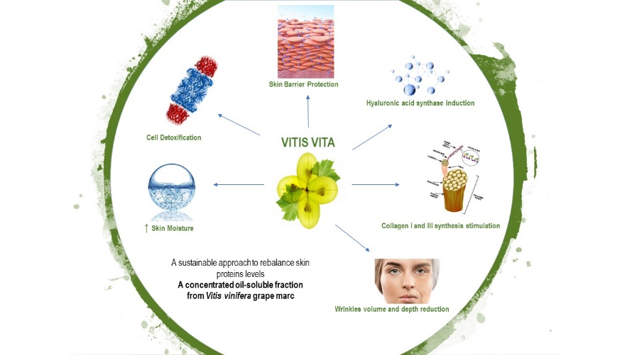
Fig. 1 Effects of oil-soluble fraction from Vitis vinifera grape marc on skin properties.

Recent Publications
- Carola A, Tito A, Bimonte M, Mustilli AC, Cucchiara M, Monoli I, Hill J, Apone F, Colucci G. (2012). Liposoluble extracts of Vitis vinifera grape marc and cell cultures with synergistic anti-ageing effects. HPC Today, vol. 7 nr.3 July/September 2012.
- A. Barbulova, F. Apone & G. Colucci (2015). New trends in Cosmetics: by-products of plant origin and their potential use as cosmetic active ingredients. Cosmetics, 2, 82-92.

 Biography
Sonia Laneri has her expertise in chemical synthesis of drugs expecially heterocyclic nucleus and pseudohormones, their characterization by spectroscopic methods and their therapeutic application. Moreover, she is Manager of the Research Centre “Centro di Scienze Cosmetiche” – Pharmacy Department, University of Naples Federico II, where efficacy in vivo and ex vivo studies on cosmetic products were done. Her latest research works are focused on the synthesis and performance of new cosmeceuticals and provitamins for dermocosmetic use.
Email: slaneri@unina.it

