One-Stage Vermilion Reconstruction with Axial Pattern Composite Tissue Flap
YANG Xiaonan, JIN Xiaolei, QI Zuoliang, China

Abstract (300 word limit)

Objective: To discuss the effect of one-stage vermilion reconstruction with axial pattern composite tissue flap.

Methods: According to the size of vermilion defect, the axial pattern composite tissue flap with pedicle in oral commissure was designed and transposed to reconstruct simple lip defect. The defect at the donor site was closed directly.

Results: 9 patients were treated with satisfactory aesthetic results. All the flaps survived completely. The characters and color of repaired lips were similar to normal ones. The oral commissure kept normal with no obvious scar at the donor sites.

Conclusions: The method of vermilion repair with axial pattern composite flap has the advantages of avoiding inconvenience in feeding, speaking and cleaning. The procedure is simple with available blood supply and shortens the treatment. Both aesthetic and functional results are satisfactory.
Image
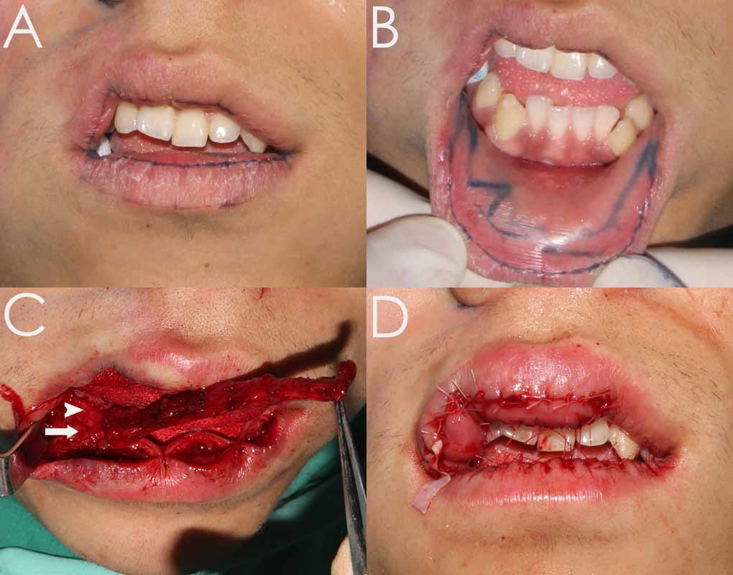
Figure Design and transposition of one-side-pedicle vermilion axial pattern composite tissue flap. (A, B) Design of operation; (C) The vermilion flap with the pedicle located inside the commissure was raised from the lower lip; (Arrow, accessory inferior labial artery; Arrowhead, musclomucosal pedicle); (D) Postoperative view.
Recent Publications (minimum 5)
- Yang XN (2017) Muscle-derived stem cells in peripheral nerve regeneration: reality or illusion? Regen. Med.
- Yang XN (2015) Autologous Fat Grafting With Combined 3-Dimensional and Mirror-Image Analyses for Progressive Hemifacial Atrophy ，Ann Plast Surg ，Aug.2015.
- Yang XN（Accepted）Roberts syndrome: long-term survival after corrective surgeries in two patients with severe deformities and a literature review，EXP THER MED.
- Yang XN (2013) Peripheral nerve repair with epimysium conduit. Biomaterials

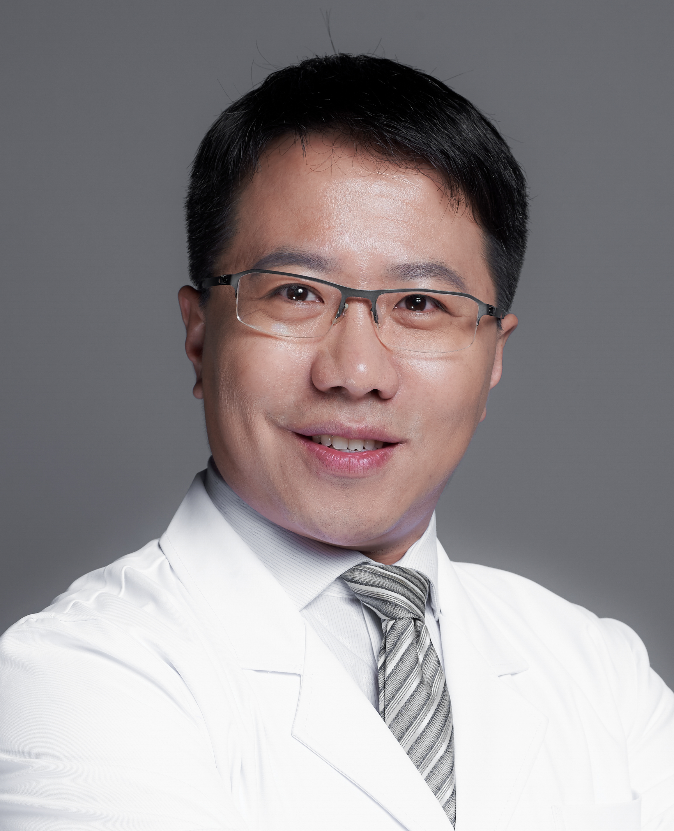Biography (150 word limit)
Yang Xiaonan, M.D., Ph.D., Associate Professor of Plastic and Aesthetic Surgery, Plastic Surgery Hospital, PUMC, CAME, Beijing, China. Dr. Yang is an experienced Plastic Surgeon with a demonstrated history of working in the hospital & health care industry. Skilled in Clinical Research, Medical Education, Facial Plastic & Reconstructive Surgery, Botox Cosmetic, filler injection, liposuction, fat grafting and Breast Surgery. Strong healthcare services professional with a Doctor of Philosophy (Ph.D.) focused in Plastic surgery from Shanghai Jiao Tong University. Visiting experience at Harvard University, USA, in 2014.
Email: yxnan@aliyun.com

