

Keratitis-Icthyosis-Deafness (KID) syndrome-a rare congenital syndrome
Corresponding Auther: Snoor S. Hadi. M.B.,Ch.B., M.Sc (Dermatology)
Department of Internal Medicine (Dermatology). Azadi General Teaching Hospital. Duhok. Iraq
Abstract
KID syndrome (Keratitis-Icthyosis-Deafness syndrome), first described in 1915 by Frederick Burns who provided a detailed clinical description delineating all the key features of this syndrome.and there are only 200 cases published over the world till now¹ I report a 30 year old female who presented with persistant scaly skin over parts of her body and scalp with diffuse alopecia. There was erythrokeratoderma of face and diffuse hyperkeratotic hyperpigmented infected plaque over pubis. There was history of recurrent episodes of folliculitis over the scalp. There was no evidence of tuberculosis or any malignancy. Eye involvement in the form of impaired vision and irritation were present. There was bilateral sensorineural progressive hearing loss.
It is a great opportunity for me to share an interesting rare case with KID syndrome to add another case to the published cases worldwide and to increases awareness of this unique syndrome, suggesting the proper diagnostic strategy and effective treatments to improve the quality of life as it is a chronic non healing disease.
Keywords: Keratitis-ichthyosis-deafness, Keratitis, deafness, Ichthyosis.

Case report:
I report a 30 years old female from north of Iraq born of non-consanguineous parents as a full-term normal vaginal delivery. She came from poor socioeconomic culture with low intellectual performance. She started to have symptoms of the disease by age of one year as lesions with pustules at axilla and abdomen which increased in thickness as she grew older. She gave history of dry scaly face which increases in severity by age. She had history of teeth abnormalities which ended by denture. There was history of impaired vision and irritation, but had intact visual acuity and no other abnormal ophthalmological symptom or sign. She had progressive decreasing in hearing since childhood ended by wearing hearing assisted device. Gait was normal. No other congenital abnormality or systemic disease was detected. There was no family history of similar problem.

On examination she showed sparse thin hair over the scalp with follicular atrophy at places and multiple folliculitis lesions with scattered alopecia (Figure 1A).
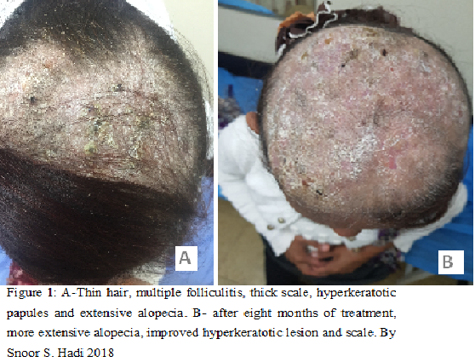

She had thick painful granulomatous and infected plagues in the pubis with no vaginal mucosal involvement (figure 2A).
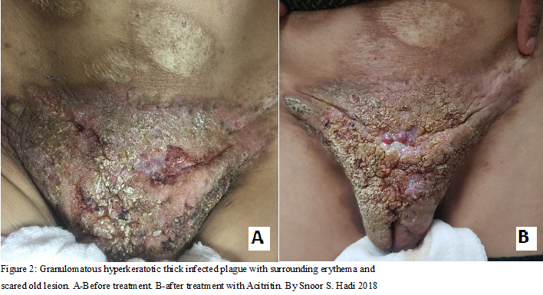

Hypotrichosis of eyebrow and eyelashes with thick face skin and perioral furrows were also present (Figure 3A).
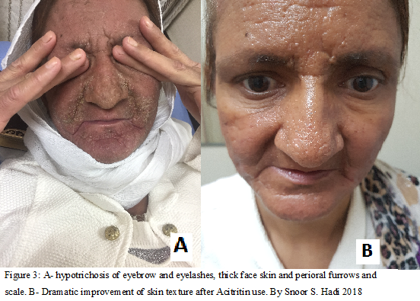 Old scaring lesions with atrophy of both breasts and axilla were noticed which were more prominent at right side (Figure 4).
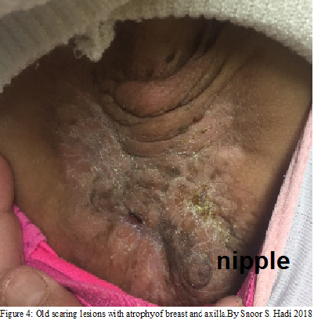
Results of blood tests showed iron deficiency anemia, mild leukocytosis with normal renal and liver function tests. Screening for hepatitis viruses, human immunodeficiency virus, and tuberculosis were negative. Scraping for fungal growth was negative. There was heavy growth of staphylococcus aureus species from a swab taken from pubic lesion. Chest x-ray and abdominal ultrasonography revealed no abnormalities. Punch biopsy taken from two different areas of pubis which showed hyperkeratotic epidermal layer with absent granular layer and inflammatory cell infiltration, no atypia or dysplasia was noticed.
We used genomic DNA of the patient extracted from paraffin-embedded tissue samples for mutation analysis of the GJB2 gene. The DNA was extracted using Quiagen Kit.⁶
PCR was performed using standard conditions with primer pairs covering the coding region of the GJB2 gene (primer sequences and PCR conditions are available on request). The PCR products were purified with the GFXTM PCR DNA Purification Kit (Amersham Biosciences) and directly sequenced using the BigDye® Terminator v1.1 Cycle Sequencing Kit (Applied Biosystems) on an ABI 3100 genetic analyser (Applied Biosystems). The sequencing analysis showed in addition to a known polymorphism (– 34C→T; NCBI ref SNP ID: 15 9578260) a heterozygous 148G→A transition in connexin 26 (Cx26) resulting in substitution of aspartic acid with asparagine in codon 50 (D50N).

Supportive treatment including emollient and bath oils as well as iron and multivitamins were given with topical and systemic antibiotics and systemic Isotretinon tablets 40mg daily for one year but with little improvement of skin lesion. Followed by more powerful retin A derivatives (Acitretin 35 mg daily for two months) with noticeable improvement of face and pubic skin lesions (Figures: 1B, 2B, 3B).

- .

Biography:
Snoor S. Hadi. Has completed the master's degree in Clinical Dermatology at age of 29 years old from university of Duhok /college of medicine. She is now working as specialist dermatologist and cosmologist in Azadi General Teaching Hospital. She attended many conferences and training courses on dermatology and cosmology and had had been a speaker in many of them nationally and internationally.
Presenting author Details:
Full Name: Snoor Subhi Hadi
Contact Number: 009647504968826
Email: Snoor.hadi1986@gmail.com
Facebook account: Snoor Aqrawi
Instagram: dr.Snoor Derma & Beauty Clinic
Category: Oral presentation/case report

