UNEXPECTED CAUSE OF TRACHEAL OBSTRUCTION: PLEOMORPHIC ADENOMA WITH LIPOMETAPLASIA
Florencia Von Stecher, María de los Milagros Lewkowicz, Agustina Bruno, Alejandro Damonte, Alejandra Avagnina, Joaquín García Moratto
Pathology Department and Surgery Division, Hospital de Clínicas José de San Martín, Buenos Aires, Argentina

Abstract

Pleomorphic adenoma of the trachea is a benign tumor, extremely rare, that generates obstructive symptoms and sometimes is confused with asthma, which delays its diagnosis. We present the case of a 40-year-old woman with history of asthma and airway obstruction, of 8-months duration. Fibrobronchoscopy showed polypoid, pedunculated lesion in first tracheal ring which occluded 80% of the lumen, that was resected. The histopathological diagnosis was pleomorphic adenoma with lipometaplasia. Treatment of these tumors consists in complete resection of the lesion and long-term follow-up due to low probability of recurrence, malignancy and metastasis.

Image
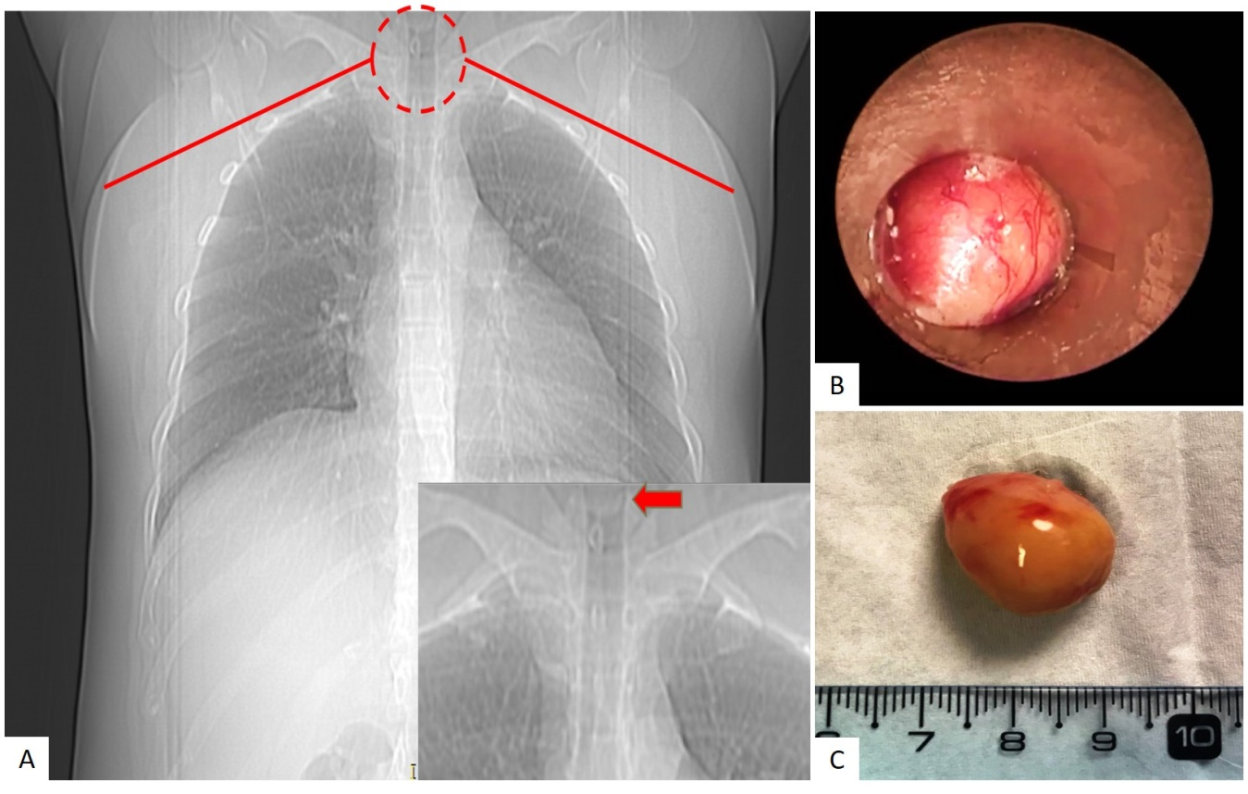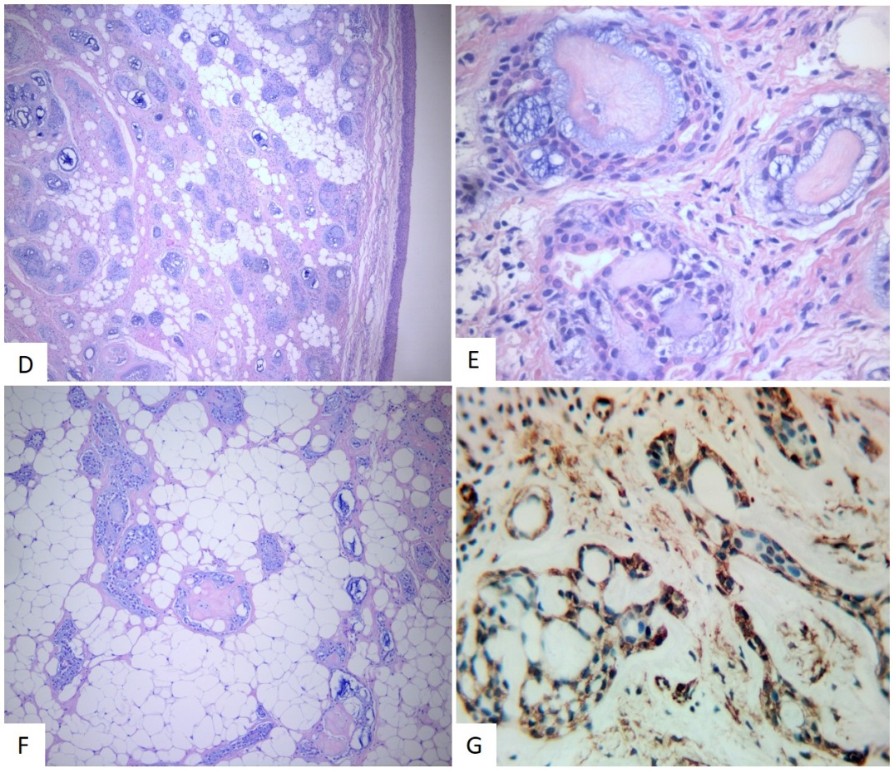
A) Chest X-ray showing a well-defined endotracheal nodular cental formation on the upper margin of the photo.
B) Rigid bronchoscopy. A vegetating pedunculated lesion is observed at the level of the first tracheal ring that occludes 80% of the lumen.
C) Macroscopy: 1.5 cm lumpectomy piece with smooth and shiny external surface.
D) Microscopy: Hematoxylin-Eosin 40x. The histological study showed a circumscribed cell proliferation, consisting of cells arranged in nests, cords, ducts and sieve structures.
D) Microscopy: Hematoxylin-Eosin 400x. It is a biphasic cell proliferation, made up of epithelial and myoepithelial cells and immersed in a myxoid and hyaline matrix.
F) Microscopy: Hematoxylin-Eosin 100x and 40x. In addition, abundant interposed adipose tissue was observed, which represented approximately 60% of the tumor.
G) Staining with Smooth Muscle Actin. 400x. With immunostaining, myoepithelial cells are highlighted.
Recent Publications
- Insler JE, Seder CW, Furlan K, Mir F, Reddy VB and Gattuso P. Benign Endobronchial Tumors: A Clinicopathologic Review. Front. Surg. 2021; 8:644656. doi: 10.3389/fsurg.2021.644656.
- Diaz-Mendoza J, Debiane L, Peralta AR, Simoff M. Tracheal tumors. Curr Opin Pulm Med. 2019;25(4):336-343. doi:10.1097/MCP.0000000000000585
- Doxtader EE, Shah AA, Zhang Y, Wang H, Dyhdalo KS, Farver C. Primary salivary gland-type tumors of the tracheobronchial tree diagnosed by transbronchial fine needle aspiration: Clinical and cytomorphologic features with histopathologic correlation. Diagn Cytopathol. 2019;47(11):1168-1176. doi:10.1002/dc.24285.
- Moores D, Mane P. Pathology of primary tracheobronchial malignancies other than adenoid cystic carcinomas. Thorac Surg Clin. 2018;28(2):149-54.
- Koul R, Alomrann R, Rathod S, Kim J, Leylek A, Ahmed N et al. Clinical characteristics and prognosis of primary tracheal cancer: A single institution experience. Int J Hematol Oncol Stem Cell Res. 2018;12(4):298-302.


Biography
Maria de los Milagros Lewkowicz is a medical doctor who studied and graduated in UBA (University of Buenos Aires). Currently in the 4th year of her residency in pathology at a University Hospital called Hospital de Clinicas "José de San Martín" in Argentina. She will present an extremely strange and clinically enriching case, studied as a team by Pathologist and Surgeons of the hospital. This clinical case has been recently published in the most important magazine in the country called Medicine.
Email: milagros151289@gmail.com

Notes/Comments:

