Obstructive shock due to the incorrect setup of a digital drainage system after pulmonary lobectomy
Abstract
We report a case of life-threatening obstructive shock from extreme negative intrapleural pressure that occurred due to the incorrect setup of a digital drainage system following video-assisted thoracic surgery. Such devices are increasingly prevalent due to increased precision and mobility. Those caring for such patients should be cognizant of their potential pitfalls. Small user errors in the value and units to which the suction is set via the menu system can have significant consequences.
Authors: Dilraj Thind, Shirin Jamshidi, Jana Vitesnikova
Images
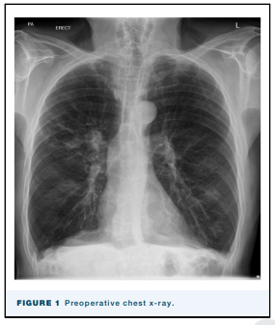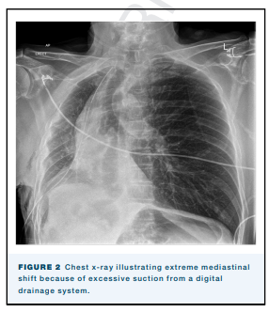

Biography

Dr Shirin Jamshidi is an anaesthesiologist at the Royal Hobart Hospital in Hobart, Australia. Her interests include doctor’s wellbeing as well as orthopedic and obstetric surgery. The observation of how digital technologies are being adapted into patient management and their potential pitfalls is what inspired this presentation.

