Effect of endobronchial valve application on the respiratory function in patients with pulmonary tuberculosis and concomitant chronic nonspecific lung diseases.
D.V. Krasnov, E.P. Myshkova, S.V. Skluev, I.F. Felker
FSBI Novosibirsk Tuberculosis Research Institute, MoH, Russia
The article presents a retrospective analysis of treatment results in patients with destructive pulmonary tuberculosis and concomitant chronic nonspecific lung diseases.
The aim of the study was to evaluate the effect of endobronchial valve (EBV) application on the respiratory function.
Materials and methods: 102 patients were included in an open comparative retrospective study. In 49 patients (main group), the EBV was used in the treatment, and 53 patients (comparison group) received standard anti-tuberculous chemotherapy. The parameters of the respiratory function (RF) were measured at three critical points during hospital stage of treatment and in the long-term period.
Results: the installation of EBV led to a slight decrease in the level of vital lungs capacity (VLC) and the forced expiration volume. After removal of the valve, these RF values came to the initial level. Standard anti-TB therapy of patients in the comparison group contributed to a 6% decrease in the VLC values below the baseline, while the level of bronchial patency was preserved. At the final measurement in the main group, the proportion of patients with normal volumetric RF values increased with a simultaneous decrease in the proportion of patients with moderate and significantly reduced rates. Also in the main group, there was an increase in the proportion of patients with normal indices of bronchial patency, and in the comparison group the proportion of patients with normal indices remained at the same level.
Conclusion: EBV application leads to a non-significant (less than 10% decrease in relation to the initial indices) and reversible disruption of both volume and bronchial patency of respiratory function. There is a significant irreversible decrease in the parameters of the respiratory function during the long treatment of patients with infiltrative pulmonary tuberculosis.
- Kulchavenya E. Extrapulmonary Tuberculosis: are statistical reports accurate? Therapeutic Advances in Infectious Disease. 2014. Vol. 2(2). S.61–70. doi: 10.1177/2049936114528173.
- Sklyuev S.V., Petrenko T.I. EHffektivnost' ustanovki ehndobronhial'nogo klapana pri kompleksnoj terapii bol'nyh s neehffektivno lechennym destruktivnym infil'trativnym tuberkulezom legkih // Tuberkulez i bolezni legkih. 2013. №7. S. 11–15 (in Russian).
- Petrova Ya.K., Krasnov D.V., Sklyuev S.V. i dr. Primenenie metoda klapannoj bronhoblokacii v kompleksnom lechenii destruktivnogo tuberkuleza legkih u bol'nyh s VICH-infekciej // Tuberkulez i bolezni legkih. 2015. №5. S.142 (in Russian).
- Krasnov D.V., Skvortsov D.A., Krasnov V.A. i dr. Hirurgicheskoe lechenie bol'nyh rasprostranennym fibrozno-kavernoznym tuberkulezom legkih s primeneniem osteoplasticheskoj torakoplastiki iz mini-dostupa // Tuberkulez i bolezni legkih. 2015. №6. S. 82-83 (in Russian).
- Levin A., Sklyuev, S., Felker I. et al. Endobronchial valve treatment of destructive multidrug-resistant tuberculosis // The International Journal of Tuberculosis and Lung Disease. 1 November 2016. Vol. 20. №11. Р. 1539–1545(7).

Main group
Comparison group
The use of the endobronchial valve results in a non-significant (less than 10% decrease in relation to the initial indices) and reversible disruption of both volume and bronchial patency of respiratory function.

Figure 1. Functional response on an endobronchial valve installation in patients with pulmonary tuberculosis and comorbidity.

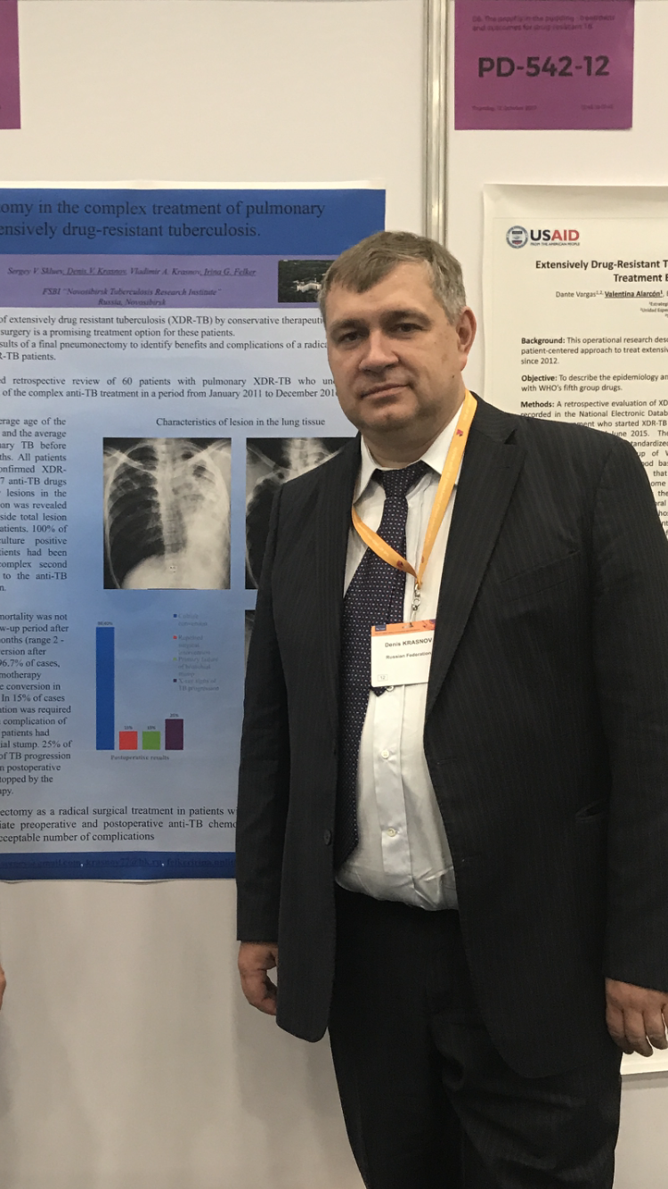

Krasnov D.V. - Chief Researcher in the Novosibirsk Tuberculosis Research Institute, head of the surgical department for tuberculosis patients and he is the scientific leader of a number of research works on phthisiology and thoracic surgery.
Krasnov D.V. is a recognized expert in the field of tuberculosis surgery, has a degree of Doctor of Medicine. He is a high professional in all methods of surgical treatment in patients with pulmonary tuberculosis. In 2013, he participated in the development and drafting of international recommendations for the surgical treatment of multidrug-resistant tuberculosis for the WHO European Region.
Krasnov D.V. carried out a large amount of research work in the field of surgical treatment of patients with pulmonary tuberculosis and especially drug resistant tuberculosis. Results of his research work were repeatedly reported at international scientific and practical conferences, congresses and symposia.

